Firmware and Software for Electronics
Book 8 of the Electrical Engineering Series
Lothar J. Musiol
Copyright © 2026 Lothar J. Musiol. All rights reserved. Kindle edition.
Embedded C, Python, C#, and HDL at the Bench: Toolchains, Real Time, Connected Devices, Test Automation, and AI-Assisted Development

How to Use This Book
Most of what an electronic product does today is decided by software: the control loop in the thermostat, the filter in the drone, the retry logic in the sensor node, the test script that passes or fails every board at the end of the line. This book teaches that software from the bench side, for readers who already know the hardware or are learning it in Books 1 to 7. Part I, Chapters 1 to 5, sets up the workbench: the job and a method that works, toolchains and builds, C for microcontrollers, MicroPython and Python, and C# with .NET. Part II, Chapters 6 to 11, talks to hardware: GPIO and interrupts, timers and PWM, the ADC, UART and I2C, SPI, CAN and USB, and what the HAL does under the registers. Part III, Chapters 12 to 16, gives the firmware structure, timing, and energy: state machines, FreeRTOS, deep sleep, fixed-point math and DSP, and sensor fusion. Part IV, Chapters 17 to 20, connects the device: Wi-Fi and MQTT, BLE, LoRa and GPS, over-the-air updates and security, and cameras, point clouds, and edge AI. Part V, Chapters 21 to 24, moves to the PC and to quality: Python and C# on the bench, debugging, and testing with version control. Part VI, Chapters 25 and 26, covers two newer ways to build: AI-assisted development and hardware description languages.
One method runs through every worked example: write a short spec, split the job into modules, write or prompt one module at a time, review it against a checklist, build and unit-test it on the PC, test it on the hardware, commit it, iterate with precise bug reports, and document it. Chapter 1 introduces the spec template and the review checklist, and Appendix A repeats them for the bench. Each chapter opens with a question from real work, says where you meet the topic, builds the idea in words before the code, and works it through with real numbers. From the Bench notes give the practical habits, On the Job notes describe the work as it is done in companies, and AI Pair-Programming notes say what assistants tend to get wrong in that chapter's topic. Every chapter ends with practice problems graded Core, Extension, and Challenge, whose worked solutions in Appendix B also name the usual mistake, and with a short list of what you will actually use.
The listings are short and complete, and each was checked. C that runs without hardware was compiled with gcc using -Wall and -Wextra and run, and its printed results are the numbers quoted in the text. C and C++ written for ESP-IDF 5, the Arduino core for ESP32 3, the Pico SDK, the STM32 HAL, and the libraries named in the listings were syntax-checked against declaration stubs of those interfaces; that catches typing and type errors but not every difference between library versions, so build them in your own toolchain before you flash them. Python that runs on a PC was run; Python that needs a board, an instrument, or a camera was compile-checked. The C# listings were built with the .NET 10 SDK, with stand-ins for the serial-port and GPIO classes, and their xUnit tests pass. The Verilog was simulated with Icarus Verilog and linted with Verilator. The figures were computed from the same models and data as the worked examples.
The series gives each subject one home. Logic levels, pull-ups, and the circuits around a microcontroller pin are Book 1's and Book 2's. Sensor physics and the economics of making a chip are Book 3's. Radio front ends are Book 4's. Modulation, LoRa airtime, and the spectral view of signals are Book 5's. Batteries, regulators, and power budgets at the circuit level are Book 6's. Layout, EMC, and the instruments on the bench are Book 7's. This book uses their results where it needs them and does not derive them again.
The reference hardware is the series reader lab: an ESP32-S3 board, an OLED display, an ultrasonic distance sensor, a PIR motion sensor, a BME280 sensor, a GPS module, a LoRa radio, a servo, an 18650 battery module, and a camera. Other boards appear where they suit the job better: the Raspberry Pi Pico, an STM32 board, the nRF52840, the Teensy 4.1, the Raspberry Pi 5, and in Chapter 26 a small FPGA board. Prices are typical street prices in 2026 and change often. Library and framework versions change too; where an interface is version-specific, the text says which version was used. Two safety rules hold throughout. Lithium cells can burn when they are shorted, crushed, or charged without protection, so use protected cells and a charger module made for them. And none of the projects needs an open mains-powered device, so keep such equipment closed.

Contents
Part I. Tools and Method
Chapter 1. The Firmware Engineer's Job and a Method That Works
Chapter 2. Toolchains and Builds: From Source File to Flash
Chapter 3. C for Microcontrollers: Bits, Types, and Memory
Chapter 4. Python Twice: MicroPython on the Board, Python on the PC
Chapter 5. C# for Electronics: .NET on the Desktop and on the Chip
Part II. Talking to Hardware
Chapter 6. GPIO, Buttons, and Interrupts
Chapter 7. Timers and PWM: LEDs, Servos, and the Ultrasonic Ranger
Chapter 8. The ADC: Sampling, Scaling, and Calibration
Chapter 9. UART and I2C: The BME280 and the GPS
Chapter 10. SPI, CAN, and USB
Chapter 11. Register Level versus HAL
Part III. Structure, Time, and Energy
Chapter 12. Super Loops and State Machines
Chapter 13. FreeRTOS: Tasks, Queues, and Real Time
Chapter 14. Low Power and Sleep
Chapter 15. Fixed-Point Math and DSP
Chapter 16. Sensor Fusion: IMU Filters, Kalman, and SLAM Basics
Part IV. Connected and Intelligent Devices
Chapter 17. Wi-Fi and MQTT
Chapter 18. BLE, LoRa, and GPS Firmware
Chapter 19. OTA Updates and Security Basics
Chapter 20. Cameras, Point Clouds, and Edge AI
Part V. The PC Side, Debugging, and Quality
Chapter 21. Python on the Bench
Chapter 22. C# Dashboards and Test Benches
Chapter 23. Debugging
Chapter 24. Testing, Version Control, and Safety
Part VI. New Ways to Build
Chapter 25. AI-Assisted Development: The Method in Practice
Chapter 26. HDL: Software That Becomes Hardware
Appendix A. Quick Reference: Formulas, Spec Template, Review Checklist, and Prompt Skeleton
Appendix B. Worked Solutions to the Practice Problems
Appendix C. Sources
About the Author
Also by Lothar J. Musiol

Part I. Tools and Method
Part I sets up the workbench. It names the job, introduces the method that every later chapter follows, and introduces C for microcontrollers, Python on the board and on the PC, C# for desktop tools and test rigs, and, in Chapter 26, Verilog for FPGA logic. By the end of Part I you can build and flash ESP32-S3 firmware in C, MicroPython, or C#, and use Python or C# on the PC to communicate with the board. Verilog targets an FPGA, not the ESP32-S3.

Chapter 1. The Firmware Engineer's Job and a Method That Works
A weather node runs perfectly on your desk for a week. You screw it to the garden fence, and on the first frosty morning it stops reporting. No component has failed in the conventional sense. The humidity reading went above 100 % in fog, a line of code that never expected it divided by a number that was now zero, and the watchdog that should have restarted the board was never switched on. Every one of those three mistakes would have been caught by a one-page specification and a ten-minute review. This chapter is about that page and that review.
Where you meet this: Every product with a microcontroller in it, every bench test that a script runs instead of a person, and every time you ask an AI assistant to write code that will touch real hardware.
Many products now depend on software for much of their behavior: the thermostat's control loop, the drone's attitude filter, the battery charger's state machine, and the test rig that checks each board before it ships. Engineers who can write that software and understand the hardware it controls are valuable across product, test, and validation teams. This book teaches software from the bench side. It assumes you know what a pull-up resistor does (Book 1), how a MOSFET switches a load (Book 2), and roughly why a radio link has a range (Books 4 and 5). It does not assume you have written much code.

1.1 Four languages, one bench
Four languages cover nearly everything an electronics engineer writes. C, with a little C++, runs on the microcontroller, because it compiles to small, fast machine code and gives direct access to hardware registers. Python runs in two places: as MicroPython or CircuitPython on the board, where it is the quickest way to try a sensor, and as ordinary Python on the PC, where it drives instruments, logs data, and plots results. C# runs on the PC, where Visual Studio and .NET make serial dashboards, test benches, and unit tests unusually productive, and, through .NET nanoFramework and Meadow, on some microcontrollers too. The fourth language, Verilog, describes hardware rather than instructions; Chapter 26 shows how it becomes a circuit inside an FPGA.
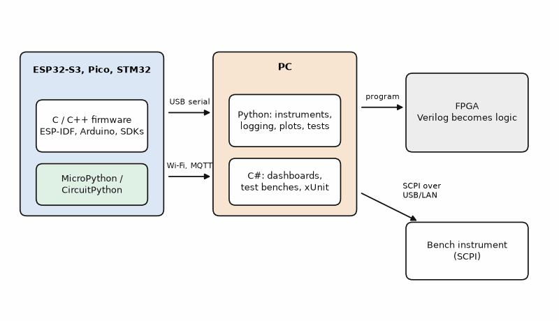
Figure 1.1 — Where each language of this book runs. C and C++ on the microcontroller; MicroPython or CircuitPython on the same chip when speed of trying matters more than speed of running; Python and C# on the PC for instruments, dashboards, and tests; Verilog compiled into the logic of an FPGA. The arrows are the links the book uses: USB serial, Wi-Fi with MQTT, and SCPI over USB or LAN.
The reference hardware is the series reader lab: an ESP32-S3 board, an OLED display, an ultrasonic distance sensor, a PIR motion sensor, a BME280 temperature, humidity, and pressure sensor, a GPS module, a LoRa radio, a servo, an 18650 battery module, and a camera. Where a job suits another board better, the book uses it: the Raspberry Pi Pico for learning and cheap control, an STM32 for industrial work and register-level detail, the nRF52840 for Bluetooth Low Energy, the Teensy 4.1 for fast signal processing, and the Raspberry Pi 5 for Linux, vision, and edge AI.

1.2 What firmware is, and why it is different
Firmware is software that controls hardware directly and usually runs without an operating system, or with a very small one. Three things make it different from the code on a laptop. First, it shares the world with physics: a pin that changes 1 µs too late can break a protocol, and a loop that never sleeps empties a battery. Second, it often cannot be watched: there is no screen, sometimes no serial port, and the bug appears only on a cold morning on a fence. Third, it must survive on its own for months, so every error has to be expected, handled, and recovered from without a person.
Those three facts explain the habits of good firmware engineers. They measure timing with a scope instead of trusting it. They design for the failure first and the feature second. And they work in small, tested steps, because a bug that slips through costs hours to find on hardware and days to fix in the field.

1.3 The method
Every worked example in this book follows the same nine steps. They are deliberately ordinary. Their value is that you do all of them, every time, whether you write the code yourself, copy it from a forum, or ask an AI assistant for it.
1. Write a short spec: purpose, hardware, pins, interfaces, timing, power, error handling, and acceptance tests.
2. Break the job into small modules, each with one responsibility and a clear interface.
3. Write, or prompt for, one module at a time, with the spec attached.
4. Review the code against a checklist before running it.
5. Build it and unit-test it on the PC, where tests are fast and repeatable.
6. Test it on the hardware, with the scope or logic analyzer confirming the timing.
7. Commit it to version control with a message that says what changed and why.
8. Iterate with precise bug reports: what you did, what you expected, what you measured.
9. Document it: the spec, the pin map, the test results, and the known limits.
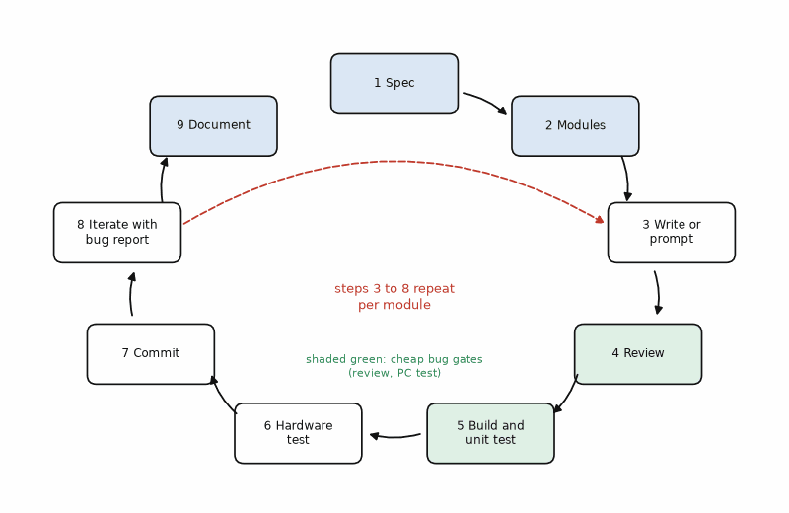
Figure 1.2 — The nine-step method as a loop. Steps 1 and 2 happen once per feature; steps 3 to 8 repeat once per module until its acceptance tests pass; step 9 closes the feature. The two gates where most bugs are caught cheaply are the review (step 4) and the PC test (step 5), before any hardware is involved.
The spec does not need to be long. One page is enough for most modules, and a good spec is mostly numbers: which pins, which bus speed, how often, how much current, how long the module may block, and what it must do when the sensor does not answer. The template below is the one this book uses. Copy it into the top of a project's README and fill it in before writing any code.
Spec template (one page per module or feature)
- Purpose: one sentence. What the module does and for whom.
- Hardware: board, chip, sensor or actuator, supply voltage, logic level.
- Pins: every GPIO with its direction, pull-up or pull-down, and active level.
- Interfaces: bus and speed (I2C 400 kHz, UART 115200 8N1, SPI mode 0 at 8 MHz), addresses, data formats, units.
- Timing: how often it runs, deadlines, the longest it may block, and its startup time.
- Power: active and sleep current targets, and when it may sleep.
- Error handling: what happens on a timeout, a bad checksum, an out-of-range value, a lost connection.
- Acceptance tests: numbered, measurable checks that decide when the module is done.
- Out of scope: what this module deliberately does not do.
The review checklist is the other half. It is short enough to use on every module and specific enough to catch the bugs that firmware really has.
Review checklist (use before the first run)
- Pins and addresses match the spec and the schematic, not a tutorial.
- Bus speed, baud rate, mode, and byte order match both ends.
- Every wait has a timeout; nothing blocks forever.
- Interrupt handlers are short, set a flag or send to a queue, and call no blocking or printing functions.
- Shared mutable data is accessed atomically or protected by an appropriate lock or critical section; volatile alone does not make shared access thread-safe. Use volatile for memory-mapped I/O or asynchronous observations only when the platform requires it.
- Every return code is checked, and every error path does something sensible.
- Units and scaling are written down and tested at both ends of the range.
- No secrets, passwords, or keys in the source code.
- Every library call exists in the version you build against; check the documentation for each one you have not used before.
- A watchdog or a recovery path exists for the case nobody thought of.
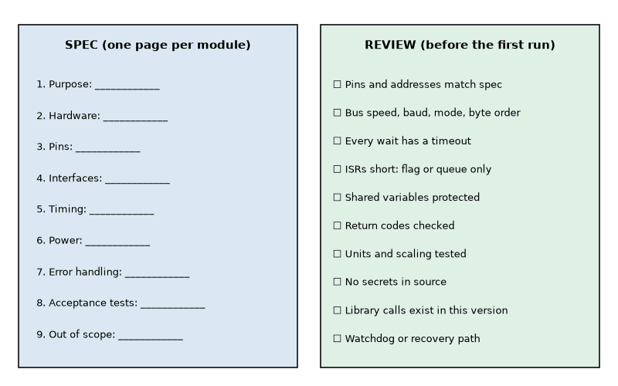
Figure 1.3 — The spec template and review checklist as a one-page card, for printing and pinning above the bench. The text of the card is the two lists above.
Key idea. The method is not paperwork. It moves bug-finding from the fence post, where it costs a day, to the desk, where it costs a minute. The spec states what correct means; the checklist and the tests prove it.
AI rule. Treat generated code as an unverified draft: take pins and addresses from the specification; give every wait a timeout; confirm each library call against the exact version being built; keep secrets out of source control; and have a qualified person review security settings. Apply this rule before the first build and again whenever the module changes.

Worked Example 1.1: A spec for the garden weather node
Problem. Write the spec for the reader lab's weather node: an ESP32-S3 that reads the BME280 every 10 seconds, shows the values on the OLED, and logs them to a 4 MB flash partition. Each log record holds a 4-byte timestamp and three 4-byte floats. How many days of records fit before the log wraps?
Solution. Purpose: measure and log temperature, humidity, and pressure in the garden. Hardware: ESP32-S3 board, BME280 and SSD1306 OLED, both at 3.3 V. Pins: I2C SDA on GPIO 8, SCL on GPIO 9, external 4.7 kΩ pull-ups (the pull-up sizing is Book 1's). Interfaces: I2C at 400 kHz; BME280 at address 0x76, chip ID 0x60; OLED at 0x3C. Timing: one reading every 10 s, the I2C transaction may block at most 10 ms. Power: mains-powered in this version. Error handling: three failed reads in a row show "SENSOR?" and keep retrying; humidity is clamped to 0 to 100 %. Acceptance tests: (1) temperature within 1 °C of a reference thermometer, (2) a pulled sensor cable is reported within 30 s and recovers when reconnected, (3) 24 hours without a reset. Out of scope: wireless, which comes in Chapter 17. The record is 4 + 3 × 4 = 16 bytes. A day holds 86 400/10 = 8640 records, or 138 240 bytes. The partition holds 4 194 304 bytes, so the log lasts 4 194 304/138 240 = 30.3 days before it wraps. The usual mistake is to write the spec after the code, when it describes what was built instead of what was needed.

Worked Example 1.2: Splitting the node into modules
Problem. Split the weather node of Worked Example 1.1 into modules, and decide which can be unit-tested on the PC.
Solution. Five modules, each with one job: bme280 (read raw registers and compensate them into °C, %, and hPa), display (draw three lines on the OLED), logger (append 16-byte records to the flash ring), scheduler (run the others every 10 s and count failures), and main (startup and pin setup). The compensation math in bme280, the ring-buffer arithmetic in logger, and the failure counting in scheduler are pure functions of their inputs, so they compile and run on the PC with test data. Only the thin layer that touches the I2C peripheral and the flash chip needs the board. That split is the point: most of the logic, and most of the bugs, can be tested in seconds without hardware.

1.4 What firmware engineers actually do
The work is less heroic and more interesting than it looks from outside. A typical week mixes reading data sheets and errata, writing and reviewing drivers, chasing a timing bug with a logic analyzer, writing test scripts, and arguing with the hardware engineer about which side owns a problem. The most valuable skill is not typing code fast; it is turning a vague symptom into a precise, reproducible bug report.
On the Job
Embedded work is one of the largest areas of electronics employment, in cars, medical devices, appliances, industrial controls, drones, and smart-home products. The chips are STM32, ESP32, NXP, Infineon, and Renesas parts; the tools are a vendor IDE or VS Code, a debug probe, a logic analyzer, git, and a continuous-integration server that builds and tests every commit. A realistic first task: bring up a new revision of a sensor board, confirm the I2C sensor answers, measure the sleep current, and write the test script that production will run on every unit.

1.5 AI assistants on the bench
AI coding assistants, built into code editors or used as separate chat tools, now write many first drafts, including firmware. They are fast and often right about general programming, and they are most often wrong about the specific things that matter in embedded work: pin numbers, register addresses, bus settings, and the exact API of the library version you use. The method above is how to use them safely. Give them the spec, ask for one module, review against the checklist, test on the PC and then on the bench. Chapter 25 develops this in full; most chapters carry a short note on what assistants tend to get wrong in that chapter's topic.
AI Pair-Programming Note
Paste the filled-in spec template into the prompt and ask for one module. An assistant that sees "BME280 at 0x76 on GPIO 8 and 9, I2C 400 kHz, at most 10 ms blocking" produces far better code than one asked to "read a BME280".
From the Bench
Keep a lab notebook, paper or text file, for every board. Write the date, the firmware commit, what you changed, and what you measured. When a problem comes back three weeks later, the notebook is usually the fastest debugger you own.

Practice
1. (Core) Name the four languages of this book and one job each does best.
2. (Core) A log record has an 8-byte timestamp and four 2-byte integers. How many records fit in a 1 MB (1 048 576 byte) partition?
3. (Core) At one record per 30 s, how many days does the partition of Problem 2 last?
4. (Core) Write the Timing line of a spec for a button that must be recognized within 50 ms and an OLED that refreshes twice per second.
5. (Extension) A module reads a sensor that sometimes does not answer. Write two acceptance tests for its error handling.
6. (Extension) Which modules of the weather node in Worked Example 1.2 need the real board for testing, and why?
7. (Extension) Rewrite the bug report "the display is broken" as a precise report.
8. (Challenge) The weather node must keep 90 days of 16-byte records at one per 10 s. How big must the partition be, and what could you change if the flash only has 4 MB free?

What You’ll Actually Use
Everyday working tools
- The nine-step method, especially the one-page spec and the review checklist.
- A lab notebook per board, with the firmware commit for every measurement.
- Byte and record arithmetic for logs, buffers, and partitions.
Mostly for exams and deeper study
- The history and taxonomy of embedded languages; the four in this book cover most work.

Chapter 2. Toolchains and Builds: From Source File to Flash
You press Build, and forty seconds later a file appears that makes an LED blink on a chip the size of a fingernail. In between, about a dozen programs ran: a preprocessor, a compiler, an assembler, a linker that placed every byte at a fixed address, and a flasher that pushed the result through a USB cable. When something goes wrong in that chain, and it will, the error message comes from one of those programs. Knowing which one is half of fixing it.
Where you meet this: The first hour of every new project, every "undefined reference" error, every "region FLASH overflowed" message, and every board that will not accept new firmware.

2.1 What a build does
A C file is text. Turning it into instructions that run on a microcontroller takes four steps. The preprocessor pastes in the header files and expands macros. The compiler translates each C file into machine code for the target processor, an Xtensa core for the ESP32-S3, an Arm Cortex-M for the STM32, RP2040, and nRF52840, and writes one object file per source file. The linker joins the object files and libraries, and places every function and variable at an address, following a linker script that describes the chip's flash and RAM. Finally a converter turns the linked ELF file into the format the flasher wants: a .bin for esptool, a .hex for many Arm programmers, or a .uf2 file that a Pico accepts by drag and drop.
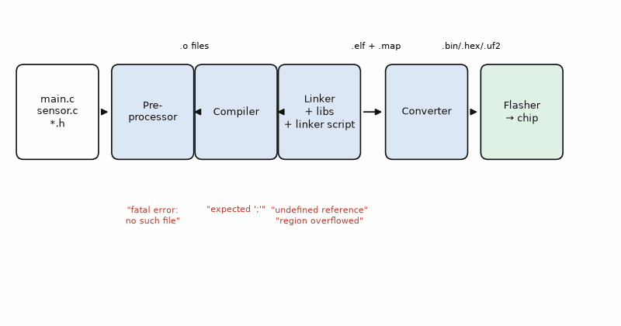
Figure 2.1 — The build pipeline. Source and header files go through the preprocessor and compiler into one object file each; the linker combines them with libraries according to the linker script and writes the ELF file and a map file; a converter writes the image that the flasher sends to the chip. Errors name their stage: "fatal error: no such file" is the preprocessor, "expected ';'" the compiler, "undefined reference" and "region overflowed" the linker.
The ELF file also contains debug information, the map between machine instructions and source lines that a debugger needs (Chapter 23). The map file lists where every symbol landed and how big it is. When the flash fills up, the map file shows which function or table is responsible.

2.2 The five toolchains of this book
ESP-IDF is Espressif's official framework for the ESP32 family. It uses CMake and a command-line tool, idf.py, with three everyday commands: idf.py build, idf.py flash, and idf.py monitor. Its menuconfig screen sets hundreds of options, from the FreeRTOS tick rate to the flash size, and it includes drivers, Wi-Fi, Bluetooth, and FreeRTOS. It is the most complete and the most demanding of the five.
The Arduino framework wraps the same chips in a simpler interface: setup() runs once, loop() runs forever, and functions such as digitalWrite() hide the hardware. On an ESP32 the Arduino core sits on top of ESP-IDF, so FreeRTOS is still there underneath. Its strength is its libraries; its weakness is that the hidden layers make timing and power harder to control.
PlatformIO is a build system and package manager that runs inside VS Code. One small file, platformio.ini, names the board, the framework, the serial speed, and the libraries with their versions, and PlatformIO downloads the right compiler and libraries for each project. It handles ESP32, Pico, STM32, nRF52, and Teensy boards with the same commands, and it pins library versions, which matters more than it seems (Section 2.4).
The Pico SDK is Raspberry Pi's C/C++ kit for the RP2040 and RP2350. It also uses CMake. Its output includes a .uf2 file: hold the BOOTSEL button while plugging in the Pico, it appears as a USB drive, and copying the file onto it flashes the chip. STM32CubeIDE is ST's Eclipse-based IDE. Its configurator, CubeMX, generates the startup code, clock tree, and peripheral setup from a graphical pin map, and its HAL library is what most STM32 code in industry is written against (Chapter 11).
Listing 2.1 — Blinking an LED with ESP-IDF on the ESP32-S3 (C). Build and flash with idf.py build flash monitor.
// Blink an external LED on GPIO 4 of an ESP32-S3 (ESP-IDF 5.x).
// Wire: GPIO 4 -> 330 ohm -> LED anode, LED cathode -> GND.
#include "freertos/FreeRTOS.h"
#include "freertos/task.h"
#include "driver/gpio.h"
#define LED_GPIO GPIO_NUM_4
void app_main(void)
{
gpio_reset_pin(LED_GPIO);
gpio_set_direction(LED_GPIO, GPIO_MODE_OUTPUT);
int level = 0;
while (1) {
level = !level;
gpio_set_level(LED_GPIO, level);
vTaskDelay(pdMS_TO_TICKS(500)); // 0.5 s on, 0.5 s off
}
}
Listing 2.2 — A PlatformIO project file for the reader-lab ESP32-S3 with the Arduino framework.
; PlatformIO project file for the reader-lab ESP32-S3 (Arduino framework)
[env:esp32-s3-devkitc-1]
platform = espressif32
board = esp32-s3-devkitc-1
framework = arduino
monitor_speed = 115200
lib_deps =
adafruit/Adafruit BME280 Library
adafruit/Adafruit SSD1306
build_flags =
-D CORE_DEBUG_LEVEL=3
Listing 2.3 — The same blink with the Pico SDK (C), with a counter printed over USB serial.
// Blink the on-board LED of a Raspberry Pi Pico (Pico SDK).
// GPIO 25 is the LED on the original Pico; the Pico W routes it through the radio chip.
#include <stdio.h>
#include "pico/stdlib.h"
#define LED_PIN 25
int main(void)
{
stdio_init_all(); // printf over USB serial
gpio_init(LED_PIN);
gpio_set_dir(LED_PIN, GPIO_OUT);
unsigned n = 0;
while (true) {
gpio_put(LED_PIN, 1);
sleep_ms(500);
gpio_put(LED_PIN, 0);
sleep_ms(500);
printf("blink %u\n", ++n);
}
}
The three listings do the same thing and show the family resemblance. Each sets a pin as output, writes it high and low, and waits. The ESP-IDF version waits with vTaskDelay, a FreeRTOS call that lets other tasks run; the Pico version busy-waits in sleep_ms, which is fine on a chip that has nothing else to do. Chapter 13 explains why that difference matters.

2.3 Reading the size report
Every toolchain prints a size report after linking, and it is worth reading every time. The GNU tool size prints three numbers. Text is code and constant data, stored in flash. Data is initialized variables: they occupy flash, which holds their starting values, and RAM, where they live while the program runs. Bss is variables that start at zero; they occupy only RAM. So flash used is text plus data, and static RAM used is data plus bss. The stack and the heap come on top of the static RAM, and the linker script reserves room for them.
flash = text + data, static RAM = data + bss

Worked Example 2.1: Will it fit?
Problem. An STM32F411 project (512 KB flash, 128 KB RAM) reports text = 38 412, data = 1 204, bss = 6 880 bytes. Find the flash and RAM used and the percentages. The linker script reserves 1 KB of stack and 512 bytes of heap. How much RAM is left?
Solution. Flash = 38 412 + 1 204 = 39 616 bytes, which is 39 616/524 288 = 7.6 % of 512 KB. Static RAM = 1 204 + 6 880 = 8 084 bytes, 8 084/131 072 = 6.2 %. With 1024 bytes of stack and 512 of heap, 9 620 bytes are committed and 131 072 − 9 620 = 121 452 bytes remain. The trap is the stack: 1 KB is CubeIDE's default minimum, and a single 1 KB local buffer in a function uses all of it. The linker does not check the stack's real depth; Chapter 13 shows how to measure it.
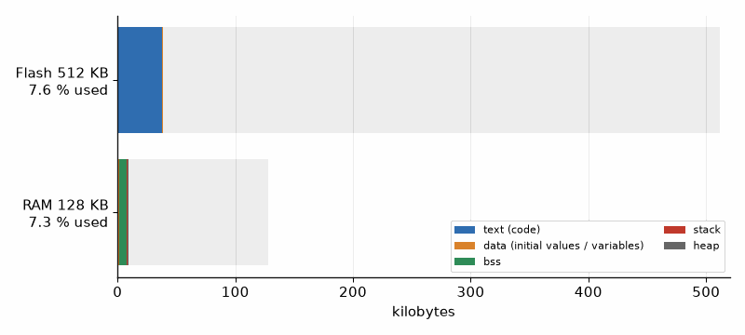
Figure 2.2 — The size report of Worked Example 2.1 drawn to scale. The STM32F411's flash holds 39 616 bytes of code and initial values (7.6 %); its RAM holds 1 204 bytes of data, 6 880 of bss, 1 KB of stack, and 512 bytes of heap, 7.3 % in all.

2.4 Flashing and the serial monitor
Flashing moves the image from the PC into the chip's flash. The ESP32-S3 can be flashed through a USB-to-UART bridge or through its own USB port, which also provides a serial console and a JTAG debugger without extra hardware. The Pico takes a .uf2 file by drag and drop or through picotool. STM32 boards are flashed through an ST-LINK probe over SWD, the two-wire debug port of Chapter 23.

Worked Example 2.2: How long does flashing take?
Problem. An ESP32-S3 image is 1 200 000 bytes. It is flashed over a USB-to-UART bridge at 921 600 baud with 8N1 framing (10 bits per byte). Estimate the transfer time without compression. Why is the real time shorter?
Solution. The byte rate is 921 600/10 = 92 160 bytes per second, so 1 200 000/92 160 = 13.0 s. esptool compresses the image before sending it and the chip decompresses it on the fly, so a firmware image with large zero-filled or repetitive regions often goes over in less than half that time. Over the native USB port the link is not limited by a UART baud rate at all. A common mistake is to raise the baud rate further on a long or cheap USB cable and then blame the firmware for the checksum errors.
Library versions deserve the same care as pin numbers. An example that uses version 2 of a library can fail to compile against version 3, or, worse, compile and behave differently. PlatformIO's lib_deps and ESP-IDF's component manager both let you pin a version; do it as soon as a project works, and record the toolchain version in the README.
AI Pair-Programming Note
Assistants often mix framework conventions: an ESP-IDF answer with Arduino's delay(), a Pico SDK file with an STM32 HAL include, or an API from an older ESP-IDF major version. State the framework and its version in the first line of the prompt, and paste the compiler's exact error message, not a summary, when asking for a fix.
From the Bench
When a board refuses to flash, work through the chain in order: is the right serial port selected, is another program (a serial monitor) holding it open, is the cable a data cable rather than a charge-only cable, and does the chip enter its boot mode? On the ESP32-S3 that means holding BOOT while tapping RESET; on the Pico, holding BOOTSEL while plugging in. Most "dead" boards are one of those four.

Practice
1. (Core) Which build stage produces "undefined reference to 'bme280_read'", and what usually causes it?
2. (Core) A report shows text = 210 000, data = 3 000, bss = 41 000 bytes. Find flash and static RAM used.
3. (Core) How long does a 600 000-byte image take to send at 460 800 baud with 10 bits per byte, without compression?
4. (Core) Name the file a Pico accepts by drag and drop, and how to put the Pico into the mode that accepts it.
5. (Extension) Why does an initialized global array, int table[256] = {1, 2, 3}, cost both flash and RAM, while static const int table[256] = {1, 2, 3} on an Arm microcontroller costs only flash?
6. (Extension) A project compiled yesterday and fails today with no code changes. Name two likely causes and how to prevent them.
7. (Extension) The RP2040 has 264 KB of RAM. A project reports data = 2 KB and bss = 250 KB. What will probably go wrong at run time, even though the link succeeds?
8. (Challenge) A 1 MB OTA partition must hold the application. The size report shows text = 905 000 and data = 48 000 bytes, and the next feature adds about 90 KB. Does it fit, and what would you check first to make room?

What You’ll Actually Use
Everyday working tools
- The size report: flash = text + data, static RAM = data + bss, plus stack and heap.
- Recognizing which build stage an error comes from.
- PlatformIO or the component manager with pinned versions; idf.py build flash monitor.
- The boot-mode recipe for each board (BOOT plus RESET, BOOTSEL).
Mostly for exams and deeper study
- Linker-script syntax; you will read one far more often than you write one.

Chapter 3. C for Microcontrollers: Bits, Types, and Memory
An int on your laptop is 32 bits. On a classic Arduino Uno it is 16 bits, so a millisecond counter stored in it goes negative after 32.8 seconds. The program that worked in a two-second test fails half a minute after power-up, every time, and the cause is one word in a declaration. Embedded C is ordinary C with the hardware's fingerprints on it: exact sizes, bits that mean something, variables that change behind the compiler's back, and memory that you can count.
Where you meet this: Every driver, every register write, every data sheet table of bit fields, and every bug that appears only after the board has run for 49.7 days.
This chapter is not a C course. It covers the five habits that separate C on a microcontroller from C on a PC: exact-width types, bit manipulation, volatile, the memory map, and wraparound arithmetic. If C is new to you, keep a general C reference beside this chapter (Appendix C names one) and type in every listing.

3.1 Exact-width types
The C standard says only that an int is at least 16 bits. On the ESP32, STM32, RP2040, and nRF52840 it is 32 bits; on 8-bit AVR chips it is 16. Firmware that talks to registers, packets, and files needs sizes that never change, so it uses the types from stdint.h: uint8_t, int16_t, uint32_t, and their relatives. A register is uint32_t; a byte from I2C is uint8_t; a temperature in hundredths of a degree fits int16_t, from −327.68 to +327.67 °C.
Mixing sizes has one rule that catches everyone once. In an expression, values smaller than int are promoted to int before the arithmetic. Two uint8_t values of 200 and 100 add to 300 without trouble, but storing the result back into a uint8_t keeps only the low eight bits, 300 − 256 = 44. The compiler is allowed to say nothing about it; turn on -Wall -Wextra and -Wconversion, and read the warnings.

3.2 Bits that mean something
Hardware is configured by writing bits into registers. A data sheet's register description is a map: bits 7 to 5 set the temperature oversampling, bits 4 to 2 the pressure oversampling, bits 1 and 0 the mode. Four operations cover almost all of it. OR with a mask sets bits, AND with the inverted mask clears them, XOR toggles them, and AND followed by a shift reads a field.
set: r |= m clear: r &= ~m toggle: r ^= m read: (r & mask) >> shift
Listing 3.1 — Setting, clearing, and writing bit fields, ending with the BME280's ctrl_meas value (C, runs on the PC).
// Building the BME280 ctrl_meas register value with bit fields; runs on the PC.
#include <stdint.h>
#include <stdio.h>
#define BIT(n) (1u << (n))
#define SET_BITS(r, m) ((r) |= (m))
#define CLEAR_BITS(r, m) ((r) &= ~(m))
// ctrl_meas (register 0xF4): osrs_t in bits 7..5, osrs_p in bits 4..2, mode in bits 1..0
#define OSRS_T_SHIFT 5u
#define OSRS_P_SHIFT 2u
#define MODE_MASK 0x03u
#define MODE_NORMAL 0x03u
static uint8_t field_write(uint8_t reg, uint8_t mask, unsigned shift, uint8_t value)
{
return (uint8_t)((reg & ~(mask << shift)) | ((value & mask) << shift));
}
int main(void)
{
uint32_t reg = 0xA4u; // 1010 0100
SET_BITS(reg, BIT(3)); // 1010 1100 = 0xAC
CLEAR_BITS(reg, BIT(5)); // 1000 1100 = 0x8C
printf("reg = 0x%02X\n", (unsigned)reg);
uint8_t ctrl_meas = 0;
ctrl_meas = field_write(ctrl_meas, 0x07u, OSRS_T_SHIFT, 1); // temperature x1
ctrl_meas = field_write(ctrl_meas, 0x07u, OSRS_P_SHIFT, 1); // pressure x1
ctrl_meas = field_write(ctrl_meas, MODE_MASK, 0, MODE_NORMAL);
printf("ctrl_meas = 0x%02X\n", (unsigned)ctrl_meas); // 0x27
return 0;
}

Worked Example 3.1: Building a register value
Problem. A register holds 0xA4. Set bit 3 and clear bit 5. Then build the BME280 ctrl_meas value for temperature oversampling ×1 (code 1 in bits 7..5), pressure oversampling ×1 (code 1 in bits 4..2), and normal mode (code 3 in bits 1..0).
Solution. 0xA4 is 1010 0100. Setting bit 3 (mask 0x08) gives 1010 1100 = 0xAC. Clearing bit 5 (mask 0x20) gives 1000 1100 = 0x8C. For ctrl_meas: 1 << 5 = 0x20, 1 << 2 = 0x04, and 3 in the low bits, so the value is 0x20 + 0x04 + 0x03 = 0x27, the value many BME280 examples write without explaining it. Listing 3.1 prints both results. The usual mistake is to shift by the field's highest bit (7) instead of its lowest (5), which writes 0x80 and selects ×4 oversampling.

3.3 Volatile: the variable that changes by itself
An optimizing compiler assumes that a variable changes only when the code in front of it changes it. That is false for a hardware register, which the peripheral updates, and for a flag that an interrupt handler sets. If the main loop waits for such a flag in a tight loop, the compiler may read it once, keep it in a CPU register, and loop forever. Declaring it volatile tells the compiler to read it from memory every time.
Volatile is necessary and not sufficient. It does not make a read-modify-write atomic, and it does not make a 64-bit value safe to read while an interrupt is changing it half-way. Chapter 6 shows the patterns for sharing data with interrupts, and Chapter 13 the patterns for sharing it between tasks.
Common misconception. Volatile makes a variable thread-safe. It only stops the compiler from caching it. Two tasks incrementing the same volatile counter still lose counts, because each increment is a read, an add, and a write that can be interrupted in between.

3.4 Where things live: the memory map
A microcontroller has two kinds of memory with different jobs. Flash keeps the program and constant data when the power is off; RAM holds everything that changes. The linker places each kind of object in its region, as Chapter 2's size report showed. Code and const tables go to flash. Initialized variables live in RAM, with their starting values copied from flash at startup. Zero-initialized variables live in RAM in the bss region. The heap grows upward from the end of bss for malloc, and the stack grows downward from the top of RAM for function calls and local variables. When the two meet, the program fails in ways that look random.
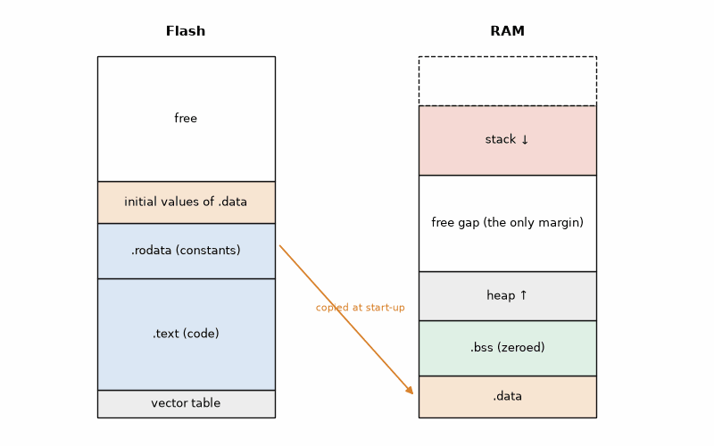
Figure 3.1 — The memory map of a typical Arm Cortex-M microcontroller. Flash holds the vector table, code, constants, and the initial values of initialized variables; RAM holds those variables (data), the zeroed variables (bss), the heap growing up, and the stack growing down. The gap between heap and stack is the only safety margin.
Most firmware avoids the heap after startup. Allocating and freeing blocks of different sizes for months fragments it until an allocation fails, at an unpredictable time. The usual style is to allocate everything once at startup, or statically, and never free it. That is also a rule in the MISRA C guidelines of Chapter 24.

3.5 Structs, padding, and packets
A struct groups related fields, such as one log record. The compiler aligns each field to its natural boundary, so a uint32_t starts at an address divisible by four, and it inserts padding bytes to make that true. Field order therefore changes the size. It also means a struct is not a portable packet format: another compiler or processor may pad and order bytes differently. Firmware that sends data over a link packs the bytes explicitly, as Chapter 18 does.
Listing 3.2 — The same four fields in two orders; padding makes one struct 12 bytes and the other 8 (C, runs on the PC).
// Field order changes a struct's size: padding made visible; runs on the PC.
#include <stddef.h>
#include <stdint.h>
#include <stdio.h>
struct rec_a { uint8_t id; uint32_t time; uint16_t hum; uint8_t flags; };
struct rec_b { uint32_t time; uint16_t hum; uint8_t id; uint8_t flags; };
int main(void)
{
printf("rec_a: %zu bytes (time at %zu, hum at %zu, flags at %zu)\n",
sizeof(struct rec_a), offsetof(struct rec_a, time),
offsetof(struct rec_a, hum), offsetof(struct rec_a, flags));
printf("rec_b: %zu bytes\n", sizeof(struct rec_b));
return 0;
}

Worked Example 3.2: Padding in a log record
Problem. Find the size of struct rec_a { uint8_t id; uint32_t time; uint16_t hum; uint8_t flags; } on a 32-bit microcontroller, and the size after reordering the fields from largest to smallest. How much flash does the reordering save for 100 000 records?
Solution. id occupies byte 0; time must start at a multiple of 4, so bytes 1 to 3 are padding and time sits at 4 to 7; hum sits at 8 and 9; flags at 10; the struct's size is rounded up to a multiple of its largest alignment, 4, so it is 12 bytes. Ordered time, hum, id, flags, the fields occupy 0 to 3, 4 and 5, 6, 7, with no padding: 8 bytes. Listing 3.2 prints 12 and 8. For 100 000 records the reordering saves 400 000 bytes. The usual mistake is to "fix" the padding with a packed attribute, which saves the same space but makes every access to the misaligned uint32_t slower, and on some cores a fault.
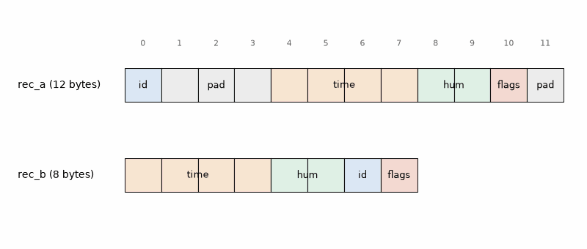
Figure 3.2 — Byte layout of the two log records of Worked Example 3.2. Gray bytes are padding. Ordered as written, the record takes 12 bytes, with 3 bytes of padding after id and 1 at the end; ordered largest field first, it takes 8.

3.6 Time that wraps around
Firmware measures time with a counter that ticks every millisecond or microsecond. Every counter wraps: a uint16_t millisecond counter after 65 536 ms, 65.5 s; a uint32_t after 4 294 967 296 ms, 49.7 days. Code that compares absolute times breaks at the wrap. Code that subtracts first and compares the difference keeps working, because unsigned subtraction in C is defined to wrap the same way the counter does.
Listing 3.3 — A wraparound-safe timeout test, and the naive version that fails near the wrap (C, runs on the PC).
// Wraparound-safe timeouts with a 32-bit millisecond counter; runs on the PC.
#include <stdbool.h>
#include <stdint.h>
#include <stdio.h>
static bool timed_out(uint32_t now, uint32_t start, uint32_t timeout_ms)
{
return (uint32_t)(now - start) >= timeout_ms; // correct across the wrap
}
static bool timed_out_naive(uint32_t now, uint32_t start, uint32_t timeout_ms)
{
return now >= start + timeout_ms; // wrong near the wrap
}
int main(void)
{
uint32_t start = 0xFFFFFF00u; // 256 ms before the counter wraps to 0
uint32_t now = 0xFFFFFF80u; // 128 ms later, before the wrap
printf("elapsed %u ms, safe %d, naive %d\n",
(unsigned)(now - start), timed_out(now, start, 1000),
timed_out_naive(now, start, 1000)); // 128, 0, 1 (naive is wrong)
now = 0x00000064u; // 356 ms after start, after the wrap
printf("elapsed %u ms, safe %d\n",
(unsigned)(now - start), timed_out(now, start, 1000)); // 356, 0
return 0;
}

Worked Example 3.3: The 49.7-day bug
Problem. A uint32_t millisecond counter reads 0xFFFFFF00 when a 1000 ms timeout starts. 128 ms later it reads 0xFFFFFF80. Evaluate the safe test (now − start) >= 1000 and the naive test now >= start + 1000.
Solution. The safe test computes 0xFFFFFF80 − 0xFFFFFF00 = 0x80 = 128, which is less than 1000, so it correctly says "not yet". In the naive test, start + 1000 = 0xFFFFFF00 + 0x3E8 overflows to 0x2E8 = 744, and 0xFFFFFF80 is far above 744, so it says the timeout has expired 872 ms early. Listing 3.3 prints both results. The bug appears only within one timeout period of the wrap, once every 49.7 days, which is why it survives every test on the bench.
AI Pair-Programming Note
Assistants write timing code in the naive form surprisingly often, and they use int or long where a fixed width matters. In review, search the code for every comparison involving a time value and every place where a sensor value is stored, and check the type and the arithmetic.
From the Bench
Compile firmware with the warnings on and treat them as errors once a project is stable: -Wall -Wextra -Werror in the build flags. The first time it costs an afternoon; after that it catches sign mistakes, truncations, and unused results before they ever reach the board.

Practice
1. (Core) Write the expression that sets bits 0 and 4 of a uint8_t r without changing the others, and the one that clears bit 7.
2. (Core) A register reads 0x5A. What does it read after r ^= 0x0F?
3. (Core) Extract the 3-bit field in bits 4..2 of the value 0x1C.
4. (Core) After how many days does a uint32_t counter of microseconds wrap? And one of seconds?
5. (Extension) Two uint8_t values, 180 and 90, are added and the result is stored in a uint8_t. What is stored, and how would you detect the problem at compile time?
6. (Extension) Find the size of struct { uint8_t a; uint16_t b; uint8_t c; uint32_t d; } on a 32-bit microcontroller, and the smallest size achievable by reordering.
7. (Extension) A loop waits with while (!data_ready) { } for a flag that an interrupt sets. It works at -O0 and hangs at -O2. Explain and fix.
8. (Challenge) A temperature in hundredths of a degree is stored as int16_t. What is the warmest and coldest temperature it can hold, and what happens if a faulty sensor reports 400.00 °C?

What You’ll Actually Use
Everyday working tools
- stdint.h types everywhere a size matters.
- The four bit operations and the field write: clear the field, then OR in the shifted value.
- volatile for registers and interrupt flags, and its limits.
- Wraparound-safe time tests: (now − start) >= timeout.
- Static allocation at startup instead of malloc and free at run time.
Mostly for exams and deeper study
- The exact integer-promotion rules of the C standard; the warnings flags catch most cases in practice.

Chapter 4. Python Twice: MicroPython on the Board, Python on the PC
Type four lines into a serial terminal connected to an ESP32-S3, press Enter, and the board lists every I2C device it can see. No compiler, no flashing, no build folder: the chip runs a Python interpreter, and you are talking to it. Ten minutes later the same language, on your PC, is writing the sensor's readings to a spreadsheet file. That double life is why Python is the fastest way from "does this sensor even answer?" to a plot of last night's temperature.
Where you meet this: Bringing up a new sensor, teaching and prototyping on the Pico and ESP32, logging data on the PC, and every bench script that talks to a board over USB.

4.1 MicroPython and CircuitPython
MicroPython is a compact implementation of Python 3 for microcontrollers. It runs on the ESP32 family, the RP2040 and RP2350, STM32 boards, and the nRF52840. After flashing its firmware once, you get an interactive prompt, the REPL, over USB serial, and you upload .py files with an editor such as Thonny or the mpremote command-line tool. A file named main.py runs at boot. The machine module gives access to pins, buses, timers, and sleep modes; the API is similar across chips, so code moves between an ESP32-S3 and a Pico with few changes.
CircuitPython is Adafruit's version of the same idea, tuned for beginners. The board appears as a USB drive called CIRCUITPY, you edit code.py on it, and the board restarts the program every time the file is saved. Its library bundle covers hundreds of sensors and displays with a uniform style. It uses the board and busio modules instead of machine, so code does not move unchanged between the two.
The price of this convenience is speed and memory. Python code is interpreted, so a loop that toggles a pin runs many times slower than the same loop in C, and every object carries overhead in RAM. For reading a sensor once a second, driving a display, or logging, it does not matter. For a 40 kHz control loop or a protocol with microsecond timing, it does; there, the work belongs in C or in a hardware peripheral that MicroPython configures, such as the RP2040's PIO state machines or a hardware timer.
Listing 4.1 — MicroPython on the ESP32-S3: scan the I2C bus, read the BME280 chip ID, and read the raw temperature once a second.
# MicroPython on the ESP32-S3: find the BME280, read its chip ID and raw temperature.
from machine import I2C, Pin
import time
i2c = I2C(0, scl=Pin(9), sda=Pin(8), freq=400_000)
print("devices:", [hex(a) for a in i2c.scan()]) # expect 0x3c (OLED) and 0x76
BME = 0x76
chip_id = i2c.readfrom_mem(BME, 0xD0, 1)[0]
print("chip id: 0x%02x" % chip_id) # 0x60 = BME280, 0x58 = BMP280
i2c.writeto_mem(BME, 0xF2, b"\x01") # humidity oversampling x1 (set before ctrl_meas)
i2c.writeto_mem(BME, 0xF4, b"\x27") # temperature x1, pressure x1, normal mode
while True:
d = i2c.readfrom_mem(BME, 0xFA, 3) # temp_msb, temp_lsb, temp_xlsb
raw_t = (d[0] << 12) | (d[1] << 4) | (d[2] >> 4)
print("raw temperature:", raw_t) # 20-bit value; compensation needs the calibration data
time.sleep(1)
Listing 4.1 is the bring-up script for the reader lab's BME280. The scan should report 0x76 (or 0x77, if the board's address pin is tied high) and 0x3C for the OLED. A chip ID of 0x60 confirms a BME280; 0x58 means the board carries the cheaper BMP280, which has no humidity sensor, a mix-up that is common with low-cost modules. The raw temperature is a 20-bit number that the sensor's calibration constants turn into degrees; in practice you use a driver library for that step, and Chapter 9 shows what such a driver does.

Worked Example 4.1: Is MicroPython fast enough?
Problem. You time a MicroPython loop that toggles a pin 10 000 times with time.ticks_us() and measure 52 ms. What square-wave frequency does the loop produce? Is MicroPython fast enough to (a) read the BME280 once per second, (b) generate the 40 kHz burst of an ultrasonic transmitter by toggling a pin?
Solution. Each toggle takes 52 ms/10 000 = 5.2 µs. One period of the square wave is two toggles, 10.4 µs, so the frequency is about 96 kHz, with jitter whenever the interpreter does housekeeping such as garbage collection. (a) Yes, by a factor of thousands: a BME280 read takes about a millisecond of bus time. (b) No: 40 kHz needs a toggle every 12.5 µs with jitter well below a microsecond, and the interpreter's pauses would ruin the burst. Use a PWM peripheral (Chapter 7) configured from MicroPython instead. The method's point is to decide with a measurement, not a feeling.

4.2 Python on the PC
On the PC, Python is the glue of the bench. With the pyserial package it reads a board's serial output; with pyvisa it controls oscilloscopes and power supplies (Chapter 21); with numpy and matplotlib it analyzes and plots; with pytest it runs automated tests (Chapter 24). The same code runs on Windows, macOS, Linux, and on the Raspberry Pi 5, which is a full Linux computer.
Two habits keep PC scripts reliable. Create a virtual environment for each project (python -m venv .venv) and record its packages in a requirements.txt file, so that the script still runs next year on another machine. And treat the serial link as unreliable: lines can be truncated at startup, characters can be corrupted, and the board can be unplugged. Listing 4.2 shows the pattern: a timeout, a check of the field count, and a check that each field is a number, before anything is written.
Listing 4.2 — A PC logger with pyserial: reads CSV lines from the board, validates them, and appends them with a timestamp to log.csv (Python).
"""Log 'temperature,humidity,pressure' lines from the ESP32-S3 to log.csv with PC timestamps."""
import csv
import sys
from datetime import datetime
import serial # pyserial
PORT = sys.argv[1] if len(sys.argv) > 1 else "COM5"
with serial.Serial(PORT, 115200, timeout=2) as ser, open("log.csv", "a", newline="") as f:
writer = csv.writer(f)
while True:
line = ser.readline().decode("ascii", errors="replace").strip()
if not line:
print("timeout: no data for 2 s")
continue
fields = line.split(",")
if len(fields) != 3:
print("bad line:", line)
continue
try:
t, h, p = (float(x) for x in fields)
except ValueError:
print("bad number:", line)
continue
writer.writerow([datetime.now().isoformat(timespec="seconds"), t, h, p])
f.flush() # keep the file valid if the script is stopped

Worked Example 4.2: How many lines per second can the link carry?
Problem. The ESP32-S3 sends lines such as 23.41,45.2,1013.25 followed by carriage return and line feed, at 115 200 baud with 8N1 framing. How long does one line take, and what is the maximum line rate? How big does log.csv grow in 24 hours at one line per second, if each logged row is 40 bytes?
Solution. The line has 18 visible characters plus 2 line-ending characters, 20 bytes. With 10 bits per byte, that is 200 bits, and at 115 200 bit/s it takes 200/115 200 = 1.74 ms. The maximum rate is 1/1.74 ms = 576 lines per second. At one line per second the link is 0.17 % busy. The log grows by 86 400 × 40 = 3 456 000 bytes, about 3.5 MB per day, or about 1.2 GB per year. The usual mistake is to forget the start and stop bits and divide by 8 instead of 10, which overstates the rate by 25 %.
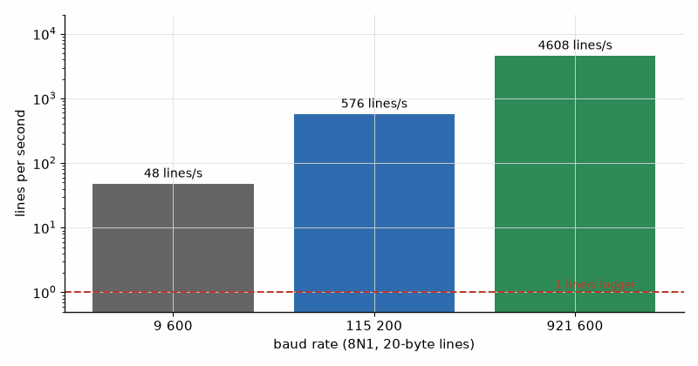
Figure 4.1 — Maximum rate of 20-byte CSV lines over a UART with 8N1 framing at three common baud rates: 48 lines per second at 9 600 baud, 576 at 115 200, and 4 608 at 921 600. The dashed line marks a one-per-second logger, far below every limit.
The Pi 5 deserves a separate mention. It runs the same desktop Python, has I2C, SPI, UART, and GPIO on its 40-pin header, and its gpiozero and lgpio libraries drive them. For a project that needs a camera, a large display, or a neural network (Chapter 20), the Pi 5 does the heavy work in Python while an ESP32 or Pico handles the microsecond timing.
AI Pair-Programming Note
Assistants often mix MicroPython, CircuitPython, and desktop Python: import board in a MicroPython script, machine.Pin on a PC, or a CPython library that does not exist on the microcontroller. Name the exact runtime and board in the prompt, and run the script once in the REPL line by line before trusting it.
From the Bench
When the REPL stops answering, the board is usually stuck in a loop in main.py. Press Ctrl-C in the terminal to interrupt it, or Ctrl-D for a soft reset. If main.py crashes the board before the REPL appears, connect with mpremote and use its command to remove the file, or reflash MicroPython. Keep main.py short and do the work in an imported module, so a typo does not lock you out.

Practice
1. (Core) What chip ID does the BME280 report, and what does 0x58 mean?
2. (Core) How long does a 32-byte line take at 115 200 baud, 8N1?
3. (Core) Name the file that MicroPython runs at boot and the one CircuitPython runs on save.
4. (Core) A logger writes 60-byte rows every 10 s. How many megabytes per year?
5. (Extension) A MicroPython loop of 1000 ADC reads takes 38 ms. What sample rate does it reach, and is it suitable for sampling a 1 kHz audio tone?
6. (Extension) Listing 4.2 checks the field count and the numbers. Name one more check worth adding for a temperature, humidity, and pressure line, and write it in one line of Python.
7. (Extension) Why does Listing 4.2 call f.flush() after every row?
8. (Challenge) A board sends 576 lines per second at 115 200 baud and the PC script also prints each line to the console. The log starts to miss lines. Explain why, and propose two fixes.

What You’ll Actually Use
Everyday working tools
- The REPL and mpremote for bringing up a sensor in minutes.
- pyserial with a timeout and validation of every line.
- Line-time arithmetic: 10 bits per byte at 8N1.
- A virtual environment and requirements.txt per project.
Mostly for exams and deeper study
- The internals of the MicroPython interpreter and its garbage collector; measure instead.

Chapter 5. C# for Electronics: .NET on the Desktop and on the Chip
The board works, the serial monitor scrolls numbers, and your manager asks for "a little window with a graph and a big red light when the pressure drops". In C# with Visual Studio that window is an afternoon's work: drag a chart onto a form, open the serial port, parse the lines, and bind the values to the display. Test engineers have built production rigs this way for twenty years, and the same language now runs on an ESP32 too.
Where you meet this: Serial dashboards, production test benches, calibration tools, configuration utilities shipped with a product, and unit tests that check firmware logic on the PC.

5.1 Why C# belongs in an electronics book
C# is a statically typed language that runs on .NET, Microsoft's open-source runtime for Windows, Linux, and macOS. Three things make it unusually productive for bench software. The tooling is excellent: Visual Studio and VS Code with the C# Dev Kit give a debugger, refactoring, and IntelliSense that knows every method's signature, which catches many mistakes before the program runs. The libraries cover the bench: System.IO.Ports for serial ports, sockets and HTTP for networked instruments, and mature charting and plotting packages. And the desktop frameworks, WPF and WinForms on Windows, WinUI 3 for modern Windows apps, and .NET MAUI across Windows, macOS, Android, and iOS, turn a parser into a usable tool with little extra code.
C# catches many type errors at compile time. A .NET application can be published as a self-contained, single-file executable for a target operating system and architecture, which can simplify deployment; native libraries and framework-specific requirements may still add steps. Compared with C, C# manages memory automatically and has safe strings and collections, so whole classes of crashes disappear. The trade-off is that C# on a PC is not hard real-time: the operating system and garbage collector can delay your code, a fact Worked Example 5.1 measures.
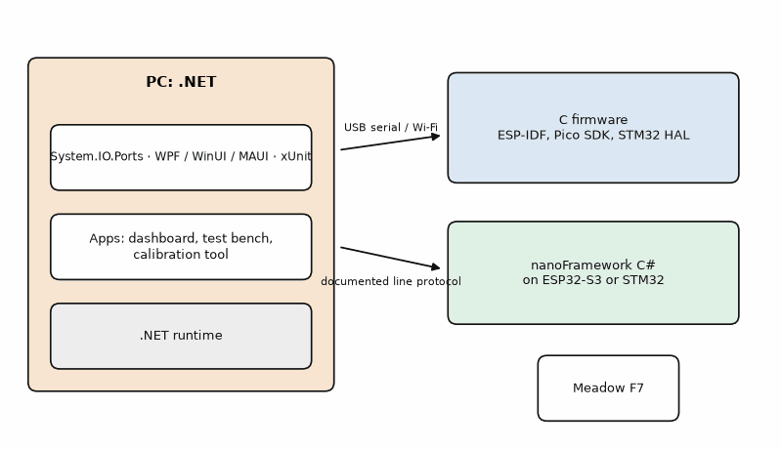
Figure 5.1 — C# across the bench. On the PC, .NET with System.IO.Ports, WPF, WinUI, or MAUI, and xUnit talks to firmware over USB serial or the network. On the microcontroller, .NET nanoFramework runs C# on the ESP32 and some STM32 boards, and Meadow runs .NET on its own STM32F7-based boards. The C firmware of the other chapters and a C# program on the PC meet at a documented line protocol.

5.2 A serial console in C#
The SerialPort class opens a COM port (or /dev/ttyACM0 on Linux) with a baud rate, parity, data bits, and stop bits, and reads text lines or raw bytes. Listing 5.1 is the C# counterpart of Chapter 4's Python logger. Three details matter more than the rest. The read timeout means the program notices a dead board instead of hanging. The invariant culture means “23.41” parses as twenty-three point four one in a locale such as de-DE, where the decimal separator is a comma; without it, parsing follows the active locale and can reject or misread machine-readable data. And every line is checked before it is used.
Listing 5.1 — A .NET console program that reads and validates the reader lab's CSV lines (C#).
// .NET console app: read "t,h,p" lines from the ESP32-S3 and print them with checks.
// Project: dotnet new console; dotnet add package System.IO.Ports
using System;
using System.Globalization;
using System.IO.Ports;
class SerialConsole
{
static void Main(string[] args)
{
string portName = args.Length > 0 ? args[0] : "COM5";
using var port = new SerialPort(portName, 115200, Parity.None, 8, StopBits.One)
{
NewLine = "\r\n",
ReadTimeout = 2000 // ms; never wait forever
};
port.Open();
Console.WriteLine($"Listening on {portName}. Ctrl+C to stop.");
while (true)
{
try
{
string line = port.ReadLine();
string[] f = line.Split(',');
if (f.Length == 3 &&
double.TryParse(f[0], NumberStyles.Float, CultureInfo.InvariantCulture, out double t) &&
double.TryParse(f[1], NumberStyles.Float, CultureInfo.InvariantCulture, out double h) &&
double.TryParse(f[2], NumberStyles.Float, CultureInfo.InvariantCulture, out double p))
Console.WriteLine($"{DateTime.Now:HH:mm:ss} {t,6:F2} °C {h,5:F1} % {p,7:F2} hPa");
else
Console.WriteLine($"bad line: {line}");
}
catch (TimeoutException)
{
Console.WriteLine("no data for 2 s - is the board running?");
}
}
}
}

Worked Example 5.1: A 10 ms timer on a 15.625 ms system tick
Problem. A dashboard uses a System.Threading.Timer with a 10 ms period to poll a board 100 times per second. Suppose it runs on a Windows configuration whose effective timer granularity is 15.625 ms. What rate might it achieve, and how do you check the actual rate on the PC that will run the dashboard?
Solution. On a configuration where callbacks are constrained by a 15.625 ms timer granularity, they may arrive about every 15.6 ms, roughly 64 per second rather than 100. System.Threading.Timer uses thread-pool callbacks, and scheduling, system configuration, or load can change the observed intervals; this is an example, not a guarantee for every Windows PC. Listing 5.2 measures 200 callbacks with a Stopwatch. If polling rate matters, let the firmware stream at a fixed rate with its hardware timer and timestamp each sample on the board; let the PC read what has arrived.
Listing 5.2 — Measuring the real period of a 10 ms timer with a Stopwatch (C#).
// Measure what a 10 ms System.Threading.Timer really delivers on this PC.
using System;
using System.Diagnostics;
using System.Threading;
class TimerCheck
{
static void Main()
{
const int N = 200;
var stamps = new double[N];
int n = 0;
var sw = Stopwatch.StartNew();
using var done = new ManualResetEventSlim(false);
using var timer = new Timer(_ =>
{
if (n < N) stamps[n++] = sw.Elapsed.TotalMilliseconds;
if (n == N) done.Set();
}, null, 0, 10); // ask for one tick every 10 ms
done.Wait();
double mean = (stamps[N - 1] - stamps[0]) / (N - 1);
Console.WriteLine($"requested 10.0 ms, measured mean {mean:F2} ms ({1000 / mean:F1} Hz)");
}
}
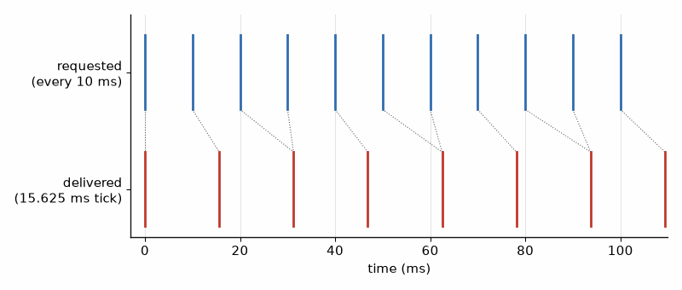
Figure 5.2 — A 10 ms timer request on a configuration with a 15.625 ms effective timer granularity (Worked Example 5.1). The requested callbacks (top) fall between ticks; callbacks (bottom) near the tick boundaries average about 64 per second rather than 100. Other Windows configurations and system loads can produce different intervals, so measure the target PC.

Worked Example 5.2: How long until the receive buffer overflows?
Problem. SerialPort's default receive buffer holds 4096 bytes. The board streams continuously at 115 200 baud, 8N1. The dashboard's UI thread freezes while a file dialog is open. How long can it stay frozen before data is lost, if nothing else reads the port?
Solution. The byte rate is 115 200/10 = 11 520 bytes per second. The buffer fills in 4096/11 520 = 0.36 s. A file dialog stays open for seconds, so data is lost almost every time. The fix is architectural, not a bigger number: read the port on a background thread or with the DataReceived event, push complete lines into a thread-safe queue, and let the UI take what it needs on its own timer (Chapter 22). Raising ReadBufferSize to 64 KB only stretches the margin to 5.7 s.

5.3 C# on the microcontroller
.NET nanoFramework is an open-source runtime that runs a subset of C# on microcontrollers, including the ESP32 family and several STM32 boards. You write and debug in Visual Studio with breakpoints on the real chip, and you add hardware support as NuGet packages such as nanoFramework.System.Device.Gpio and drivers for common sensors. The code is interpreted, so it is slower than C and uses more memory, but for a sensor node or a control panel the productivity is the point. Meadow, from Wilderness Labs, takes a different route: its own boards run full .NET on an STM32F7, with a large driver library.
Listing 5.3 — Blinking an LED on an ESP32-S3 with .NET nanoFramework (C#).
// .NET nanoFramework on an ESP32-S3: blink an LED on GPIO 4 in C#.
// Project: Visual Studio with the nanoFramework extension; NuGet nanoFramework.System.Device.Gpio
using System.Device.Gpio;
using System.Threading;
namespace NanoBlink
{
public class Program
{
public static void Main()
{
var gpio = new GpioController();
GpioPin led = gpio.OpenPin(4, PinMode.Output);
while (true)
{
led.Toggle();
Thread.Sleep(500);
}
}
}
}
This book's firmware is written in C, because that is what most products and most jobs use. C# on the chip is worth knowing for two cases: a team of C# developers who need a small device quickly, and a product where the PC tool and the device share the same data classes and protocol code.
On the Job
In production test departments, C# is common for test executives and station software: the program that powers a board, runs fifty measurements, compares each with limits, prints a label, and writes the result to a database. A realistic task is to add a new measurement to such a station: write the step, its limits, and its xUnit test, then validate it on ten known-good and two known-bad boards before release.
AI Pair-Programming Note
Assistants write good WPF and SerialPort code, with two recurring flaws: updating UI controls directly from the serial thread, which throws a cross-thread exception, and parsing numbers with the PC's culture. Put "use the invariant culture; marshal UI updates through the Dispatcher" in the prompt, and check both in review.
From the Bench
Windows renumbers COM ports when a board is plugged into a different USB socket. A dashboard that hard-codes COM5 fails on the next desk. List the ports with SerialPort.GetPortNames() and let the user pick, and remember the last choice in a settings file.

Practice
1. (Core) Name two reasons to write a test bench in C# rather than Python, and one reason to choose Python.
2. (Core) A board streams 921 600 baud, 8N1. How long does the 4096-byte default buffer last if the program stops reading?
3. (Core) What does double.Parse("23.41") return on a PC whose culture uses a comma as the decimal separator, and how do you avoid it?
4. (Core) A timer is set to 5 ms on a system with a 15.625 ms tick. About how many callbacks per second arrive?
5. (Extension) Why should a dashboard not update a TextBox from the DataReceived event handler directly?
6. (Extension) Sketch the lines of code that list available serial ports in C# and print them.
7. (Extension) What is the difference between .NET nanoFramework and Meadow from the user's point of view?
8. (Challenge) A production test must sample a voltage every 10 ms ± 0.5 ms for 2 s. Propose an architecture that meets it with a C# PC program and an ESP32-S3, and say which side owns the timing.

What You’ll Actually Use
Everyday working tools
- SerialPort with explicit settings, a read timeout, and the invariant culture.
- A background reader and a queue; the UI updates on its own timer.
- Measuring PC timing with Stopwatch before trusting it.
- Visual Studio or VS Code with the C# Dev Kit, and the NuGet package manager.
Mostly for exams and deeper study
- nanoFramework and Meadow; useful in niches, but most product firmware is C.

Part II. Talking to Hardware
Part II connects the code to the reader lab. It starts at a single pin and works outward: buttons and interrupts, timers and PWM for the servo and the ultrasonic ranger, the ADC for the battery, the serial buses that carry the BME280, the GPS, the OLED, and CAN, and finally the registers underneath every library call.

Chapter 6. GPIO, Buttons, and Interrupts
Press a cheap push button once and look at the pin with a scope: the contacts slam together, bounce apart, and touch again, five or ten times in a few milliseconds. To the microcontroller, which can read the pin millions of times per second, that one press is a burst of presses. The counter you wrote to count button presses counts seven. Nothing is wrong with the button; the firmware has not been told what a press is, and that is the job of this chapter.
Where you meet this: Every button, switch, PIR sensor, encoder, limit switch, and "data ready" line, and every interrupt handler you will ever write.

6.1 A pin, in software
A general-purpose I/O pin is configured by a few settings: direction (input or output), pull-up or pull-down resistor (inputs), drive mode (push-pull or open-drain, outputs), and interrupt trigger. The electrical side, logic levels, why a floating input reads random values, and how to size an external pull-up, is Book 1's. The firmware's job is to set those options deliberately, in one place, from the spec's pin table.
Not every pin is free. On the ESP32-S3, GPIO 0, 3, 45, and 46 are strapping pins, read at reset to choose the boot mode, so an external circuit that pulls them the wrong way stops the board from booting. GPIO 19 and 20 are the USB data lines, and GPIO 26 to 32 connect to the module's flash and PSRAM; modules with octal PSRAM also use GPIO 33 to 37. On the RP2040 every GPIO is 3.3 V only. The spec's pin table is the place to check all of this, before the board is laid out.

6.2 Debouncing
There are two families of debounce. Time lockout: accept the first edge, then ignore the pin for a fixed time, typically 20 to 50 ms. It is fast and simple, and it accepts a single noise spike as a press. Sampling: read the pin at a fixed rate, every 5 ms for example, and accept a new level only after several identical samples in a row. It rejects spikes and is the usual choice for products. Both are a few lines of C, and both are pure logic that can be tested on the PC with recorded sample sequences, which is how Listing 6.1 checks itself.
Listing 6.1 — A sampled debouncer with a PC test that replays a bouncing press and release (C).
// Sampled debouncer: call every 5 ms; the output changes after 4 equal samples.
// Pure logic, so it is unit-tested on the PC before it ever sees a button.
#include <stdbool.h>
#include <stdint.h>
#include <stdio.h>
#define DEBOUNCE_SAMPLES 4u
typedef struct {
bool stable; // debounced level
uint8_t count; // consecutive samples that disagree with 'stable'
} debounce_t;
// Returns true exactly once per accepted change of level.
static bool debounce_update(debounce_t *d, bool raw)
{
if (raw == d->stable) {
d->count = 0;
return false;
}
if (++d->count >= DEBOUNCE_SAMPLES) {
d->stable = raw;
d->count = 0;
return true;
}
return false;
}
int main(void)
{
// Raw samples every 5 ms: released (1), a bouncing press, held, then released.
const bool raw[] = {1, 1, 0, 1, 0, 0, 0, 0, 0, 0, 1, 0, 1, 1, 1, 1, 1};
debounce_t d = { .stable = true, .count = 0 };
for (unsigned i = 0; i < sizeof raw / sizeof raw[0]; i++) {
if (debounce_update(&d, raw[i]))
printf("t = %3u ms: level -> %d\n", i * 5u, d.stable);
}
return 0; // prints: t = 35 ms: level -> 0, t = 75 ms: level -> 1
}

Worked Example 6.1: How fast is a debounced button?
Problem. A button bounces for up to 3 ms. The debouncer of Listing 6.1 samples every 5 ms and needs 4 equal samples. What is the shortest and longest delay from the first contact to the accepted press? Does it meet a spec of "recognized within 50 ms"?
Solution. The bouncing ends at most 3 ms after first contact. The first sample that is certain to be clean comes at the next sample instant, 0 to 5 ms later, and the press is accepted at the fourth clean sample, 15 ms after that, so the longest delay is 3 + 5 + 15 = 23 ms. The shortest is 15 ms, when the first sample falls at the moment of contact and every sample happens to read low. Both meet 50 ms with margin. In Listing 6.1's test the first low sample is at 10 ms, the bounce resets the count at 15 ms, and the four clean samples at 20, 25, 30, and 35 ms accept the press at 35 ms.
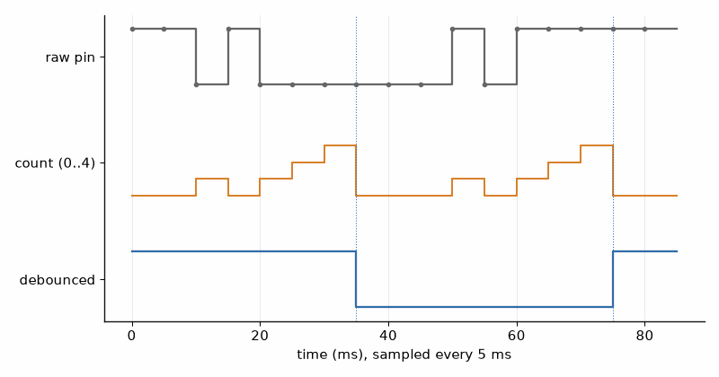
Figure 6.1 — The debouncer of Listing 6.1 on the test sequence, logic-analyzer style. Top: the raw pin, sampled every 5 ms, with a bounce on the press and on the release. Middle: the count of disagreeing samples. Bottom: the debounced level, which changes at 35 ms and 75 ms, four clean samples after each bounce.

6.3 Interrupts
Polling reads a pin in the main loop; an interrupt makes the hardware call a function, the interrupt service routine (ISR), the moment an edge arrives. Interrupts react within microseconds and let the processor sleep between events, which Chapter 14 depends on. Their cost is that the ISR runs in the middle of whatever the program was doing, so it must be short and must not break the interrupted code.
Four rules keep ISRs safe. Do the minimum: record a timestamp, set a flag, or send a small item to a queue, and leave the work to the main loop or a task. Never block: no delays, no waiting for a bus, no printf, no malloc. Share data safely: a variable that the ISR writes and the main code reads must be volatile, and anything larger than one machine word needs a critical section or a queue. On the ESP32, mark the ISR IRAM_ATTR so it is in RAM and can run while the flash cache is busy.
Listing 6.2 — The PIR sensor on an interrupt: the ISR timestamps the edge and queues it; a FreeRTOS task logs it (ESP-IDF, C).
// PIR motion sensor on GPIO 5 of an ESP32-S3 (ESP-IDF 5.x): the interrupt only
// queues an event; a task does the slow work (logging, display, camera).
#include <stdint.h>
#include "freertos/FreeRTOS.h"
#include "freertos/queue.h"
#include "freertos/task.h"
#include "driver/gpio.h"
#include "esp_log.h"
#include "esp_timer.h"
#define PIR_GPIO GPIO_NUM_5
static const char *TAG = "pir";
static QueueHandle_t pir_queue;
static void IRAM_ATTR pir_isr(void *arg)
{
int64_t t_us = esp_timer_get_time(); // ISR-safe timestamp
BaseType_t woken = pdFALSE;
xQueueSendFromISR(pir_queue, &t_us, &woken); // never block in an ISR
if (woken) portYIELD_FROM_ISR();
}
static void pir_task(void *arg)
{
int64_t t_us;
for (;;) {
if (xQueueReceive(pir_queue, &t_us, portMAX_DELAY) == pdTRUE)
ESP_LOGI(TAG, "motion at %lld ms", (long long)(t_us / 1000));
}
}
void app_main(void)
{
pir_queue = xQueueCreate(8, sizeof(int64_t));
const gpio_config_t cfg = {
.pin_bit_mask = 1ULL << PIR_GPIO,
.mode = GPIO_MODE_INPUT,
.pull_up_en = GPIO_PULLUP_DISABLE,
.pull_down_en = GPIO_PULLDOWN_ENABLE, // PIR output idles low
.intr_type = GPIO_INTR_POSEDGE, // motion = rising edge
};
ESP_ERROR_CHECK(gpio_config(&cfg));
ESP_ERROR_CHECK(gpio_install_isr_service(0));
ESP_ERROR_CHECK(gpio_isr_handler_add(PIR_GPIO, pir_isr, NULL));
xTaskCreate(pir_task, "pir", 3072, NULL, 5, NULL);
}
A PIR sensor module already produces a clean, slow output: it goes high for a few seconds when it sees motion, so it needs no debouncing, and a rising-edge interrupt is the natural trigger. A mechanical button is different: an edge interrupt on a bouncing contact fires several times. The common fix combines both techniques: the interrupt wakes the system or records the time, and a lockout or sampling debounce in the main code decides whether it was a real press, as Listing 6.3 does in MicroPython.
Listing 6.3 — A button interrupt that records only the time, with a 50 ms lockout in the main loop (MicroPython).
# MicroPython (Pico or ESP32-S3): a button interrupt that only records the time;
# the main loop applies a 50 ms lockout and does the work.
from machine import Pin
import time
button = Pin(14, Pin.IN, Pin.PULL_UP) # button to GND, active low
last_edge = 0
pressed = False
def on_edge(pin):
global last_edge, pressed
last_edge = time.ticks_ms()
pressed = True # keep the handler tiny
button.irq(trigger=Pin.IRQ_FALLING, handler=on_edge)
count = 0
while True:
if pressed and time.ticks_diff(time.ticks_ms(), last_edge) > 50:
pressed = False
if button.value() == 0: # still held after the bounces: a real press
count += 1
print("press", count)
time.sleep_ms(5)

Worked Example 6.2: The interrupt budget of a rotary encoder
Problem. A rotary encoder knob gives 20 detents per turn with 4 edges per detent on its two channels. A user spins it at up to 3 turns per second. Each ISR takes 2.5 µs on a 240 MHz ESP32-S3. How many interrupts per second, and what fraction of the CPU do they use?
Solution. 20 × 4 = 80 edges per turn, × 3 turns per second = 240 edges per second. At 2.5 µs each that is 600 µs per second, 0.06 % of one core. The interrupt load is negligible; the risk lies elsewhere. If the ISR also updated the OLED, at about 25 ms per update over I2C (Chapter 10), 240 updates per second would need 6 s of work every second. That is why the ISR only counts, and the display reads the count ten times per second.
Key idea. An interrupt handler records that something happened; the rest of the program decides what it means and does the work. Short handlers, queues, and flags keep every other deadline intact.
Common misconception. Interrupts are always better than polling. Polling a slow input every few milliseconds in a loop that already runs that often costs almost nothing and cannot cause a race condition. Interrupts earn their complexity when the event is short, rare, or must wake the chip from sleep.
AI Pair-Programming Note
Generated ISR code often calls Serial.println, printf, or ESP_LOGI inside the handler, uses delay() for debouncing inside the ISR, or forgets the pull-up. Search every ISR for any call that can block or print, and compare every pin's pull configuration with the spec's pin table. If the handler spends its time printing, the event log may be complete while the control loop misses its next deadline.
From the Bench
To see how long your ISR really takes, set a spare GPIO high at the start of the ISR and low at the end, and measure the pulse on a scope or logic analyzer. The same trick, on the edge that triggers the interrupt and the GPIO, measures the interrupt latency. Two pins and two lines of code replace a lot of guessing.

Practice
1. (Core) Which ESP32-S3 pins are strapping pins, and why should a button not pull one of them low at reset?
2. (Core) A debouncer samples every 10 ms and needs 3 equal samples. What is the worst-case delay for a button that bounces for 4 ms?
3. (Core) Name four things that must not happen inside an ISR.
4. (Core) Why does the PIR input in Listing 6.2 use the pull-down rather than the pull-up?
5. (Extension) An encoder gives 96 edges per turn at up to 10 turns per second, and the ISR takes 4 µs. Find the interrupt rate and CPU load.
6. (Extension) A 32-bit counter is incremented in an ISR and read in the main loop on a 32-bit Cortex-M. Is the read safe? What changes if the counter is 64-bit?
7. (Extension) Modify the debouncer of Listing 6.1 so it reports only presses (high to low), not releases. Which line changes?
8. (Challenge) A PIR sensor stays high for 2.5 s after motion and retriggers if motion continues. The wildlife camera must take one photo per motion event and at most one every 30 s. Specify the firmware behavior in the spec format (timing and error handling), and identify which part runs in the ISR.

What You’ll Actually Use
Everyday working tools
- The pin table in the spec, including strapping pins and reserved pins.
- A sampled or lockout debouncer, unit-tested on the PC.
- Short ISRs that queue or flag, and the GPIO-toggle trick to measure them.
- volatile and critical sections for data shared with an ISR.
Mostly for exams and deeper study
- Interrupt controller priority schemes (NVIC preemption and subpriority); you meet them when tuning a complex system.

Chapter 7. Timers and PWM: LEDs, Servos, and the Ultrasonic Ranger
A hobby servo understands one sentence: a pulse between 1 and 2 milliseconds long, repeated fifty times a second. Make the pulse 1.5 ms and the arm points straight up; make it 1.6 ms and it turns about 18 degrees. Generating that pulse in a software loop works until the processor gets busy, and then the arm twitches. A hardware timer generates it with no help from the CPU at all, accurate to a microsecond, forever. Timers are the most underrated peripheral on the chip.
Where you meet this: LED dimming, servos and motor drivers, buzzers, the ultrasonic ranger's echo, frequency counters, periodic sampling, and every "every 10 ms" in a spec.

7.1 What a timer is
A timer is a counter driven by a clock. A prescaler divides the input clock to set the tick rate; the counter counts ticks up to an auto-reload value and starts again, so the overflow rate is the timer frequency. A compare register is compared with the counter on every tick: while the counter is below it the output pin is high, and above it the pin is low. That is PWM, pulse-width modulation, entirely in hardware. Run the same counter the other way, let an input edge copy the counter into a capture register, and the timer measures time instead of making it.
f_PWM = f_clk / ((PSC + 1)(ARR + 1)), duty = CCR / (ARR + 1)
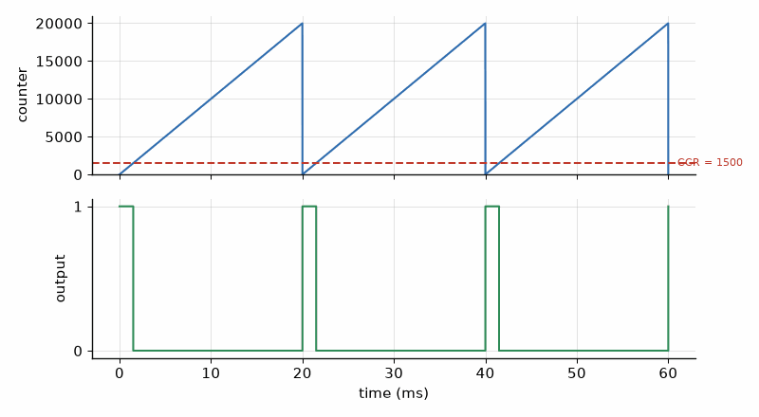
Figure 7.1 — How a timer makes PWM. The counter ramps from 0 to ARR = 19 999 and restarts every 20 ms (1 MHz ticks from an 84 MHz clock with PSC = 83). The output is high while the counter is below the compare value CCR = 1500, giving a 1.5 ms pulse every 20 ms, the servo's center position.
The PWM electronics, why an LED dims smoothly at a few kilohertz, what the motor driver does with the pulses, and the flyback diode that protects it, are Book 2's. Firmware chooses three numbers: the frequency, the resolution (how many duty steps there are), and the duty itself. The first two trade against each other, because a faster PWM leaves fewer clock ticks per period.

Worked Example 7.1: A 50 Hz servo timer on an STM32
Problem. An STM32 timer runs from an 84 MHz clock. Find PSC and ARR for 50 Hz with 1 µs ticks, and the compare values for 1.0, 1.5, and 2.0 ms pulses. Compare with the setting that gives the most duty steps, and with a 20 kHz motor PWM.
Solution. For 1 µs ticks the prescaler divides by 84, so PSC = 83. A 20 ms period is 20 000 ticks, so ARR = 19 999. The pulses are CCR = 1000, 1500, and 2000. Listing 7.1 searches for the smallest prescaler that keeps ARR within 16 bits: PSC = 25 and ARR = 64 614, which gives 64 615 steps instead of 20 000 but makes every pulse width an awkward number of ticks. For a servo, 1 µs steps are already finer than the servo can resolve, so the round numbers win. At 20 kHz for a motor driver, PSC = 0 and ARR = 4199: 4200 steps, about 12 bits of resolution, the price of a frequency above human hearing.
Listing 7.1 — Solving PSC and ARR for a target PWM frequency (C, runs on the PC).
// Prescaler and auto-reload for an STM32 timer: f_pwm = f_clk / ((PSC+1)(ARR+1)).
// Runs on the PC; paste the results into CubeMX or the init code.
#include <stdint.h>
#include <stdio.h>
typedef struct { uint32_t psc, arr; double f_actual; } timer_cfg_t;
// Choose the smallest prescaler that lets ARR fit in 16 bits (best duty resolution).
static int timer_solve(uint32_t f_clk, double f_pwm, timer_cfg_t *out)
{
for (uint32_t psc = 0; psc <= 0xFFFFu; psc++) {
double arr = f_clk / ((psc + 1.0) * f_pwm) - 1.0;
if (arr <= 65535.0) {
out->psc = psc;
out->arr = (uint32_t)(arr + 0.5);
out->f_actual = f_clk / ((psc + 1.0) * (out->arr + 1.0));
return 0;
}
}
return -1; // frequency too low for this timer clock
}
int main(void)
{
const double targets[] = { 50.0, 1000.0, 20000.0 };
for (int i = 0; i < 3; i++) {
timer_cfg_t c;
if (timer_solve(84000000u, targets[i], &c) == 0)
printf("%8.0f Hz: PSC=%5u ARR=%5u -> %.3f Hz, %u steps\n",
targets[i], (unsigned)c.psc, (unsigned)c.arr, c.f_actual, (unsigned)c.arr + 1u);
}
return 0;
}

7.2 PWM on the ESP32-S3
The ESP32 family has a dedicated LED-control peripheral, LEDC, which despite its name drives anything that needs PWM. You configure a timer with a frequency and a duty resolution in bits, attach channels to pins, and set each channel's duty. The driver computes the clock divider for you. At 50 Hz with 14-bit resolution, one duty step is 20 ms/16 384 = 1.22 µs. The MCPWM peripheral, also on the S3, adds dead time and fault inputs for motor bridges.
Listing 7.2 — A servo on the ESP32-S3's LEDC peripheral, with clamping and rounding in angle_to_duty (ESP-IDF, C).
// Servo on GPIO 15 of an ESP32-S3 with the LEDC PWM peripheral (ESP-IDF 5.x).
// 50 Hz, 14-bit duty: one step = 20 ms / 16384 = 1.22 us.
#include <stdint.h>
#include "freertos/FreeRTOS.h"
#include "freertos/task.h"
#include "driver/ledc.h"
#define SERVO_GPIO 15
#define PERIOD_US 20000u
#define DUTY_BITS LEDC_TIMER_14_BIT
#define DUTY_MAX (1u << 14)
#define PULSE_MIN_US 1000u // 0 degrees (check your servo's data sheet)
#define PULSE_MAX_US 2000u // 180 degrees
static uint32_t angle_to_duty(float deg)
{
if (deg < 0.0f) deg = 0.0f; // clamp: never drive past the end stops
if (deg > 180.0f) deg = 180.0f;
float us = PULSE_MIN_US + (PULSE_MAX_US - PULSE_MIN_US) * deg / 180.0f;
return (uint32_t)(us * DUTY_MAX / PERIOD_US + 0.5f); // round to nearest step
}
void app_main(void)
{
const ledc_timer_config_t tcfg = {
.speed_mode = LEDC_LOW_SPEED_MODE, .duty_resolution = DUTY_BITS,
.timer_num = LEDC_TIMER_0, .freq_hz = 50, .clk_cfg = LEDC_AUTO_CLK,
};
ESP_ERROR_CHECK(ledc_timer_config(&tcfg));
const ledc_channel_config_t ccfg = {
.gpio_num = SERVO_GPIO, .speed_mode = LEDC_LOW_SPEED_MODE,
.channel = LEDC_CHANNEL_0, .intr_type = LEDC_INTR_DISABLE,
.timer_sel = LEDC_TIMER_0, .duty = angle_to_duty(90.0f), .hpoint = 0,
};
ESP_ERROR_CHECK(ledc_channel_config(&ccfg));
for (;;) {
for (int deg = 0; deg <= 180; deg += 45) {
ESP_ERROR_CHECK(ledc_set_duty(LEDC_LOW_SPEED_MODE, LEDC_CHANNEL_0, angle_to_duty((float)deg)));
ESP_ERROR_CHECK(ledc_update_duty(LEDC_LOW_SPEED_MODE, LEDC_CHANNEL_0));
vTaskDelay(pdMS_TO_TICKS(1000));
}
}
}

Worked Example 7.2: How fine can the servo move?
Problem. With the LEDC setup of Listing 7.2 (50 Hz, 14 bits) and a servo that maps 1000 to 2000 µs onto 0 to 180°, find the duty values for 0°, 90°, and 180°, and the angle per duty step.
Solution. Duty = pulse/20 000 µs × 16 384. For 1000 µs: 819.2, rounded to 819. For 1500 µs: 1228.8, rounded to 1229. For 2000 µs: 1638.4, rounded to 1638. One step is 1.22 µs, and the servo moves 180° per 1000 µs, which is 0.18° per µs, so one step is 0.22°. That is finer than the dead band of a typical hobby servo, so the resolution is not the limit. The usual mistake is to compute with the period in milliseconds and the pulse in microseconds and get a duty a thousand times off; the clamp in angle_to_duty stops an out-of-range angle from driving the servo into its end stop.
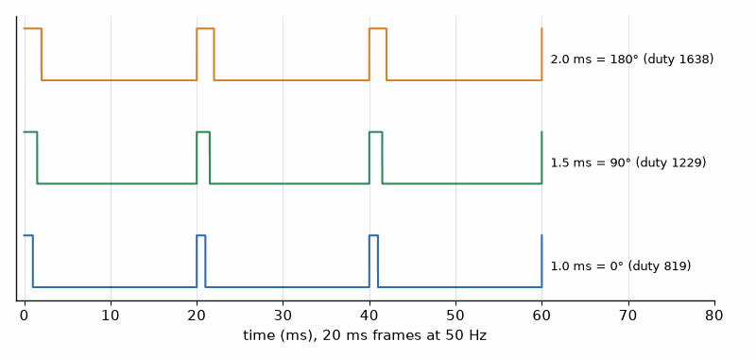
Figure 7.2 — Servo pulses at 50 Hz (Worked Example 7.2). Each 20 ms frame carries one pulse: 1.0 ms for 0° (LEDC duty 819), 1.5 ms for 90° (1229), 2.0 ms for 180° (1638). One 14-bit step is 1.22 µs, or 0.22°.

7.3 Measuring time: the ultrasonic ranger
The reader lab's ultrasonic sensor turns distance into time. A 10 µs pulse on its trigger pin makes it send a burst of eight 40 kHz cycles; its echo pin then goes high until the reflection returns. The echo width is the round-trip time, so the distance is the speed of sound times the width, divided by two. A timer's input capture measures the width to a tick; MicroPython's time_pulse_us measures it in software, accurately enough for centimeters.
d = c t / 2, c ≈ 331.3 + 0.606 T (m/s, T in °C)
Listing 7.3 — Ultrasonic distance with a timeout and temperature compensation (MicroPython).
# MicroPython: ultrasonic distance with temperature compensation.
# Use a 3.3 V sensor, or divide a 5 V module's echo down to 3.3 V (Book 1).
from machine import Pin, time_pulse_us
import time
TRIG = Pin(6, Pin.OUT, value=0)
ECHO = Pin(7, Pin.IN)
def distance_m(temp_c=20.0):
TRIG.value(1)
time.sleep_us(10) # 10 us trigger pulse
TRIG.value(0)
t_us = time_pulse_us(ECHO, 1, 30_000) # 30 ms timeout, about 5 m
if t_us < 0:
return None # no echo: out of range or wiring
c = 331.3 + 0.606 * temp_c # speed of sound in m/s
return c * t_us * 1e-6 / 2 # out and back
while True:
d = distance_m(temp_c=21.5) # later: the BME280 temperature
print("no echo" if d is None else "%.3f m" % d)
time.sleep_ms(100)

Worked Example 7.3: Why the ranger needs the BME280
Problem. An object is 1.000 m away. Find the echo width at 20 °C. A program that assumes c = 343 m/s is used on a 0 °C morning. What distance does it report?
Solution. At 20 °C, c = 331.3 + 0.606 × 20 = 343.4 m/s, and t = 2 × 1.000/343.4 = 5.824 ms. At 0 °C, c = 331.3 m/s and the echo lasts 2/331.3 = 6.037 ms. The program computes 343 × 6.037 ms/2 = 1.035 m, a 3.5 % error, 35 mm at one meter. Passing the BME280's temperature into distance_m removes it. A 1 µs timing resolution corresponds to 0.17 mm of distance, so temperature, not timing, sets the accuracy. The 30 ms timeout in Listing 7.3 caps the range at about 5 m and keeps the loop from hanging when no echo returns.
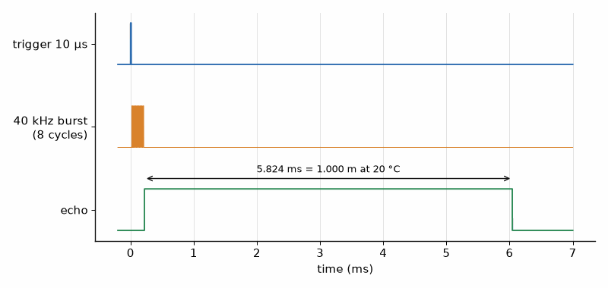
Figure 7.3 — Ultrasonic ranging timing for an object at 1.000 m and 20 °C (Worked Example 7.3). A 10 µs trigger starts a 200 µs burst of eight 40 kHz cycles; the echo line stays high for 5.824 ms, the round trip.
Key idea. Let the hardware keep time. A timer generating PWM or capturing an edge is exact no matter how busy the CPU is; software timing is exact only until the next interrupt.
AI Pair-Programming Note
Assistants often produce servo code with the pulse range of one servo applied to another, PWM frequencies that are fine for LEDs but wrong for servos, or the legacy ESP-IDF 4 LEDC API mixed with version 5. Check every number against the servo's data sheet and the duty arithmetic against a scope.
From the Bench
Never test a new servo routine with the horn attached to a mechanism. Run it free first, watch the pulse on a scope, and confirm the extremes. A servo driven against its end stop draws its stall current continuously, gets hot, and can brown out the ESP32-S3 if both share a weak supply (Book 6 sizes that supply).

Practice
1. (Core) An STM32 timer clock is 72 MHz. Find PSC and ARR for 1 kHz PWM with 1 µs ticks.
2. (Core) What compare value gives a 25 % duty cycle with ARR = 3999?
3. (Core) With LEDC at 50 Hz and 12-bit resolution, how long is one duty step?
4. (Core) Find the echo width for an object 2.50 m away at 25 °C.
5. (Extension) An LED PWM at 20 kHz from an 80 MHz clock with no prescaler: how many duty steps, and how many bits is that?
6. (Extension) A servo maps 500 to 2500 µs onto 0 to 180°. Find the LEDC duty (14 bits, 50 Hz) for 45°.
7. (Extension) The ranger reads 0.85 m on a 35 °C afternoon with the 343 m/s constant. What is the true distance?
8. (Challenge) A frequency counter uses input capture on a 1 MHz timer tick and measures one period of a signal. What is the relative resolution at 1 kHz and at 100 kHz, and how would you measure 100 kHz more precisely?

What You’ll Actually Use
Everyday working tools
- f = f_clk/((PSC + 1)(ARR + 1)) and duty = CCR/(ARR + 1).
- The frequency against resolution trade-off.
- LEDC on the ESP32 and hardware PWM on every other chip; clamp the inputs.
- Input capture or time_pulse_us for pulse widths, always with a timeout.
Mostly for exams and deeper study
- Advanced timer features such as dead-time insertion, encoder mode, and one-pulse mode; you meet them in motor control.

Chapter 8. The ADC: Sampling, Scaling, and Calibration
Two identical ESP32-S3 boards measure the same 18650 cell and disagree by 80 millivolts. Both report three decimal places, which settles the formatting rather better than it settles the battery voltage. Each chip's analog-to-digital converter has its own offset and gain error; 80 mV is the difference between "60 % charged" and "time to shut down". This chapter scales, averages, and calibrates the reader lab's battery reading, then asks how much of the answer the assembled board has earned.
Where you meet this: Battery monitors, potentiometers and joysticks, analog sensors such as thermistors, light sensors, and current-sense amplifiers, and every number on a dashboard that started as a voltage.

8.1 From voltage to code and back
An N-bit ADC divides its input range into 2^N steps and returns the number of the step the input falls in. With a 3.3 V reference and 12 bits, one step, one LSB, is 3.3/4096 = 0.806 mV. Converting back is the same arithmetic in reverse, and a divider in front of the pin multiplies the result by its ratio. Book 1 owns the ADC as a circuit: sampling, the reference, and why the input needs a low source impedance. Firmware owns the arithmetic and the errors that are left over.
code = V_in / V_ref × 2^N, V_in = code × V_ref / 2^N
First cut, not release limit
Load, temperature, source impedance, and firmware version can move a real reading away from the ideal calculation. Chapter 8.3 measures silicon and board error; verify the assembled product against a reference before treating the calculated accuracy as a specification.
The microcontrollers in this book differ. The RP2040 on the Pico has a 12-bit ADC whose reference is its 3.3 V supply, so any error in that rail is an error in every reading. The ESP32-S3 has two 12-bit ADCs with selectable input attenuation; at the 12 dB setting the usable range is roughly 0 to 3.1 V, and the chip stores factory calibration data that ESP-IDF's calibration driver applies. ADC2 on the ESP32 family is shared with the Wi-Fi radio, so use ADC1 pins for anything measured while Wi-Fi runs. The STM32 parts have 12-bit converters with an internal reference channel that firmware can measure to correct for the supply.

Worked Example 8.1: Reading the 18650 on a Pico
Problem. The reader lab's 18650 cell, at 3.70 V, is measured through a 100 kΩ/100 kΩ divider by a Pico (12 bits, 3.3 V reference). Find the pin voltage, the ideal code, the voltage the code converts back to, and the divider's current drain.
Solution. The divider halves the voltage: 1.850 V at the pin. Code = 1.850/3.3 × 4096 = 2296.2, so the ADC returns 2296. Back: 2296 × 3.3/4096 × 2 = 3.6996 V, within one LSB of the truth, 1.6 mV at the cell. The divider draws 3.70 V/200 kΩ = 18.5 µA all the time. That sounds tiny, but it is more than twice the ESP32-S3's deep-sleep current, which matters for the battery budgets of Chapter 14 and Book 6. Raise the divider to 1 MΩ/1 MΩ (1.85 µA) with a 100 nF capacitor at the pin to supply the sampling charge, or switch the divider with a MOSFET (Book 2).
Listing 8.1 — Battery voltage on a Pico with a divider and 16-sample averaging (MicroPython).
# MicroPython on a Pico: 18650 cell voltage through a 100k/100k divider on GPIO 26 (ADC0).
from machine import ADC
import time
adc = ADC(26)
VREF = 3.3 # replace with the measured 3V3 rail for better accuracy
DIVIDER = 2.0 # (100k + 100k) / 100k
def cell_volts(n=16):
total = 0
for _ in range(n):
total += adc.read_u16() >> 4 # read_u16 scales to 16 bits; the ADC has 12
code = total / n
return code * VREF / 4096 * DIVIDER
while True:
v = cell_volts()
state = "LOW - shut down soon" if v < 3.3 else "ok"
print("cell %.3f V %s" % (v, state))
time.sleep(5)

8.2 Averaging
Every ADC reading carries noise: from the reference, the supply, the input, and the converter itself. Averaging n readings reduces random noise by the square root of n, so 16 readings cut it by a factor of 4, two bits' worth. Averaging only helps if the noise is random and at least about one LSB; a perfectly quiet input that sits between two codes always reads the same code, and averaging cannot recover the fraction. That is why a little noise, called dither, can improve resolution.
σ_avg = σ / √n

Worked Example 8.2: How many samples?
Problem. Single readings of a steady input scatter with a standard deviation of 3 LSB on a 3.3 V, 12-bit ADC. How many samples must be averaged to bring the noise below 1 mV? How long does that take at 10 µs per conversion?
Solution. 3 LSB is 3 × 0.806 = 2.42 mV. To reach 1 mV the noise must fall by a factor of 2.42, so n ≥ 2.42² = 5.9; use 8, the next power of two, which gives 2.42/√8 = 0.85 mV. Eight conversions take 80 µs, negligible for a battery read every few seconds. The usual mistake is to average many more samples than needed and miss a fast change; averaging is also a low-pass filter, which Chapter 15 makes precise.
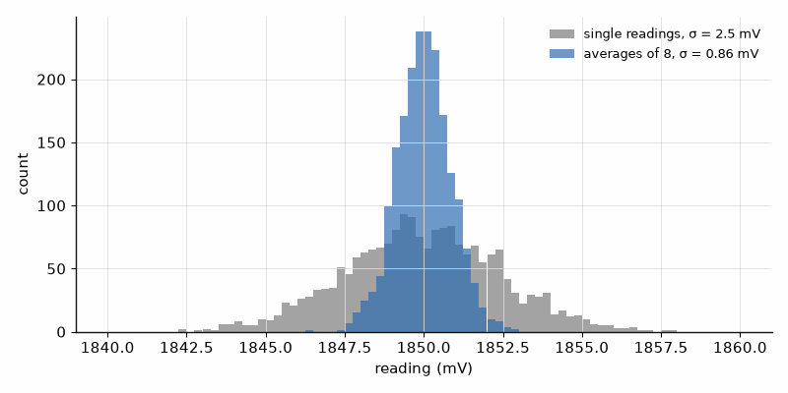
Figure 8.1 — Averaging in action (Worked Example 8.2). 2000 simulated readings of a steady 1.850 V input with 3 LSB of random noise (gray) scatter with a standard deviation of about 2.4 mV; averages of 8 (blue) scatter by about 0.85 mV, as σ/√n predicts.

8.3 Calibration
After averaging, what remains is systematic: an offset (the code at 0 V is not 0) and a gain error (the slope is not exactly V_ref/2^N). Both are fixed for a given chip, so two measurements of known voltages correct them. Apply a reference voltage near the bottom of the range and one near the top, record the codes, and fit a straight line through the two points. Store the two constants in flash, and use them in every conversion. The ESP32-S3's factory calibration does the same with data measured at the factory, and a two-point bench calibration on top of it removes most of what remains, including the divider's resistor tolerances.
Calibration does not make the converter ideal. The ESP32-S3 datasheet lists integral nonlinearity of ±8 LSB and, at the highest attenuation over 0–2.9 V, total error of ±50 mV under its stated test conditions (100 nF input capacitor, DC input, 25 °C, Wi-Fi off). Book 1’s ideal quantization equation is a starting model; for a real product, silicon limits and the assembled divider, source impedance, temperature, and calibration set the usable accuracy. Do not infer a ±20 mV battery measurement from the calibration API alone: test the actual board against a reference whose uncertainty is smaller than the error you need to resolve, and include the source, meter, settling, and repeatability in the uncertainty budget.
Listing 8.2 — Two-point calibration and integer averaging, tested on the PC with the numbers of Worked Example 8.3 (C).
// Two-point ADC calibration and averaging; pure C, tested on the PC with bench numbers.
#include <stdint.h>
#include <stdio.h>
typedef struct { float gain_v_per_code; float offset_v; } adc_cal_t;
// Measured on the bench: code c1 at v1 and code c2 at v2 from a reference source.
static adc_cal_t adc_cal_two_point(uint16_t c1, float v1, uint16_t c2, float v2)
{
adc_cal_t cal;
cal.gain_v_per_code = (v2 - v1) / (float)(c2 - c1);
cal.offset_v = v1 - cal.gain_v_per_code * (float)c1;
return cal;
}
static float adc_to_volts(const adc_cal_t *cal, uint16_t code)
{
return cal->offset_v + cal->gain_v_per_code * (float)code;
}
// Average n samples (n <= 64) with an integer sum, then convert once.
static uint16_t adc_average(const uint16_t *s, unsigned n)
{
uint32_t sum = 0;
for (unsigned i = 0; i < n; i++) sum += s[i];
return (uint16_t)((sum + n / 2) / n); // rounded mean
}
int main(void)
{
adc_cal_t cal = adc_cal_two_point(412, 0.500f, 3690, 3.000f);
printf("gain %.1f uV/code, offset %.4f V\n", cal.gain_v_per_code * 1e6, cal.offset_v);
const uint16_t s[4] = {2398, 2401, 2403, 2398};
uint16_t code = adc_average(s, 4);
printf("code %u -> %.4f V calibrated, %.4f V ideal (3.3 V / 4096)\n",
(unsigned)code, adc_to_volts(&cal, code), code * 3.3f / 4096.0f);
return 0;
}

Worked Example 8.3: A two-point calibration
Problem. A bench supply checked with a good multimeter gives 0.500 V and 3.000 V. The ADC reads codes 412 and 3690. Find the gain and offset, and convert an averaged code of 2400 with the calibration and with the ideal formula.
Solution. Gain = (3.000 − 0.500)/(3690 − 412) = 2.5/3278 = 762.7 µV per code, against the ideal 805.7 µV. Offset = 0.500 − 412 × 762.7 µV = 0.186 V. Code 2400 gives 0.186 + 2400 × 762.7 µV = 2.016 V calibrated, and 2400 × 3.3/4096 = 1.934 V ideal: an 83 mV difference, 4 % of the reading. Listing 8.2 prints exactly these values. The usual mistakes are to calibrate with the meter's probes on the board's connector rather than where the reference is applied, so the divider's own error is not included, and to calibrate at one point only, which fixes the offset or the gain but not both.
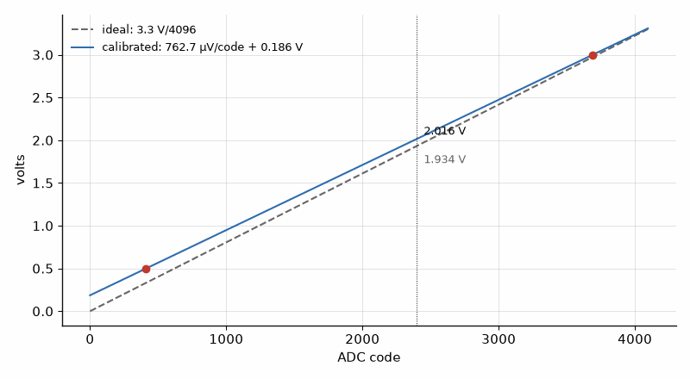
Figure 8.2 — Ideal and calibrated ADC transfer lines (Worked Example 8.3). The calibration points at 412 codes, 0.500 V, and 3690 codes, 3.000 V, define a line with a 762.7 µV slope and a 0.186 V offset; at code 2400 it reads 2.016 V where the ideal 3.3 V/4096 line reads 1.934 V.
Listing 8.3 — ESP32-S3 one-shot ADC with the chip's curve-fitting calibration and 16-sample averaging (ESP-IDF, C).
// ESP32-S3 one-shot ADC read with the chip's calibration (ESP-IDF 5.x).
// GPIO 4 is ADC1 channel 3 on the ESP32-S3.
#include <stdbool.h>
#include "freertos/FreeRTOS.h"
#include "freertos/task.h"
#include "esp_adc/adc_oneshot.h"
#include "esp_adc/adc_cali.h"
#include "esp_adc/adc_cali_scheme.h"
#include "esp_log.h"
static const char *TAG = "adc";
void app_main(void)
{
adc_oneshot_unit_handle_t adc;
const adc_oneshot_unit_init_cfg_t ucfg = { .unit_id = ADC_UNIT_1 };
ESP_ERROR_CHECK(adc_oneshot_new_unit(&ucfg, &adc));
const adc_oneshot_chan_cfg_t ccfg = { .atten = ADC_ATTEN_DB_12, .bitwidth = ADC_BITWIDTH_12 };
ESP_ERROR_CHECK(adc_oneshot_config_channel(adc, ADC_CHANNEL_3, &ccfg));
adc_cali_handle_t cali;
const adc_cali_curve_fitting_config_t kcfg = {
.unit_id = ADC_UNIT_1, .chan = ADC_CHANNEL_3,
.atten = ADC_ATTEN_DB_12, .bitwidth = ADC_BITWIDTH_12,
};
ESP_ERROR_CHECK(adc_cali_create_scheme_curve_fitting(&kcfg, &cali));
while (true) {
int raw = 0, mv = 0, sum_mv = 0;
for (int i = 0; i < 16; i++) {
ESP_ERROR_CHECK(adc_oneshot_read(adc, ADC_CHANNEL_3, &raw));
ESP_ERROR_CHECK(adc_cali_raw_to_voltage(cali, raw, &mv));
sum_mv += mv;
}
ESP_LOGI(TAG, "pin %d mV, cell %d mV", sum_mv / 16, 2 * sum_mv / 16);
vTaskDelay(pdMS_TO_TICKS(5000));
}
}
Key idea. A raw ADC code is a promise, not a measurement. Scale it, average it to the noise you can afford, and calibrate it against a known reference before you print it with three decimals. Three decimals are a display choice; the reference and assembled board decide how many are defensible.
AI Pair-Programming Note
An assistant may copy an ESP32 example that uses ADC2 while Wi-Fi is running, use the old ADC_ATTEN_DB_11 name or the ESP-IDF 4 esp_adc_cal API, or alternate between 3.3/4095 and 3.3/4096. The code can compile and still produce a confident wrong number. Check the target chip and SDK, then test both ends of the conversion range.
From the Bench
Before blaming the ADC, measure the reference. On a Pico, a reading that moves when the USB cable is changed may be the 3.3 V rail moving with the load. Measure the rail, then decide whether an external reference or a second-channel measurement is justified. The converter cannot correct a reference that the firmware has mistaken for a constant.

Practice
1. (Core) Find the LSB of a 10-bit ADC with a 3.3 V reference, and of a 16-bit ADC with a 2.5 V reference.
2. (Core) A Pico reads code 3000 through a 100 kΩ/100 kΩ divider. What is the cell voltage?
3. (Core) By what factor does averaging 64 readings reduce random noise?
4. (Core) Why should battery measurements on an ESP32 use ADC1 rather than ADC2?
5. (Extension) The divider must keep the pin below 3.0 V for a 4.20 V cell and draw under 2 µA at 3.7 V. Choose resistor values from the E12 series.
6. (Extension) A one-point calibration at 1.500 V corrects the offset only. The true gain error is +2 %. What is the error at 3.000 V?
7. (Extension) Readings of a steady input are always exactly 1823, with no scatter. What does averaging 16 of them achieve, and why?
8. (Challenge) Write the acceptance tests (spec format) for a battery-voltage module that must read within ±20 mV from 3.0 to 4.2 V, and describe the bench setup to run them.

What You’ll Actually Use
Everyday working tools
- code = V/V_ref × 2^N and back, with the divider ratio.
- Averaging by √n, sized to the noise.
- Two-point calibration with the constants stored in flash.
- ESP32 ADC1 with the factory calibration driver; the Pico's supply as its reference.
Mostly for exams and deeper study
- ADC architectures (SAR, sigma-delta) and their specifications; Book 1 and the data sheet own them.

Chapter 9. UART and I2C: The BME280 and the GPS
Two wires, a pull-up resistor on each, and a dozen chips can share them: the BME280, the OLED, an IMU, and a clock. Two different wires, no clock at all, and a GPS module streams its position to you as plain text at 9600 baud. Most of the reader lab talks to the ESP32-S3 over one of these two buses, and most first-day bugs live in them: the wrong address, the wrong baud rate, a missing pull-up, or a bus that hangs because one transfer never finished.
Where you meet this: Every sensor breakout, every GPS and cellular module, every debug console, and every "no device found at 0x76".

9.1 UART: asynchronous serial
A UART sends each byte as a frame: a start bit (low), eight data bits with the least significant bit first, and a stop bit (high). There is no clock line; both ends agree on the bit time in advance, the baud rate, and the receiver re-synchronizes on every start bit. That is why the settings must match exactly: 115 200 baud, 8 data bits, no parity, 1 stop bit, written 115200 8N1. The electrical side, 3.3 V logic levels versus RS-232 and RS-485 line drivers, belongs to Books 1 and 7.
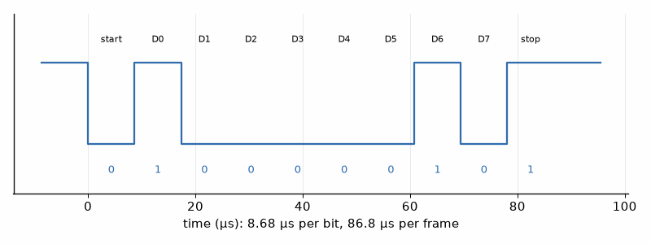
Figure 9.1 — One UART frame: the character 'A' (0x41) at 115 200 baud, 8N1, as a logic analyzer shows it. The start bit, eight data bits sent LSB first (1, 0, 0, 0, 0, 0, 1, 0), and the stop bit each last 8.68 µs; the whole frame takes 86.8 µs.
Because the receiver samples each bit near its middle, timed from the start edge, the two ends' clocks may differ a little. By the tenth bit an error of e accumulates to 10e bit times, and the sample must still land inside the right bit, so the total mismatch must stay below a few percent. Practical designs keep each side within about 2 %. The error comes from dividing the peripheral clock by an integer, or by an integer plus a fraction on chips with fractional dividers.

Worked Example 9.1: Baud-rate error
Problem. Find the actual baud rate and the error for 115 200 baud on (a) a 16 MHz AVR with 16× oversampling and an integer divider, (b) the same chip with 8× oversampling, (c) an STM32 at 84 MHz with 16× oversampling and a 4-bit fractional divider.
Solution. (a) The divider is 16 MHz/(16 × 115 200) = 8.68, rounded to 9 (register value 8). The actual rate is 16 MHz/(16 × 9) = 111 111 baud, −3.5 %: too far, and the classic reason a 16 MHz Uno is unreliable at 115 200 with some partners. (b) 16 MHz/(8 × 115 200) = 17.36, rounded to 17: 117 647 baud, +2.1 %, usable. (c) 84 MHz/(16 × 115 200) = 45.57; with sixteenths, 45 + 9/16 = 45.5625, giving 115 226 baud, +0.02 %. The ESP32-S3 and RP2040 also have fractional dividers. When two boards will not talk at a high baud rate, compute this before anything else.

9.2 GPS: text over UART
The reader lab's GPS module speaks NMEA 0183: lines of ASCII text that start with $, carry comma-separated fields, and end with * and a two-digit hexadecimal checksum, the XOR of every character between $ and *. Most modules start at 9600 baud and send a burst of sentences once per second. GGA carries the fix: time, latitude and longitude in degrees and minutes, fix quality, satellites, and altitude. RMC adds speed and date. A parser must check the checksum, reject sentences without a fix, and convert ddmm.mmmm into decimal degrees.
Listing 9.1 — NMEA checksum and GGA parsing, with the standard example sentence as a test (Python, runs on the PC, Pi, or MicroPython).
"""NMEA 0183 checksum and GGA parsing for the reader lab's GPS (runs on the PC or a Pi)."""
def nmea_checksum_ok(sentence: str) -> bool:
"""XOR of every character between '$' and '*' must equal the two hex digits after '*'."""
if not sentence.startswith("$") or "*" not in sentence:
return False
body, _, given = sentence[1:].partition("*")
calc = 0
for ch in body:
calc ^= ord(ch)
return given[:2].upper() == "%02X" % calc
def parse_gga(sentence: str):
"""Return (lat_deg, lon_deg, fix_quality, satellites, altitude_m) or None."""
if not nmea_checksum_ok(sentence):
return None
f = sentence.split("*")[0].split(",")
if not f[0].endswith("GGA") or f[6] == "0":
return None # wrong type or no fix
lat = int(f[2][:2]) + float(f[2][2:]) / 60 # ddmm.mmmm
lon = int(f[4][:3]) + float(f[4][3:]) / 60 # dddmm.mmmm
if f[3] == "S":
lat = -lat
if f[5] == "W":
lon = -lon
return lat, lon, int(f[6]), int(f[7]), float(f[9])
if __name__ == "__main__":
s = "$GPGGA,123519,4807.038,N,01131.000,E,1,08,0.9,545.4,M,46.9,M,,*47"
print(nmea_checksum_ok(s), parse_gga(s))
print(nmea_checksum_ok(s.replace("4807", "4808"))) # one corrupted digit -> False

Worked Example 9.2: Checking a GPS sentence
Problem. Check and decode $GPGGA,123519,4807.038,N,01131.000,E,1,08,0.9,545.4,M,46.9,M,,*47. How busy is a 9600-baud link carrying about 450 characters of NMEA per second?
Solution. XORing every character from G to the last comma gives 0x47, matching the *47, so the sentence is intact; Listing 9.1 confirms it and rejects the same sentence with one digit changed. Latitude 4807.038 N is 48° + 7.038'/60 = 48.1173°; longitude 01131.000 E is 11° + 31.000'/60 = 11.5167°, a point in Munich. Fix quality 1 (GPS fix), 8 satellites, altitude 545.4 m. At 10 bits per character, 450 characters per second are 4500 bit/s, 47 % of the link. Raising the update rate to 5 Hz without raising the baud rate or disabling unneeded sentences overflows it, a common reason for "GPS freezes at 5 Hz".

9.3 I2C: two wires, many chips
I2C uses a clock line, SCL, and a data line, SDA, both open-drain with pull-up resistors (sized in Book 1, and checked for rise time in Book 7). The controller starts a transfer with a START condition, sends a 7-bit address and a read/write bit, and every byte is followed by an acknowledge bit from the receiver. A device that does not exist, or is busy, answers with a NACK. Reading a sensor register is a write of the register number followed by a repeated START and a read.
Priority inversion can turn that working read into a missed deadline. Suppose a sensor task at priority 6 needs the I2C mutex within a 10 ms period; a display task at priority 2 holds it for 2 ms, while a compute task at priority 4 is ready for 15 ms. Without priority inheritance, the sensor blocks behind the display, the compute task preempts the display, and the sensor misses its 10 ms deadline. A FreeRTOS mutex temporarily boosts the display task so it can release the bus; measure the real hold time under Wi-Fi traffic and keep logging or long transfers outside the critical section. The stack sizes in the task table still need high-water measurements on the deepest path. The 10 ms deadline is then missed, so the control task receives stale sensor data for that cycle.
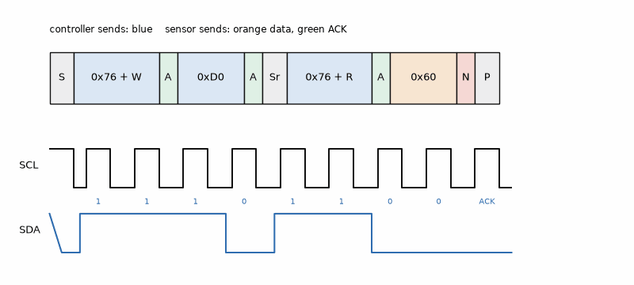
Figure 9.2 — Reading the BME280's chip ID: START, address 0x76 with write, register 0xD0, repeated START, address 0x76 with read, the data byte 0x60 with the controller's NACK, and STOP. Each byte takes 9 clocks, 8 bits plus acknowledge.
The ESP-IDF driver of Listing 9.2 follows the spec of Worked Example 1.1 line by line: pins 8 and 9, 400 kHz, address 0x76, a 50 ms timeout on every transfer, a check of the chip ID, and an error path that reports and returns instead of hanging. Listing 9.3 is the other half of a driver: the compensation that turns the raw 20-bit value into hundredths of a degree, using calibration constants stored in the sensor. Its test uses the example values from the Bosch data sheet and must print 25.08 °C.
A loaded bus changes the timing. A target may stretch SCL low while it finishes work; the ESP-IDF device setting scl_wait_us and the transfer timeout must allow the documented stretch, then fail within a bounded time if the line never recovers. More devices and cable add capacitance, slowing the pull-up rise; at 400 kHz, check the rise time on the assembled bus rather than assuming the ideal clock setting proves compliance. A missed timeout can leave the Book 5 LoRa node reporting stale data while the firmware waits for a sensor that has stopped answering.
Listing 9.2 — A BME280 bring-up with the ESP-IDF i2c_master driver: chip-ID check, configuration, and a raw read with timeouts (C).
// BME280 over I2C on the ESP32-S3 with the ESP-IDF 5.x i2c_master driver.
// Spec: SDA GPIO 8, SCL GPIO 9, external 4.7k pull-ups, 400 kHz, address 0x76,
// every transfer times out after 50 ms.
#include <stdint.h>
#include "freertos/FreeRTOS.h"
#include "freertos/task.h"
#include "driver/i2c_master.h"
#include "esp_log.h"
#define BME280_ADDR 0x76
#define REG_CHIP_ID 0xD0
#define REG_CTRL_HUM 0xF2
#define REG_CTRL_MEAS 0xF4
#define REG_DATA 0xF7 // press[3], temp[3], hum[2]
#define I2C_TIMEOUT_MS 50
static const char *TAG = "bme280";
static esp_err_t write_reg(i2c_master_dev_handle_t dev, uint8_t reg, uint8_t val)
{
const uint8_t buf[2] = { reg, val };
return i2c_master_transmit(dev, buf, sizeof buf, I2C_TIMEOUT_MS);
}
void app_main(void)
{
const i2c_master_bus_config_t bus_cfg = {
.i2c_port = I2C_NUM_0, .sda_io_num = GPIO_NUM_8, .scl_io_num = GPIO_NUM_9,
.clk_source = I2C_CLK_SRC_DEFAULT, .glitch_ignore_cnt = 7,
.flags.enable_internal_pullup = false, // external 4.7k fitted
};
i2c_master_bus_handle_t bus;
ESP_ERROR_CHECK(i2c_new_master_bus(&bus_cfg, &bus));
const i2c_device_config_t dev_cfg = {
.dev_addr_length = I2C_ADDR_BIT_LEN_7, .device_address = BME280_ADDR,
.scl_speed_hz = 400000,
};
i2c_master_dev_handle_t dev;
ESP_ERROR_CHECK(i2c_master_bus_add_device(bus, &dev_cfg, &dev));
uint8_t reg = REG_CHIP_ID, id = 0;
esp_err_t err = i2c_master_transmit_receive(dev, &reg, 1, &id, 1, I2C_TIMEOUT_MS);
if (err != ESP_OK || id != 0x60) {
ESP_LOGE(TAG, "no BME280 (err %d, id 0x%02x)", err, id);
return; // spec: report, do not hang
}
ESP_ERROR_CHECK(write_reg(dev, REG_CTRL_HUM, 0x01)); // humidity x1 first
ESP_ERROR_CHECK(write_reg(dev, REG_CTRL_MEAS, 0x27)); // T x1, P x1, normal mode
for (;;) {
uint8_t d[8];
reg = REG_DATA;
if (i2c_master_transmit_receive(dev, &reg, 1, d, sizeof d, I2C_TIMEOUT_MS) == ESP_OK) {
int32_t adc_T = ((int32_t)d[3] << 12) | ((int32_t)d[4] << 4) | (d[5] >> 4);
ESP_LOGI(TAG, "raw T %ld", (long)adc_T); // compensate with Listing 9.3
} else {
ESP_LOGW(TAG, "read failed");
}
vTaskDelay(pdMS_TO_TICKS(1000));
}
}
Listing 9.3 — The BME280 temperature compensation, unit-tested on the PC against the data sheet's example (C).
// BME280/BMP280 temperature compensation (integer formula from the Bosch data sheet),
// with the data sheet's own test vector as a PC unit test.
#include <stdint.h>
#include <stdio.h>
typedef struct { uint16_t T1; int16_t T2, T3; } bme280_tcal_t; // read from 0x88..0x8D
// Returns temperature in 0.01 degC; *t_fine is needed later by the pressure
// and humidity formulas.
static int32_t bme280_temp_x100(const bme280_tcal_t *c, int32_t adc_T, int32_t *t_fine)
{
int32_t var1 = ((((adc_T >> 3) - ((int32_t)c->T1 << 1))) * ((int32_t)c->T2)) >> 11;
int32_t var2 = (((((adc_T >> 4) - ((int32_t)c->T1)) *
((adc_T >> 4) - ((int32_t)c->T1))) >> 12) * ((int32_t)c->T3)) >> 14;
*t_fine = var1 + var2;
return (*t_fine * 5 + 128) >> 8;
}
int main(void)
{
const bme280_tcal_t cal = { 27504, 26435, -1000 }; // data sheet example
int32_t t_fine;
int32_t t = bme280_temp_x100(&cal, 519888, &t_fine);
printf("T = %ld.%02ld degC (t_fine %ld)\n", (long)(t / 100), (long)(t % 100), (long)t_fine);
return t == 2508 ? 0 : 1; // expected 25.08 degC
}

Worked Example 9.3: The method applied to a driver
Problem. Apply the nine steps to the BME280 driver, and find the bus time for one 8-byte burst read of pressure, temperature, and humidity at 100 kHz and 400 kHz.
Solution. (1) Spec: Worked Example 1.1's, plus "returns temperature in 0.01 °C, humidity in 0.001 %, pressure in Pa; error codes for NACK and timeout". (2) Modules: bus access (write_reg, read block), calibration read, compensation, and the public read function. (3) Write the compensation first, because it is pure. (4) Review: address, register numbers, and byte order checked against the data sheet; ctrl_hum written before ctrl_meas, because the data sheet says humidity settings take effect only after a ctrl_meas write. (5) PC test: Listing 9.3 with the data sheet vector. (6) Bench: logic analyzer on SDA and SCL, chip ID 0x60, transfers under the 10 ms budget. (7) Commit. (8) Bug report if needed, with the analyzer capture. (9) README with pins and units. Bus time: address and register write, 2 × 9 clocks; address read, 9; eight data bytes, 72; with START, repeated START, and STOP about 100 clock periods in all. At 100 kHz that is about 1.0 ms; at 400 kHz about 0.25 ms. Either fits the budget easily.
Key idea. Serial-bus bugs are found with the logic analyzer, not by rereading the code. Decode the bus, compare every byte with the data sheet, and the bug is usually visible in the first capture.
Common misconception. The I2C address in the data sheet is the one to type into the code. Some data sheets give the 8-bit form with the read/write bit included, 0xEC for a BME280 at 0x76, or 0x52 for the VL53L1X that most libraries call 0x29. Software almost always wants the 7-bit address. If a scan finds the device at half the value you expected, this is why.
AI Pair-Programming Note
Generated I2C code often uses the BMP280 or BME680 register map for a BME280, the 8-bit address, the legacy i2c_cmd_link API of ESP-IDF 4 in a version 5 project, or a timeout of portMAX_DELAY, which hangs forever if the sensor is unplugged. Each of these is a line in the review checklist. Without a deadline, one disconnected sensor can stop the reporting task; with a bounded timeout, the rest of the firmware can report stale data and enter its defined recovery path.
From the Bench
A bus that worked yesterday and hangs today often has SDA stuck low: a sensor was reset in the middle of a read and is still waiting to send its next bit. The standard recovery is to toggle SCL up to nine times as a GPIO until SDA goes high, then send a STOP. Build it into the driver's init, and the board recovers from a brown-out without a power cycle. A logic analyzer samples threshold crossings, not the analog rise shape: at 24 MS/s one sample interval is 41.7 ns, before threshold, channel-skew, and timebase errors. Use an oscilloscope to verify rise time, and report the analyzer's actual sample rate and resolution when timing a short interrupt or bus event.

Practice
1. (Core) How long does one byte take at 9600 baud, 8N1? How many bytes per second can the link carry?
2. (Core) What is the 7-bit address of a device whose data sheet gives 0xEE as the write address?
3. (Core) Compute the NMEA checksum of the body "GPTXT,01" (the characters between $ and *).
4. (Core) Convert the latitude 3329.6720,N to decimal degrees.
5. (Extension) A 48 MHz chip with 16× oversampling and an integer divider must talk at 230 400 baud. Find the error.
6. (Extension) Reading the BME280's 26 calibration bytes at 0x88 and 7 at 0xE1 at 400 kHz: estimate the bus time.
7. (Extension) A GPS at 9600 baud sends 450 characters per second at 1 Hz. What is the lowest standard baud rate that carries the same sentences at 10 Hz with no more than 60 % load?
8. (Challenge) An I2C scan finds 0x3C but not 0x76, although the BME280 board's LED is lit. List, in order, the four checks you would make, and what each measurement would show.

What You’ll Actually Use
Everyday working tools
- 115200 8N1 and the 10-bits-per-byte rule.
- Baud error from the divider; keep each end within about 2 %.
- NMEA checksum and ddmm.mmmm conversion.
- 7-bit I2C addresses, chip-ID checks, timeouts on every transfer, and bus recovery.
- Data sheet test vectors as unit tests for compensation code.
Mostly for exams and deeper study
- The full I2C timing specification (setup and hold times, clock stretching limits); the logic analyzer and Book 7 cover what you need.

Chapter 10. SPI, CAN, and USB
The OLED on the reader lab redraws its 128 × 64 pixels in about 23 ms over I2C, so the fastest animation it can show is about 43 frames per second, with the bus busy the whole time. Move the same display to SPI at 8 MHz and a frame takes about a millisecond. Same display, same pixels, twenty times faster: the bus decides. This chapter covers the three buses that take over when I2C is too slow, too short, or too local: SPI for speed on the board, CAN for robustness across a machine, and USB for the PC.
Where you meet this: Displays, SD cards, fast ADCs, radio chips such as the LoRa module, cars, robots, industrial controllers, and every board you plug into a laptop.

10.1 SPI: fast and simple
SPI uses four lines: a clock (SCK) driven by the controller, data out (MOSI, also called COPI or SDO), data in (MISO, also CIPO or SDI), and one chip select (CS) per device, active low. Every clock edge moves one bit in each direction at once, there are no addresses and no acknowledgments, and clock rates of 10 to 80 MHz are common. Its one complication is the mode: the clock polarity (CPOL) says whether the clock idles low or high, and the clock phase (CPHA) says whether data is sampled on the first or second edge. Mode 0, CPOL = 0 and CPHA = 0, is the most common; the data sheet's timing diagram decides.
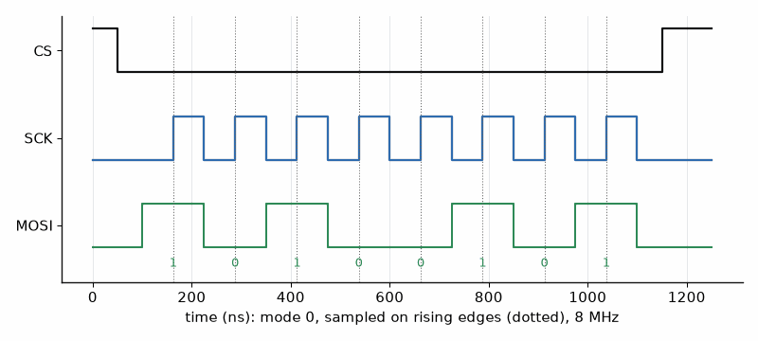
Figure 10.1 — An SPI mode 0 transfer of the byte 0xA5 (1010 0101), most significant bit first. Chip select goes low, the controller puts each bit on MOSI while the clock is low, and both sides sample on the rising edge; eight clocks later chip select goes high. At 8 MHz the byte takes 1 µs.
Listing 10.1 — The SSD1306 OLED over SPI, with a frame-rate measurement (MicroPython).
# MicroPython on the ESP32-S3: SSD1306 128x64 OLED over SPI at 8 MHz,
# using the ssd1306 driver module from micropython-lib.
from machine import Pin, SPI
import time
import ssd1306
spi = SPI(1, baudrate=8_000_000, polarity=0, phase=0, # SPI mode 0
sck=Pin(12), mosi=Pin(11))
oled = ssd1306.SSD1306_SPI(128, 64, spi, dc=Pin(13), res=Pin(14), cs=Pin(10))
frames = 0
t0 = time.ticks_ms()
while True:
oled.fill(0)
oled.text("BME280 node", 0, 0)
oled.text("T 23.41 C", 0, 16)
oled.text("frame %d" % frames, 0, 32)
oled.show() # sends the 1024-byte frame buffer
frames += 1
if frames % 100 == 0:
dt = time.ticks_diff(time.ticks_ms(), t0)
print("%.1f frames/s" % (100_000 / dt))
t0 = time.ticks_ms()

Worked Example 10.1: I2C or SPI for the OLED?
Problem. The SSD1306 OLED has a 1024-byte frame buffer (128 × 64 pixels, 1 bit each). Estimate the time to send a full frame over I2C at 400 kHz and over SPI at 8 MHz, and the CPU load of a 10 frames per second animation in each case if the CPU waits for the transfer.
Solution. Over I2C every byte costs 9 clocks, so 1024 bytes are 9216 clocks, 23.0 ms at 400 kHz, plus a few bytes of address and control: about 23 ms, or at most about 43 frames per second. Over SPI each byte is 8 clocks: 8192 clocks at 8 MHz is 1.02 ms. At 10 frames per second a waiting CPU spends 230 ms per second on I2C, 23 %, and 10 ms per second on SPI, 1 %. With DMA (Chapter 11) the SPI transfer costs almost no CPU at all. The SSD1306 accepts SPI clocks up to about 10 MHz; above that, bits are lost.

10.2 CAN: the robust bus
CAN was designed for cars and is now everywhere machines are: robots, e-bikes, industrial controls, and drones. Two wires carry a differential signal through a transceiver chip, so the bus tolerates meters of cable and electrical noise (the transceiver and termination are Books 2 and 7's). There are no addresses: each frame carries an 11-bit identifier that names the message, not the sender, and every node hears every frame. The identifier also sets priority, because when two nodes start together the lower identifier wins arbitration bit by bit without destroying either frame. Every frame carries a 15-bit CRC, and every node checks it and acknowledges it.
Firmware for CAN has three parts: the bit timing, the message filters (so a node handles only the identifiers it cares about), and the payload layout. Classic CAN carries up to 8 data bytes; CAN FD up to 64 and faster data phases. The ESP32-S3's CAN controller is called TWAI; STM32 parts have bxCAN or FDCAN; the RP2040 has none, but a Pico can use an external SPI CAN controller.

Worked Example 10.2: CAN timing and bus load
Problem. A bus runs at 500 kbit/s. Find the bit time and a 16-time-quantum bit with an 87.5 % sample point. A classic frame with an 11-bit ID and 8 data bytes has 108 bits plus 3 bits of interframe space, and stuffing can add up to 24 bits. Find the frame time and the bus load of 100 such frames per second.
Solution. The bit time is 1/500 000 = 2 µs, so one quantum is 125 ns. A sample point at 87.5 % means 14 quanta before it (1 sync, 13 propagation and phase-1) and 2 after it (phase 2). The frame takes 111 to 135 bits, 222 to 270 µs. One hundred frames per second occupy 22 to 27 ms of every second: 2.2 to 2.7 % bus load. Designers keep total load well under about 50 %, so that high-priority frames never wait long behind others.
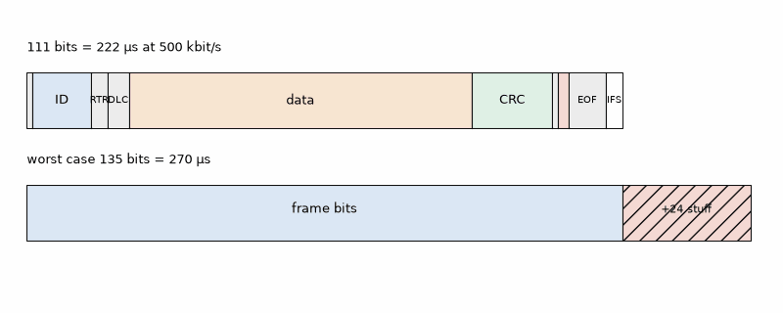
Figure 10.2 — Anatomy of a classic CAN data frame with an 11-bit identifier and 8 data bytes (Worked Example 10.2): start of frame, identifier, control bits, 64 data bits, 15-bit CRC, delimiters, acknowledge, end of frame, and interframe space, 111 bits in all, up to 135 with worst-case bit stuffing. At 500 kbit/s that is 222 to 270 µs.
Listing 10.2 — Packing temperature, humidity, and pressure into an 8-byte CAN payload with explicit byte order (C, runs on the PC).
// Packing reader-lab values into an 8-byte classic CAN payload, and back.
// Layout (little-endian): temp int16 0.01 degC | hum uint16 0.01 % | press uint32 Pa.
#include <stdint.h>
#include <stdio.h>
static void put_u16(uint8_t *p, uint16_t v) { p[0] = (uint8_t)v; p[1] = (uint8_t)(v >> 8); }
static void put_u32(uint8_t *p, uint32_t v) { put_u16(p, (uint16_t)v); put_u16(p + 2, (uint16_t)(v >> 16)); }
static uint16_t get_u16(const uint8_t *p) { return (uint16_t)(p[0] | (p[1] << 8)); }
static uint32_t get_u32(const uint8_t *p) { return get_u16(p) | ((uint32_t)get_u16(p + 2) << 16); }
static void env_pack(uint8_t out[8], int16_t t_x100, uint16_t h_x100, uint32_t p_pa)
{
put_u16(out, (uint16_t)t_x100);
put_u16(out + 2, h_x100);
put_u32(out + 4, p_pa);
}
int main(void)
{
uint8_t frame[8];
env_pack(frame, -523, 4520, 101325); // -5.23 degC, 45.20 %, 1013.25 hPa
for (int i = 0; i < 8; i++) printf("%02X ", frame[i]);
printf("\n");
int16_t t = (int16_t)get_u16(frame);
printf("T %.2f C, H %.2f %%, P %.2f hPa\n", t / 100.0, get_u16(frame + 2) / 100.0,
get_u32(frame + 4) / 100.0);
return 0;
}
Listing 10.2 shows the payload rule from Chapter 3: never send a struct, send bytes in a documented order. The node writes little-endian, scaled integers; Listing 10.3, on the PC, unpacks them with the same layout. The identifier, the layout, and the scaling belong in a short message table in the spec, often kept as a DBC file that analysis tools can read.
Listing 10.3 — Decoding the node's frames on a PC or a Pi 5 with python-can (Python).
"""PC side of the CAN link with python-can: decode the node's 0x120 frames.
Works with SocketCAN on Linux or the Pi 5, or a USB-CAN adapter on Windows."""
import struct
import can
ENV_ID = 0x120
with can.Bus(interface="socketcan", channel="can0", bitrate=500_000) as bus:
for msg in bus: # iterates forever, one frame at a time
if msg.arbitration_id != ENV_ID or msg.dlc != 8:
continue
t, h, p = struct.unpack("<hHI", msg.data) # little-endian, as packed on the node
print(f"{msg.timestamp:.3f} T {t / 100:.2f} C H {h / 100:.2f} % P {p / 100:.2f} hPa")

10.3 USB
USB connects a board to a PC with a protocol stack in both. A full-speed USB device such as the RP2040 or the ESP32-S3's USB port signals at 12 Mbit/s. Firmware chooses a device class, and the PC loads a matching driver without any installation: CDC-ACM for a virtual serial port, HID for keyboards, mice, and game controllers, MSC for a drive (the Pico's BOOTSEL drive is one), and MIDI or audio for instruments. The TinyUSB stack, used by the Pico SDK and ESP-IDF, implements all of them.
A CDC virtual serial port looks like a UART to the PC program, but the baud rate you set is ignored: data moves in USB packets at the bus speed. That is why a Pico prints faster over USB than over its UART, and why a C# or Python program that sets 115 200 baud still works if the firmware ignores it. Full-speed bulk transfers carry at most 19 packets of 64 bytes per 1 ms frame, 1.2 MB/s in theory; real throughput depends on the host and the firmware.
Key idea. Choose the bus by distance and speed: I2C for slow sensors on the same board, SPI for fast peripherals on the same board, UART for simple point-to-point links and modules, CAN for robust multi-node links across a machine, USB for the PC.
On the Job
Automotive and industrial firmware engineers live with CAN. A typical task: add a new message to a vehicle's CAN database, implement its packing in the node's firmware, filter it in two other nodes, and prove with a bus logger that load and latency stay within the system spec at the worst case, with every node transmitting.
AI Pair-Programming Note
Generated SPI code often uses the wrong mode, MSB-first where the device wants LSB-first, or a clock far above the device's maximum. Generated CAN code often leaves out the transceiver's standby pin, mixes up 11-bit and 29-bit identifiers, or packs structs directly. Check the mode and clock against the data sheet's timing diagram, and decode the bus with an analyzer.
From the Bench
A CAN bus needs exactly two 120 Ω terminations, one at each end. Measure between CAN-H and CAN-L with the power off: 60 Ω is right, 120 Ω means one terminator is missing, and 40 Ω means there is one too many. Most "CAN doesn't work" reports end at that measurement.

Practice
1. (Core) Name the four SPI lines and what CPOL = 1, CPHA = 1 means.
2. (Core) How long does a 512-byte SD-card block take over SPI at 20 MHz, ignoring commands?
3. (Core) What is the bit time at 250 kbit/s, and how long is the worst-case 135-bit frame?
4. (Core) Pack 21.50 °C (int16, 0.01 °C) into two little-endian bytes.
5. (Extension) A display needs 240 × 240 pixels at 16 bits each per frame. What SPI clock allows 30 frames per second, ignoring overhead?
6. (Extension) Two nodes start sending at the same moment with identifiers 0x120 and 0x0F0. Which wins arbitration, and what happens to the other frame?
7. (Extension) Why does setting 9600 baud on a Pico's USB serial port not slow it down?
8. (Challenge) A robot has 6 motor controllers each sending a 8-byte status frame at 200 Hz, and an IMU sending 8-byte frames at 1 kHz, on a 500 kbit/s bus. Find the worst-case load. Is it acceptable, and what would you change if more nodes were added?

What You’ll Actually Use
Everyday working tools
- SPI modes from the data sheet's timing diagram; maximum clock from the data sheet.
- Frame-time and bus-load arithmetic for CAN.
- Explicit byte order and scaling in every payload; a message table in the spec.
- USB CDC for consoles, HID for input devices, TinyUSB as the stack.
- The 60 Ω termination check.
Mostly for exams and deeper study
- CAN error-confinement states and the details of USB enumeration; the stacks handle them, and you read about them when debugging.

Chapter 11. Register Level versus HAL
HAL_GPIO_TogglePin(GPIOA, GPIO_PIN_5) is one line of C. Underneath, it reads a register, flips a bit, and writes a 32-bit value to an address that the reference manual calls GPIOA_BSRR, 0x40020018. One day the library call will be too slow, will not exist for the feature you need, or will hide a bug, and on that day the reference manual and its register tables are the only documentation that is never wrong. This chapter goes down one layer, and then explains why you will usually come back up.
Where you meet this: Every vendor HAL, every "why is this pin not toggling", every peripheral feature the library does not expose, and every job interview that asks what volatile is for.

11.1 The layers
Firmware sits on a stack of layers. At the bottom are the peripheral registers: memory addresses where reading or writing bits controls the hardware. Above them, a thin layer of definitions turns addresses into names; for Arm chips that is CMSIS, the vendor's header files that define structs such as GPIOA->BSRR. Above that, the vendor's hardware abstraction layer, ST's HAL and LL, the Pico SDK's hardware_ functions, Espressif's drivers, wraps sequences of register writes into functions with checking. Your drivers and your application sit on top. The Arduino framework and MicroPython add one more layer above the vendor's.
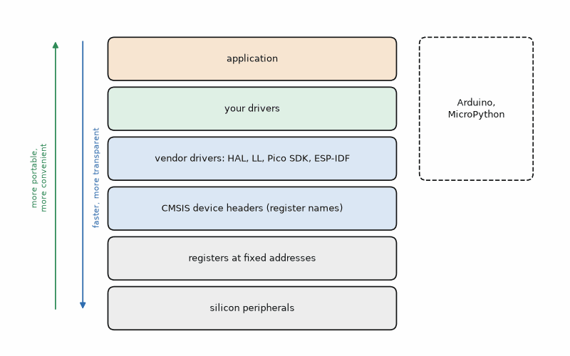
Figure 11.1 — The firmware layer stack, from silicon to application. Each layer up adds portability and convenience and costs some speed and transparency. The register layer is documented in the chip's reference manual; every layer above it is software you can read.

11.2 Reading a register map
A reference manual describes each peripheral by a base address and a list of registers at offsets from it. For the STM32F411's GPIO port A the base is 0x40020000. MODER, at offset 0x00, holds two mode bits per pin. ODR, at 0x14, is the output data. BSRR, at 0x18, is the bit set/reset register: writing 1 to bit n (0 to 15) sets pin n, writing 1 to bit n + 16 resets it, and zeros do nothing. It exists so that one write changes some pins without reading or disturbing the others, which makes it safe even if an interrupt changes another pin of the same port at the same time.
Listing 11.1 — Register-level blink on an STM32F411: enable the port clock, set the mode bits, and write BSRR (C).
// Register-level blink on an STM32F411 Nucleo (LED LD2 on PA5), no HAL.
// Addresses from the STM32F411 reference manual (RM0383).
#include <stddef.h>
#include <stdint.h>
typedef struct {
volatile uint32_t MODER, OTYPER, OSPEEDR, PUPDR, IDR, ODR, BSRR, LCKR, AFR[2];
} gpio_regs_t;
_Static_assert(offsetof(gpio_regs_t, BSRR) == 0x18, "BSRR must be at offset 0x18");
#define RCC_AHB1ENR (*(volatile uint32_t *)0x40023830u)
#define GPIOA ((gpio_regs_t *)0x40020000u)
#define LED_PIN 5u
static void delay(volatile uint32_t n) { while (n--) { } }
int main(void)
{
RCC_AHB1ENR |= 1u << 0; // clock the GPIOA block first
GPIOA->MODER = (GPIOA->MODER & ~(3u << (LED_PIN * 2))) // 2 mode bits per pin
| (1u << (LED_PIN * 2)); // 01 = general-purpose output
for (;;) {
GPIOA->BSRR = 1u << LED_PIN; // set PA5: one write, no read
delay(400000);
GPIOA->BSRR = 1u << (LED_PIN + 16); // reset PA5
delay(400000);
}
}

Worked Example 11.1: One write, two pins
Problem. Find the single BSRR value that sets PA5 and resets PA6. Why is it safer than ODR |= (1 << 5); ODR &= ~(1 << 6);?
Solution. Setting PA5 needs bit 5: 0x0000 0020. Resetting PA6 needs bit 6 + 16 = 22: 0x0040 0000. Together: 0x0040 0020. The two ODR statements each read ODR, modify it, and write it back. If an interrupt between the read and the write changes another pin of port A, the main code's write restores the old value and undoes the interrupt's change. The BSRR write has no read, so there is nothing to undo, and both pins change in the same clock cycle.
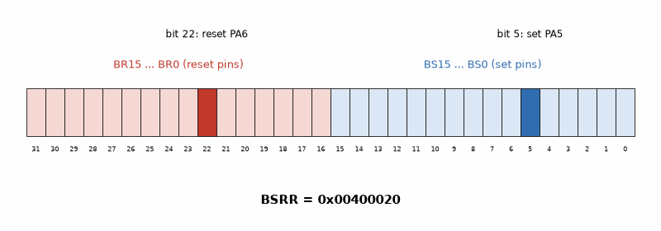
Figure 11.2 — The STM32 BSRR register for Worked Example 11.1. The low half (BS0 to BS15) sets pins, the high half (BR0 to BR15) resets them; writing 0x0040 0020 sets bit 5 (set PA5) and bit 22 (reset PA6).

11.3 The HAL, honestly
The HAL version of the same blink, Listing 11.2, is longer to set up and shorter to read. It enables the clock with a named macro, configures the pin with a struct that names every option, and toggles with a function. It is portable across the STM32 family, CubeMX generates most of it, and colleagues can read it without the reference manual. Its costs are a little speed and code size, and a habit of hiding things: HAL_Delay depends on the SysTick interrupt, so calling it inside an interrupt handler of higher priority hangs forever.
Listing 11.2 — The same blink with the STM32 HAL (C).
// The same blink with the STM32 HAL (as generated by STM32CubeIDE, trimmed).
#include "stm32f4xx_hal.h"
int main(void)
{
HAL_Init(); // SysTick at 1 kHz, flash settings
__HAL_RCC_GPIOA_CLK_ENABLE();
GPIO_InitTypeDef io = {0};
io.Pin = GPIO_PIN_5;
io.Mode = GPIO_MODE_OUTPUT_PP;
io.Pull = GPIO_NOPULL;
io.Speed = GPIO_SPEED_FREQ_LOW;
HAL_GPIO_Init(GPIOA, &io);
for (;;) {
HAL_GPIO_TogglePin(GPIOA, GPIO_PIN_5);
HAL_Delay(500); // ms, from the SysTick counter
}
}
The RP2040 shows the other side of the argument. Its SDK's gpio_put is an inline function that compiles to one write to the single-cycle I/O block (SIO) at 0xd0000000, so there is nothing to gain by bypassing it, and its sio_hw struct gives direct access when you want two pins to change in the same cycle, as Listing 11.3 does with the toggle register.
Listing 11.3 — The Pico SDK's gpio_put and the SIO set, clear, and toggle registers it uses (C).
// RP2040: the SDK call and the register write it becomes (Pico SDK).
// sio_hw points at the single-cycle I/O block at 0xd0000000.
#include "pico/stdlib.h"
#include "hardware/structs/sio.h"
#define PIN_A 2
#define PIN_B 3
int main(void)
{
gpio_init(PIN_A);
gpio_init(PIN_B);
gpio_set_dir(PIN_A, GPIO_OUT);
gpio_set_dir(PIN_B, GPIO_OUT);
const uint32_t mask = (1u << PIN_A) | (1u << PIN_B);
for (;;) {
gpio_put(PIN_A, 1); // SDK: inline function writing the SIO set register
sio_hw->gpio_clr = 1u << PIN_A;// direct: GPIO_OUT_CLR at offset 0x018
sio_hw->gpio_togl = mask; // both pins flip in the same cycle
}
}

Worked Example 11.2: How fast can a pin toggle?
Problem. A disassembly shows that a register-level toggle loop on a 125 MHz RP2040 takes 4 cycles per iteration, and a loop calling a non-inline library function takes 24 cycles. Find the toggle rates and the resulting square-wave frequencies.
Solution. 125 MHz/4 = 31.25 million toggles per second; a square wave needs two toggles per period, so 15.6 MHz. With 24 cycles: 5.2 million toggles per second, a 2.6 MHz square wave. A factor of six matters for bit-banging a protocol; it does not matter for an LED. For anything faster or more regular, the RP2040's PIO state machines or a hardware peripheral generate the waveform without the CPU. The method's step 6 applies: measure the pin on a scope rather than trusting cycle counts, because flash wait states and interrupts change them.

11.4 DMA: letting the hardware copy
Direct memory access is a peripheral that copies data between memory and other peripherals without the CPU. Firmware configures a source, a destination, a length, and a trigger, such as "SPI transmit buffer empty", and the DMA controller moves each byte when the trigger fires, interrupting the CPU only when the whole transfer is done. It is how a display refreshes, an ADC streams samples at a steady rate, and a UART receives a burst while the CPU sleeps.

Worked Example 11.3: What DMA buys the OLED
Problem. The OLED frame of Worked Example 10.1 takes 1.02 ms over SPI at 8 MHz. At 30 frames per second, what fraction of the CPU does a waiting transfer use, and what does DMA leave?
Solution. 30 × 1.02 ms = 30.7 ms per second, 3.1 % of the CPU spent waiting. With DMA the CPU spends a few microseconds per frame starting the transfer and handling the completion interrupt, roughly 0.01 %. The catch is that the frame buffer must not be changed while the DMA reads it: draw into a second buffer and swap when the completion interrupt arrives (double buffering). On the ESP32-S3, the SPI master driver uses DMA automatically for large transfers, and the buffer must be in DMA-capable internal RAM.
Key idea. Use the HAL by default and the registers on purpose: for speed, for features the HAL lacks, or to understand what the HAL is doing. Either way, the reference manual is the authority.
Common misconception. Register-level code is always faster. Modern SDK functions are often inline and compile to the same single write; the speed gain is real only in tight loops that call non-inline functions, and the maintenance cost is paid on every future change.
AI Pair-Programming Note
Register addresses and bit positions are where assistants are least reliable: they confidently produce offsets from a different chip family or a different peripheral. Check every address and bit against the reference manual, and prefer the vendor's header names (GPIOA->BSRR) over raw numbers, so the compiler checks the names.
From the Bench
When a peripheral does nothing at all, check its clock enable first. On STM32 parts every peripheral's clock is off after reset, and writes to an unclocked peripheral's registers are ignored. In a debugger, read the register back: if it still shows the reset value after your write, the clock is off.

Practice
1. (Core) What BSRR value resets PA0 and PA1 and sets PA15?
2. (Core) Which register would you write on the RP2040 to flip pins 2 and 3 in one cycle, and at what address?
3. (Core) Write the two lines that set PA7 to output mode (MODER value 01) without disturbing other pins.
4. (Core) A loop takes 8 cycles at 80 MHz per toggle. What square-wave frequency does it produce?
5. (Extension) Explain how ODR read-modify-write can lose an interrupt's change, with a timeline of three steps.
6. (Extension) A UART receives 64-byte bursts at 921 600 baud. With an interrupt per byte at 1.5 µs each, what is the CPU load during a burst? What does DMA change?
7. (Extension) Why does HAL_Delay hang when called inside a high-priority interrupt handler?
8. (Challenge) An ADC must sample at exactly 48 kHz into a 512-sample buffer while the CPU processes the previous buffer. Describe the timer, ADC, and DMA configuration, and how the CPU knows which half to process.

What You’ll Actually Use
Everyday working tools
- Base address plus offset; bit fields from the reference manual.
- Atomic set and reset registers (BSRR, SIO set/clear/xor) instead of read-modify-write.
- Clock enable first, and read back to confirm.
- DMA with double buffering or circular half-transfer interrupts.
Mostly for exams and deeper study
- Writing a whole HAL of your own; you will read one more often than you write one.

Part III. Structure, Time, and Energy
Part III is about how firmware is organized, rather than what it talks to. It starts with the loop and the state machine that most small products use, moves to a real-time operating system for the products that outgrow them, then makes the device sleep, makes its arithmetic fast without floating point, and ends by fusing several imperfect sensors into one good estimate.

Chapter 12. Super Loops and State Machines
The wildlife camera took 400 photographs of one deer. Each motion event started another capture, including while the previous image was being saved. The card filled; the battery followed. The missing rule was simple: ignore motion during a 30-second cooldown. Five states—SLEEP, CAPTURE, SAVE, COOLDOWN, and LOWBATT—and their transitions make that rule explicit. The switch statement is short. In the field, it is the difference between one useful photograph and a record of repeated failure.
Where you meet this: Every product with modes: chargers, thermostats, vending machines, protocol handlers, menu systems, robots, and every bug report that starts "but it only happens if you press the button while it's saving".

12.1 The super loop
The simplest firmware structure is an initialization followed by an endless loop that calls each job in turn: read the sensors, update the logic, refresh the display, check the buttons. It needs no operating system, it is easy to follow, and for many products it is the right answer. It has one rule: no job may block. A job that waits, for a sensor, a network, or a delay, delays every other job, and the slowest job sets the response time of all of them.
The cure is to let each job run briefly and often: check whether it is time to do something, do a small piece of work, and return. Listing 12.1 runs three jobs at 5 ms, 500 ms, and 1 s intervals, each with its own timestamp and the wraparound-safe test of Chapter 3. Nothing in it calls delay().
Listing 12.1 — Three jobs at three rates in one non-blocking loop (Arduino framework, C++).
// Arduino framework (ESP32-S3): three jobs at three rates, none of them blocking.
#include <Arduino.h>
const int LED_PIN = 4;
const int BUTTON_PIN = 14;
unsigned long lastBlink = 0, lastSample = 0, lastReport = 0;
int presses = 0;
bool ledOn = false, lastButton = true;
void setup() {
pinMode(LED_PIN, OUTPUT);
pinMode(BUTTON_PIN, INPUT_PULLUP);
Serial.begin(115200);
}
void loop() {
unsigned long now = millis();
if (now - lastSample >= 5) { // every 5 ms: sample the button
lastSample = now;
bool b = digitalRead(BUTTON_PIN);
if (lastButton && !b) presses++; // falling edge (debounce as in Chapter 6)
lastButton = b;
}
if (now - lastBlink >= 500) { // every 500 ms: heartbeat LED
lastBlink = now;
ledOn = !ledOn;
digitalWrite(LED_PIN, ledOn);
}
if (now - lastReport >= 1000) { // every second: report
lastReport = now;
Serial.printf("presses: %d\n", presses);
}
}

Worked Example 12.1: The slowest job sets the latency
Problem. A super loop reads the BME280 (2 ms), runs the control logic (5 ms), and redraws the whole OLED over I2C (12 ms, a partial update). The button is sampled once per loop, and the debouncer needs 4 equal samples. Find the worst-case button latency. The spec says 50 ms. Fix it.
Solution. One loop takes 2 + 5 + 12 = 19 ms. Four samples at one per loop take up to 4 × 19 = 76 ms, plus up to one more loop before the first sample: up to 95 ms. That fails the spec. The fix is to split the slow job: redraw one of the OLED's eight 128 × 8-pixel pages per loop, about 1.5 ms each, so the loop takes 2 + 5 + 1.5 = 8.5 ms. The latency becomes at most 5 × 8.5 = 42.5 ms, and the full display still refreshes every 68 ms, about 15 times per second. Splitting the work fixed the timing without an operating system.
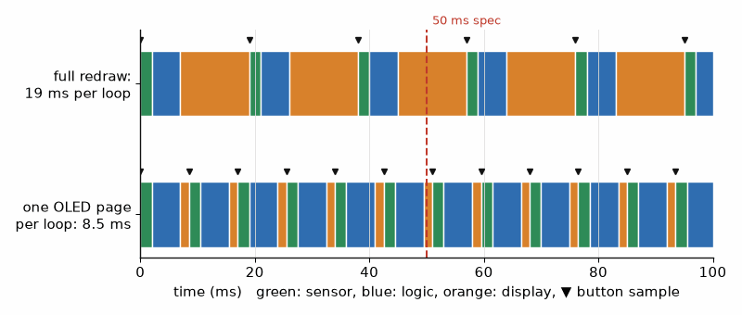
Figure 12.1 — Super-loop timelines for Worked Example 12.1. Top: with a 12 ms full OLED redraw, each loop takes 19 ms and the button is sampled every 19 ms, so a debounced press can take up to 95 ms. Bottom: redrawing one page per loop shortens the loop to 8.5 ms and the worst-case latency to 42.5 ms, within the 50 ms spec.

12.2 State machines
A state machine describes behavior as a set of states, the events that can happen, and for each state and event, the next state and the action to take. It makes two things visible that ordinary code hides: what the device does in every combination of mode and input, including the awkward ones, and which inputs are deliberately ignored. The drawing comes first, as part of the spec; the code follows the drawing one-to-one.
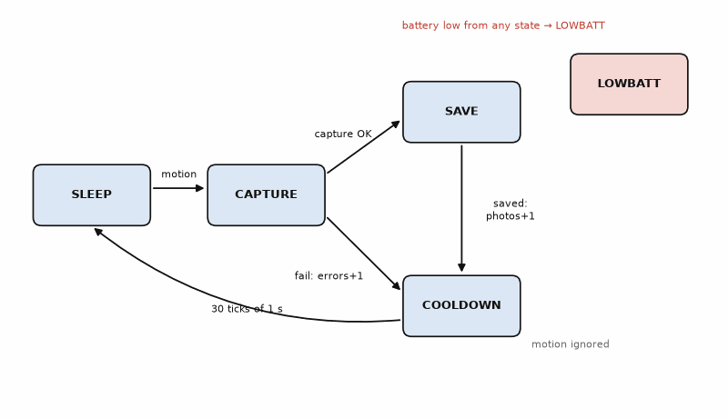
Figure 12.2 — The wildlife camera's state machine. Motion wakes it from SLEEP to CAPTURE; a good photo goes to SAVE and then COOLDOWN for 30 s, during which motion is ignored; a failed capture counts an error and also cools down; a low-battery event from any state ends in LOWBATT.
In C, the simplest implementation is an enum for the states, an enum for the events, and one function with a switch on the current state. Listing 12.2 is exactly the drawing. Because the function only changes a struct, it runs on the PC with a scripted list of events, which is the method's step 5: the test feeds a motion event during cool-down and checks that it is ignored, then ticks 30 seconds and checks that the camera sleeps again.
Listing 12.2 — The camera state machine as a switch on the current state, with a scripted PC test (C).
// Wildlife-camera state machine: pure logic, driven by events, tested on the PC.
#include <stdio.h>
typedef enum { ST_SLEEP, ST_CAPTURE, ST_SAVE, ST_COOLDOWN, ST_LOWBATT } state_t;
typedef enum { EV_MOTION, EV_CAPTURE_OK, EV_CAPTURE_FAIL, EV_SAVED, EV_TICK_1S, EV_BATT_LOW } event_t;
#define COOLDOWN_S 30
typedef struct { state_t st; int cooldown_left; int photos; int errors; } cam_t;
static const char *NAMES[] = { "SLEEP", "CAPTURE", "SAVE", "COOLDOWN", "LOWBATT" };
static void cam_handle(cam_t *c, event_t ev)
{
if (ev == EV_BATT_LOW) { c->st = ST_LOWBATT; return; } // from any state
switch (c->st) {
case ST_SLEEP:
if (ev == EV_MOTION) c->st = ST_CAPTURE; // action: start camera
break;
case ST_CAPTURE:
if (ev == EV_CAPTURE_OK) c->st = ST_SAVE;
else if (ev == EV_CAPTURE_FAIL) { c->errors++; c->st = ST_COOLDOWN; c->cooldown_left = COOLDOWN_S; }
break;
case ST_SAVE:
if (ev == EV_SAVED) { c->photos++; c->st = ST_COOLDOWN; c->cooldown_left = COOLDOWN_S; }
break;
case ST_COOLDOWN: // motion is ignored here
if (ev == EV_TICK_1S && --c->cooldown_left == 0) c->st = ST_SLEEP;
break;
case ST_LOWBATT: // stays until reset
break;
}
}
int main(void)
{
cam_t c = { ST_SLEEP, 0, 0, 0 };
const event_t script[] = { EV_MOTION, EV_CAPTURE_OK, EV_SAVED, EV_MOTION };
for (unsigned i = 0; i < sizeof script / sizeof script[0]; i++) cam_handle(&c, script[i]);
printf("after photo + motion in cooldown: %s, photos %d\n", NAMES[c.st], c.photos);
for (int s = 0; s < COOLDOWN_S; s++) cam_handle(&c, EV_TICK_1S);
printf("after 30 ticks: %s\n", NAMES[c.st]);
cam_handle(&c, EV_BATT_LOW);
printf("after low battery: %s\n", NAMES[c.st]);
return (c.photos == 1 && c.st == ST_LOWBATT) ? 0 : 1;
}

Worked Example 12.2: From drawing to test cases
Problem. List the test cases that cover every arrow of Figure 12.2 at least once, and the one ignored input that matters most.
Solution. Seven arrows, seven cases: (1) SLEEP + motion → CAPTURE; (2) CAPTURE + OK → SAVE; (3) CAPTURE + fail → COOLDOWN with errors = 1; (4) SAVE + saved → COOLDOWN with photos = 1; (5) COOLDOWN + 30 ticks → SLEEP, and 29 ticks are not enough; (6) battery low from at least two different states → LOWBATT; (7) COOLDOWN + motion → still COOLDOWN, and the count of remaining seconds is unchanged. Case 7 is the deer bug from the opening; it gets its own test because it is the requirement most likely to break when someone later "improves" the code. Listing 12.2 runs cases 2, 4, 5, 6, and 7.
Key idea. Draw the states before writing the code. A state machine turns a vague behavior into a finite list of cases, and a finite list of cases can be tested completely on the PC.
Common misconception. State machines are for complicated protocols only. A button with short and long presses, a charger with four phases, and a menu with three screens are all state machines; writing them as one is shorter than the nest of flags it replaces.
AI Pair-Programming Note
Ask the assistant for the state table first, as text, before any code: "list every state, event, next state, and action, including events that are ignored". Review the table against the spec; then ask for the code that implements exactly that table, plus the test sequence. Assistants are good at this when the table is fixed first and poor at inventing the behavior.
From the Bench
Log every state change with a timestamp: "12:03:07.214 SLEEP -> CAPTURE (motion)". One line per transition costs almost nothing, and when a field unit misbehaves, the log tells you exactly which path it took. Keep the last 100 transitions in a RAM ring buffer, and dump it after a watchdog reset (Chapter 24).

Practice
1. (Core) A super loop has jobs of 1, 3, and 8 ms. What is the longest a button press can wait for its first sample?
2. (Core) Rewrite "blink the LED every 250 ms" so it does not block, in three lines of C using millis().
3. (Core) Name the states of a phone charger: not connected, charging, full, fault. Which events move between them?
4. (Core) In Listing 12.2, what happens to a motion event that arrives in SAVE?
5. (Extension) The 8 ms job of Problem 1 is split into 4 equal pieces. Find the new loop time and the debounced worst-case latency with 4 samples.
6. (Extension) Add a SETUP state to the camera that is entered by a long button press from SLEEP and left by another long press. Write the two new rows of the state table.
7. (Extension) Why is it easier to test a state machine that takes events as parameters than one that reads GPIO pins inside its switch statement?
8. (Challenge) A garage door controller has states CLOSED, OPENING, OPEN, CLOSING, and STOPPED, a button, two limit switches, and an obstacle sensor. Draw its state table, including what the button does in each state, and identify the one transition that matters most for safety.

What You’ll Actually Use
Everyday working tools
- Non-blocking jobs with their own timestamps; the slowest job sets the latency.
- Splitting long jobs into small slices.
- State tables drawn before code, switch-based implementations, and PC tests for every arrow.
- A transition log with timestamps.
Mostly for exams and deeper study
- Hierarchical state machines and UML statechart notation; useful in large systems, rarely needed in small ones.

Chapter 13. FreeRTOS: Tasks, Queues, and Real Time
On 4 July 1997 the Mars Pathfinder lander touched down, and within days it began resetting itself. Engineers reproduced a priority inversion: a low-priority task held a shared resource, a high-priority task waited for it, and medium-priority tasks kept the low one from running. The watchdog saw the missed deadline and reset the computer. Enabling priority inheritance on the mutex fixed the fault; the change was uploaded from Earth. The fix fit in one configuration flag. The investigation did not. A real-time operating system makes concurrent work easier to organize and gives timing failures more places to hide.
Where you meet this: ESP-IDF (FreeRTOS is always running underneath it), most STM32 projects beyond a blink, drones, audio, network stacks, and any product with more than three things to do at different rates.

13.1 Tasks and the scheduler
A task is a function with its own stack that runs as if it had the CPU to itself. The scheduler decides which task runs: in FreeRTOS, always the highest-priority task that is ready, and among equal priorities, each in turn at every tick. A task that waits, for a delay, a queue, or a semaphore, is blocked and uses no CPU, so lower-priority tasks run. That is the big gain over the super loop: a slow job no longer delays a fast one, because the fast one has a higher priority and preempts it.
The tick is a periodic interrupt that drives time in the RTOS. ESP-IDF's default is 100 Hz, a 10 ms tick; many STM32 projects use 1000 Hz. Delays are counted in ticks, so their resolution is one tick, a fact that Worked Example 13.2 turns into a bug.
Schedulable on paper, measured on the board
CPU-load arithmetic and a first stack allocation are estimates. Wi-Fi, formatted logging, interrupt nesting, and SDK changes can alter the observed workload; repeat the measurements in Worked Example 13.3 and the bench check under peak product conditions. A measured high-water mark is evidence about the tested paths, not a guarantee about paths you did not run.
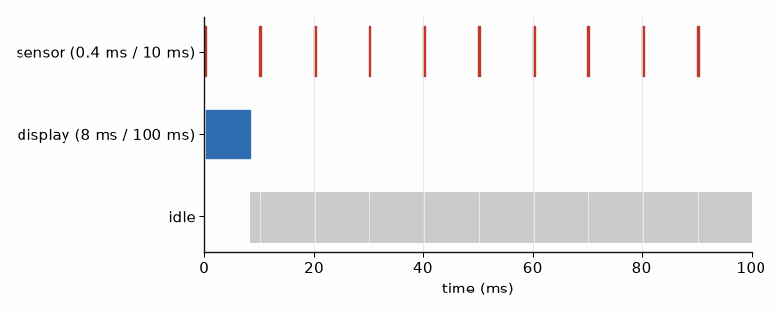
Figure 13.1 — A FreeRTOS schedule over 100 ms for the tasks of Worked Example 13.1. The sensor task (highest priority, 0.4 ms every 10 ms) preempts the display task (8 ms every 100 ms) whenever it becomes ready; the idle task fills the rest. Total load 12.1 %.

Worked Example 13.1: Is the task set schedulable?
Problem. The weather node has a sensor task (0.4 ms every 10 ms), a display task (8 ms every 100 ms), and a LoRa task (60 ms every 60 s). Find the total CPU load and compare it with the rate-monotonic bound for three tasks, n(2^(1/n) − 1).
Solution. Loads: 0.4/10 = 4 %, 8/100 = 8 %, 60/60 000 = 0.1 %; total 12.1 %. The bound for three tasks is 3(2^(1/3) − 1) = 0.780, so 78 %. With priorities assigned by rate (fastest period, highest priority), every task meets its deadline when the total is under the bound, and 12.1 % is far under it. The bound is sufficient, not necessary; above it, a timeline like Figure 13.1 decides. The numbers come from measurement: toggle a GPIO in each task and read the durations with a logic analyzer.

13.2 Queues and semaphores
Tasks must exchange data without the races of Chapter 3. A queue copies fixed-size items from a producer to a consumer, and a consumer that waits on an empty queue blocks without using CPU. A binary semaphore signals that something happened, for example from an ISR to a task. A mutex protects a shared resource, such as an I2C bus used by two tasks. FreeRTOS mutexes provide priority inheritance: while a high-priority task waits, the holder temporarily runs at that priority. That is the Pathfinder fix. In a weather node, the same delay can leave a sensor task holding the bus while the next radio report becomes due. If the report does not carry a sample timestamp or age limit, yesterday's humidity can pass for current data.
Listing 13.1 — A sensor task feeding a display task through a queue, with a fixed-rate delay, a receive timeout, and a stack check (ESP-IDF, C).
// Two FreeRTOS tasks and a queue on the ESP32-S3 (ESP-IDF 5.x): the sensor task
// produces readings every 100 ms, the display task consumes them.
#include <stdint.h>
#include "freertos/FreeRTOS.h"
#include "freertos/queue.h"
#include "freertos/task.h"
#include "esp_log.h"
typedef struct { int32_t t_x100; uint32_t seq; } reading_t;
static const char *TAG = "rtos";
static QueueHandle_t q;
static void sensor_task(void *arg)
{
TickType_t next = xTaskGetTickCount();
uint32_t seq = 0;
for (;;) {
reading_t r = { .t_x100 = 2341, .seq = seq++ }; // stand-in for the BME280 read
if (xQueueSend(q, &r, 0) != pdTRUE) // never block the producer
ESP_LOGW(TAG, "queue full, reading %lu dropped", (unsigned long)r.seq);
vTaskDelayUntil(&next, pdMS_TO_TICKS(100)); // fixed rate, no drift
}
}
static void display_task(void *arg)
{
reading_t r;
for (;;) {
if (xQueueReceive(q, &r, pdMS_TO_TICKS(1000)) != pdTRUE) {
ESP_LOGW(TAG, "no reading for 1 s"); // spec: detect a dead sensor task
continue;
}
ESP_LOGI(TAG, "#%lu %ld.%02ld C", (unsigned long)r.seq,
(long)(r.t_x100 / 100), (long)(r.t_x100 % 100));
if (r.seq % 50 == 0) // stack check every 5 s
ESP_LOGI(TAG, "display stack free: %u bytes",
(unsigned)uxTaskGetStackHighWaterMark(NULL));
}
}
void app_main(void)
{
q = xQueueCreate(16, sizeof(reading_t));
// ESP-IDF stack sizes are in bytes; higher number = higher priority
xTaskCreate(sensor_task, "sensor", 3072, NULL, 6, NULL);
xTaskCreate(display_task, "display", 4096, NULL, 4, NULL);
}

Worked Example 13.2: The 5 ms delay that is zero
Problem. At the ESP-IDF default tick of 100 Hz, what do vTaskDelay(pdMS_TO_TICKS(5)) and vTaskDelay(pdMS_TO_TICKS(15)) actually wait? What about 25 ms?
Solution. pdMS_TO_TICKS multiplies by 100 and divides by 1000 with integer arithmetic. 5 ms becomes 500/1000 = 0 ticks, and vTaskDelay(0) only yields: no delay at all. 15 ms becomes 1 tick, and because the delay starts somewhere inside the current tick, it ends at the next tick boundary, 0 to 10 ms later. 25 ms becomes 2 ticks, 10 to 20 ms. Listing 13.2 prints the table. A sensor that needs 5 ms between commands gets 0 ms and returns garbage. Raise the tick to 1000 Hz in menuconfig, or use a hardware timer or esp_rom_delay_us for short waits, and never rely on a delay of one or two ticks for timing.
Listing 13.2 — The arithmetic of pdMS_TO_TICKS at a 100 Hz tick (C, runs on the PC).
// Why vTaskDelay(pdMS_TO_TICKS(5)) does not wait 5 ms at a 100 Hz tick: run on the PC.
#include <stdint.h>
#include <stdio.h>
typedef uint32_t TickType_t;
#define configTICK_RATE_HZ 100u // the ESP-IDF default
#define pdMS_TO_TICKS(ms) ((TickType_t)(((TickType_t)(ms) * (TickType_t)configTICK_RATE_HZ) / (TickType_t)1000u))
int main(void)
{
const unsigned ms[] = { 5, 10, 15, 25, 100 };
for (int i = 0; i < 5; i++) {
TickType_t t = pdMS_TO_TICKS(ms[i]);
unsigned lo = t ? (t - 1) * 1000u / configTICK_RATE_HZ : 0; // delay starts mid-tick
unsigned hi = t * 1000u / configTICK_RATE_HZ;
printf("%3u ms -> %u ticks -> real delay %u to %u ms\n", ms[i], (unsigned)t, lo, hi);
}
return 0;
}

Worked Example 13.3: Sizing a queue and a stack
Problem. A producer can deliver bursts of 20 readings within 50 ms; the consumer handles one reading every 5 ms. How deep must the queue be? The display task's stack is 4096 bytes and uxTaskGetStackHighWaterMark reports 1200 bytes never used. Is the stack size right?
Solution. During the burst the consumer removes 10 readings, so 10 accumulate; the queue needs 10 slots and 16 gives margin. Each reading is 8 bytes, so the queue uses 128 bytes. The stack used at most 2896 of 4096 bytes. A 25 % margin is a heuristic, not proof. Here 1200 bytes remain (29 %), acceptable only if the test covers the deepest path, formatted logging, and relevant interrupt nesting. Suppose the same task's minimum free stack falls to 640 bytes during repeated Wi-Fi transmission and formatted logging: only 15.6 % remains. If the project uses 25 % as its reserve target, this build misses that target; raise the allocation or reduce stack use, then repeat the test. This is a worked measurement, not a universal Wi-Fi margin. A high-water mark shows only free stack observed; repeat under peak Wi-Fi and peripheral load. The longest observed run is not a WCET bound. ESP-IDF stack sizes are bytes; standard FreeRTOS often counts 4-byte words.
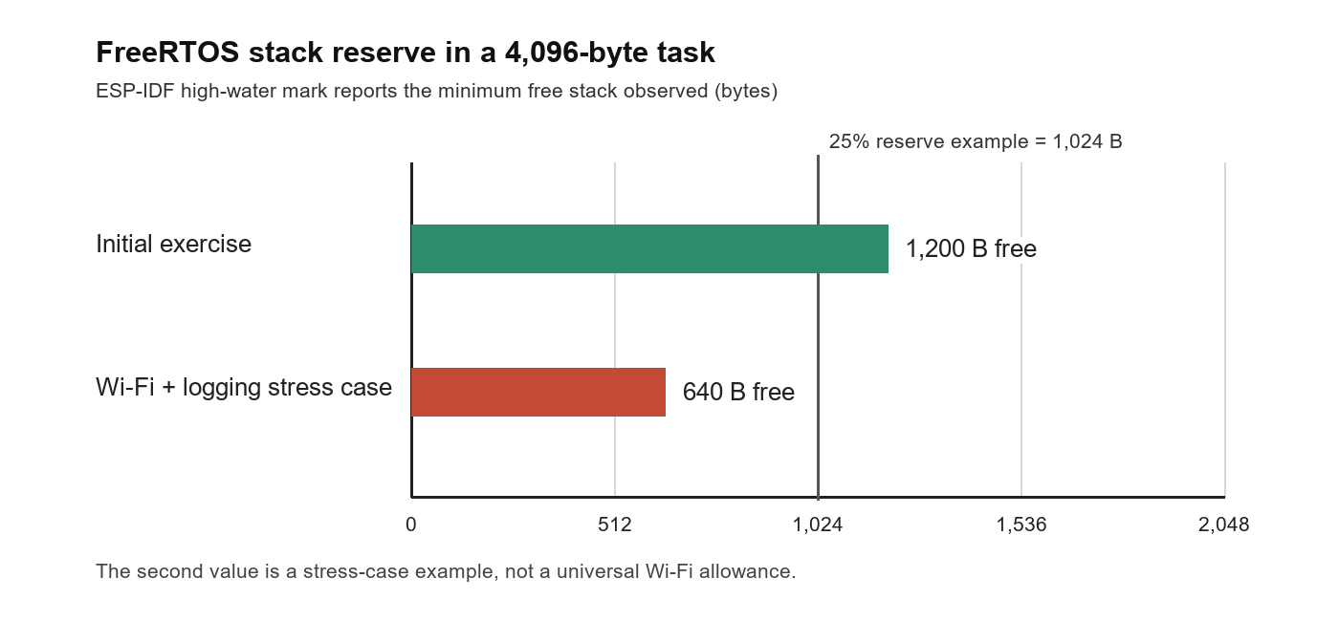
Figure 13.3 — Minimum free stack in Worked Example 13.3. The 1,200-byte value is the initial exercise; 640 bytes is the stated stress-case example. The 1,024-byte line illustrates a 25 % reserve for a 4,096-byte allocation, not a universal sizing rule.
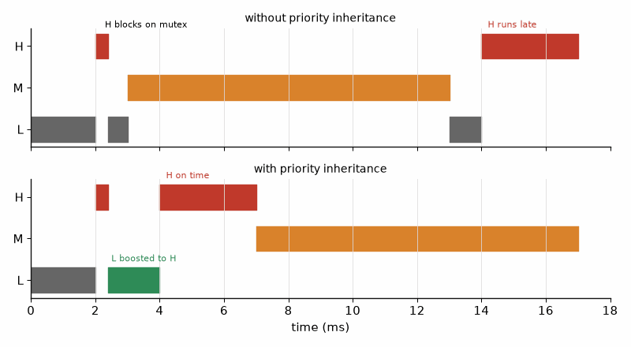
Figure 13.2 — Priority inversion and its fix. Top: the low task L holds a mutex; the high task H blocks on it; a medium task M preempts L and H waits for all of M. Bottom: with priority inheritance L runs at H's priority until it releases the mutex, and H finishes early.
Assign task priorities from deadlines and response-time needs, then check that the workload is schedulable. Connect tasks with queues, protect shared resources with mutexes, and put a timeout on every wait. If the sensor task overflows its stack while Wi-Fi and LoRa are active, the node can reset before its next scheduled report; a dashboard gap is then a data-loss event, not a cosmetic glitch.
Common misconception. More tasks make firmware faster. Every task needs its own stack and adds context switches and synchronization. Group jobs that run at the same rate and share data into one task; use a separate task when a job must wait or must preempt another.
On the Job
Firmware engineers spend more time on concurrency bugs than on almost any other kind: a reading occasionally lost, a display that freezes after three days, a deadlock between two mutexes taken in opposite orders. Keep a task table with period, priority, stack, deadline, and measured worst case; define lock order; use a trace tool to record switches; soak-test for days under peak Wi-Fi and peripheral load. Measure high-water marks on deep paths and leave margin. Use response-time analysis for safety or product deadlines: the longest observed time is not a WCET bound.
AI Pair-Programming Note
Generated FreeRTOS code often gets one of four details wrong: an ISR calls a blocking API, a wait uses portMAX_DELAY, an ESP-IDF stack is counted in words, or vTaskDelay(1) is described as one millisecond. State the SDK, tick rate, and stack units in the prompt. Then measure the deepest task path with logging and radio traffic enabled; a clean idle trace is a pleasant result, but a poor release criterion.
From the Bench
Toggle a GPIO at task entry and exit, with one pin per task, then capture the pins on a logic analyzer. The trace shows preemption, jitter, and missed deadlines. Record the analyzer sample rate beside the result: a trace can locate an event only as precisely as its sampling and trigger path allow.

Practice
1. (Core) What is the resolution of vTaskDelay at a 1000 Hz tick, and what does pdMS_TO_TICKS(5) return?
2. (Core) Which FreeRTOS function sends to a queue from an ISR, and why is there a separate version?
3. (Core) Find the CPU load of tasks taking 1 ms every 5 ms, 3 ms every 20 ms, and 10 ms every 100 ms.
4. (Core) What is the rate-monotonic bound for two tasks?
5. (Extension) Why is vTaskDelayUntil better than vTaskDelay for a sensor that must be read exactly every 100 ms?
6. (Extension) Two tasks share the I2C bus. Task A takes mutex 1 (bus) then mutex 2 (log); task B takes mutex 2 then mutex 1. What can happen, and what rule prevents it?
7. (Extension) A producer adds a reading every 2 ms; the consumer takes 3 ms per reading. What happens to any queue, however deep?
8. (Challenge) Write the task table (name, period, priority, stack, worst-case time) for the weather node with sensor, display, logger (writes flash every 10 s, up to 40 ms), and LoRa tasks, and check the load. Which task gets the lowest priority, and why?

What You’ll Actually Use
Everyday working tools
- Tasks with priorities by rate; queues between them; mutexes with priority inheritance for shared buses.
- The tick and pdMS_TO_TICKS; vTaskDelayUntil for fixed rates.
- Stack high-water marks; ESP-IDF stacks in bytes.
- GPIO-per-task timing on a logic analyzer.
Mostly for exams and deeper study
- Formal schedulability analysis beyond the rate-monotonic bound; rarely done by hand outside safety-critical work.

Chapter 14. Low Power and Sleep
The garden node was designed to last most of a year on one 18650 cell. It died in nine days. The firmware did sleep, exactly as written, for 597 seconds out of every 600, and in those seconds the chip drew a few microamps. The board around it did not sleep: its voltage regulator, its power LED, and its USB bridge together drew 13.5 mA, around the clock. Low-power firmware starts with a current measurement of the whole board, and only then with code.
Where you meet this: Every battery or solar product: sensor nodes, trackers, wildlife cameras, remote controls, wearables, and the "it lasted a week instead of a year" support ticket.

14.1 Where the energy goes
A duty-cycled device spends a short time awake, measuring and transmitting at tens or hundreds of milliamps, and a long time asleep at microamps. Its average current is the time-weighted mean of the two, and the battery life is the usable capacity divided by that average. The first-order arithmetic is this chapter's; usable capacity, temperature, self-discharge, and the regulator's efficiency are Book 6's, and they always shorten the result.
I_avg = (I_active t_active + I_sleep t_sleep) / T, life ≈ C / I_avg
There is no useful universal percentage for sleep-current drift: regulator, sensor leakage, board contamination, temperature, and production spread all matter. Measure the complete board at the minimum, room, and maximum specified temperatures and on representative units. For scale, if this chapter's 20 µA sleep current rises by 10 µA, the 597/600 sleep fraction adds about 9.95 µA to average current; the 0.420 mA estimate becomes 0.430 mA and ideal 3000 mAh life falls from about 298 to 291 days. This is arithmetic for the example, not a claim that every board drifts by 10 µA.
Two terms dominate in practice. The active energy is the active current times the active time, and the active time is usually dominated by waiting: for Wi-Fi to associate, for DHCP, for a server to answer. The sleep current is whatever the whole board draws while the chip sleeps, and on development boards that is often a thousand times the chip's own figure.
Listing 14.1 — A first-order power-budget calculator for the three cases of Worked Examples 14.1 to 14.3 (Python, runs on the PC).
"""Average current and battery life of a duty-cycled node (first-order; Book 6 adds the rest)."""
def average_ma(active_ma, active_s, sleep_ma, period_s):
sleep_s = period_s - active_s
return (active_ma * active_s + sleep_ma * sleep_s) / period_s
def life_days(capacity_mah, avg_ma):
return capacity_mah / avg_ma / 24
CASES = [
("module, 3 s Wi-Fi", 80, 3.0, 0.020),
("dev board, 3 s Wi-Fi", 80, 3.0, 13.5),
("module, 0.8 s Wi-Fi", 80, 0.8, 0.020),
]
for name, a_ma, a_s, s_ma in CASES:
avg = average_ma(a_ma, a_s, s_ma, 600)
print(f"{name:22s} average {avg:7.3f} mA life {life_days(3000, avg):7.1f} days")

Worked Example 14.1: The node on a bare module
Problem. An ESP32-S3 module wakes every 10 minutes, spends 3 s connecting to Wi-Fi and sending one MQTT message at an average of 80 mA, and sleeps at 20 µA (the chip's deep sleep of about 7 to 8 µA, plus the BME280, the regulator's quiescent current, and leakage). Find the average current and the life on a 3000 mAh 18650 cell.
Solution. Active: 80 mA × 3 s/600 s = 0.400 mA. Sleep: 0.020 mA × 597/600 = 0.020 mA. Average 0.420 mA. Life 3000/0.420 = 7140 h = 298 days, before Book 6's corrections. The active part is 95 % of the energy, so the active time is where to work next.

Worked Example 14.2: The same firmware on a development board
Problem. The same firmware runs on a development board whose sleep current measures 13.5 mA (its AMS1117-type linear regulator alone is specified at about 5 mA of quiescent current; the power LED and the USB-to-UART bridge take the rest). Find the life.
Solution. Average = 0.400 + 13.5 × 597/600 = 0.400 + 13.43 = 13.83 mA. Life = 3000/13.83 = 217 h = 9.0 days. The firmware is identical; the board decides. For battery work use a bare module or a board designed for low power, with a low-quiescent regulator, no always-on LED, and a USB bridge that is unpowered when USB is unplugged. Measure the sleep current before writing any power-saving code, then repeat across the specified temperature range; room-temperature current is not a year-long guarantee.
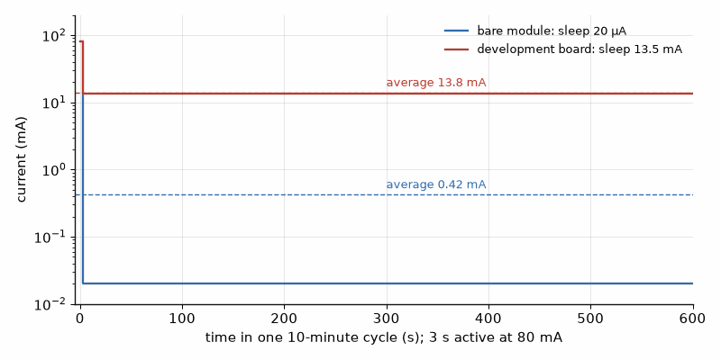
Figure 14.1 — Current over one 10-minute cycle of the sensor node, on a logarithmic axis (Worked Examples 14.1 and 14.2). A 3 s active burst at 80 mA, then deep sleep at 20 µA on a bare module (blue) or 13.5 mA on a development board (red). Dashed lines mark the averages, 0.42 mA and 13.8 mA.

14.2 Sleep modes
Microcontrollers offer a ladder of sleep modes. In light sleep the CPU stops but RAM and state are kept, and the chip resumes where it stopped; on the ESP32-S3 it draws a few hundred microamps. In deep sleep almost everything is switched off, the chip draws a few microamps, and waking up is a reset: the program starts again from app_main, and only data in the small RTC memory survives. Wake-up sources are a timer, a level on an RTC-capable pin (the PIR sensor), a touch pad, or the ultra-low-power coprocessor, which can read a sensor while the main cores sleep. The RP2040 has a dormant mode woken by a pin or the real-time clock; the nRF52840 sleeps between BLE events automatically under its SoftDevice or Zephyr stack.
Listing 14.2 — Deep sleep on the ESP32-S3 with a timer and a PIR wake-up, and counters kept in RTC memory (ESP-IDF, C).
// ESP32-S3 sensor node: wake every 10 minutes or on PIR motion, do the work, sleep.
// RTC_DATA_ATTR variables survive deep sleep; everything else restarts from scratch.
#include <stdint.h>
#include "esp_attr.h" // RTC_DATA_ATTR
#include "esp_sleep.h"
#include "esp_log.h"
#include "driver/gpio.h"
#define PIR_GPIO GPIO_NUM_5 // an RTC-capable pin (GPIO 0..21 on the S3)
#define INTERVAL_US (10ULL * 60 * 1000000)
static const char *TAG = "node";
RTC_DATA_ATTR static uint32_t boots;
RTC_DATA_ATTR static uint32_t motion_events;
void app_main(void)
{
boots++;
esp_sleep_wakeup_cause_t cause = esp_sleep_get_wakeup_cause();
if (cause == ESP_SLEEP_WAKEUP_EXT0) motion_events++;
ESP_LOGI(TAG, "boot %lu, cause %d, motion %lu", (unsigned long)boots, (int)cause,
(unsigned long)motion_events);
// ... read the BME280, send one MQTT or LoRa message (Chapters 17 and 18) ...
ESP_ERROR_CHECK(esp_sleep_enable_timer_wakeup(INTERVAL_US));
ESP_ERROR_CHECK(esp_sleep_enable_ext0_wakeup(PIR_GPIO, 1)); // wake on PIR high
ESP_LOGI(TAG, "sleeping");
esp_deep_sleep_start(); // does not return
}
Listing 14.3 — The same pattern in MicroPython, with the boot count kept in RTC memory.
# MicroPython on the ESP32-S3: count wake-ups in RTC memory, sleep 10 minutes or until the PIR fires.
import esp32
import machine
from machine import Pin
pir = Pin(5, Pin.IN, Pin.PULL_DOWN)
esp32.wake_on_ext0(pin=pir, level=esp32.WAKEUP_ANY_HIGH)
rtc = machine.RTC()
mem = rtc.memory() # bytes kept through deep sleep
boots = int(mem) + 1 if mem else 1
rtc.memory(str(boots))
if machine.reset_cause() == machine.DEEPSLEEP_RESET:
print("woke, boot", boots, "wake reason", machine.wake_reason())
else:
print("power-on")
# ... read the sensor and send the reading ...
machine.deepsleep(10 * 60 * 1000) # milliseconds

Worked Example 14.3: Shortening the active time
Problem. Storing the Wi-Fi channel and access point address in RTC memory, using a static IP address instead of DHCP, and sending without waiting for a reply shorten the active time from 3 s to 0.8 s at the same 80 mA. Find the new average and life for the bare module.
Solution. Active: 80 × 0.8/600 = 0.107 mA. Sleep: 0.020 mA. Average 0.127 mA, life 3000/0.127 = 23 700 h = 987 days, 2.7 years, more than three times longer. At this point the sleep current is 16 % of the total and the cell's own self-discharge (Book 6) becomes comparable, so further firmware work has little effect. Switching the radio to LoRa, with no association at all, goes further (Chapter 18).
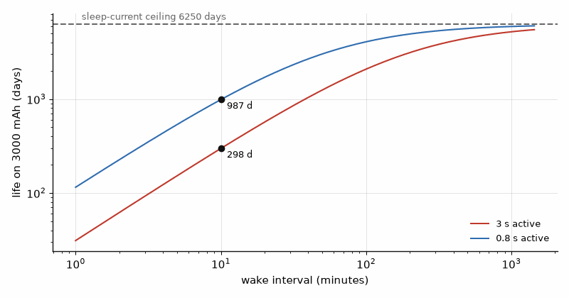
Figure 14.2 — Battery life on a 3000 mAh cell against the wake interval, for 3 s and 0.8 s active at 80 mA and 20 µA in sleep (Worked Examples 14.1 and 14.3). At 10 minutes the lives are 298 and 987 days; at long intervals both approach the sleep-current ceiling of 6250 days, where self-discharge dominates in practice.
Key idea. Measure the board's sleep current first, then shorten the time awake. Firmware can only save what the hardware lets it save, and most of a duty-cycled node's energy goes into waiting while awake.
Common misconception. Deep sleep is like pausing the program. On the ESP32 family, waking from deep sleep is a reset: global variables start from their initial values, peripherals must be configured again, and only RTC memory survives. Code written as if execution continued after esp_deep_sleep_start never runs.
AI Pair-Programming Note
Assistants produce sleep code that compiles but leaves the drain on: pins left driving LEDs or sensors, pull-ups fighting a pin held low, Wi-Fi not stopped before light sleep, or a wake-up pin that is not RTC-capable. Ask for a list of every pin's state during sleep as part of the answer, and check it against the schematic.
From the Bench
A multimeter cannot follow a current that jumps from 80 mA to 20 µA in a millisecond; its average is meaningless and its burden voltage can brown out the board on the jump. Use a power profiler (Nordic's Power Profiler Kit II and Joulescope are common) or a shunt resistor with a scope, and record a whole cycle. The area under the curve is the energy, and the flat part is the sleep current you must explain. Keep the instrument, shunt, wiring, temperature, and board state in the record; a changed burden voltage can make the measurement part of the problem.

Practice
1. (Core) Find the average current of a node active for 2 s at 50 mA every 5 minutes and sleeping at 10 µA.
2. (Core) How long does a 2500 mAh cell last at the average of Problem 1?
3. (Core) What survives an ESP32 deep sleep, and what happens to a normal global variable?
4. (Core) Name three wake-up sources of the ESP32-S3 in deep sleep.
5. (Extension) The node of Worked Example 14.1 must last 2 years on 3000 mAh. With 3 s active at 80 mA and 20 µA sleep, what is the shortest wake interval?
6. (Extension) A BME280 in forced mode measures in about 10 ms at 0.7 mA and sleeps at 0.1 µA. What does it add to the average at one measurement per 10 minutes?
7. (Extension) Why does a pull-up resistor of 10 kΩ on a pin that is held low during sleep matter, and how much current does it waste at 3.3 V?
8. (Challenge) A wildlife camera sleeps at 25 µA, wakes on the PIR about 40 times per day, and each event costs 1.5 s at 180 mA (camera, JPEG, SD write). It also wakes once per hour for 2 s at 80 mA to report. Find the average and the life on two 3000 mAh cells in parallel.

What You’ll Actually Use
Everyday working tools
- I_avg = (I_a t_a + I_s t_s)/T, and life = capacity/I_avg as a first estimate.
- Measure the whole board's sleep current first.
- Deep sleep is a reset; RTC memory for state; RTC-capable wake pins.
- Shorten active time: cached Wi-Fi parameters, static IP, fewer round trips.
- A power profiler or shunt and scope for real profiles.
Mostly for exams and deeper study
- The full sleep-mode matrix of each chip's technical reference manual; consult it for the mode you use.

Chapter 15. Fixed-Point Math and DSP
The filter worked perfectly in Python. Ported to the RP2040 as integer code, it settled at 985 instead of 1000 and stayed there forever, fifteen counts short of the truth, with no error, no warning, and a correct-looking formula on the screen. Integer arithmetic throws away everything after the binary point, and a filter that adds a small fraction of the error at each step can round that fraction down to zero. This chapter shows how to keep the fractions you need, and when a chip with a floating-point unit makes the question disappear.
Where you meet this: Audio and vibration processing, motor control loops, sensor smoothing, battery fuel gauges, and any filter or FFT on a microcontroller without a floating-point unit.

15.1 Do you need fixed point?
A floating-point unit (FPU) does float arithmetic in hardware in one or a few cycles. Without one, the compiler calls software routines that take tens to hundreds of cycles per operation. The reader-lab chips differ: the RP2040's Cortex-M0+ cores have no FPU; the RP2350's Cortex-M33 cores, the STM32F4 and the nRF52840 have a single-precision FPU; the ESP32-S3 has a single-precision FPU; the Teensy 4.1's Cortex-M7 has a double-precision FPU. On a single-precision FPU, write float and the f suffix (0.5f, sinf), because a stray double constant silently pulls in slow software double arithmetic. Fixed point remains the choice on chips without an FPU, in tight interrupt routines, and wherever the result must be bit-exact on every platform.

15.2 The Q format
A fixed-point number is an integer with an agreed scale. In Q15, a 16-bit signed integer stands for raw/32768, covering −1 to slightly under +1 in steps of about 30.5 millionths. Adding two Q15 numbers is an integer addition. Multiplying gives a Q30 product in 32 bits, which is shifted right by 15 to return to Q15, with rounding if you add half an LSB first. The one product that overflows is −1 × −1 = +1, which Q15 cannot represent, so the result is saturated to the largest value.

Worked Example 15.1: A Q15 multiplication
Problem. Multiply 0.5 by 0.25 in Q15, then multiply −1 by −1.
Solution. 0.5 is 16384 and 0.25 is 8192. The product is 134 217 728, which in 32 bits is fine; shifting right by 15 gives 4096, and 4096/32768 = 0.125. For −1 × −1: (−32768)² = 1 073 741 824, shifted right by 15 gives 32768, one above the Q15 maximum of 32767, so the code saturates it to 32767 = 0.99997. Listing 15.1 prints both results.
Listing 15.1 — Q15 multiplication with rounding and saturation, and a first-order low-pass filter with and without fractional bits in the state (C, runs on the PC).
// Fixed-point helpers and a first-order IIR low-pass for chips without an FPU (RP2040).
// Pure C, tested on the PC.
#include <stdint.h>
#include <stdio.h>
typedef int16_t q15_t; // value = raw / 32768, range [-1, 1)
static q15_t q15_mul(q15_t a, q15_t b)
{
int32_t p = ((int32_t)a * b + (1 << 14)) >> 15; // round to nearest
if (p > INT16_MAX) p = INT16_MAX; // only -1 * -1 overflows
return (q15_t)p;
}
// y += (x - y) / 16, naive: the state has no fractional bits.
static int32_t iir_naive(int32_t *y, int32_t x) { *y += (x - *y) >> 4; return *y; }
// Same filter with 8 extra fractional bits kept in the state.
static int32_t iir_scaled(int32_t *acc, int32_t x)
{
*acc += ((x << 8) - *acc) >> 4;
return (*acc + 128) >> 8; // rounded output
}
int main(void)
{
printf("0.5 * 0.25 = %d/32768\n", q15_mul(16384, 8192)); // 4096 = 0.125
printf("-1 * -1 saturates to %d\n", q15_mul(INT16_MIN, INT16_MIN));
int32_t yn = 0, acc = 0, n16 = 0;
for (int n = 1; n <= 200; n++) { // step from 0 to 1000 counts
iir_naive(&yn, 1000);
int32_t ys = iir_scaled(&acc, 1000);
if (n == 16) n16 = ys;
}
printf("after 16 samples: %ld (64.4 %% of 1000 expected)\n", (long)n16);
printf("after 200 samples: naive %ld, scaled %ld\n", (long)yn, (long)((acc + 128) >> 8));
return 0;
}

15.3 A low-pass filter in one line
The first-order IIR low-pass, y ← y + α (x − y), is the workhorse of sensor smoothing. With α = 1/16 the multiplication becomes a shift by 4, which is why the filter is so popular on small chips. The analog equivalent, the RC low-pass, is Book 2's; here the question is what the integer version does.

Worked Example 15.2: Time constant, corner frequency, and the dead band
Problem. The filter y ← y + (x − y)/16 runs at 100 Hz. Find its time constant and corner frequency, the response after 16 samples to a step from 0 to 1000, and what the naive integer version settles to.
Solution. After n samples the response to a step is 1 − (15/16)^n. For n = 16, (15/16)^16 = 0.356, so the output is 64.4 % of the step, 644. The time constant is −1/ln(1 − 1/16) = 15.5 samples = 0.155 s at 100 Hz, and the corner frequency is 1/(2π × 0.155 s) = 1.03 Hz. The naive integer version computes (x − y) >> 4, which is 0 whenever x − y is below 16, so the output stops moving once it is within 15 counts: Listing 15.1 shows it stuck at 985. Keeping 8 extra fractional bits in the state removes the dead band, and the scaled filter reaches 1000.
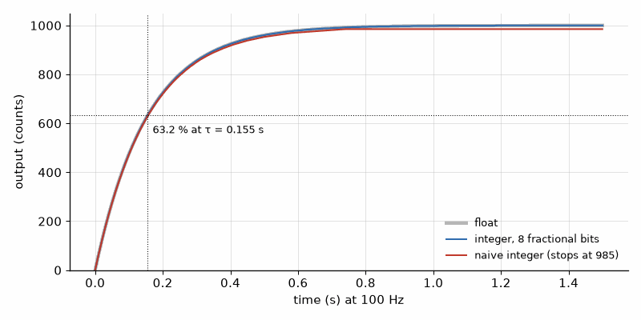
Figure 15.1 — Step response of the low-pass filter y ← y + (x − y)/16 at 100 Hz (Worked Example 15.2): floating point (gray), integer with 8 fractional bits in the state (blue), and naive integer (red), which stops 15 counts short at 985. The dotted line marks 63.2 % at the time constant of 0.155 s.
Common misconception. Shifting a negative number right divides it by a power of two. Right-shifting a negative signed integer is implementation-defined in C (arithmetic on GCC for ARM and Xtensa, but not guaranteed), and even where it is arithmetic it rounds toward minus infinity, so −1 >> 4 is −1, not 0. Test filters with falling as well as rising steps.

15.4 The FFT on a microcontroller
An N-point FFT at sample rate fs splits the spectrum into bins fs/N wide and needs N/fs seconds of data per frame. A tone that does not fall exactly on a bin spreads into its neighbors (leakage), and multiplying the frame by a window such as Hann trades a slightly wider peak for far lower leakage. The spectral view of signals is Book 5's. On the chip, use the vendor's optimized library rather than writing your own: CMSIS-DSP on ARM (arm_rfft_fast_f32 on the Teensy 4.1 or an STM32F4) and Espressif's ESP-DSP on the ESP32-S3. Plan the parameters on the PC first, as Listing 15.2 does.

Worked Example 15.3: Planning a vibration FFT
Problem. A vibration monitor samples at 10 kHz and runs a 1024-point FFT. Find the bin width, the frame length, and where a 1000 Hz tone lands, and compare leakage with and without a Hann window.
Solution. Bin width 10 000/1024 = 9.77 Hz; frame 1024/10 000 = 102.4 ms. The tone sits at bin 1000/9.77 = 102.4, between bins 102 (996.1 Hz) and 103, so it leaks. Listing 15.2 shows the largest component above 1.5 kHz at −42 dB of the peak without a window and −111 dB with Hann. With the window, a small second tone 60 dB down is visible; without it, the leakage would hide it.
Listing 15.2 — Planning an FFT on the PC: bin width, frame time, and the effect of a Hann window (Python with NumPy).
"""Plan an FFT on the PC before writing it for the MCU: bin width, leakage, and the window."""
import numpy as np
FS = 10_000 # sample rate, Hz
N = 1024 # FFT length
F_TONE = 1000.0 # test tone, Hz
t = np.arange(N) / FS
x = np.sin(2 * np.pi * F_TONE * t)
print(f"bin width {FS / N:.2f} Hz, frame {N / FS * 1000:.1f} ms, tone at bin {F_TONE * N / FS:.1f}")
for name, w in (("rectangular", np.ones(N)), ("Hann", np.hanning(N))):
spec = np.abs(np.fft.rfft(x * w))
spec_db = 20 * np.log10(spec / spec.max() + 1e-12)
far = spec_db[int(1500 * N / FS):] # everything above 1.5 kHz
print(f"{name:12s} peak at {np.argmax(spec) * FS / N:7.1f} Hz, leakage above 1.5 kHz {far.max():6.1f} dB")
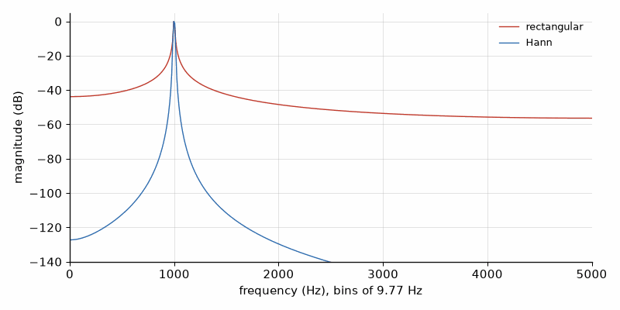
Figure 15.2 — Spectrum of a 1000 Hz tone sampled at 10 kHz with a 1024-point FFT (Worked Example 15.3), without a window (red) and with a Hann window (blue). The tone falls at bin 102.4; the rectangular window leaks to −42 dB above 1.5 kHz, the Hann window to −111 dB.
Key idea. Pick the number format from the hardware: float on a chip with an FPU (with the f suffix), fixed point with enough fractional bits where there is none. Test every filter against a floating-point reference on the PC before trusting it on the chip.
AI Pair-Programming Note
Assistants convert float filters to integer code readily and often reproduce the dead band of Worked Example 15.2, or multiply two 16-bit values into a 16-bit result. Step 4 of the method catches it: ask for a test that compares the integer filter with a float reference over rising and falling steps, and run it on the PC.
From the Bench
Feed a known signal before trusting a DSP chain: a function generator at a known frequency and amplitude into the ADC, and check that the peak lands in the expected bin at the expected level. A peak in the wrong bin almost always means the real sample rate differs from the one you assumed.

Practice
1. (Core) Write 0.75 and −0.5 in Q15, and find their product in Q15.
2. (Core) Which of these chips have a hardware FPU: RP2040, ESP32-S3, Teensy 4.1, nRF52840?
3. (Core) Find the bin width and frame time of a 512-point FFT at 8 kHz.
4. (Core) The filter y ← y + (x − y)/8 runs at 50 Hz. Find its time constant in samples and seconds.
5. (Extension) For the naive filter of Problem 4, how far below a step can the output get stuck?
6. (Extension) Why does float y = x * 0.1; run slower than float y = x * 0.1f; on an ESP32-S3?
7. (Extension) How many fractional bits does the state need so that the shift-by-4 filter of Worked Example 15.2 has a dead band below 0.1 count?
8. (Challenge) A 200 Hz vibration tone and a 210 Hz tone must be told apart with an FFT at 2 kHz. Choose N, and say why a Hann window makes the problem harder as well as easier.

What You’ll Actually Use
Everyday working tools
- Know whether the chip has an FPU, single or double precision; use the f suffix.
- Q15 multiply: 32-bit product, round, shift by 15, saturate.
- y ← y + (x − y) >> k with extra fractional bits in the state.
- Bin width fs/N, frame N/fs, Hann window against leakage.
- CMSIS-DSP and ESP-DSP instead of a homemade FFT.
- Compare every integer filter against a float reference on the PC.
Mostly for exams and deeper study
- Exact frequency responses of digital filters and the z-transform; Book 5 has the spectral view.

Chapter 16. Sensor Fusion: IMU Filters, Kalman, and SLAM Basics
Lay an IMU board flat on the bench, integrate the gyroscope, and watch the angle climb: half a degree per second, ten degrees after twenty seconds, while nothing moves. Read the accelerometer instead and the angle is right on average but jumps by two degrees from sample to sample, and by much more the moment the board is carried. Neither sensor alone can say how the board is tilted. Together, with a dozen lines of arithmetic, they can, to a fifth of a degree. That combination is sensor fusion, and it is how every drone, phone, and balancing robot knows which way is up.
Where you meet this: Drones, gimbals, balancing robots, phone orientation, vehicle dead reckoning between GPS fixes, robot vacuums and lawn mowers that map their surroundings, and any product that combines two imperfect sensors into one good estimate.

16.1 Two imperfect sensors
A MEMS gyroscope measures angular rate. Integrated over time it gives angle changes that are smooth and fast, but every small offset in the rate (the bias) integrates into a steadily growing error, the drift. An accelerometer measures acceleration including gravity; when the board is still, the direction of gravity gives the tilt directly, with no drift, but with noise, and any real acceleration of the board is mistaken for tilt. The gyro is good over short times and bad over long ones; the accelerometer is the opposite. Fusion takes the short-term information from one and the long-term information from the other. The MEMS physics of both sensors, and the noise densities in their datasheets, are Book 3's.
Book 5, Chapter 23.5 introduces sensor fusion as an estimation problem. This chapter focuses on its embedded implementation: reading an IMU, coding filters, and supplying sensor data to mapping software.

16.2 Reading the IMU
The MPU-6050 is the IMU on countless cheap breakout boards and a good first driver: I2C address 0x68 (0x69 with AD0 high), WHO_AM_I register 0x75 reading 0x68, and a reset state that is asleep (PWR_MGMT_1 at 0x6B), so the first write must wake it. Its fourteen data bytes from 0x3B hold three accelerometer axes, the temperature, and three gyro axes, each a big-endian signed 16-bit value. At the default ranges the accelerometer gives 16 384 counts per g and the gyro 131 counts per degree per second. It is an older part; for new designs, modern IMUs such as TDK's ICM-42688-P (WHO_AM_I 0x47 at register 0x75, power control in PWR_MGMT0 at 0x4E, gyro at 16.4 counts per degree per second on its ±2000 °/s range) offer lower noise and SPI at higher rates. The driver pattern is the same.
Listing 16.1 — A minimal MPU-6050 driver: identity check, wake-up, and one 14-byte burst read converted to g and degrees per second (MicroPython on the ESP32-S3).
# MicroPython: minimal MPU-6050 driver on the ESP32-S3 (I2C on GPIO 8/9).
from machine import I2C, Pin
import struct, time
ADDR = 0x68 # AD0 low; 0x69 with AD0 high
WHO_AM_I, PWR_MGMT_1, ACCEL_XOUT_H = 0x75, 0x6B, 0x3B
ACC_LSB_PER_G = 16384 # +-2 g range (reset default)
GYR_LSB_PER_DPS = 131 # +-250 deg/s range (reset default)
i2c = I2C(0, scl=Pin(9), sda=Pin(8), freq=400_000)
def init():
who = i2c.readfrom_mem(ADDR, WHO_AM_I, 1)[0]
if who != 0x68:
raise OSError("MPU-6050 not found, WHO_AM_I=0x%02X" % who)
i2c.writeto_mem(ADDR, PWR_MGMT_1, b"\x01") # wake up, clock from X gyro PLL
time.sleep_ms(100)
def read():
"""Return (ax, ay, az) in g and (gx, gy, gz) in deg/s from one 14-byte burst."""
raw = i2c.readfrom_mem(ADDR, ACCEL_XOUT_H, 14)
ax, ay, az, _temp, gx, gy, gz = struct.unpack(">7h", raw) # big-endian, signed
acc = tuple(v / ACC_LSB_PER_G for v in (ax, ay, az))
gyr = tuple(v / GYR_LSB_PER_DPS for v in (gx, gy, gz))
return acc, gyr
init()
while True:
acc, gyr = read()
print("acc %.3f %.3f %.3f g gyro %.2f %.2f %.2f dps" % (acc + gyr))
time.sleep_ms(100)

Worked Example 16.1: Tilt from raw accelerometer counts
Problem. The board is still. The MPU-6050 reports ay = 2845 and az = 16 135 counts, ax = 0. Find the tilt about the x axis and check that the reading is plausible.
Solution. Tilt = atan2(ay, az) = atan2(2845, 16 135) = atan(0.1763) = 10.0°. Plausibility: the magnitude √(2845² + 16 135²) = 16 384 counts = 1.000 g, as it must be for a board at rest. A magnitude well away from 1 g means the board is accelerating and the accelerometer's tilt should be trusted less at that moment.

16.3 The complementary filter
The complementary filter blends the integrated gyro angle with the accelerometer angle at every sample: angle ← α (angle + ω Δt) + (1 − α) angle_acc. With α close to 1 the gyro dominates over short times and the accelerometer pulls the estimate back over long times. The crossover is set by the time constant τ = α Δt/(1 − α). It is one line of code, it runs on any chip, and on many hobby projects it is all the fusion needed.
angle ← α (angle + ω Δt) + (1 − α) angle_acc, τ = α Δt/(1 − α)

Worked Example 16.2: Choosing α and the price of gyro bias
Problem. The filter runs at 100 Hz with α = 0.98. The gyro has an uncorrected bias of 0.5 °/s. Find the time constant, the crossover frequency, and the steady error the bias causes with the board still.
Solution. τ = 0.98 × 0.01 s/0.02 = 0.49 s, crossover 1/(2π × 0.49 s) = 0.32 Hz. Setting the update to a fixed point with the board still: angle (1 − α) = α b Δt + (1 − α) truth, so the error is α b Δt/(1 − α) = b τ = 0.5 × 0.49 = 0.25°. Without fusion the same bias drifts 10° in 20 s; Listing 16.2 shows 9.94°. Measuring the bias at startup (average the gyro for a second while still) and subtracting it removes most of the 0.25°.
Listing 16.2 — Complementary filter and a two-state Kalman filter (angle and gyro bias) for one tilt axis, tested on simulated data with a 0.5 °/s gyro bias and 2° accelerometer noise (C, runs on the PC and on the ESP32-S3).
// Complementary filter and 1-D Kalman filter for one tilt axis, on simulated data.
// Pure C, runs on the PC. Same code runs on the ESP32-S3 at 100 Hz.
#include <math.h>
#include <stdint.h>
#include <stdio.h>
#define DT 0.01f // 100 Hz
static uint32_t seed = 12345;
static float noise(void) // approximately Gaussian, sigma 1 (sum of 12 uniforms)
{
float s = 0.0f;
for (int i = 0; i < 12; i++) { seed = seed * 1664525u + 1013904223u; s += (seed >> 8) / 16777216.0f; }
return s - 6.0f;
}
typedef struct { float angle, bias, P[2][2]; } kalman_t; // state: angle and gyro bias
static float complementary(float *angle, float gyro_dps, float acc_deg, float alpha)
{
*angle = alpha * (*angle + gyro_dps * DT) + (1.0f - alpha) * acc_deg;
return *angle;
}
static float kalman_step(kalman_t *k, float gyro_dps, float acc_deg)
{
const float Q_angle = 0.001f, Q_bias = 0.003f, R = 4.0f; // R = (2 deg)^2
k->angle += (gyro_dps - k->bias) * DT; // predict
k->P[0][0] += DT * (DT * k->P[1][1] - k->P[0][1] - k->P[1][0] + Q_angle);
k->P[0][1] -= DT * k->P[1][1];
k->P[1][0] -= DT * k->P[1][1];
k->P[1][1] += Q_bias * DT;
float S = k->P[0][0] + R; // update
float K0 = k->P[0][0] / S, K1 = k->P[1][0] / S;
float y = acc_deg - k->angle;
k->angle += K0 * y;
k->bias += K1 * y;
float P00 = k->P[0][0], P01 = k->P[0][1];
k->P[0][0] -= K0 * P00; k->P[0][1] -= K0 * P01;
k->P[1][0] -= K1 * P00; k->P[1][1] -= K1 * P01;
return k->angle;
}
int main(void)
{
const float truth = 10.0f, bias = 0.5f; // true tilt (deg), gyro bias (deg/s)
float gyro_only = 0.0f, comp = 0.0f, e_acc = 0.0f, e_comp = 0.0f, e_kal = 0.0f;
kalman_t k = { 0 };
int n = 0;
for (int i = 1; i <= 2000; i++) { // 20 s
float gyro = bias + 0.1f * noise(); // the board is still
float acc = truth + 2.0f * noise(); // accelerometer tilt, sigma 2 deg
if (i == 1) { gyro_only = truth; comp = acc; k.angle = acc; } // gyro starts from the true angle
gyro_only += gyro * DT;
complementary(&comp, gyro, acc, 0.98f);
kalman_step(&k, gyro, acc);
if (i > 1000) { // statistics over the last 10 s
e_acc += (acc - truth) * (acc - truth);
e_comp += (comp - truth) * (comp - truth);
e_kal += (k.angle - truth) * (k.angle - truth);
n++;
}
}
printf("gyro only after 20 s: %.2f deg (drift %.2f)\n", gyro_only, gyro_only - truth);
printf("rms error: accel %.2f, complementary %.2f, kalman %.2f deg\n",
sqrtf(e_acc / n), sqrtf(e_comp / n), sqrtf(e_kal / n));
printf("kalman bias estimate %.3f deg/s\n", k.bias);
return 0;
}
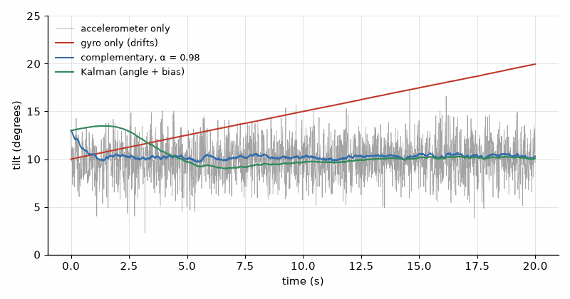
Figure 16.1 — Tilt estimates over 20 s with the board still at 10° (Listing 16.2): the accelerometer alone (gray, noisy, rms error 1.96°), the gyro alone (red, drifting 10° in 20 s), the complementary filter with α = 0.98 (blue, rms 0.33°), and the Kalman filter (green, rms 0.19°).

16.4 The Kalman filter in one dimension
The Kalman filter makes the blending weight a calculation instead of a choice. It keeps an estimate and its variance P. Each step it predicts (the estimate moves with the gyro and the variance grows by the process noise Q), then corrects with the measurement, weighting it by the gain K = P/(P + R), where R is the measurement variance. A confident estimate (small P) and a noisy sensor (large R) give a small gain; the reverse gives a large one. Listing 16.2 adds the gyro bias as a second state, so the filter learns the bias by itself (it estimates 0.513 °/s against the true 0.5). The extended and unscented versions for full 3-D orientation follow the same predict-correct pattern; on the job you use a tested library or the sensor's own fusion engine (BNO085-class parts compute orientation on chip) and tune Q and R.

Worked Example 16.3: Two Kalman steps by hand
Problem. The estimate is 10.0° with variance P = 1.0 deg². A measurement of 12.0° arrives with R = 4.0 deg² (σ = 2°). Update the estimate. Then the process adds Q = 0.1 deg², and a second measurement of 11.0° arrives. Update again.
Solution. Step 1: K = 1.0/(1.0 + 4.0) = 0.20. Estimate 10.0 + 0.20 × (12.0 − 10.0) = 10.40°. Variance (1 − 0.20) × 1.0 = 0.80. Step 2: predict P = 0.80 + 0.10 = 0.90; K = 0.90/4.90 = 0.184; estimate 10.40 + 0.184 × (11.0 − 10.40) = 10.51°; P = (1 − 0.184) × 0.90 = 0.73. The variance falls with every measurement until Q balances it, and the gain settles to a constant; a complementary filter is close to that steady-state Kalman filter with a fixed gain.
Common misconception. Tuning Q and R until the plot looks smooth. A small Q makes the output smooth and slow, so it lags real motion. Measure R from the sensor at rest (the variance of the accelerometer angle), choose Q from how fast the real quantity can change, and test with real motion, not only with the board lying still.

16.5 SLAM basics
A robot that maps a room and locates itself in that map at the same time is doing SLAM, simultaneous localization and mapping. The two halves depend on each other: the map is built from range readings taken at known poses, and the pose is found by matching new readings against the map. The mapping half can be shown on its own. An occupancy grid divides the floor into cells, each holding the log-odds that it is occupied. A range reading marks the cells along the beam as more likely free and the cell at the end as more likely occupied, by adding fixed log-odds increments. Repeated readings sharpen the map; a moving object fades out again.
Listing 16.3 — An occupancy grid with log-odds updates from ToF range readings at a known pose: the mapping half of SLAM (Python).
"""Occupancy grid from range readings: the mapping half of SLAM, with known robot poses."""
import math
CELL = 0.05 # 5 cm cells
SIZE = 40 # 2 m x 2 m map
L_HIT = math.log(0.7 / 0.3) # +0.847: evidence that a cell is occupied
L_MISS = math.log(0.4 / 0.6) # -0.405: evidence that a cell is free
grid = [[0.0] * SIZE for _ in range(SIZE)] # log-odds, 0 = unknown (p = 0.5)
def update(x, y, heading_deg, rng):
"""Walk the beam from the robot at (x, y) meters; mark free cells and the hit cell."""
h = math.radians(heading_deg)
steps = int(rng / CELL)
for s in range(steps + 1):
cx = int((x + s * CELL * math.cos(h)) / CELL)
cy = int((y + s * CELL * math.sin(h)) / CELL)
if not (0 <= cx < SIZE and 0 <= cy < SIZE):
return
grid[cy][cx] += L_HIT if s == steps else L_MISS
def prob(l):
return 1.0 - 1.0 / (1.0 + math.exp(l))
# Three readings from a ToF sensor, robot at (0.5 m, 1.0 m) facing a wall at x = 1.5 m.
for _ in range(3):
update(0.5, 1.0, 0.0, 1.0)
print("wall cell p = %.3f, free cell p = %.3f" % (prob(grid[20][30]), prob(grid[20][20])))

Worked Example 16.4: Three readings of a wall
Problem. A ToF sensor with a hit probability model of 0.7 and a miss model of 0.4 reads the same wall three times. Find the occupancy probability of the wall cell and of a cell in front of it, starting from 0.5.
Solution. The hit increment is ln(0.7/0.3) = 0.847, the miss increment ln(0.4/0.6) = −0.405. After three readings the wall cell holds 2.54, so p = 1 − 1/(1 + e^2.54) = 0.927; the free cell holds −1.22, so p = 0.229. Listing 16.3 prints both. Adding log-odds rather than multiplying probabilities keeps the update to one addition per cell, which suits a microcontroller.
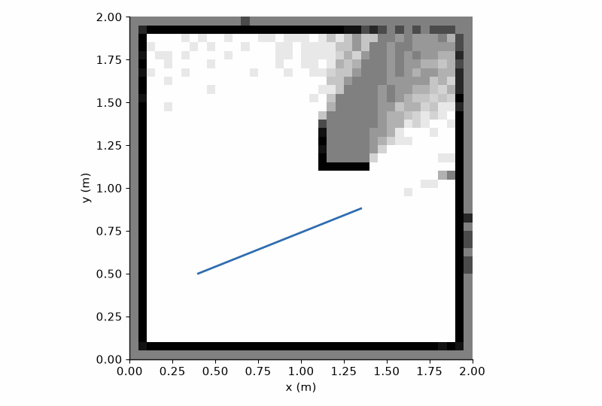
Figure 16.2 — An occupancy grid after a robot scanned a 2 m room with a ToF sensor (log-odds model of Worked Example 16.4): white cells are free, black cells occupied, gray cells unknown. The robot's path is the blue line.
Full SLAM, with scan matching and loop closure, runs on the Pi 5 rather than on a microcontroller: ROS 2 packages such as slam_toolbox take a 2-D LiDAR scan and odometry and produce the map and pose. The firmware's part is to deliver clean, timestamped sensor data: wheel encoder counts, IMU angles from this chapter, and range scans (Chapter 20). Millimeter-wave radar is a third range source: TI's IWR6843 works at 60 to 64 GHz, and its 4 GHz sweep gives a range resolution of c/(2B) = 3 × 10⁸/(2 × 4 × 10⁹) = 3.75 cm, through smoke and darkness. Its point-cloud output looks to firmware like the LiDAR clouds of Chapter 20. The radar front end is Book 4's.
Key idea. Fusion trusts each sensor where it is good: the gyro over short times, the accelerometer, GPS, or range sensor over long times. A complementary filter does it with a fixed weight, a Kalman filter computes the weight from the variances.
AI Pair-Programming Note
Assistants write plausible fusion code with wrong units: gyro rates left in degrees per second while the angle is in radians, a Δt hard-coded to 0.01 while the loop runs at 50 Hz, or accelerometer axes swapped. Step 1 of the method fixes this: put the units, axis directions, and sample rate in the spec, and require a test on simulated data with a known answer, like Listing 16.2.
From the Bench
Calibrate the gyro bias at every power-up: keep the board still for one second, average about a hundred samples per axis, and store the means. Then turn the board slowly through 90° on a protractor or against a square and check that the fused angle reads 90°. If it reads 87° or 93°, the scale or the axis mapping is wrong, not the filter.

Practice
1. (Core) An MPU-6050 at rest reports az = 16 384 and ax = ay = 0. What is the tilt, and what does the gyro read in degrees per second if gx = 262?
2. (Core) A gyro with a bias of 0.2 °/s is integrated for 60 s with the board still. What angle does it report?
3. (Core) Find τ for a complementary filter at 200 Hz with α = 0.99.
4. (Core) Compute one Kalman update: estimate 5.0, P = 2.0, measurement 6.0, R = 2.0.
5. (Extension) For the filter of Problem 3, what steady error does a gyro bias of 0.2 °/s cause?
6. (Extension) In Worked Example 16.4, how many consistent hit readings take a cell from unknown to above p = 0.99?
7. (Extension) Why does the accelerometer tilt of a board in a car accelerating at 0.3 g read wrong, and by about how much?
8. (Challenge) A 100 Hz complementary filter must reject accelerometer vibration at 20 Hz by at least a factor of 50 while keeping the bias error below 0.1° for a gyro bias of 0.05 °/s. Choose α and check both conditions.

What You’ll Actually Use
Everyday working tools
- atan2(ay, az) for tilt, and |a| ≈ 1 g as a plausibility check.
- Gyro bias calibration at startup.
- Complementary filter with τ = α Δt/(1 − α).
- Kalman gain K = P/(P + R); measure R, choose Q.
- Occupancy grids with log-odds; full SLAM on the Pi 5 with ROS 2 packages.
- A test on simulated data with a known answer for every fusion filter.
Mostly for exams and deeper study
- Extended and unscented Kalman filters and full 3-D quaternion fusion; use a tested library.
- Scan matching and loop closure inside SLAM.

Part IV. Connected and Intelligent Devices
Part IV puts the reader lab on the network and gives it eyes. Chapter 17 connects the ESP32-S3 over Wi-Fi and MQTT, Chapter 18 adds BLE, LoRa, and GPS, Chapter 19 makes updates and security part of the design, and Chapter 20 handles cameras, point clouds, and small neural networks. The radio physics and link budgets are Books 4 and 5's; here the subject is the firmware that keeps a connection alive for months.

Chapter 17. Wi-Fi and MQTT
Forty sensor nodes in a greenhouse ran without trouble for a month. Then the power failed for ten seconds. When it came back, all forty rebooted at the same moment, all forty asked the router for an address, all forty hammered the broker, and the broker, a small Pi in a cupboard, fell over and took the rest of the night to recover. Each node's firmware was correct on its own. Together they were a denial-of-service attack. Connected firmware has to be written for the bad day: the dropped link, the restarted router, and the thousand siblings that restart with it.
Where you meet this: Home automation, smart meters, greenhouse and building sensors, industrial monitoring, anything with a cloud dashboard, and every "it was online yesterday" support call.

17.1 Wi-Fi from firmware
The ESP32-S3 has 2.4 GHz Wi-Fi (802.11 b/g/n) and Bluetooth LE on the chip, and the ESP-IDF driver is event-driven: you start the station, and the driver reports events such as started, connected, got an IP address, and disconnected, to a handler you register. The firmware's job is to react to those events, never to assume the link is up. Three rules prevent most field failures. Credentials are configuration, not code: they come from menuconfig, a secrets file kept out of version control, or a provisioning step, never from a string literal that ends up in git. Every disconnect leads to a reconnect, forever. And nothing that needs the network blocks anything that does not: the sensor keeps measuring and the display keeps updating while Wi-Fi is down. Remember from Chapter 8 that ADC2 is not available while Wi-Fi runs.

17.2 MQTT in one page
MQTT is a small publish-subscribe protocol over TCP. Devices do not talk to each other; they publish messages to a broker under a topic such as lab/garden/bme280, and any client that subscribed to that topic, or to a wildcard such as lab/garden/#, receives them. The broker can be Mosquitto on the Pi 5 or a cloud service. Four features do most of the work. QoS 0 sends once with no confirmation; QoS 1 repeats until the broker acknowledges, so a message can arrive twice; QoS 2 delivers exactly once at the cost of a four-message handshake. A retained message is stored by the broker and delivered at once to new subscribers, so a dashboard that starts later sees the last value. The keepalive makes a silent client's connection time out. And the last will is a message the broker publishes on the client's behalf when it disappears without saying goodbye, such as lab/garden/status = offline.
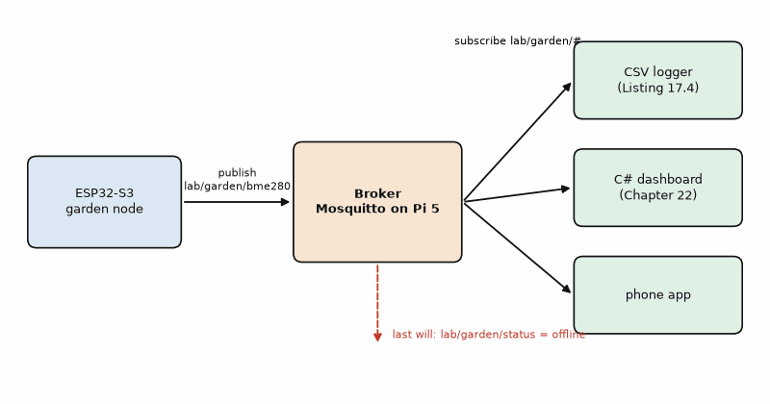
Figure 17.1 — The publish-subscribe pattern of this chapter: the garden node publishes to the broker on the Pi 5, and three subscribers (the CSV logger of Listing 17.4, the C# dashboard of Chapter 22, and a phone app) receive the same messages without knowing about the node or each other.

Worked Example 17.1: The spec for the network module
Problem. Apply step 1 of the method to the garden node's network module before writing any code: topics, payload, QoS, timing, and failure behavior.
Solution. Purpose: publish one BME280 reading per minute to the lab broker. Topics: lab/garden/bme280 for data, lab/garden/status for "online" (retained, published on connect) and "offline" (the last will). Payload: JSON {"t":23.41,"h":45.2,"p":1013.25}, units °C, %, hPa, fixed decimals. QoS 1 for data (a duplicate is harmless, a gap is not), keepalive 120 s. Failure behavior: sensor reading and display continue without the network; Wi-Fi and MQTT reconnect with exponential back-off from 1 s to 60 s with 25 % jitter; readings during an outage are dropped in this version (buffering is a later iteration). Acceptance tests: (1) messages arrive in the CSV log every 60 ± 1 s; (2) the router is switched off for 5 minutes and the node is publishing again within 75 s of it returning; (3) the broker shows "offline" within 3 minutes of unplugging the node (1.5 × keepalive); (4) 7 days without a reset.
Listing 17.1 — Wi-Fi station and MQTT publishing on the ESP32-S3 with event handlers and an event group; credentials from menuconfig (ESP-IDF, C).
// ESP-IDF: connect to Wi-Fi, then publish one BME280 reading per minute over MQTT.
// Wi-Fi credentials and the broker URI come from menuconfig (Kconfig), never from the source.
#include <stdio.h>
#include "esp_event.h"
#include "esp_log.h"
#include "esp_netif.h"
#include "esp_wifi.h"
#include "freertos/FreeRTOS.h"
#include "freertos/event_groups.h"
#include "freertos/task.h"
#include "mqtt_client.h"
#include "nvs_flash.h"
static const char *TAG = "node";
static EventGroupHandle_t s_events;
#define WIFI_UP BIT0
#define MQTT_UP BIT1
static void on_wifi(void *arg, esp_event_base_t base, int32_t id, void *data)
{
if (base == WIFI_EVENT && (id == WIFI_EVENT_STA_START || id == WIFI_EVENT_STA_DISCONNECTED)) {
xEventGroupClearBits(s_events, WIFI_UP);
esp_wifi_connect(); // the driver retries; MQTT reconnects by itself
} else if (base == IP_EVENT && id == IP_EVENT_STA_GOT_IP) {
xEventGroupSetBits(s_events, WIFI_UP);
}
}
static void on_mqtt(void *arg, esp_event_base_t base, int32_t id, void *data)
{
if (id == MQTT_EVENT_CONNECTED) xEventGroupSetBits(s_events, MQTT_UP);
if (id == MQTT_EVENT_DISCONNECTED) xEventGroupClearBits(s_events, MQTT_UP);
}
static void wifi_start(void)
{
esp_netif_create_default_wifi_sta();
wifi_init_config_t cfg = WIFI_INIT_CONFIG_DEFAULT();
ESP_ERROR_CHECK(esp_wifi_init(&cfg));
ESP_ERROR_CHECK(esp_event_handler_register(WIFI_EVENT, ESP_EVENT_ANY_ID, on_wifi, NULL));
ESP_ERROR_CHECK(esp_event_handler_register(IP_EVENT, IP_EVENT_STA_GOT_IP, on_wifi, NULL));
wifi_config_t wc = { 0 };
snprintf((char *)wc.sta.ssid, sizeof wc.sta.ssid, "%s", CONFIG_NODE_WIFI_SSID);
snprintf((char *)wc.sta.password, sizeof wc.sta.password, "%s", CONFIG_NODE_WIFI_PASSWORD);
ESP_ERROR_CHECK(esp_wifi_set_mode(WIFI_MODE_STA));
ESP_ERROR_CHECK(esp_wifi_set_config(WIFI_IF_STA, &wc));
ESP_ERROR_CHECK(esp_wifi_start());
}
void app_main(void)
{
ESP_ERROR_CHECK(nvs_flash_init()); // Wi-Fi keeps calibration data in NVS
ESP_ERROR_CHECK(esp_netif_init());
ESP_ERROR_CHECK(esp_event_loop_create_default());
s_events = xEventGroupCreate();
wifi_start();
esp_mqtt_client_config_t mc = { .broker.address.uri = CONFIG_NODE_BROKER_URI };
esp_mqtt_client_handle_t client = esp_mqtt_client_init(&mc);
esp_mqtt_client_register_event(client, ESP_EVENT_ANY_ID, on_mqtt, NULL);
esp_mqtt_client_start(client);
char payload[48];
for (;;) {
xEventGroupWaitBits(s_events, WIFI_UP | MQTT_UP, pdFALSE, pdTRUE, portMAX_DELAY);
float t = 23.41f, h = 45.2f, p = 1013.25f; // from the Chapter 9 driver
int n = snprintf(payload, sizeof payload, "{\"t\":%.2f,\"h\":%.1f,\"p\":%.2f}", t, h, p);
int id = esp_mqtt_client_publish(client, "lab/garden/bme280", payload, n, 1, 0);
ESP_LOGI(TAG, "published %d bytes, msg id %d", n, id);
vTaskDelay(pdMS_TO_TICKS(60000));
}
}
Listing 17.2 — The same node in MicroPython with umqtt.simple, a secrets file, and reconnect with back-off.
# MicroPython: publish once per minute with umqtt.simple, reconnecting with back-off.
import network, time, json, random
from umqtt.simple import MQTTClient
import secrets # secrets.py on the board: SSID, PASSWORD, BROKER
TOPIC = b"lab/garden/bme280"
def wifi_connect():
wlan = network.WLAN(network.STA_IF)
wlan.active(True)
if not wlan.isconnected():
wlan.connect(secrets.SSID, secrets.PASSWORD)
for _ in range(100): # up to 10 s
if wlan.isconnected():
break
time.sleep_ms(100)
return wlan.isconnected()
def backoff_s(attempt):
base = min(2 ** attempt, 60)
return base - random.random() * base / 4
client = MQTTClient(b"garden-node-1", secrets.BROKER, keepalive=120)
attempt = 0
while True:
try:
if not wifi_connect():
raise OSError("Wi-Fi")
client.connect()
attempt = 0
while True:
reading = {"t": 23.41, "h": 45.2, "p": 1013.25} # from the Chapter 9 driver
client.publish(TOPIC, json.dumps(reading))
time.sleep(60)
except OSError as e:
wait = backoff_s(attempt)
print("connection lost (%s), retry in %.1f s" % (e, wait))
attempt += 1
time.sleep(wait)

Worked Example 17.2: How big is one reading?
Problem. Find the size of one MQTT PUBLISH packet for the topic lab/garden/bme280 and the payload {"t":23.41,"h":45.2,"p":1013.25} at QoS 0 and at QoS 1, and the data per day at one message per minute.
Solution. The topic is 17 bytes and the payload 32. The variable header holds a 2-byte topic length and the topic, so the remaining length is 2 + 17 + 32 = 51 bytes, which fits in one length byte; with the 1-byte packet type the packet is 53 bytes at QoS 0. QoS 1 adds a 2-byte packet identifier (55 bytes) and a 4-byte PUBACK from the broker. At 1440 messages per day, 53 bytes make 76 kB; with 40 bytes of IPv4 and TCP headers per packet it is 134 kB per day before Wi-Fi framing. That is nothing for Wi-Fi, but it is the reason the same reading goes as 8 binary bytes over LoRa (Chapter 18).

17.3 Reconnecting politely
A reconnect loop that retries at once, forever, works for one device and fails for a hundred. Exponential back-off doubles the wait after every failure up to a cap, so a dead broker is not hammered. Jitter, a random fraction taken off each wait, spreads devices that failed at the same moment, so they do not all return in the same second.
Listing 17.3 — Exponential back-off from 1 s to a 60 s cap with up to 25 % jitter (C, runs on the PC).
// Reconnect back-off: 1, 2, 4, ... s capped at 60 s, with up to 25 % random jitter.
// Pure C, runs on the PC; on the ESP32-S3 replace rand() with esp_random().
#include <stdint.h>
#include <stdio.h>
#include <stdlib.h>
static uint32_t backoff_ms(unsigned attempt)
{
uint32_t base = 1000u << (attempt < 6 ? attempt : 6); // 1 s .. 64 s
if (base > 60000u) base = 60000u; // cap at 60 s
uint32_t jitter = (uint32_t)rand() % (base / 4 + 1); // 0 .. 25 %
return base - jitter; // never more than the cap
}
int main(void)
{
srand(1);
uint32_t total = 0;
for (unsigned a = 0; a < 10; a++) {
uint32_t d = backoff_ms(a);
total += d;
printf("attempt %u: wait %5.1f s (total %6.1f s)\n", a + 1, d / 1000.0, total / 1000.0);
}
return 0;
}

Worked Example 17.3: Forty nodes after a power cut
Problem. Forty nodes reboot together. Without jitter, with the waits 1, 2, 4, 8, 16, 32, 60, 60, 60, 60 s, how long has a node waited after ten failed attempts, and how many nodes reach the broker in the same second? With 25 % jitter at the 60 s step, how are they spread?
Solution. Without jitter the waits add to 1 + 2 + 4 + 8 + 16 + 32 + 4 × 60 = 303 s, and all forty retry in the same second every time, which is the hook's failure. With 25 % jitter each wait at the cap falls anywhere between 45 and 60 s, so the forty retries spread over 15 s, about 2.7 per second, a load any broker survives. Listing 17.3 prints one node's sequence: 0.8, 1.6, 3.2, 8.0, 13.5, 30.7, 57.6 s, and so on.
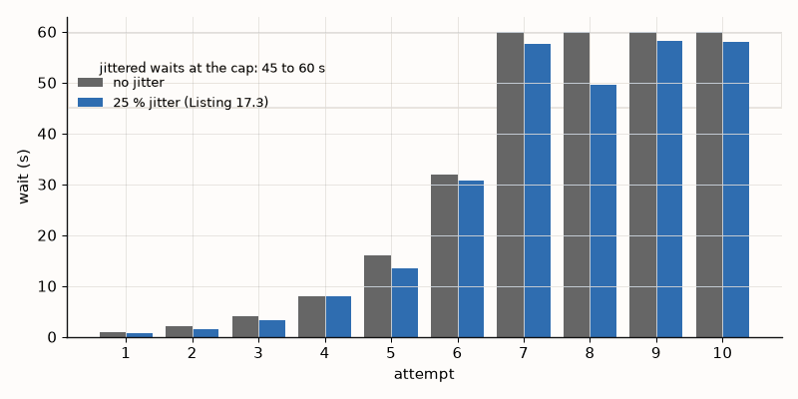
Figure 17.2 — Reconnect waits over ten failed attempts (Worked Example 17.3): exponential back-off capped at 60 s without jitter (gray) and one node's waits with up to 25 % jitter from Listing 17.3 (blue). The shaded band at the cap shows where jittered retries fall, 45 to 60 s.
Listing 17.4 — The PC side: a paho-mqtt subscriber that writes every reading to a CSV file and survives a malformed payload (Python).
"""PC side: subscribe to the garden node and append every reading to a CSV file."""
import csv
import json
from datetime import datetime, timezone
import paho.mqtt.client as mqtt
BROKER = "localhost" # Mosquitto on the PC or the Pi 5
TOPIC = "lab/garden/#"
def on_message(client, userdata, msg):
try:
data = json.loads(msg.payload)
except ValueError:
print("bad payload on", msg.topic, msg.payload[:40])
return
row = [datetime.now(timezone.utc).isoformat(timespec="seconds"), msg.topic,
data.get("t"), data.get("h"), data.get("p")]
with open("garden.csv", "a", newline="") as f:
csv.writer(f).writerow(row)
print(*row)
client = mqtt.Client(mqtt.CallbackAPIVersion.VERSION2)
client.on_message = on_message
client.on_connect = lambda c, u, flags, rc, props: c.subscribe(TOPIC, qos=1)
client.connect(BROKER, 1883, keepalive=60)
client.loop_forever()
Key idea. Write connected firmware for the bad day: event-driven connection handling, credentials outside the source, reconnect forever with back-off and jitter, and a last will so the rest of the system knows when a node is gone.
Common misconception. Testing the network code only on a good link. Unplug the router, restart the broker, fill the Wi-Fi band with traffic, and power-cycle all nodes together before calling it done; those are the failures the field delivers in the first month.
AI Pair-Programming Note
Assistants generate connect-and-publish examples that work on the first run and contain a retry loop with no delay, a password in a string literal, and a blocking wait for Wi-Fi in the sensor loop. Put "reconnect with back-off and jitter, credentials from configuration, sensor loop never blocks on the network" in the prompt's constraints, and check each in review.
On the Job
On the Job: In a product team the broker, the topic tree, and the payload format are usually owned by a backend or cloud colleague, not the firmware engineer. Agree them in writing (step 1 of the method, shared) before either side writes code, and version the payload with a field such as "v":1 from day one. The most expensive bug in connected products is a payload change that the server and half the deployed devices understand differently.
From the Bench
Run mosquitto_sub -v -t "lab/#" in a terminal on the PC or Pi whenever a networked node is on the bench. It shows every message with its topic, so a misspelled topic, a missing decimal, or a node that went silent is visible at once without any dashboard.

Practice
1. (Core) Which subscribers receive a message published to lab/garden/bme280: lab/#, lab/garden/+, lab/+/status, #?
2. (Core) Find the PUBLISH packet size at QoS 0 for topic home/t (6 bytes) and payload 21.5 (4 bytes).
3. (Core) What do retained messages and the last will each solve?
4. (Core) Why must a Wi-Fi password never be a string literal in the source?
5. (Extension) The keepalive is 120 s. Within what time, at most, does the broker publish the last will of a node that lost power?
6. (Extension) Two hundred nodes retry with jitter of up to 25 % at the 60 s cap. On average how many retries per second reach the broker?
7. (Extension) A node publishes with QoS 1 and the subscriber counts messages. Over a week it counts 10 082 for 10 080 minutes. What happened, and how should the subscriber handle it?
8. (Challenge) Design the binary payload for the same reading (temperature, humidity, pressure, plus a 1-byte version and a 1-byte sequence number) and find the QoS 0 packet size with the same topic. Compare with Worked Example 17.2.

What You’ll Actually Use
Everyday working tools
- Event-driven Wi-Fi with reconnect on every disconnect.
- Credentials in configuration, never in the source or git.
- MQTT topics, wildcards, QoS 0/1, retained messages, last will, keepalive.
- Exponential back-off with jitter.
- mosquitto_sub -v on the bench; a payload version field from day one.
Mostly for exams and deeper study
- QoS 2 and MQTT 5 features (user properties, shared subscriptions); learn them when a project needs them.

Chapter 18. BLE, LoRa, and GPS Firmware
The LoRa node sent its readings once a minute, as JSON, because that was how the Wi-Fi version did it. On the bench everything arrived. On The Things Network, the 32-byte application payload plus 13 bytes of LoRaWAN overhead takes about 308 ms on air at SF9: roughly 444 seconds per day, almost fifteen times the network’s 30-second daily allowance. The 8-byte payload still takes about 185 ms per LoRaWAN uplink, or 267 seconds per day at one message a minute. At this rate and without extra MAC commands or retries, one message every ten minutes uses about 26.7 seconds a day. The raw-LoRa figures are shorter because they omit LoRaWAN overhead. On Wi-Fi bytes are free; on LoRa every byte is airtime, and airtime is regulated. Each radio in this chapter shapes the firmware differently.
Where you meet this: Fitness trackers and phone-connected gadgets (BLE), farm, water, and city sensors kilometers from any router (LoRa), asset trackers, drones, and anything that needs position or exact time (GPS).

18.1 BLE: services and characteristics
Bluetooth Low Energy organizes data as a GATT server: services, each a group of characteristics, each a small value with a UUID and properties such as read, write, and notify. The Bluetooth SIG defines standard services with 16-bit UUIDs, and using them means any generic app (nRF Connect, for example) understands the device without custom code. The Environmental Sensing service, 0x181A, fits the garden node: Temperature 0x2A6E as a signed 16-bit value in 0.01 °C, Humidity 0x2A6F as an unsigned 16-bit value in 0.01 %, and Pressure 0x2A6D as an unsigned 32-bit value in 0.1 Pa, all little-endian. A peripheral advertises until a phone connects, then sends notifications when values change. The ESP32-S3 runs BLE from ESP-IDF, Arduino, or MicroPython; the nRF52840 is the low-power specialist, usually programmed with Zephyr.
Listing 18.1 — A BLE Environmental Sensing peripheral with three notifying characteristics (MicroPython with aioble on the ESP32-S3).
# MicroPython with aioble: a BLE Environmental Sensing peripheral on the ESP32-S3.
import asyncio
import struct
import aioble
import bluetooth
ESS_UUID = bluetooth.UUID(0x181A) # Environmental Sensing service
TEMP_UUID = bluetooth.UUID(0x2A6E) # Temperature: sint16, 0.01 degC
HUM_UUID = bluetooth.UUID(0x2A6F) # Humidity: uint16, 0.01 %
PRES_UUID = bluetooth.UUID(0x2A6D) # Pressure: uint32, 0.1 Pa
ADV_INTERVAL_US = 250_000 # advertise every 250 ms
ess = aioble.Service(ESS_UUID)
temp_c = aioble.Characteristic(ess, TEMP_UUID, read=True, notify=True)
hum_c = aioble.Characteristic(ess, HUM_UUID, read=True, notify=True)
pres_c = aioble.Characteristic(ess, PRES_UUID, read=True, notify=True)
aioble.register_services(ess)
def read_sensor():
return 23.41, 45.2, 1013.25 # from the Chapter 9 driver
async def sensor_task():
while True:
t, h, p = read_sensor()
temp_c.write(struct.pack("<h", round(t * 100)), send_update=True) # little-endian
hum_c.write(struct.pack("<H", round(h * 100)), send_update=True)
pres_c.write(struct.pack("<I", round(p * 1000)), send_update=True) # hPa -> 0.1 Pa
await asyncio.sleep_ms(2000)
async def advertise_task():
while True:
async with await aioble.advertise(ADV_INTERVAL_US, name="garden-node",
services=[ESS_UUID]) as connection:
print("connected:", connection.device)
await connection.disconnected(timeout_ms=None)
async def main():
await asyncio.gather(sensor_task(), advertise_task())
asyncio.run(main())

Worked Example 18.1: Encoding the characteristics
Problem. Encode 23.41 °C, 45.2 %, and 1013.25 hPa as the three Environmental Sensing characteristics, byte by byte.
Solution. Temperature: 23.41/0.01 = 2341 = 0x0925, sent little-endian as 25 09. Humidity: 45.2/0.01 = 4520 = 0x11A8, sent as A8 11. Pressure: 1013.25 hPa = 101 325 Pa = 1 013 250 units of 0.1 Pa = 0x000F7602, sent as 02 76 0F 00. The usual mistake is big-endian order (09 25), which a phone app shows as 94.77 °C, or pressure in hPa instead of 0.1 Pa, which reads as a near vacuum.

18.2 LoRa: every byte is airtime
LoRa trades data rate for range: a higher spreading factor (SF7 to SF12) makes each symbol longer and the link more robust, and every step roughly doubles the airtime. The modulation and the airtime formula are Book 5's; the firmware consequences are three. Pack the data in binary, with fixed scaling, not as text. Respect the duty-cycle limit of the band (1 % in the common EU 868 MHz sub-bands, so a 124 ms packet allows one transmission per 12.4 s) and any network policy. And decide between raw LoRa point to point and LoRaWAN, which adds a network server, encryption, and device management.
Listing 18.2 — Packing the garden reading into 8 bytes with fixed scaling, big-endian, and unpacking it on the gateway (C, runs on the PC).
// Pack one garden reading into 8 bytes for LoRa, and unpack it again.
// Pure C, runs on the PC; the same functions run on the node and on the gateway.
#include <stdint.h>
#include <stdio.h>
#include <math.h>
typedef struct {
uint8_t version, seq;
float t_c, rh, p_hpa, vbat;
} reading_t;
static void put16(uint8_t *b, uint16_t v) { b[0] = (uint8_t)(v >> 8); b[1] = (uint8_t)v; } // big-endian
static uint16_t get16(const uint8_t *b) { return (uint16_t)((b[0] << 8) | b[1]); }
static int clampi(long v, long lo, long hi) { return (int)(v < lo ? lo : v > hi ? hi : v); }
void pack(const reading_t *r, uint8_t out[8])
{
out[0] = r->version;
out[1] = r->seq;
put16(&out[2], (uint16_t)(int16_t)clampi(lround(r->t_c * 100.0f), -32768, 32767)); // 0.01 degC
out[4] = (uint8_t)clampi(lround(r->rh * 2.0f), 0, 200); // 0.5 %
put16(&out[5], (uint16_t)clampi(lround(r->p_hpa * 10.0f), 0, 65535)); // 0.1 hPa
out[7] = (uint8_t)clampi(lround((r->vbat - 2.5f) * 50.0f), 0, 255); // 20 mV from 2.5 V
}
void unpack(const uint8_t in[8], reading_t *r)
{
r->version = in[0];
r->seq = in[1];
r->t_c = (int16_t)get16(&in[2]) / 100.0f;
r->rh = in[4] / 2.0f;
r->p_hpa = get16(&in[5]) / 10.0f;
r->vbat = 2.5f + in[7] / 50.0f;
}
int main(void)
{
reading_t r = { 1, 42, 23.41f, 45.2f, 1013.25f, 3.86f }, back;
uint8_t buf[8];
pack(&r, buf);
for (int i = 0; i < 8; i++) printf("%02X ", buf[i]);
unpack(buf, &back);
printf("\n-> v%u #%u %.2f C %.1f %% %.1f hPa %.2f V\n",
back.version, back.seq, back.t_c, back.rh, back.p_hpa, back.vbat);
r.t_c = -12.5f; pack(&r, buf); unpack(buf, &back);
printf("negative check: %.2f C\n", back.t_c);
return 0;
}

Worked Example 18.2: JSON or 8 bytes
Problem. Compare the airtime of the 32-byte JSON payload of Chapter 17 with the 8-byte binary payload of Listing 18.2 at SF9, 125 kHz, coding rate 4/5, 8-symbol preamble, explicit header and CRC. Then check one message per minute against The Things Network's fair-use limit of 30 s of uplink airtime per day.
Solution. For raw LoRa at SF9, Book 5’s formula gives 123.9 ms for an 8-byte packet and 246.8 ms for a 32-byte packet. Those figures do not include LoRaWAN framing. With the 13-byte LoRaWAN overhead and no extra MAC commands, an 8-byte application payload becomes a 21-byte on-air payload and takes 185.3 ms; a 32-byte application payload becomes 45 bytes and takes 308.2 ms. On The Things Network, one 32-byte message per minute therefore uses about 444 seconds of airtime per day, nearly 14.8 times the 30-second allowance. An 8-byte message per minute uses about 267 seconds, nearly 8.9 times the allowance. For the 8-byte payload, 30/0.1853 gives at most 161 messages per day, or an average interval of about 8 minutes 57 seconds. A ten-minute interval uses about 26.7 seconds per day and leaves a small margin for this example; added MAC commands, retries, or a different data rate require a fresh calculation. The EU 1 % duty-cycle rule is a separate limit, not a substitute for the network policy.
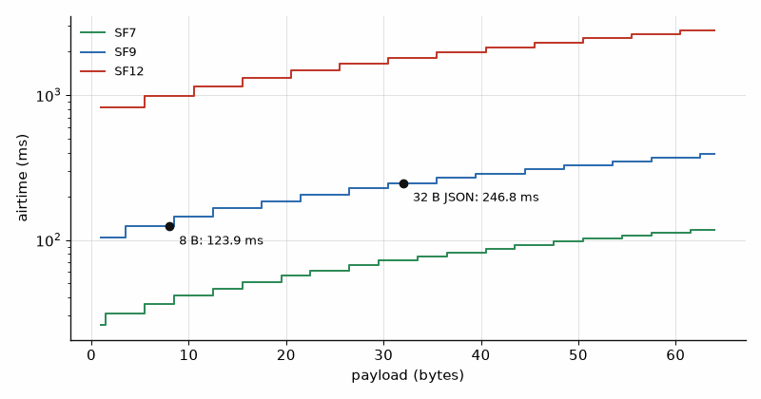
Figure 18.1 — LoRa airtime against payload size at 125 kHz and coding rate 4/5 for SF7, SF9, and SF12 (Book 5's formula). The marked points are the 8-byte binary payload (123.9 ms) and the 32-byte JSON payload (246.8 ms) at SF9 from Worked Example 18.2.
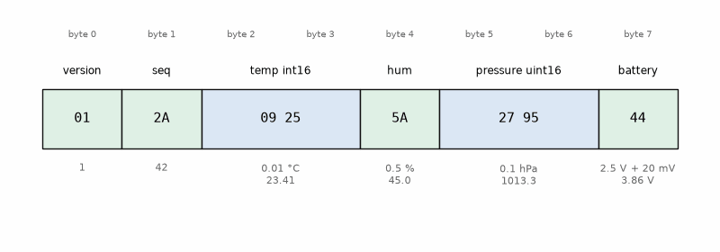
Figure 18.2 — The 8-byte LoRa payload of Listing 18.2: version, sequence number, temperature (int16, 0.01 °C), humidity (uint8, 0.5 %), pressure (uint16, 0.1 hPa), and battery (uint8, 20 mV steps from 2.5 V), with the bytes of the example reading.
Listing 18.3 — Raw LoRa point-to-point transmission with a compile-time check of the EU duty-cycle interval (Arduino C++ on the ESP32-S3). This is not a LoRaWAN client.
// Arduino + RadioLib: send the 8-byte reading on an SX1276 (RFM95W) module from the ESP32-S3.
// EU 868 MHz, SF9, BW 125 kHz, CR 4/5; use 915 MHz in the Americas.
#include <Arduino.h>
#include <RadioLib.h>
// Pins: NSS, DIO0, RESET, DIO1 (from the spec's pin table)
SX1276 radio = new Module(10, 4, 5, 6);
extern void pack_reading(uint8_t out[8]); // Listing 18.2, called with the latest reading
const uint32_t TX_INTERVAL_MS = 600000; // one reading every ten minutes
const uint32_t MIN_INTERVAL_MS = 12400; // 1 % duty cycle for 123.9 ms airtime
static_assert(TX_INTERVAL_MS >= MIN_INTERVAL_MS, "interval breaks the 1 % duty-cycle limit");
uint32_t last_tx = 0;
void setup()
{
Serial.begin(115200);
int state = radio.begin(868.1f, 125.0, 9, 5, RADIOLIB_SX127X_SYNC_WORD, 14, 8);
if (state != RADIOLIB_ERR_NONE) {
Serial.printf("radio init failed, code %d\n", state);
while (true) delay(1000);
}
}
void loop()
{
if (millis() - last_tx >= TX_INTERVAL_MS) {
uint8_t buf[8];
pack_reading(buf);
uint32_t t0 = millis();
int state = radio.transmit(buf, sizeof buf);
last_tx = millis();
Serial.printf("tx %s, %lu ms on air\n",
state == RADIOLIB_ERR_NONE ? "ok" : "failed", (unsigned long)(last_tx - t0));
}
}
RadioLib’s transmit call here sends raw LoRa; it does not implement LoRaWAN or connect to The Things Network. The ten-minute interval is for this example’s payload and settings. A LoRaWAN device must include protocol overhead, optional MAC commands, retries, and its current data rate when checking network airtime. Regulatory duty-cycle limits and a network’s fair-use policy are separate constraints.

18.3 GPS firmware
A GPS module is a UART device that talks NMEA sentences (Chapter 9), by default often at 9600 baud and one fix per second. The firmware decisions are around it. A fix takes time: about half a minute from a cold start, a second or two from a hot start, which needs the module's backup battery or supply to keep the almanac and time. The module typically draws 20 to 30 mA while tracking, so a battery node switches it off between fixes or uses the module's own power-save modes. Many modules accept binary configuration commands (UBX on u-blox parts) to change the rate, the sentences, and the baud rate. And the PPS (pulse per second) output, aligned to UTC within well under a microsecond on good modules, makes GPS the best clock most projects will ever have: connect it to an interrupt pin and timestamp against it.
Listing 18.4 — GPS helpers: the haversine distance between fixes, the NMEA checksum, and speed from an RMC sentence (Python, runs on the PC or the Pi).
"""GPS helpers for the PC or the Pi: distance between fixes, and an RMC speed parser."""
import math
R_EARTH = 6_371_000.0 # mean Earth radius, m
def haversine_m(lat1, lon1, lat2, lon2):
p1, p2 = math.radians(lat1), math.radians(lat2)
dphi, dlmb = p2 - p1, math.radians(lon2 - lon1)
a = math.sin(dphi / 2) ** 2 + math.cos(p1) * math.cos(p2) * math.sin(dlmb / 2) ** 2
return 2 * R_EARTH * math.asin(math.sqrt(a))
def nmea_checksum_ok(sentence):
body, _, given = sentence.strip().lstrip("$").partition("*")
calc = 0
for ch in body:
calc ^= ord(ch)
return given != "" and calc == int(given[:2], 16)
def rmc_speed_kmh(sentence):
"""Speed over ground from $GPRMC or $GNRMC, in km/h; None without a valid fix."""
if not nmea_checksum_ok(sentence):
return None
f = sentence.split("*")[0].split(",")
if not f[0].endswith("RMC") or f[2] != "A" or f[7] == "":
return None
return float(f[7]) * 1.852 # knots to km/h
if __name__ == "__main__":
d = haversine_m(48.1173, 11.5167, 48.1374, 11.5755)
print("GGA fix to Marienplatz: %.0f m" % d)
print("1e-5 deg of latitude: %.2f m" % haversine_m(48.0, 11.0, 48.00001, 11.0))
s = "$GPRMC,123519,A,4807.038,N,01131.000,E,022.4,084.4,230394,003.1,W*6A"
print("RMC checksum ok:", nmea_checksum_ok(s), " speed %.1f km/h" % rmc_speed_kmh(s))

Worked Example 18.3: What the digits mean
Problem. The GGA sentence of Chapter 9 places the node at 48.1173° N, 11.5167° E. How far is that from Munich's Marienplatz at 48.1374° N, 11.5755° E, and how much distance does the last digit of a fifth decimal place represent?
Solution. Listing 18.4 gives 4903 m by the haversine formula. One unit in the fifth decimal of latitude, 0.00001°, is 1.11 m; NMEA's 4807.038 format has a resolution of 0.001 minute = 1.85 m. Neither is the accuracy: a consumer module is typically good to a few meters in the open and much worse between buildings, so averaging or fusing with the IMU (Chapter 16) matters more than extra digits.
Key idea. Each radio shapes the firmware: BLE through standard services and little-endian characteristics, LoRa through airtime and duty cycle, GPS through fix time, power, and its PPS clock.
Common misconception. Treating a LoRa node like a Wi-Fi node with a longer range. Text payloads, frequent messages, and acknowledgments for everything break the duty-cycle limit and the network's policy. Design the payload in bytes, and send only what changed or what is due.
AI Pair-Programming Note
Ask an assistant for LoRa code and it often mixes libraries (RadioLib calls with another library's constructor), picks 915 MHz for an EU node or the reverse, or omits the duty-cycle check. Name the library, its version, the module, the band, and the duty-cycle limit in the prompt, and compile against the real library before trusting any of it.
From the Bench
Use a phone app such as nRF Connect for every BLE peripheral: it lists the services, decodes the standard characteristics, and shows notifications as they arrive. If the app shows 94.77 °C, the bytes are in the wrong order; if it shows nothing, the characteristic is not notifying, or the phone never subscribed.

Practice
1. (Core) Encode −5.20 °C as the BLE Temperature characteristic.
2. (Core) Unpack the LoRa payload 01 07 FF 06 64 27 9F 32 with the scaling of Listing 18.2.
3. (Core) At the EU 1 % duty cycle, how often may a node send a 246.8 ms packet?
4. (Core) Why is the PPS output more useful for timekeeping than the time in the NMEA sentence?
5. (Extension) An 8-byte application payload becomes a 21-byte on-air LoRaWAN packet after 13 bytes of overhead. At SF7, 125 kHz, coding rate 4/5, its airtime is about 56.6 ms. How many messages per day fit into The Things Network’s 30 s fair-use limit? What interval would you choose to leave room for retries?
6. (Extension) A GPS module draws 25 mA and needs 30 s for a fix from cold and 2 s from hot. Compare the charge per fix and explain the role of the backup supply.
7. (Extension) Why do BLE standard characteristics use fixed-point integers rather than floats?
8. (Challenge) Design a payload for a GPS tracker on LoRa: latitude and longitude to about 1 m, battery, and a sequence number. How many bytes, and what is the scaling?

What You’ll Actually Use
Everyday working tools
- Standard BLE services and characteristics (Environmental Sensing 0x181A); little-endian, fixed-point values.
- nRF Connect on a phone for every BLE test.
- Binary LoRa payloads with fixed scaling and a version byte.
- Airtime, the duty cycle, and the network's fair-use policy before choosing the message rate.
- GPS: cold and hot start, power switching, and PPS for time.
Mostly for exams and deeper study
- The full GATT and LoRaWAN specifications; learn the parts your project uses.

Chapter 19. OTA Updates and Security Basics
Two hundred sensor nodes went onto lamp posts with no over-the-air update. When a reconnect bug appeared, each repair required a cherry picker, a ladder, a laptop, and a USB cable. A later deployment had OTA, but accepted unsigned images over plain HTTP. The first design made every correction a field visit; the second let a nearby attacker choose the firmware. A useful update path must recover from a bad release and reject code the owner did not approve. This chapter treats both as product requirements, because the workshop is not where either failure will be found.
Where you meet this: Every connected product, from smart plugs to cars; regulators increasingly require secure updates and a vulnerability process, so this is now part of the job description, not an extra.

19.1 How OTA works on the ESP32-S3
On the ESP32-S3, this A/B pattern keeps the current image available while the other slot is written. Other platforms use different bootloaders, partition layouts, and rollback guarantees; check the target documentation rather than assuming they behave the same way.
Listing 19.1 — A partition table for 8 MB of flash: NVS, OTA data, two 3 MB application slots, and a file-system partition (ESP-IDF CSV).
# ESP-IDF partition table for an 8 MB flash with two OTA slots
# Name, Type, SubType, Offset, Size
nvs, data, nvs, 0x9000, 0x6000
otadata, data, ota, 0xf000, 0x2000
phy_init, data, phy, 0x11000, 0x1000
ota_0, app, ota_0, 0x20000, 0x300000
ota_1, app, ota_1, 0x320000, 0x300000
storage, data, spiffs, 0x620000, 0x1E0000
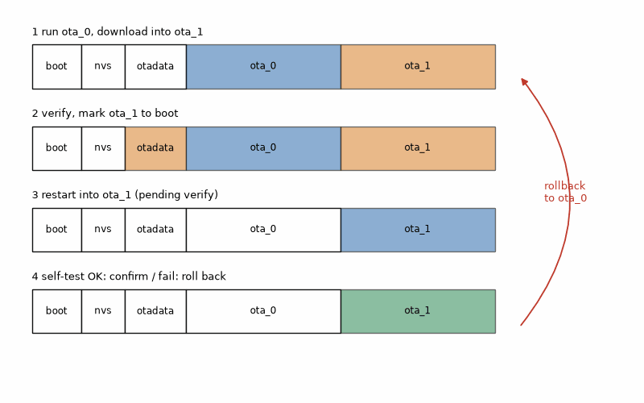
Figure 19.1 — The A/B update of Listing 19.2 in four steps: run from ota_0 and download into ota_1; verify and mark ota_1 to boot; restart into ota_1 in pending-verify state; confirm after the self-test, or roll back to ota_0 on failure or crash.

Worked Example 19.1: Sizing the slots and the download
Problem. The firmware image is 1.2 MB. Check that it fits the partition table of Listing 19.1 with room to grow, and find the download time over Wi-Fi at an effective 2 Mbit/s and the pure airtime over LoRa at SF9 and 125 kHz.
Solution. Each slot is 0x300000 = 3 145 728 bytes; 1.2 MB uses 38 %, leaving room for the firmware to grow to more than twice its size. The partitions end at 0x800000, exactly 8 MB. Over Wi-Fi: 1.2 × 10⁶ × 8 bits/(2 × 10⁶ bit/s) = 4.8 s. Over LoRa the raw bit rate at SF9, 125 kHz, CR 4/5 is 9 × 125 000/512 × 4/5 = 1758 bit/s (Book 5), so the pure airtime is 9.6 × 10⁶/1758 = 5460 s, 1.5 hours; at the EU 1 % duty cycle that becomes 152 hours, more than six days, before any packet overhead or retries. Full-image OTA over LoRa is impractical; LoRa devices update by delta patches, by a different radio, or not at all, and that decision belongs in the spec.
Listing 19.2 — HTTPS OTA with TLS server verification and rollback; signed-image verification must be configured separately (ESP-IDF, C).
// ESP-IDF: download an image over HTTPS into the other OTA slot, then confirm or roll back
// after a self-test. TLS verifies the server; enable Secure Boot V2 or a documented OTA
// signature check separately before describing this as signed-image enforcement. Requires
// CONFIG_BOOTLOADER_APP_ROLLBACK_ENABLE=y for rollback.
#include <stdbool.h>
#include "esp_crt_bundle.h"
#include "esp_https_ota.h"
#include "esp_log.h"
#include "esp_ota_ops.h"
#include "esp_system.h"
static const char *TAG = "ota";
extern bool self_test(void); // sensor answers, Wi-Fi connects, broker reachable
void ota_confirm_or_rollback(void) // call early in app_main
{
const esp_partition_t *running = esp_ota_get_running_partition();
esp_ota_img_states_t state;
if (esp_ota_get_state_partition(running, &state) == ESP_OK &&
state == ESP_OTA_IMG_PENDING_VERIFY) {
if (self_test()) {
ESP_LOGI(TAG, "new image passed self-test, keeping it");
esp_ota_mark_app_valid_cancel_rollback();
} else {
ESP_LOGE(TAG, "self-test failed, rolling back");
esp_ota_mark_app_invalid_rollback_and_reboot();
}
}
}
esp_err_t ota_update(const char *url)
{
esp_http_client_config_t http = {
.url = url,
.crt_bundle_attach = esp_crt_bundle_attach, // verify the server's TLS certificate
.timeout_ms = 10000,
};
esp_https_ota_config_t cfg = { .http_config = &http };
ESP_LOGI(TAG, "downloading %s", url);
esp_err_t err = esp_https_ota(&cfg); // writes the inactive slot, sets it to boot next
if (err == ESP_OK) {
ESP_LOGI(TAG, "image written, restarting");
esp_restart();
}
ESP_LOGE(TAG, "OTA failed: %s", esp_err_to_name(err));
return err; // the running image is untouched
}

19.2 Integrity and authenticity
A SHA-256 hash detects accidental corruption only when the expected hash is trusted. If an attacker can replace both the image and its manifest, the matching hashes prove nothing about who made the image. Authenticity requires a digital signature that the device verifies with a trusted public key before accepting the update. On the ESP32-S3, Secure Boot V2 verifies RSA-3072 signatures when it is enabled and provisioned; ESP-IDF also documents software signature verification for OTA, with different protection limits. The HTTPS call in Listing 19.2 verifies the server certificate; it does not, by itself, configure image-signature verification. Flash encryption protects confidentiality at rest, not authenticity. Its eFuses are one-way, and losing the signing key can strand deployed devices without a valid update path.
Listing 19.3 — Write and check an update manifest with version, size, and SHA-256 (Python, runs on the build PC).
"""Write and check an update manifest: version, size, and SHA-256 of the firmware image."""
import hashlib
import json
import sys
from pathlib import Path
def sha256_file(path, chunk=65536):
h = hashlib.sha256()
with open(path, "rb") as f:
while block := f.read(chunk):
h.update(block)
return h.hexdigest()
def make_manifest(image, version):
p = Path(image)
return {"version": version, "file": p.name, "size": p.stat().st_size, "sha256": sha256_file(p)}
def check(image, manifest):
p = Path(image)
if p.stat().st_size != manifest["size"]:
return "size mismatch"
if sha256_file(p) != manifest["sha256"]:
return "hash mismatch"
return "ok"
if __name__ == "__main__":
if len(sys.argv) != 3:
sys.exit("usage: l19_3_manifest.py firmware.bin 1.4.2")
m = make_manifest(sys.argv[1], sys.argv[2])
Path(sys.argv[1]).with_suffix(".json").write_text(json.dumps(m, indent=2))
print(json.dumps(m, indent=2))
print("check:", check(sys.argv[1], m))

Worked Example 19.2: What the manifest catches
Problem. A 1 200 000-byte image and its manifest are created with Listing 19.3. One byte of the image is then changed. What does the check report, and what attack does the manifest not stop?
Solution. The PC utility reports a hash mismatch: the size still matches, but the changed byte changes the digest. Listing 19.3 demonstrates this check on the build PC; it does not implement on-device rejection. The device must verify a trusted digest or signed manifest before selecting the new image, or use image-signature verification. If an attacker controls the download server, a matching unsigned manifest is not protection. TLS with certificate verification protects the connection against an in-path attacker; it does not protect against a compromised server.

Worked Example 19.3: Counting failed updates in a fleet
Problem. A staged rollout to 10 000 devices measures a 0.1 % unrecoverable first-boot failure rate. How many devices need another recovery path after one rollout? What changes if automatic rollback succeeds?
Solution. 10 000 × 0.001 = 10 devices. That is a scenario calculation, not a forecast or an acceptable target. If rollback is verified, those devices are service outages until the old image reconnects and resumes reporting; they are not counted as recovered merely because the bootloader selected the previous slot. Across a fleet, record the denominator, the failure definition, the recovery time, and the result by hardware and firmware version.

19.3 A security baseline for small devices
Security baseline for a connected node
- No default passwords: unique credentials per device, set at provisioning.
- No secrets in the source or in git; keys in NVS (encrypted) or a secure element.
- TLS with certificate verification for every connection that carries commands or updates.
- Signed updates (Secure Boot V2 or MCUboot) with rollback protection.
- JTAG and the serial bootloader disabled or locked in production.
- Every input from the network length-checked and range-checked before use.
- A way to report vulnerabilities, and a plan for how long the product gets updates.
The EU Cyber Resilience Act sets cybersecurity requirements for products with digital elements, including vulnerability handling and security updates. Its reporting obligations apply from 11 September 2026; its main obligations apply from 11 December 2027. As of this 2026 snapshot, Delegated Regulation (EU) 2022/30 under the Radio Equipment Directive also imposes cybersecurity requirements on specified categories of radio equipment; that delegated regulation is repealed from 11 December 2027 as the Cyber Resilience Act takes full effect. Check the rules and product scope for your market at design time; the engineering baseline is the same.
Key idea. Plan updates on day one: two slots, a self-test that confirms or rolls back, TLS server verification, and independent image-signature verification. If the new image cannot reach the broker but confirms itself anyway, the deployed node can remain unreachable until another recovery path exists; for a fleet, count those nodes as unavailable until recovery is demonstrated, not merely until the reboot completes. A hash checks integrity only against a trusted expected value; a signature checks who approved the image.
Common misconception. Enabling secure boot or flash encryption on the only prototype to see what happens. The eFuses are one-time, and a wrong key or a development setting burned into the chip can leave a board that never boots unsigned code again. Follow the vendor's development-mode instructions on a spare board first.
AI Pair-Programming Note
Apply Chapter 1's AI rule. Check TLS, image signatures, rollback, and eFuse settings against this ESP-IDF version. A successful download proves none of the failure paths. A measured 0.1 % unrecoverable first-boot rate corresponds to 1 affected device per 1 000 updated devices, or 10 in a rollout of 10 000. That is arithmetic, not a reliability target. Replace it with staged-rollout results and a tested recovery time before promising a service level.
On the Job
On the Job: Keep the production signing key on a build server or HSM, not developer laptops. Limit access, document key replacement, and require firmware to reject images without that signature.
From the Bench
Interrupt Wi-Fi, serve a truncated image, alter an image, and force the self-test to fail. In each case, verify that the old image boots, reconnects, and resumes reporting. A bootloader message is encouraging; the device returning to its service is the test.

Practice
1. (Core) Why does an OTA scheme need two application slots?
2. (Core) A 1.6 MB image is downloaded at an effective 1 Mbit/s. How long does it take?
3. (Core) What is the difference between a hash and a signature in an update?
4. (Core) Name three items of the security baseline that cost almost nothing to implement.
5. (Extension) The firmware grows to 3.4 MB. What happens with the partition table of Listing 19.1, and what are the options?
6. (Extension) Why should the self-test run before esp_ota_mark_app_valid_cancel_rollback, and what should it check for the garden node?
7. (Extension) A product ships with the same Wi-Fi access-point password, "admin123", on every unit. What is the risk, and what is the fix?
8. (Challenge) For a 4 kB LoRa update, find packet count, airtime, and EU 1% duty-cycle time with 50-byte payloads (2-byte sequence number) and 0.33 s per packet.

What You’ll Actually Use
Everyday working tools
- A/B partitions, pending-verify, self-test, confirm or roll back.
- Slot size against image size, with room to grow.
- Hash for integrity, signature for authenticity, TLS with certificate checks.
- Secure Boot V2 and flash encryption, practiced on a spare board first.
- The security baseline box as a review checklist item.
Mostly for exams and deeper study
- Cryptographic details and regulation text; consult primary sources when needed.

Chapter 20. Cameras, Point Clouds, and Edge AI
A light pulse leaves the sensor, hits a wall one meter away, and comes back 6.7 nanoseconds later. To tell one meter from one meter and one centimeter, the chip must resolve 67 picoseconds, the time light needs for two centimeters. The VL53L1X, a chip a few millimeters across, does this thousands of times per measurement and hands the firmware a single number in millimeters. A camera hands it 150 000 bytes per frame instead, and an event camera a stream of individual pixel changes with microsecond timestamps. This chapter is about turning those three kinds of optical data into decisions on small hardware.
Where you meet this: Doorbells and wildlife cameras, robot vacuums, gesture and presence sensors in phones and laptops, drones that avoid obstacles, industrial inspection, and every product described as having "AI on the edge".

20.1 A camera on the ESP32-S3
The ESP32-S3 boards with a camera, such as the ESP32-S3-EYE and its many clones, connect an OV2640 or similar sensor through an 8-bit parallel interface plus a configuration bus (SCCB, a dialect of I2C). The esp32-camera component configures the sensor and fills frame buffers by DMA. Three choices dominate. The pixel format: JPEG compressed by the sensor itself, or raw RGB565 or grayscale for image processing. The frame size. And where the buffers live: raw frames are large, so they go in PSRAM. The camera also takes most of the free GPIO, so the spec's pin table must be redone: on the ESP32-S3-EYE pinout, GPIO 8 and 9, the reader lab's I2C pins, become camera data lines, and the BME280 moves.
Listing 20.1 — Camera setup for an ESP32-S3-EYE-style board: QVGA JPEG with two frame buffers in PSRAM, and a frame-rate measurement (ESP-IDF with esp32-camera, C).
// ESP-IDF + esp32-camera: OV2640 on an ESP32-S3-EYE-style board, QVGA JPEG, frame buffers in PSRAM.
#include "esp_camera.h"
#include "esp_log.h"
#include "esp_timer.h"
static const char *TAG = "cam";
esp_err_t camera_start(void)
{
camera_config_t c = {
.pin_pwdn = -1, .pin_reset = -1, .pin_xclk = 15,
.pin_sccb_sda = 4, .pin_sccb_scl = 5,
.pin_d7 = 16, .pin_d6 = 17, .pin_d5 = 18, .pin_d4 = 12,
.pin_d3 = 10, .pin_d2 = 8, .pin_d1 = 9, .pin_d0 = 11,
.pin_vsync = 6, .pin_href = 7, .pin_pclk = 13,
.xclk_freq_hz = 20000000,
.ledc_timer = LEDC_TIMER_0, .ledc_channel = LEDC_CHANNEL_0,
.pixel_format = PIXFORMAT_JPEG, // the sensor compresses; RGB565 would be 153 600 bytes
.frame_size = FRAMESIZE_QVGA, // 320 x 240
.jpeg_quality = 12, // 0..63, lower is better quality
.fb_count = 2, // capture the next frame while this one is used
.fb_location = CAMERA_FB_IN_PSRAM,
.grab_mode = CAMERA_GRAB_LATEST,
};
return esp_camera_init(&c);
}
void camera_measure(int frames)
{
int64_t t0 = esp_timer_get_time();
size_t bytes = 0;
for (int i = 0; i < frames; i++) {
camera_fb_t *fb = esp_camera_fb_get();
if (!fb) { ESP_LOGE(TAG, "capture failed"); continue; }
bytes += fb->len; // use fb->buf here: send, save, or analyze
esp_camera_fb_return(fb); // always give the buffer back
}
int64_t us = esp_timer_get_time() - t0;
ESP_LOGI(TAG, "%d frames, %.1f fps, %u bytes per frame",
frames, frames * 1e6 / (double)us, (unsigned)(bytes / (frames ? frames : 1)));
}

Worked Example 20.1: The frame budget
Problem. Find the size of one QVGA (320 × 240) frame in RGB565 and of two buffers, the data rate of 640 × 480 RGB at 30 frames per second, and the Wi-Fi rate of a QVGA JPEG stream at about 10 kB per frame and 25 frames per second.
Solution. QVGA RGB565: 320 × 240 × 2 = 153 600 bytes; two buffers 307 200 bytes, most of the ESP32-S3's 512 kB internal SRAM, which Wi-Fi and FreeRTOS also need, so the buffers go in PSRAM. VGA RGB at 30 fps: 640 × 480 × 3 × 30 = 27.6 MB/s, far more than the chip can move or process, which is why the sensor's JPEG engine matters. The JPEG stream: 10 kB × 25 = 250 kB/s = 2 Mbit/s, comfortable on Wi-Fi. Image analysis on the S3 therefore works on small grayscale frames (96 × 96 for many person-detection models) while JPEG goes to the network.
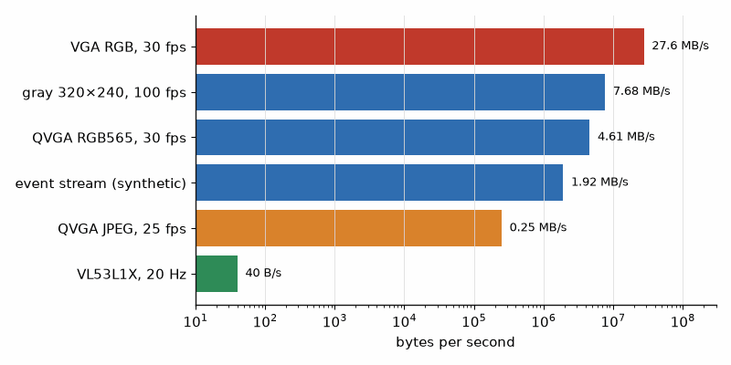
Figure 20.1 — Data rates of the optical sources in this chapter on a logarithmic axis (Worked Examples 20.1 and 20.4): VGA RGB at 30 fps 27.6 MB/s, QVGA RGB565 at 30 fps 4.6 MB/s, 320 × 240 grayscale at 100 fps 7.7 MB/s, the synthetic event stream 1.9 MB/s, a QVGA JPEG stream 0.25 MB/s, and a VL53L1X at 20 Hz, 40 bytes per second.

20.2 Time of flight: one number, many photons
A direct time-of-flight sensor sends short infrared pulses (940 nm on the VL53L1X) and times their return with single-photon detectors (SPADs) and a time-to-digital converter. The round trip takes 2d/c, so one centimeter of distance is 66.7 ps of time. No single photon is timed that precisely; the sensor builds a histogram from thousands of pulses during its timing budget, and the peak gives the distance to a millimeter. The photonics are Book 3's. For the firmware the VL53L1X is an I2C device at address 0x29 with 16-bit register addresses, a model ID of 0xEA at register 0x010F, a timing budget from 20 ms (short mode only) or 33 ms (all modes) up to 1000 ms, and up to 50 measurements per second. Longer budgets reach farther: about 140 ms for the full 4 m in long mode.
t = 2d/c, Δt per 1 cm = 2 × 0.01 m/(3 × 10⁸ m/s) = 66.7 ps
Listing 20.2 — Identifying a VL53L1X by its 16-bit model-ID register, then continuous ranging at 20 Hz with the Pololu library (Arduino C++ on the ESP32-S3).
// Arduino on the ESP32-S3: identify a VL53L1X by its 16-bit model-ID register,
// then range continuously with the Pololu VL53L1X library.
#include <Arduino.h>
#include <Wire.h>
#include <VL53L1X.h>
const uint8_t ADDR = 0x29; // 7-bit address (0x52 in 8-bit notation)
VL53L1X tof;
static int read_reg8(uint16_t reg) // VL53L1X registers have 16-bit addresses
{
Wire.beginTransmission(ADDR);
Wire.write(reg >> 8);
Wire.write(reg & 0xFF);
if (Wire.endTransmission(false) != 0) return -1; // repeated start
if (Wire.requestFrom(ADDR, (uint8_t)1) != 1) return -1;
return Wire.read();
}
void setup()
{
Serial.begin(115200);
Wire.begin(1, 2, 400000); // SDA 1, SCL 2: the camera board uses 8 and 9
int id = read_reg8(0x010F), type = read_reg8(0x0110);
Serial.printf("model id 0x%02X (expect 0xEA), module type 0x%02X (expect 0xCC)\n", id, type);
if (id != 0xEA || !tof.init()) {
Serial.println("VL53L1X not found");
while (true) delay(1000);
}
tof.setTimeout(500);
tof.setDistanceMode(VL53L1X::Long);
tof.setMeasurementTimingBudget(50000); // 50 ms, in microseconds
tof.startContinuous(50); // one measurement every 50 ms, 20 Hz
}
void loop()
{
uint16_t mm = tof.read(); // waits for the next result
if (tof.timeoutOccurred()) Serial.println("timeout");
else Serial.printf("%u mm\n", mm);
}

Worked Example 20.2: Light against sound
Problem. Compare the round-trip time for 1 m and the time per centimeter of the VL53L1X with the ultrasonic sensor of Chapter 7 (sound at 343 m/s), and find the measurement rate at a 50 ms timing budget.
Solution. Light: 2 × 1 m/(3 × 10⁸ m/s) = 6.67 ns for 1 m, 66.7 ps per centimeter. Sound: 2 × 1 m/343 m/s = 5.83 ms for 1 m, 58.3 µs per centimeter, almost a million times slower, which is why the ultrasonic sensor can be timed with a GPIO interrupt and the ToF sensor needs dedicated silicon. At a 50 ms budget the VL53L1X delivers 1/0.050 = 20 readings per second, and the 2-byte result is 40 bytes per second on the bus.

20.3 Point clouds
A multizone ToF sensor (the VL53L5CX reports an 8 × 8 grid over 45° by 45°), a 2-D LiDAR, a depth camera, and the radar of Chapter 16 all produce the same kind of data: a set of points in space. Each zone or beam has a direction; its range along that direction becomes x, y, z. Once the data is a point cloud, the same tools apply to every source: fit planes to find the floor or a wall, cluster points into objects, drop points into a grid (Chapter 16's occupancy grid), and compare clouds to find motion. A microcontroller handles 64 points per frame comfortably; tens of thousands of LiDAR points per second belong on the Pi 5, with NumPy or the Open3D library.
Listing 20.3 — Converting an 8 × 8 multizone ToF frame into a point cloud and fitting a plane (Python with NumPy).
"""Turn an 8 x 8 multizone ToF depth frame into a point cloud and fit the floor plane."""
import numpy as np
ZONES, FOV_DEG = 8, 45.0 # VL53L5CX-class sensor: 8 x 8 zones, 45 x 45 deg
def zone_angles():
step = np.radians(FOV_DEG) / ZONES
a = (np.arange(ZONES) - (ZONES - 1) / 2) * step # zone centers, radians
return np.meshgrid(a, a) # azimuth (columns), elevation (rows)
def to_points(depth_mm):
"""Each zone reports range along its own ray; convert to x (right), y (up), z (forward), meters."""
az, el = zone_angles()
r = depth_mm / 1000.0
x = r * np.cos(el) * np.sin(az)
y = r * np.sin(el)
z = r * np.cos(el) * np.cos(az)
pts = np.stack([x, y, z], axis=-1).reshape(-1, 3)
return pts[np.isfinite(pts).all(axis=1)]
def fit_plane(pts):
"""Least-squares plane through the points: returns unit normal and rms distance."""
c = pts.mean(axis=0)
_, _, vt = np.linalg.svd(pts - c)
n = vt[-1]
return n, float(np.sqrt(np.mean(((pts - c) @ n) ** 2)))
if __name__ == "__main__":
# Synthetic frame: the sensor looks at a flat wall 1.000 m ahead, with 5 mm range noise.
az, el = zone_angles()
rng = np.random.default_rng(1)
depth = 1000.0 / (np.cos(el) * np.cos(az)) + rng.normal(0, 5, (ZONES, ZONES))
pts = to_points(depth)
n, rms = fit_plane(pts)
print("points:", len(pts), " corner zone range %.0f mm" % depth[0, 0])
print("normal (%.3f, %.3f, %.3f), rms %.1f mm" % (*n, rms * 1000))

Worked Example 20.3: A wall in 64 points
Problem. The sensor faces a flat wall 1.000 m away, and each zone reports range along its own ray. What range does a corner zone report, and how well does a plane fit recover the wall with 5 mm of range noise?
Solution. With 8 zones over 45°, zone centers are 5.625° apart, and the corner zone sits 3.5 steps = 19.69° off axis in both directions. Its ray meets the wall at 1/(cos 19.69° × cos 19.69°) = 1.128 m, so a corner reading of 1128 mm is correct, not an error: the wall is flat and the ray is long. Listing 20.3 converts all 64 ranges and fits a plane with normal (0.001, −0.002, −1.000), the z axis, with an rms residual of 4.0 mm, consistent with the noise. The usual mistake is to treat every zone's range as the distance straight ahead, which bends a flat wall into a bowl. Check the datasheet: some sensors report the perpendicular distance instead.
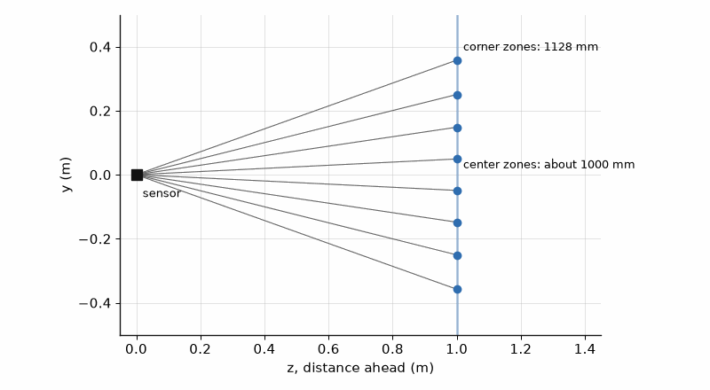
Figure 20.2 — The 64 points of Worked Example 20.3 seen from the side: the zone rays fan out over 45° from the sensor, and their end points lie on the flat wall at z = 1.0 m although the corner zones report 1128 mm.

20.4 Event cameras
An event camera has no frames. Each pixel reports, on its own, when its brightness changes by more than a threshold: an event of x, y, a timestamp with microsecond resolution, and a polarity (brighter or darker). A static scene produces almost nothing; a moving edge produces a dense stream with no motion blur and a very wide dynamic range. Sony's IMX636, developed with Prophesee, is a 1280 × 720 example. The processing is different too: events are accumulated over a short window into an image, or fed to algorithms that work on the stream directly. Event sensors are established in industrial vibration and counting applications; their wider use in phones, cars, and robots is an outlook, not yet a fact.
Listing 20.4 — Generating a synthetic event stream for a moving edge, accumulating it into a 10 ms frame, and comparing the data rate with frames (Python with NumPy).
"""Event-camera data: accumulate (x, y, t, polarity) events into frames, and estimate data rates."""
import numpy as np
W, H = 320, 240
EVENT_DTYPE = np.dtype([("x", "<u2"), ("y", "<u2"), ("t", "<u4")]) # 8 bytes; polarity in bit 15 of x
def synthetic_edge(speed_px_per_s=1000.0, duration_s=0.1, seed=2):
"""A vertical edge sweeping right; every crossed pixel fires one ON event (with timing jitter)."""
rng = np.random.default_rng(seed)
xs = np.arange(int(speed_px_per_s * duration_s))
xx, yy = np.meshgrid(xs, np.arange(H))
t_us = (xx / speed_px_per_s * 1e6 + rng.normal(0, 50, xx.shape)).clip(0)
ev = np.zeros(xx.size, EVENT_DTYPE)
ev["x"] = xx.ravel() | 0x8000 # ON polarity
ev["y"] = yy.ravel()
ev["t"] = t_us.ravel().astype(np.uint32)
return np.sort(ev, order="t")
def accumulate(ev, t0_us, window_us):
"""Sum polarities (+1 ON, -1 OFF) of the events inside one time window into an image."""
sel = ev[(ev["t"] >= t0_us) & (ev["t"] < t0_us + window_us)]
img = np.zeros((H, W), np.int16)
pol = np.where(sel["x"] & 0x8000, 1, -1)
np.add.at(img, (sel["y"], sel["x"] & 0x7FFF), pol)
return img
if __name__ == "__main__":
ev = synthetic_edge()
rate = len(ev) / 0.1
print("events: %d in 100 ms, %.2f Mev/s, %.2f MB/s at 8 bytes/event" % (len(ev), rate / 1e6, rate * 8 / 1e6))
frame = accumulate(ev, 50_000, 10_000)
cols = np.nonzero(frame.any(axis=0))[0]
print("10 ms window at t = 50 ms: edge spans columns %d..%d" % (cols.min(), cols.max()))
print("same scene as 8-bit frames at 100 fps: %.2f MB/s" % (W * H * 100 / 1e6))

Worked Example 20.4: Events or frames
Problem. A vertical edge crosses a 320 × 240 sensor at 1000 pixels per second. Each crossed pixel fires one event of 8 bytes. Compare the event data rate with 8-bit frames at 100 fps.
Solution. Each column of 240 pixels fires as the edge passes, 1000 columns per second, so 240 000 events per second; Listing 20.4 counts 24 000 events in 100 ms, 0.24 million events per second and 1.92 MB/s. The frames would be 320 × 240 × 100 = 7.68 MB/s, four times more, and still blurred. In a 10 ms window the edge spans columns 50 to 60, ten pixels, which is its motion in that time. The advantage shrinks for busy scenes: a camera shaking in front of foliage can produce tens of millions of events per second, more than frames, so the choice depends on the scene.
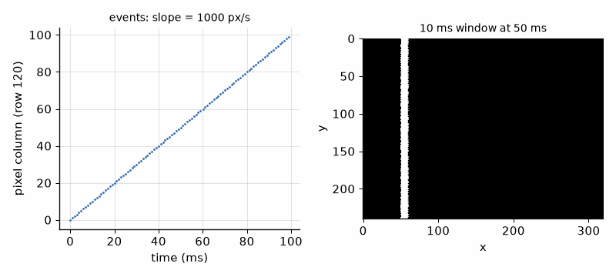
Figure 20.3 — The synthetic event stream of Worked Example 20.4: left, events in x and time for one row, forming a straight line whose slope is the edge speed of 1000 pixels per second; right, the events of the 10 ms window starting at 50 ms accumulated into an image, a band 10 pixels wide.

20.5 Edge AI
A neural network trained on a PC can run on the device if it is small enough and stored in integers. Quantization maps each float tensor to int8 with a scale and a zero point, real = scale × (q − zero_point), which cuts the memory by four and lets the chip use fast integer arithmetic: products of int8 values summed in int32. TensorFlow Lite Micro and Espressif's ESP-DL run such models on the ESP32-S3, whose vector instructions speed up exactly those multiply-accumulate loops; typical tasks are wake-word detection, gesture recognition from the IMU, and person detection on 96 × 96 grayscale images. Larger models move to the Pi 5: the Raspberry Pi AI HAT+ adds a Hailo accelerator of 13 or 26 TOPS over PCIe, and the Raspberry Pi AI Camera runs the network inside its Sony IMX500 sensor and outputs results instead of images.
Listing 20.5 — Affine int8 quantization and an int8 dot product with int32 accumulation, compared with float (Python with NumPy).
"""Affine int8 quantization as used by TensorFlow Lite Micro: real = scale * (q - zero_point)."""
import numpy as np
def qparams(rmin, rmax):
scale = (rmax - rmin) / 255.0
zero_point = int(round(-128 - rmin / scale))
return scale, zero_point
def quantize(x, scale, zp):
return np.clip(np.round(x / scale) + zp, -128, 127).astype(np.int8)
def dequantize(q, scale, zp):
return scale * (q.astype(np.int32) - zp)
if __name__ == "__main__":
s, zp = qparams(-2.0, 6.0)
print("scale %.5f (8/255), zero point %d" % (s, zp))
x = np.array([-2.0, 0.0, 1.0, 3.3, 6.0])
q = quantize(x, s, zp)
print("q =", q.tolist(), " back =", np.round(dequantize(q, s, zp), 4).tolist())
rng = np.random.default_rng(0)
v = rng.uniform(-2, 6, 10_000)
err = np.abs(dequantize(quantize(v, s, zp), s, zp) - v)
print("max error %.5f (scale/2 = %.5f)" % (err.max(), s / 2))
# A dot product the way an int8 kernel does it: int8 x int8 products summed in int32.
w = rng.uniform(-1, 1, 64); a = rng.uniform(-2, 6, 64)
sw, zw = qparams(-1, 1); qw = quantize(w, sw, zw); qa = quantize(a, s, zp)
acc = np.sum((qw.astype(np.int32) - zw) * (qa.astype(np.int32) - zp))
print("float %.4f, int8 %.4f" % (w @ a, sw * s * acc))

Worked Example 20.5: Quantizing an activation
Problem. An activation ranges from −2.0 to 6.0. Find the int8 scale and zero point, quantize 1.0 and 3.3, find the largest rounding error, and the memory of a 250 000-parameter model in float32 and int8.
Solution. Scale = 8.0/255 = 0.03137; zero point = round(−128 − (−2.0/0.03137)) = round(−64.25) = −64. 1.0 → round(31.9) − 64 = −32, which dequantizes to 1.0039; 3.3 → 105 − 64 = 41 → 3.2941. The largest error is half a step, 0.0157, as Listing 20.5 confirms over 10 000 random values; the rounded zero point shifts the ends slightly, so −2.0 comes back as −2.0078. A 64-element dot product gives 4.1097 in int8 against 4.1143 in float. The model shrinks from 250 000 × 4 = 1 MB to 250 kB, which fits the ESP32-S3's flash and PSRAM with room for the application.
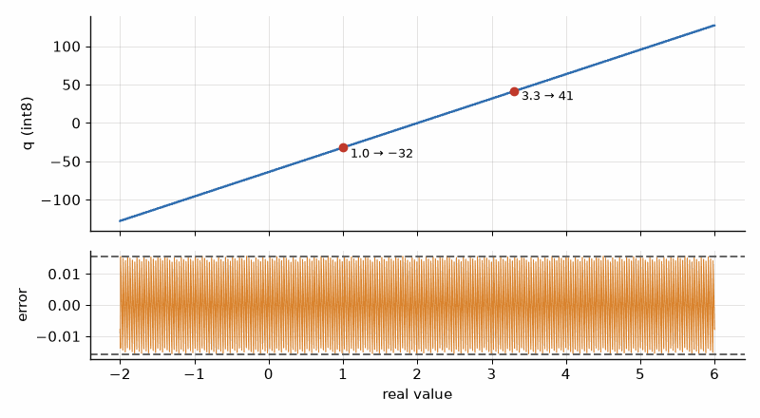
Figure 20.4 — Int8 quantization of the range −2 to 6 (Worked Example 20.5): the staircase of quantized values against the real input, with steps of 0.0314, and the rounding error below, never exceeding half a step, 0.0157.
Listing 20.6 — Capturing frames on the Raspberry Pi 5 with Picamera2 and flagging motion by frame differencing (Python).
"""Raspberry Pi 5: capture frames with Picamera2 and flag motion by frame differencing."""
import time
import numpy as np
from picamera2 import Picamera2
picam2 = Picamera2()
picam2.configure(picam2.create_video_configuration(main={"size": (640, 480), "format": "RGB888"}))
picam2.start()
time.sleep(1.0) # let exposure and white balance settle
prev = None
t0, n = time.monotonic(), 0
while n < 300:
frame = picam2.capture_array() # 480 x 640 x 3, uint8
gray = frame.mean(axis=2).astype(np.int16)
if prev is not None:
changed = np.count_nonzero(np.abs(gray - prev) > 25) / gray.size
if changed > 0.02: # more than 2 % of pixels changed
print("motion: %.1f %% of pixels" % (changed * 100))
prev, n = gray, n + 1
print("%.1f fps" % (n / (time.monotonic() - t0)))
picam2.stop()
Key idea. Optical data comes as one number (ToF), a frame (camera), or a stream (event camera), and the firmware's first job is to reduce it: JPEG in the sensor, a point cloud fitted to a plane, events accumulated over a window, a model quantized to int8.
Common misconception. Judging an edge-AI model by its accuracy on the PC. The int8 model on the device sees images from a different camera, with different lighting, at a different resolution. Collect test images with the real device, in the real place, and measure there.
AI Pair-Programming Note
Assistants give camera pin maps for the wrong board (there are dozens of ESP32 camera boards), pick a frame size that needs PSRAM on a board without it, and claim frame rates without measuring. Put the exact board, the PSRAM size, and the target frame rate in the spec, and run the measurement of Listing 20.1 before trusting any number.
From the Bench
A phone camera sees the 940 nm emitter of a ToF sensor or the IR LEDs of a night-vision camera as a faint purple glow (many phones filter it on the main camera; try the front camera). It is the quickest check that the emitter works before you suspect the firmware.

Practice
1. (Core) How large is one 96 × 96 grayscale frame, and one 640 × 480 RGB565 frame?
2. (Core) What time resolution corresponds to 5 mm of distance in a ToF sensor?
3. (Core) The VL53L1X runs with a 100 ms timing budget. How many readings per second, at most?
4. (Core) Quantize 2.5 with the scale and zero point of Worked Example 20.5, and dequantize it.
5. (Extension) A multizone sensor at 8 × 8 zones and 15 Hz streams to the Pi. How many points per second, and how many bytes at 2 bytes per zone?
6. (Extension) In Worked Example 20.3, what range does an edge zone in the middle row (3.5 steps off axis horizontally, 0.5 steps vertically) report?
7. (Extension) An edge moves at 5000 pixels per second across a 1280 × 720 event sensor. Estimate the event rate and data rate at 8 bytes per event.
8. (Challenge) A person-detection model takes 96 × 96 grayscale input and runs in 200 ms on the ESP32-S3. The camera gives QVGA. Describe the pipeline from frame buffer to decision, estimate the frames per second, and say where the time goes.

What You’ll Actually Use
Everyday working tools
- esp32-camera: JPEG for the network, small grayscale for analysis, buffers in PSRAM.
- Redo the pin table when a camera joins the board.
- ToF: 66.7 ps per cm, timing budget against rate and range, 16-bit register addresses.
- Point clouds: ranges along rays, plane fits, NumPy or Open3D on the Pi.
- Int8 quantization with scale and zero point; measure accuracy on the device.
- Pi 5 with Picamera2, the AI HAT+, or the AI Camera for larger models.
Mostly for exams and deeper study
- Training neural networks and the internals of event-vision algorithms; use existing models and libraries first.

Part V. The PC Side, Debugging, and Quality
Part V moves to the other end of the USB cable. Chapter 21 automates the bench with Python, Chapter 22 builds dashboards and production test benches in C#, Chapter 23 finds the bugs that remain, and Chapter 24 adds the tests, version control, and safety habits that keep them from coming back. The instruments themselves, and how to measure well with them, are Book 7's.

Chapter 21. Python on the Bench
The filter needed a frequency response: sixty points from 100 Hz to 100 kHz, each one a generator setting, a pause, and two readings off the scope. By hand that is an afternoon of turning knobs and typing numbers, with a transposed digit somewhere in the middle. A forty-line Python script does it in thirty seconds, writes a CSV file, plots the result, and does it again identically next week, after the capacitor has been changed. Bench automation is where Python earns its place in every electronics lab.
Where you meet this: Characterizing circuits and sensors, production calibration, long-term logging, environmental tests, and every measurement that has to be repeated more than twice.

21.1 Talking to instruments
Almost every bench instrument made in the last twenty years speaks SCPI, a text command language: *IDN? asks for the identity, and commands such as FREQ 1000 or :MEAS:VPP? CHAN1 set and read values. The transport is USB (as a USBTMC device), Ethernet (LXI, VXI-11, or a raw socket), or an old GPIB adapter. PyVISA hides the transport: rm.list_resources() lists the instruments it can see, open_resource opens one by its address string, write sends a command, and query sends one and returns the answer. A VISA library underneath does the work: the vendor's (NI-VISA, Keysight IO Libraries) or the pure-Python pyvisa-py. The command spellings differ between vendors and models, so the programming manual of the instrument is the reference, and a script that controls two brands keeps their commands in separate small classes.
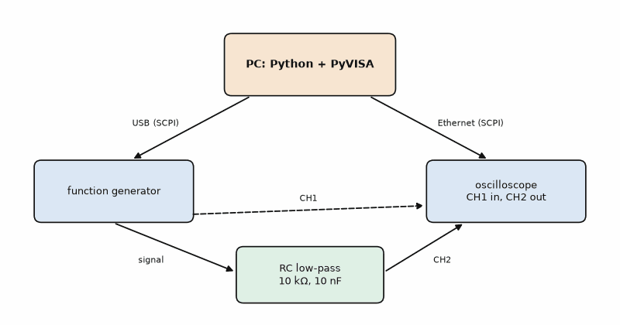
Figure 21.1 — The automated bench of Listing 21.1: the PC runs Python with PyVISA and talks SCPI over USB to the function generator and over Ethernet to the oscilloscope; the generator drives the RC filter, and the scope's channel 1 and channel 2 measure its input and output.
Listing 21.1 — A frequency sweep with a function generator and an oscilloscope over SCPI, with a simulation mode for testing without instruments (Python with PyVISA and NumPy).
"""Frequency sweep of a filter with a function generator and an oscilloscope over SCPI (PyVISA).
SCPI command spellings differ between vendors; the ones below follow common forms.
Run with --sim to test the script logic without instruments (an ideal RC low-pass).
"""
import argparse
import csv
import math
import time
import numpy as np
R, C = 10e3, 10e-9 # device under test: fc = 1/(2 pi R C) = 1591.5 Hz
class SimBench:
"""Stands in for the generator and scope; answers like an RC low-pass with 1 V in."""
def __init__(self):
self.f = 1000.0
def write(self, cmd):
if cmd.startswith("FREQ"):
self.f = float(cmd.split()[1])
def query(self, cmd):
if cmd == "*IDN?":
return "SIM,Bench,0,1.0"
h = 1 / math.sqrt(1 + (2 * math.pi * self.f * R * C) ** 2)
vin = 2.0 # 2 Vpp
return str(vin if "CHAN1" in cmd else vin * h)
def open_bench(sim):
if sim:
b = SimBench()
return b, b
import pyvisa
rm = pyvisa.ResourceManager()
gen = rm.open_resource("USB0::0x1AB1::0x0642::DG1ZA000000001::INSTR") # from rm.list_resources()
scope = rm.open_resource("TCPIP0::192.168.1.50::INSTR")
for inst in (gen, scope):
inst.timeout = 5000 # ms
gen.write("FUNC SIN"); gen.write("VOLT 2.0"); gen.write("OUTP ON")
return gen, scope
def sweep(gen, scope, f_start=100, f_stop=100e3, per_decade=20, settle=0.3):
n = int(round(math.log10(f_stop / f_start) * per_decade)) + 1
rows = []
for f in np.logspace(math.log10(f_start), math.log10(f_stop), n):
gen.write(f"FREQ {f:.3f}")
time.sleep(settle) # let the scope's measurement update
vin = float(scope.query(":MEAS:VPP? CHAN1"))
vout = float(scope.query(":MEAS:VPP? CHAN2"))
rows.append((f, vin, vout, 20 * math.log10(vout / vin)))
return rows
def corner(rows):
"""-3 dB frequency by linear interpolation in log(f)."""
for (f1, *_, g1), (f2, *_, g2) in zip(rows, rows[1:]):
if g1 >= -3.0103 > g2:
x = (-3.0103 - g1) / (g2 - g1)
return 10 ** (math.log10(f1) + x * (math.log10(f2) - math.log10(f1)))
return None
if __name__ == "__main__":
ap = argparse.ArgumentParser()
ap.add_argument("--sim", action="store_true")
args = ap.parse_args()
gen, scope = open_bench(args.sim)
print("instrument:", scope.query("*IDN?").strip())
rows = sweep(gen, scope, settle=0 if args.sim else 0.3)
with open("sweep.csv", "w", newline="") as f:
w = csv.writer(f)
w.writerow(["f_Hz", "vin_Vpp", "vout_Vpp", "gain_dB"])
w.writerows(rows)
print(f"{len(rows)} points, corner at {corner(rows):.1f} Hz (theory {1 / (2 * math.pi * R * C):.1f} Hz)")

Worked Example 21.1: Planning and checking a sweep
Problem. The filter is R = 10 kΩ, C = 10 nF. Plan a sweep from 100 Hz to 100 kHz with 20 points per decade and 0.3 s of settling per point, and check the script against theory before connecting instruments.
Solution. Three decades at 20 points per decade gives 3 × 20 + 1 = 61 points, logarithmically spaced so each decade gets the same resolution. Time: 61 × 0.3 s = 18 s of settling plus the queries, about half a minute. Theory: fc = 1/(2π × 10 kΩ × 10 nF) = 1591.5 Hz (Book 2's formula). In simulation mode the script prints 61 points and a corner at 1591.2 Hz, so the sweep, the CSV, and the interpolation work; any difference on the real bench is now the circuit or the measurement, not the script. That separation is step 5 of the method applied to bench code.
Listing 21.2 — Plotting the sweep as a Bode magnitude plot with the −3 dB line (Python with Matplotlib).
"""Plot sweep.csv as a Bode magnitude plot and mark the -3 dB point."""
import csv
import matplotlib.pyplot as plt
with open("sweep.csv", newline="") as f:
rows = [tuple(map(float, r)) for r in list(csv.reader(f))[1:]]
freq = [r[0] for r in rows]
gain = [r[3] for r in rows]
fig, ax = plt.subplots(figsize=(8, 4.5))
ax.semilogx(freq, gain, "o-", ms=3)
ax.axhline(-3.01, ls="--", color="gray")
ax.set_xlabel("frequency (Hz)")
ax.set_ylabel("gain (dB)")
ax.grid(True, which="both", alpha=0.3)
fig.tight_layout()
fig.savefig("bode.png", dpi=100)
print("saved bode.png with", len(rows), "points")
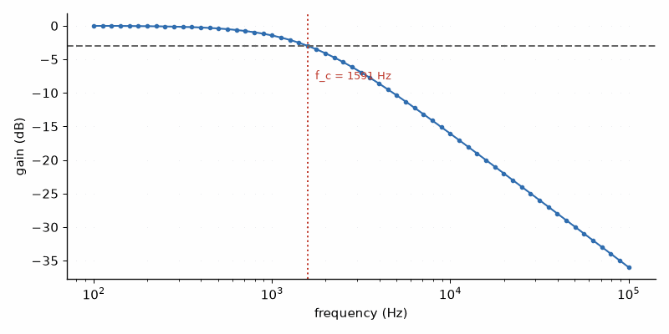
Figure 21.2 — The Bode magnitude plot of the simulated sweep (Worked Example 21.1): 61 points from 100 Hz to 100 kHz, the −3 dB line, and the interpolated corner at 1591 Hz. Above the corner the gain falls at 20 dB per decade.
Many characterization labs and production lines drive the same instruments from LabVIEW, NI's graphical programming environment, and sequence their tests with TestStand. LabVIEW and TestStand are covered in Book 9, Test and Measurement Instruments; the VISA resource names and SCPI commands of this section carry over unchanged.
Common misconception. Reading the scope before its measurement has updated. A scope measures over its last few acquisitions, so a query sent right after the frequency change can return the old value, and the curve shows a step shifted by one point. Wait for the settling time, or use the instrument's operation-complete query (*OPC?) and single-acquisition mode where it offers them.

21.2 Calibration
A sensor that is consistent but offset can be corrected in software. Measure it against a better reference at several points across the range, fit the reference as a function of the sensor reading, and apply that fit in the firmware or the logger. A straight line (gain and offset) is enough for most sensors over a moderate range; the residuals after the fit tell you whether it is. The correction is only as good as the reference and only valid in the conditions of the calibration.
Listing 21.3 — A gain-and-offset calibration of a BME280 against a reference thermometer, with residuals (Python with NumPy).
"""Two-parameter calibration of a sensor against a reference: fit, residuals, and the correction."""
import numpy as np
# Paired readings: reference thermometer (degC) and the BME280 under test (degC).
ref = np.array([5.02, 10.11, 15.05, 20.00, 24.98, 30.04, 35.10])
dut = np.array([5.61, 10.69, 15.52, 20.49, 25.38, 30.44, 35.43])
gain, offset = np.polyfit(dut, ref, 1) # ref = gain * dut + offset
corrected = gain * dut + offset
resid = corrected - ref
print("raw error: mean %+.3f, max %.3f degC" % (np.mean(dut - ref), np.max(np.abs(dut - ref))))
print("fit: ref = %.5f * dut %+.4f" % (gain, offset))
print("after correction: rms %.3f, max %.3f degC" % (np.sqrt(np.mean(resid ** 2)), np.max(np.abs(resid))))

Worked Example 21.2: Calibrating a temperature sensor
Problem. A BME280 on the garden node and a reference thermometer are read at seven temperatures from 5 to 35 °C. Find the raw error, the fit, the error after correction, and the corrected value of a reading of 22.00 °C.
Solution. The BME280 reads 0.47 °C high on average (maximum 0.59 °C), a typical self-heating offset of a sensor on a board with a warm processor next to it. Listing 21.3 fits ref = 1.00871 × dut − 0.6443, and the residuals drop to 0.024 °C rms and 0.039 °C maximum. A reading of 22.00 °C is corrected to 1.00871 × 22.00 − 0.6443 = 21.55 °C. The residuals now reflect the reference's resolution and the noise, so a curved fit would add nothing; and the result holds only for this board, in this housing, at this measurement rate, because self-heating changes with all three.
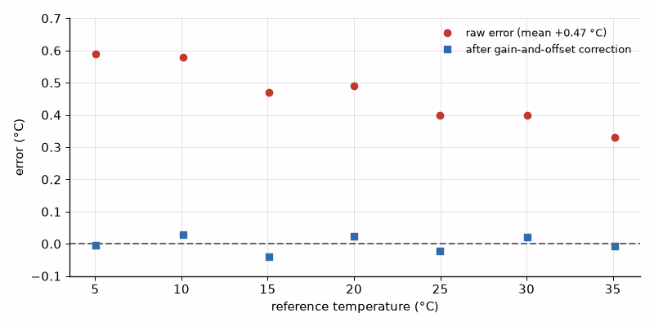
Figure 21.3 — Calibration of Worked Example 21.2: errors of the raw BME280 readings against the reference (red, about +0.47 °C) and after the gain-and-offset correction (blue, within ±0.04 °C), across 5 to 35 °C.

21.3 Logging that survives the night
A logging script on the bench runs for hours or days, so it must expect what the bench delivers: a serial port that disappears when the board resets, a malformed line, a full disk, and a PC that goes to sleep. Write each record with a timestamp in UTC (local time jumps twice a year), flush or close the file after every write so a crash loses one line instead of an hour, start a new file every day, and reconnect when the port returns. Chapter 4's logger has the basic pattern; Chapter 17's MQTT subscriber is the networked version.
Key idea. Automate any measurement you will repeat: PyVISA and SCPI for the instruments, a simulation mode to test the script without them, CSV files with UTC timestamps, and a plot generated from the file, never from memory.
AI Pair-Programming Note
Assistants write PyVISA scripts fluently but guess the SCPI commands, mixing one vendor's syntax with another's. Give the instrument model and paste the relevant page of its programming manual into the prompt, and test every command interactively with query before the script runs a sweep.
From the Bench
Before automating, type the commands by hand in an interactive Python session: open the instrument, send *IDN?, then each command of the planned script, one at a time, watching the instrument's front panel. Ten minutes of this finds the wrong command spellings, timeouts, and unit surprises that would otherwise appear as a silent wrong curve.

Practice
1. (Core) What does *IDN? return, and why is it the first query in every script?
2. (Core) How many points does a sweep from 10 Hz to 1 MHz at 10 points per decade have?
3. (Core) Find the corner frequency of R = 4.7 kΩ and C = 22 nF.
4. (Core) Apply the fit of Worked Example 21.2 to a reading of 30.00 °C.
5. (Extension) A sweep with 61 points and 0.3 s settling takes 45 s in practice. Where do the extra 27 s come from, and how could you reduce them?
6. (Extension) Why are the timestamps in a long log written in UTC?
7. (Extension) The calibration residuals form a clear U shape across the range. What does that tell you, and what do you do?
8. (Challenge) A production line calibrates 500 sensors per day at two temperatures. Each point needs 10 minutes in the chamber to settle. Design the procedure so that the chamber time per sensor is under one minute.

What You’ll Actually Use
Everyday working tools
- PyVISA: list_resources, open_resource, write, query; SCPI from the programming manual.
- A simulation mode to test bench scripts without instruments.
- Logarithmic sweeps, CSV files, plots generated from the file.
- Gain-and-offset calibration with np.polyfit and a look at the residuals.
- UTC timestamps, flush after every record, reconnect after resets.
Mostly for exams and deeper study
- The IEEE 488.2 standard and VISA internals; the library handles them.

Chapter 22. C# Dashboards and Test Benches
The dashboard ran for an hour, then froze. The window could still be dragged, but the numbers stopped changing and the close button did nothing. The serial code was correct; it ran in the wrong place. A SerialPort raises its DataReceived event on a background thread, and the program updated a text box from that thread, which WPF forbids, so it threw an exception that nobody caught, inside a thread nobody watched. One line, Dispatcher.BeginInvoke, fixes it. This chapter builds the dashboard and the production test bench properly, with the parsing tested before any window exists.
Where you meet this: Lab dashboards, service and configuration tools shipped with products, end-of-line test stations in production, and the Windows programs that industrial customers expect alongside the hardware.

22.1 Separate the logic from the window
The most useful design decision in a desktop tool is to keep everything that can be tested away from the user interface. Parsing a line, checking limits, computing a pass or fail: these are plain classes with no reference to a window or a port, and xUnit tests them in a second on any PC. The window then only connects the port to the parser and the parser to the display. Chapter 5 introduced C# and the SerialPort class; this chapter builds on its "t,h,p" line format. The tools are Visual Studio (the Community edition is free for individuals) or VS Code with the C# Dev Kit; WPF is the mature Windows desktop framework, WinUI 3 the newer one, and .NET MAUI targets Windows, Android, and iOS from one code base.
Listing 22.1 — A parser for the node's "t,h,p" lines with culture-independent number parsing and range checks from the BME280 datasheet; no I/O, so it can be unit-tested (C#).
// Parse and validate one "t,h,p" line from the garden node. No I/O here, so it can be unit-tested.
using System.Globalization;
namespace GardenBench;
public readonly record struct Reading(double TempC, double HumidityPct, double PressureHPa);
public static class ReadingParser
{
// BME280 operating ranges from the datasheet: -40..85 degC, 0..100 %RH, 300..1100 hPa.
public static bool TryParse(string? line, out Reading reading, out string error)
{
reading = default;
error = "";
if (string.IsNullOrWhiteSpace(line)) { error = "empty line"; return false; }
string[] f = line.Trim().Split(',');
if (f.Length != 3) { error = $"expected 3 fields, got {f.Length}"; return false; }
var inv = CultureInfo.InvariantCulture; // "23.41" on every PC, regardless of host locale
if (!double.TryParse(f[0], NumberStyles.Float, inv, out double t) ||
!double.TryParse(f[1], NumberStyles.Float, inv, out double h) ||
!double.TryParse(f[2], NumberStyles.Float, inv, out double p))
{ error = "not a number"; return false; }
if (t is < -40 or > 85) { error = $"temperature {t} out of range"; return false; }
if (h is < 0 or > 100) { error = $"humidity {h} out of range"; return false; }
if (p is < 300 or > 1100) { error = $"pressure {p} out of range"; return false; }
reading = new Reading(t, h, p);
return true;
}
}
Listing 22.2 — xUnit tests for the parser: a valid line, six kinds of bad line with the expected reason, and a check under de-DE culture settings (C#).
// xUnit tests for ReadingParser: dotnet test runs them in about a second, no hardware needed.
using GardenBench;
using Xunit;
public class ReadingParserTests
{
[Fact]
public void ValidLine_IsParsed()
{
Assert.True(ReadingParser.TryParse("23.41,45.2,1013.25\r\n", out var r, out _));
Assert.Equal(23.41, r.TempC, 3);
Assert.Equal(45.2, r.HumidityPct, 3);
Assert.Equal(1013.25, r.PressureHPa, 3);
}
[Theory]
[InlineData("", "empty line")]
[InlineData("23.41,45.2", "expected 3 fields, got 2")]
[InlineData("23,41;45,2;1013,25", "expected 3 fields, got 4")] // Decimal-comma locale input
[InlineData("23.41,abc,1013.25", "not a number")]
[InlineData("123.0,45.2,1013.25", "temperature 123 out of range")]
[InlineData("23.41,45.2,0", "pressure 0 out of range")]
public void BadLine_IsRejectedWithReason(string line, string expected)
{
Assert.False(ReadingParser.TryParse(line, out _, out string error));
Assert.Equal(expected, error);
}
[Fact]
public void ParsingDoesNotDependOnPcCulture()
{
var saved = System.Globalization.CultureInfo.CurrentCulture;
try
{
System.Globalization.CultureInfo.CurrentCulture = new System.Globalization.CultureInfo("de-DE");
Assert.True(ReadingParser.TryParse("23.41,45.2,1013.25", out var r, out _));
Assert.Equal(23.41, r.TempC, 3);
}
finally { System.Globalization.CultureInfo.CurrentCulture = saved; }
}
}

Worked Example 22.1: Tests that find a locale-dependent parsing bug
Problem. A first draft of the parser used double.Parse(f[0]) without a culture. Which test of Listing 22.2 fails with the de-DE locale active, what does the user see, and why does the test set the culture explicitly?
Solution. Under de-DE the comma is the decimal separator and the period a thousands separator, so double.Parse("23.41") returns 2341, as Problem 3 of Chapter 5 showed. ParsingDoesNotDependOnPcCulture switches the thread to de-DE and expects 23.41; with the old code it would fail with 2341, and the user would see the temperature out of range or, worse, accepted as 2341 if the range check were missing. The test sets the culture itself so it fails on every developer's PC and on the build server, not only on the customer's. With Listing 22.1 all 13 tests of Listings 22.2 and 22.5 pass in under half a second (dotnet test, .NET 10).

22.2 The dashboard and its threads
WPF, like every desktop framework, allows only the UI thread to touch controls. SerialPort's DataReceived event runs on a thread-pool thread. The bridge is the window's Dispatcher: BeginInvoke queues a small piece of work on the UI thread and returns at once. Keep the work in the event handler short (read the lines, parse them) and the work on the UI thread shorter (update the text and the plot). For real projects a chart library such as ScottPlot or LiveCharts replaces the hand-drawn Polyline of the listing.
Listing 22.3, part 1 — The dashboard window: port selector, connect button, status line, large value display, and a plot canvas (WPF XAML).
<Window x:Class="GardenBench.MainWindow"
xmlns="http://schemas.microsoft.com/winfx/2006/xaml/presentation"
xmlns:x="http://schemas.microsoft.com/winfx/2006/xaml"
Title="Garden Node" Height="360" Width="560">
<DockPanel Margin="10">
<StackPanel DockPanel.Dock="Top" Orientation="Horizontal">
<ComboBox x:Name="PortBox" Width="100"/>
<Button x:Name="ConnectButton" Content="Connect" Margin="8,0" Padding="10,2" Click="Connect_Click"/>
<TextBlock x:Name="StatusText" VerticalAlignment="Center" Text="not connected"/>
</StackPanel>
<TextBlock x:Name="ValueText" DockPanel.Dock="Top" FontSize="28" Margin="0,10" Text="--.-- °C"/>
<Border BorderBrush="Gray" BorderThickness="1">
<Canvas x:Name="Plot" ClipToBounds="True">
<Polyline x:Name="TempLine" Stroke="SteelBlue" StrokeThickness="2"/>
</Canvas>
</Border>
</DockPanel>
</Window>
Listing 22.3, part 2 — The dashboard code: serial data parsed on the event thread and handed to the UI thread with Dispatcher.BeginInvoke, with a five-minute rolling plot (C#, WPF).
// WPF dashboard: serial data arrives on a worker thread and is handed to the UI thread.
using System;
using System.Collections.Generic;
using System.IO.Ports;
using System.Linq;
using System.Windows;
using System.Windows.Media;
namespace GardenBench;
public partial class MainWindow : Window
{
private SerialPort? _port;
private readonly Queue<double> _temps = new();
private const int MaxPoints = 300; // 5 minutes at one reading per second
public MainWindow()
{
InitializeComponent();
PortBox.ItemsSource = SerialPort.GetPortNames();
PortBox.SelectedIndex = 0;
Closed += (_, _) => _port?.Close();
}
private void Connect_Click(object sender, RoutedEventArgs e)
{
if (PortBox.SelectedItem is not string name) return;
_port?.Close();
_port = new SerialPort(name, 115200) { NewLine = "\r\n", ReadTimeout = 2000 };
_port.DataReceived += OnData; // raised on a thread-pool thread
try { _port.Open(); StatusText.Text = $"connected to {name}"; }
catch (Exception ex) { StatusText.Text = ex.Message; }
}
private void OnData(object sender, SerialDataReceivedEventArgs e)
{
var port = (SerialPort)sender;
while (port.IsOpen && port.BytesToRead > 0)
{
string line;
try { line = port.ReadLine(); } catch (TimeoutException) { return; }
bool ok = ReadingParser.TryParse(line, out var r, out string error);
// Never touch a control from this thread: queue the update on the UI thread.
Dispatcher.BeginInvoke(() =>
{
if (ok) Show(r); else StatusText.Text = "bad line: " + error;
});
}
}
private void Show(Reading r)
{
ValueText.Text = $"{r.TempC:F2} °C {r.HumidityPct:F1} % {r.PressureHPa:F1} hPa";
_temps.Enqueue(r.TempC);
if (_temps.Count > MaxPoints) _temps.Dequeue();
double lo = _temps.Min() - 0.5, hi = _temps.Max() + 0.5;
double w = Plot.ActualWidth, h = Plot.ActualHeight;
TempLine.Points = new PointCollection(_temps.Select((t, i) =>
new Point(i * w / (MaxPoints - 1), h - (t - lo) / (hi - lo) * h)));
}
}
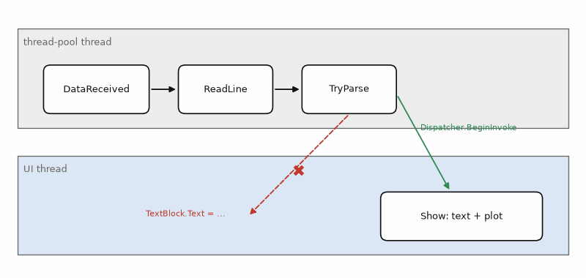
Figure 22.1 — The two threads of the dashboard (Listing 22.3): the serial port's DataReceived handler reads and parses lines on a thread-pool thread, and Dispatcher.BeginInvoke queues each display update on the UI thread, which alone touches the controls. A direct call from the worker thread (red, crossed out) is the hook's freeze.

Worked Example 22.2: How much does the plot keep?
Problem. The node sends one line per second. The plot keeps the last 300 points in a queue and redraws a Polyline on every reading. How much time does the plot cover, how much memory does it hold, and is redrawing every second a problem?
Solution. 300 points at one per second is 5 minutes. The queue holds 300 doubles, 2400 bytes, and the PointCollection 300 points of two doubles, 4800 bytes: nothing. Redrawing 300 points once a second costs well under a millisecond. The limits arrive at higher rates: at 1000 lines per second, each BeginInvoke call is a small allocation and a queued message, and the UI thread spends its time on updates the eye cannot follow. Then the handler should collect readings and the UI should refresh on a timer at 10 to 30 Hz with whatever has arrived, and the plot should decimate to about the pixel width of the canvas.

22.3 The production test bench
A test bench in production is a program that measures every board against limits and writes a record no one can argue with: the board's serial number, each step's measured value, its limits, pass or fail, and the time in UTC. Its own logic is tested like any other code, with fake instruments behind small interfaces, so the limit arithmetic is proven before the first board arrives. The real DMM behind IDmm is a SCPI instrument (Chapter 21's commands, sent from C# through a VISA library or a raw socket); the real IDut is the board's serial port.
Listing 22.4 — A production test with instrument interfaces, limit checks for the 3.3 V rail and the sensor, and a CSV record per step (C#).
// Production test: check the 3.3 V rail and the sensor of each garden-node board, log pass/fail.
using System;
using System.Collections.Generic;
using System.Globalization;
using System.IO;
namespace GardenBench;
public interface IDmm { double ReadVoltage(); } // real: SCPI over USB; tests: a fake
public interface IDut { string SerialNumber { get; } string? ReadLine(); }
public record StepResult(string Name, double Value, double Low, double High)
{
public bool Pass => Value >= Low && Value <= High;
}
public class TestBench
{
private readonly IDmm _dmm;
private readonly IDut _dut;
public TestBench(IDmm dmm, IDut dut) { _dmm = dmm; _dut = dut; }
public List<StepResult> Run()
{
var results = new List<StepResult>();
const double nominal = 3.30, tol = 0.03; // 3.30 V +-3 %
results.Add(new StepResult("3V3 rail", _dmm.ReadVoltage(), nominal * (1 - tol), nominal * (1 + tol)));
bool ok = ReadingParser.TryParse(_dut.ReadLine(), out var r, out _);
results.Add(new StepResult("sensor answers", ok ? 1 : 0, 1, 1));
if (ok) results.Add(new StepResult("room temperature", r.TempC, 15, 35));
return results;
}
public static void Log(string path, string serial, IEnumerable<StepResult> steps)
{
using var w = new StreamWriter(path, append: true);
string stamp = DateTime.UtcNow.ToString("yyyy-MM-ddTHH:mm:ssZ", CultureInfo.InvariantCulture);
foreach (var s in steps)
w.WriteLine(string.Join(",", stamp, serial, s.Name,
s.Value.ToString("F3", CultureInfo.InvariantCulture),
s.Low.ToString("F3", CultureInfo.InvariantCulture),
s.High.ToString("F3", CultureInfo.InvariantCulture), s.Pass ? "PASS" : "FAIL"));
}
}
Listing 22.5 — xUnit tests for the test bench with a fake DMM and a fake board, including the limit edges and a silent sensor (C#).
// Test the test bench itself with fake instruments: no board, no DMM, runs in CI.
using System.Linq;
using GardenBench;
using Xunit;
class FakeDmm : IDmm { public double V; public double ReadVoltage() => V; }
class FakeDut : IDut { public string SerialNumber => "GN-0001"; public string? Line; public string? ReadLine() => Line; }
public class TestBenchTests
{
[Theory]
[InlineData(3.30, true)]
[InlineData(3.205, true)] // just above the low limit 3.201
[InlineData(3.19, false)]
[InlineData(3.41, false)]
public void RailLimits(double volts, bool pass)
{
var bench = new TestBench(new FakeDmm { V = volts }, new FakeDut { Line = "23.41,45.2,1013.25" });
Assert.Equal(pass, bench.Run().Single(s => s.Name == "3V3 rail").Pass);
}
[Fact]
public void SilentSensor_FailsAndSkipsTemperature()
{
var steps = new TestBench(new FakeDmm { V = 3.30 }, new FakeDut { Line = null }).Run();
Assert.False(steps.Single(s => s.Name == "sensor answers").Pass);
Assert.DoesNotContain(steps, s => s.Name == "room temperature");
}
}

Worked Example 22.3: Limits and the guard band
Problem. The 3.3 V rail must be within ±3 %. Find the limits. The DMM's uncertainty at this range is ±0.010 V. Find guard-banded limits that keep bad boards from passing, and decide a board that measures 3.205 V under both.
Solution. Limits: 3.30 × 0.97 = 3.201 V and 3.30 × 1.03 = 3.399 V; Listing 22.5 confirms that 3.205 V passes and 3.19 V and 3.41 V fail. A reading of 3.205 V could come from a true 3.195 V, outside the specification, so a guard band shrinks the test limits by the uncertainty: 3.211 V to 3.389 V. The board at 3.205 V now fails and is retested or examined. The guard band costs a few good boards near the edge and keeps bad ones from shipping; how large the uncertainty really is belongs to the instrument's specifications and Book 7.
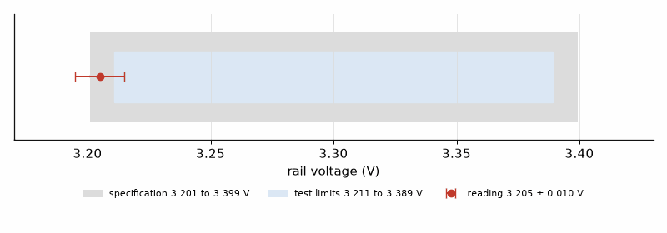
Figure 22.2 — Specification and test limits of Worked Example 22.3: the specification window 3.201 to 3.399 V (gray), the guard-banded test window 3.211 to 3.389 V (blue), and a reading of 3.205 V with its ±0.010 V uncertainty bar reaching below the specification.
Production lines that already run TestStand can call a C# test class like this one as a step through its .NET adapter. LabVIEW and TestStand are covered in Book 9, Test and Measurement Instruments.
Key idea. Put parsing, limits, and decisions in plain classes with unit tests; let the window and the port do nothing but connect them. Update controls only on the UI thread, through the Dispatcher.
Common misconception. Testing the dashboard only on the developer's PC. The customer's PC has a different culture, a different COM port number, a USB hub that sleeps, and a second program holding the port. Parse with the invariant culture, let the user choose the port, catch the exception from Open, and show a message that says what to do.
AI Pair-Programming Note
This is the kind of program AI assistants write best, and it is how Lothar built his own WPF tools, such as his MediaStar media application: by describing the program in plain text, piece by piece. The method keeps it safe: ask for the parser and its tests first, then the window, and never accept a DataReceived handler that touches a control directly. Chapter 25 walks through a complete session.
On the Job
On the Job: A test bench in production outlives its author. Write the limits into a configuration file with a revision number, log that revision with every result, and keep the bench software under version control with tagged releases. When a customer asks in two years how board 4711 was tested, the answer is one search in the log and one checkout of the tag.
From the Bench
Before a test bench goes to production, run a known-good board through it twenty times and look at the spread of each measurement. If the 3.3 V reading varies by 15 mV between runs, the fixture's contacts or the DMM's settling, not the boards, will decide who passes near the limits.

Practice
1. (Core) Why does the parser use CultureInfo.InvariantCulture?
2. (Core) Which thread runs SerialPort.DataReceived, and what must the handler do before changing a TextBlock?
3. (Core) Find the limits of a 5.0 V rail at ±5 %.
4. (Core) Write an InlineData line that tests a humidity of 101 %.
5. (Extension) With a DMM uncertainty of ±0.02 V, what are the guard-banded limits for Problem 3?
6. (Extension) The node is changed to send 200 lines per second. What changes in the dashboard's design?
7. (Extension) Why does the test bench depend on interfaces IDmm and IDut rather than on the concrete instrument classes?
8. (Challenge) A production line tests 500 boards per shift of 7.5 hours. Each test takes 12 s plus 20 s of handling. How many stations are needed, and which two changes would most reduce the count?

What You’ll Actually Use
Everyday working tools
- Logic in testable classes; xUnit with Fact, Theory, and InlineData; dotnet test.
- InvariantCulture for every number exchanged with hardware.
- Dispatcher.BeginInvoke from serial and timer threads.
- Test benches behind interfaces, with fakes for testing.
- Limits, guard bands, and a CSV record with serial number, limits, and UTC time.
Mostly for exams and deeper study
- MVVM frameworks and dependency injection containers; useful in large applications, not needed for a bench tool.

Chapter 23. Debugging
The node crashed about once a day, never on the bench, always at night. The developer added printf calls around the suspicious code, and the crash stopped. When the developer removed them, the crash returned. The printf calls had not fixed anything; at 115 200 baud each one took three and a half milliseconds, which changed the timing enough to hide a race between an interrupt and a task. A debugging tool that changes the behavior it observes can make a bug vanish without removing it. This chapter is about seeing inside a running system while disturbing it as little as possible, and about a procedure that finds bugs instead of chasing them.
Where you meet this: Every project, every week. Debugging is most of the time spent on firmware, and the engineers who are fast at it are fast because they are systematic, not because they guess well.

23.1 A procedure, not a hunt
Debugging follows the scientific method in small steps. Reproduce the failure, ideally on demand; a bug that occurs once a day becomes tractable when a test makes it occur once a minute. Gather facts before theories: the exact symptom, the last good version, what changed. Form one hypothesis, design an observation that can disprove it, and make it. Change one thing at a time. When it is fixed, explain why the fix works, add a test that would have caught it, and write the cause into the commit message: this is step 8 of the method, a precise bug report, written to your future self. "Git bisect" automates the search for the last good version: it checks out the commit halfway between a good and a bad one, you test, and in about ten steps it finds the guilty commit among a thousand.

23.2 The instruments of debugging
Each tool sees something the others miss. A debug probe on the SWD or JTAG pins (the ESP32-S3 has one built in on its USB port; the Pico uses the Raspberry Pi Debug Probe, STM32 boards an ST-LINK, and J-Link works with most) lets you stop the CPU, step through code, read variables and registers, and set watchpoints that stop the program when a memory location changes, the fastest way to find out who overwrites a variable. Serial logging shows the history but costs time. A logic analyzer records digital signals over seconds with exact timing and decodes I2C, SPI, and UART; inexpensive 8-channel analyzers with the open-source sigrok and PulseView software cover most hobby needs. An oscilloscope shows the analog truth: rise times, ringing, and brown-outs that a logic analyzer cannot see. And a spare GPIO toggled in the code is the cheapest timing instrument there is.

Worked Example 23.1: What printf costs
Problem. A debug line of 40 characters is printed at 115 200 baud with 8N1 framing. How long does it take if the call waits for the UART, and what does that do to a 1 kHz control loop?
Solution. Each character is 10 bits on the line (start, 8 data, stop), so 40 × 10/115 200 = 3.47 ms. In a 1 kHz loop that has 1 ms per cycle, one such line makes the loop miss three or four deadlines. With a buffered UART driver, printf returns sooner until the buffer fills, which makes the cost intermittent, worse for debugging than a constant one. A RAM trace avoids UART transmission in the timing-critical path, but its overhead must be measured on the target; the same is true of a GPIO timing probe.
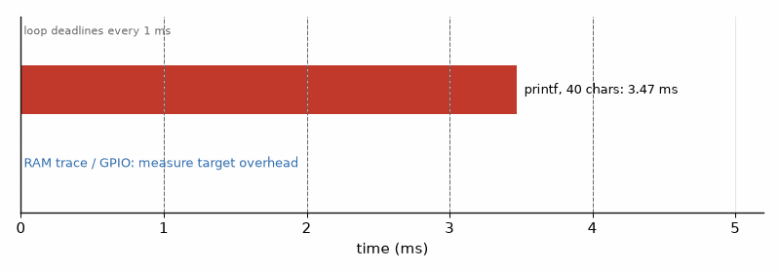

Figure 23.1 — UART logging can overrun several control-loop deadlines; RAM tracing and GPIO probes avoid serial transmission, but their overhead depends on the target and must be measured.
Listing 23.1 — A RAM trace buffer with timestamps and an atomic index (C, PC simulation). On a target, verify that atomic_uint is lock-free and ISR-safe; dump only after writers stop or protect the snapshot, since the counter does not synchronize reads of the trace buffer.
// A RAM trace avoids serial output in the timing-critical path; measure its target overhead.
// Events are stored in RAM with a timestamp and printed later, outside the timing-critical code.
// Pure C, runs on the PC; on the target, now_us() reads a hardware timer.
#include <stdatomic.h>
#include <stdint.h>
#include <stdio.h>
#define TRACE_LEN 64 // power of two, so the index wraps with a mask
typedef struct { uint32_t t_us; uint16_t id; uint16_t arg; } trace_t;
static trace_t trace_buf[TRACE_LEN];
static atomic_uint trace_head; // total events ever written
static uint32_t fake_clock;
static uint32_t now_us(void) { return fake_clock; } // target: esp_timer_get_time() etc.
static inline void trace(uint16_t id, uint16_t arg) // Atomic ticket; verify lock-free ISR support on the target
{
uint32_t i = atomic_fetch_add(&trace_head, 1) & (TRACE_LEN - 1);
trace_buf[i] = (trace_t){ now_us(), id, arg };
}
enum { EV_ISR = 1, EV_TASK_START, EV_TASK_END, EV_I2C_NACK };
static const char *names[] = { "?", "isr", "task start", "task end", "i2c nack" };
static void trace_dump(void) // call from a low-priority task or on a fault
{
uint32_t head = atomic_load(&trace_head);
uint32_t n = head < TRACE_LEN ? head : TRACE_LEN;
for (uint32_t k = head - n; k != head; k++) {
const trace_t *e = &trace_buf[k & (TRACE_LEN - 1)];
printf("%8lu us %-10s %u\n", (unsigned long)e->t_us, names[e->id], e->arg);
}
}
int main(void)
{
for (int cycle = 0; cycle < 25; cycle++) { // 25 x 3 + 1 = 76 events; the buffer keeps 64
fake_clock = 1000u * cycle; trace(EV_ISR, cycle);
fake_clock += 12; trace(EV_TASK_START, cycle);
if (cycle == 22) { fake_clock += 250; trace(EV_I2C_NACK, 0x76); }
fake_clock += 180; trace(EV_TASK_END, cycle);
}
printf("%u events written, the last %d kept\n", atomic_load(&trace_head), TRACE_LEN);
trace_dump();
return 0;
}

Worked Example 23.2: Reading the trace
Problem. Listing 23.1 records an interrupt, a task start, and a task end every millisecond for 25 cycles, plus one I2C NACK in cycle 22. The buffer holds 64 events. Which events are kept, and what does the tail tell you?
Solution. 25 × 3 + 1 = 76 events are written; the buffer keeps the last 64, so the first 12, cycles 0 to 3, are overwritten, and the dump starts at 4000 µs. The normal cycle reads isr at 0, task start at +12 µs, task end at +192 µs: the task runs for 180 µs. In cycle 22 the trace shows i2c nack 118 (0x76, the BME280) at 22 262 µs and the task end at 22 442 µs, 430 µs after the start: the NACK and its retry cost 250 µs, which is what this cycle's late output came from. These PC timestamps come from fake_clock; on hardware, replace now_us with a verified timer and measure capture overhead on the target.
Listing 23.2 — Converting an ESP32-S3 panic backtrace into function names and source lines with addr2line (Python).
"""Turn an ESP32-S3 panic backtrace into file:line with addr2line.
idf.py monitor does this automatically; this script is for a backtrace that arrived by
e-mail, in a field log, or from a customer's screenshot.
"""
import re
import subprocess
import sys
ADDR2LINE = "xtensa-esp32s3-elf-addr2line" # from the ESP-IDF toolchain
def pcs_from_backtrace(text):
"""'Backtrace: 0x4200a1b2:0x3fc9a0e0 0x4200b3c4:0x3fc9a100' -> ['0x4200a1b2', '0x4200b3c4']."""
m = re.search(r"Backtrace:((?:\s+0x[0-9a-fA-F]{8}:0x[0-9a-fA-F]{8})+)", text)
if not m:
return []
return [pair.split(":")[0] for pair in m.group(1).split()]
def resolve(elf, pcs):
out = subprocess.run([ADDR2LINE, "-pfiaC", "-e", elf, *pcs],
capture_output=True, text=True, check=True)
return out.stdout.strip().splitlines()
if __name__ == "__main__":
if len(sys.argv) != 3:
sys.exit("usage: l23_2_backtrace.py build/app.elf panic.txt")
pcs = pcs_from_backtrace(open(sys.argv[2], encoding="utf-8", errors="replace").read())
if not pcs:
sys.exit("no backtrace found")
for line in resolve(sys.argv[1], pcs):
print(line)
Listing 23.3 — Measuring an interrupt routine's duration with a probe pin, written through the GPIO set and clear registers (ESP-IDF, C).
// Measure an ISR's duration with a spare GPIO and a scope or logic analyzer (ESP-IDF, ESP32-S3).
// Writing the set and clear registers directly costs a few CPU cycles, far less than gpio_set_level().
#include "driver/gpio.h"
#include "esp_attr.h"
#include "soc/gpio_reg.h"
#include "soc/soc.h"
#define PROBE_PIN 21 // a free pin from the spec's pin table
#define PROBE_HIGH() REG_WRITE(GPIO_OUT_W1TS_REG, 1u << PROBE_PIN)
#define PROBE_LOW() REG_WRITE(GPIO_OUT_W1TC_REG, 1u << PROBE_PIN)
void probe_init(void)
{
gpio_config_t io = {
.pin_bit_mask = 1ULL << PROBE_PIN,
.mode = GPIO_MODE_OUTPUT,
};
gpio_config(&io);
PROBE_LOW();
}
void IRAM_ATTR sensor_isr(void *arg)
{
PROBE_HIGH(); // pulse width on the scope = ISR time
/* ... the ISR's real work: read a register, give a semaphore ... */
PROBE_LOW();
}

Worked Example 23.3: Choosing the logic analyzer's sample rate
Problem. Find a sample rate for decoding I2C at 400 kHz and UART at 115 200 baud, and the timing resolution each gives. The analyzer can do up to 24 MS/s on 8 channels.
Solution. An I2C bit at 400 kHz lasts 2.5 µs. Decoders need at least four samples per bit and work reliably with about ten, so 4 MS/s or more; at 24 MS/s there are 60 samples per bit and the resolution is 42 ns. A UART bit at 115 200 baud lasts 8.68 µs; 1 MS/s gives 8.7 samples per bit, enough to decode, and 4 MS/s makes the timing of a stop bit or a gap clear to 0.25 µs. Undersampling does not produce an error message; the decoder shows wrong bytes, which look like a firmware bug. The 4× figure is a decoding floor, not a measurement guarantee: Saleae recommends at least 4 samples per SPI clock and more for timing detail, and the available rate can fall as channels are enabled. If an 8 MHz bus exceeds the analyzer setting, slow the bus for diagnosis or use a faster instrument; a plausible decode is not proof.
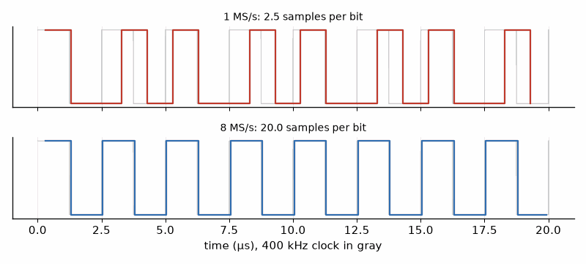
Figure 23.2 — The same 400 kHz I2C clock captured by a logic analyzer at 1 MS/s (top, 2.5 samples per bit: edges land in the wrong places and pulses vanish) and at 8 MS/s (bottom, 20 samples per bit: the clock is faithful), from Worked Example 23.3.
Key idea. Reproduce, observe, form one hypothesis, change one thing. Choose the tool that disturbs least: a probe pin or a trace buffer for timing, a debugger for state, a logic analyzer for buses, a scope for the analog truth.
Common misconception. Debugging by changing code until the symptom disappears. A bug that vanished without an explanation has usually moved. If you cannot say why the fix works, keep looking, and keep the reproduction case as a test.
AI Pair-Programming Note
Assistants are good debugging partners when given facts: paste the exact panic output, the decoded backtrace, the relevant code, and what you have already ruled out, and ask for hypotheses ranked by likelihood with an observation to test each. They are poor at guessing from "it crashes sometimes". Their first suggestion is often a plausible change to try, which is the trial-and-error the procedure avoids; ask what observation would distinguish the hypotheses instead.
From the Bench
When a board resets for no visible reason, print the reset reason at boot (esp_reset_reason() on the ESP32-S3) before anything else. Brown-out, watchdog, panic, and power-on each point in a different direction, and a brown-out sends you to the scope and the supply (Book 6), not to the code.

Practice
1. (Core) How long does a 25-character debug line take at 115 200 baud, 8N1?
2. (Core) What does a watchpoint do, and which kind of bug does it find fastest?
3. (Core) Which instrument shows ringing on an SPI clock line, a logic analyzer or a scope?
4. (Core) A git history has 1000 commits between a good and a bad version. How many bisect steps, at most?
5. (Extension) A probe pin shows a 6.4 µs pulse at each interrupt, 2000 times per second. What fraction of the CPU does the ISR use?
6. (Extension) Why must the trace buffer's index be claimed atomically, and what goes wrong with trace_head++ on a plain variable?
7. (Extension) Choose a sample rate for SPI at 8 MHz, and say whether a 24 MS/s analyzer is enough.
8. (Challenge) A node resets every few days with reset reason "task watchdog". Write the debugging plan: what to log, how to make it reproduce faster, and which hypotheses to test first.

What You’ll Actually Use
Everyday working tools
- The procedure: reproduce, facts, one hypothesis, one change, explain, test, commit message.
- Debug probe with breakpoints and watchpoints; esp_reset_reason at boot.
- Probe pins and RAM trace buffers instead of printf in timing-critical code.
- Logic analyzer at 4 to 10 samples per bit; scope for analog problems.
- Backtrace decoding with addr2line (or idf.py monitor), git bisect.
Mostly for exams and deeper study
- Trace hardware (ETM, SWO, SEGGER RTT) in depth; use it when a project's toolchain supports it.

Chapter 24. Testing, Version Control, and Safety
The UART receive code had worked in every test for two years. Then a customer's logger, streaming at 115 200 baud around the clock, started dropping data every four and a bit days, exactly. The ring buffer's 32-bit byte counters wrapped around after 4.3 billion bytes, and one comparison in the code did not survive the wrap. No bench test had run that long. A unit test that sets the counters a few bytes short of the wrap would have found it in a millisecond. Testing is the art of reaching the rare cases on purpose, and version control and safety habits are what make the fixes stick.
Where you meet this: Every professional firmware team: code review, continuous integration, release tags, test reports, and, in automotive, medical, and industrial products, safety standards that make these practices mandatory.

24.1 The test pyramid
Tests come in layers. At the bottom, many fast unit tests run on the PC: pure logic such as parsers, filters, state machines, and buffers, compiled with the PC's gcc or run with xUnit and pytest, thousands of checks in a second. In the middle, integration tests run the firmware on the real chip with simulated or real peripherals. At the top, hardware-in-the-loop (HIL) tests drive the real board from the PC, checking its outputs against limits, and system tests run the whole product in its real environment for days. The layers get slower, more expensive, and rarer toward the top, so the design goal is to push as much logic as possible down into code that can be tested on the PC. That is why Chapters 15 and 22 kept their arithmetic and parsing away from the hardware.
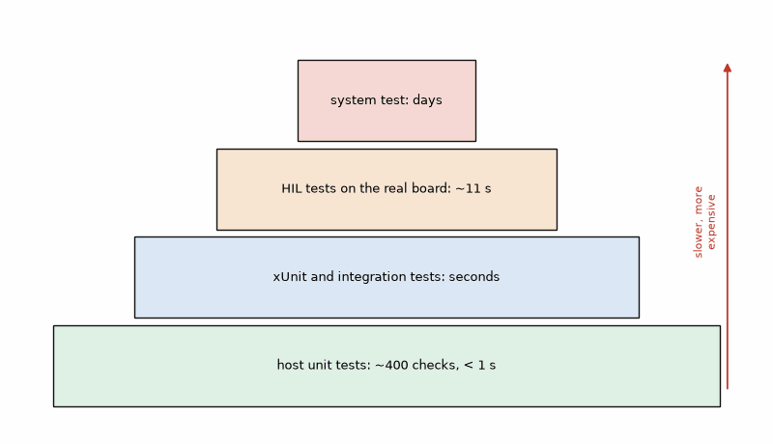
Figure 24.1 — The test pyramid with this book's examples: about 400 host unit-test checks in under a second at the base (Listing 24.2), xUnit tests of the C# tools (Chapter 22), HIL tests on the real board in about 11 s (Listing 24.3), and a week-long system test at the top. Width shows how many tests, height how slow and expensive each is.
Listing 24.1, part 1: C11 atomic interface for a single-producer, single-consumer UART ring buffer.
/* Single-producer, single-consumer UART ring buffer.
* Initialize before enabling either context. Verify target ISR support. */
#ifndef RINGBUF_H
#define RINGBUF_H
#include <stdbool.h>
#include <stdint.h>
#include <stdatomic.h>
#define RB_SIZE 256u /* power of two */
typedef struct {
uint8_t data[RB_SIZE];
_Atomic uint32_t head; /* written only by producer */
_Atomic uint32_t tail; /* written only by consumer */
_Atomic uint32_t dropped; /* producer writes; either side may read */
} ringbuf_t;
/* false means these atomics are not lock-free on this build. */
bool rb_init(ringbuf_t *rb);
bool rb_put(ringbuf_t *rb, uint8_t b); /* false if full */
bool rb_get(ringbuf_t *rb, uint8_t *b); /* false if empty */
uint32_t rb_count(const ringbuf_t *rb); /* approximate concurrent snapshot */
uint32_t rb_dropped(const ringbuf_t *rb); /* atomic diagnostic snapshot */
#endif
Listing 24.1, part 2: Release/acquire publication, wrap-safe indices, and lock-free checks.
#include "l24_1_ringbuf.h"
bool rb_init(ringbuf_t *rb)
{
atomic_init(&rb->head, 0u);
atomic_init(&rb->tail, 0u);
atomic_init(&rb->dropped, 0u);
return atomic_is_lock_free(&rb->head) &&
atomic_is_lock_free(&rb->tail) &&
atomic_is_lock_free(&rb->dropped);
}
uint32_t rb_count(const ringbuf_t *rb)
{
uint32_t head = atomic_load_explicit(&rb->head, memory_order_acquire);
uint32_t tail = atomic_load_explicit(&rb->tail, memory_order_acquire);
uint32_t count = head - tail; /* unsigned subtraction wraps */
return count > RB_SIZE ? RB_SIZE : count; /* diagnostic snapshot only */
}
uint32_t rb_dropped(const ringbuf_t *rb)
{
return atomic_load_explicit(&rb->dropped, memory_order_relaxed);
}
bool rb_put(ringbuf_t *rb, uint8_t b)
{
uint32_t head = atomic_load_explicit(&rb->head, memory_order_relaxed);
uint32_t tail = atomic_load_explicit(&rb->tail, memory_order_acquire);
/* Reject any observed distance at or above the buffer capacity. */
if ((uint32_t)(head - tail) >= RB_SIZE) {
uint32_t dropped = atomic_load_explicit(&rb->dropped, memory_order_relaxed);
atomic_store_explicit(&rb->dropped, dropped + 1u, memory_order_relaxed);
return false;
}
rb->data[head & (RB_SIZE - 1u)] = b;
atomic_store_explicit(&rb->head, head + 1u, memory_order_release);
return true;
}
bool rb_get(ringbuf_t *rb, uint8_t *b)
{
uint32_t tail = atomic_load_explicit(&rb->tail, memory_order_relaxed);
uint32_t head = atomic_load_explicit(&rb->head, memory_order_acquire);
if (head == tail) return false;
*b = rb->data[tail & (RB_SIZE - 1u)];
atomic_store_explicit(&rb->tail, tail + 1u, memory_order_release);
return true;
}
Initialize the buffer before enabling the UART interrupt or starting its reader task, and require rb_init to succeed. The release/acquire operations publish each byte before the producer advances head and ensure the consumer finishes reading before that slot is reused. rb_count is a diagnostic snapshot only. The host tests below exercise sequential behavior and counter wrap-around; they do not test interrupt scheduling. The C standard does not define an MCU interrupt ABI or ISR-safety contract: verify that the selected compiler/runtime supports these lock-free atomics in the ISR and on any participating cores. Lock-free status alone does not prove that target contract. Otherwise use the vendor RTOS queue or a documented platform-specific critical section. Keep exactly one producer and one consumer.
Listing 24.2: Host unit tests for the ring buffer, including counter wrap-around and atomic initialization (C11).
// Host unit tests: gcc -std=c11 -Wall -Wextra -Werror -o test_ringbuf l24_2_test_ringbuf.c l24_1_ringbuf.c && ./test_ringbuf
// A minimal CHECK macro keeps this self-contained; Unity or GoogleTest add reporting.
#include <stdio.h>
#include "l24_1_ringbuf.h"
static int failures, checks;
#define CHECK(cond) do { checks++; if (!(cond)) { failures++; \
printf("FAIL %s:%d: %s\n", __FILE__, __LINE__, #cond); } } while (0)
static int init_buffer(ringbuf_t *rb)
{
if (!rb_init(rb)) { CHECK(false); return 0; }
return 1;
}
static void test_empty(void)
{
ringbuf_t rb; uint8_t b;
if (!init_buffer(&rb)) return;
CHECK(rb_count(&rb) == 0);
CHECK(!rb_get(&rb, &b));
}
static void test_fifo_order(void)
{
ringbuf_t rb; uint8_t b;
if (!init_buffer(&rb)) return;
for (int i = 0; i < 10; i++) CHECK(rb_put(&rb, (uint8_t)i));
for (int i = 0; i < 10; i++) { CHECK(rb_get(&rb, &b)); CHECK(b == i); }
}
static void test_full_drops_and_counts(void)
{
ringbuf_t rb;
if (!init_buffer(&rb)) return;
for (unsigned i = 0; i < RB_SIZE; i++) CHECK(rb_put(&rb, 0xAA));
CHECK(!rb_put(&rb, 0x55));
CHECK(rb_dropped(&rb) == 1u);
CHECK(rb_count(&rb) == RB_SIZE);
}
static void test_index_wraparound(void) /* unsigned counters wrap modulo 2^32 */
{
ringbuf_t rb; uint8_t b;
if (!init_buffer(&rb)) return;
atomic_store_explicit(&rb.head, 0xFFFFFFF0u, memory_order_relaxed);
atomic_store_explicit(&rb.tail, 0xFFFFFFF0u, memory_order_relaxed);
for (int i = 0; i < 40; i++) CHECK(rb_put(&rb, (uint8_t)i));
CHECK(rb_count(&rb) == 40u);
for (int i = 0; i < 40; i++) { CHECK(rb_get(&rb, &b)); CHECK(b == i); }
CHECK(rb_count(&rb) == 0u);
}
int main(void)
{
test_empty();
test_fifo_order();
test_full_drops_and_counts();
test_index_wraparound();
printf("%d checks, %d failures\n", checks, failures);
return failures != 0;
}

Worked Example 24.1: When do the counters wrap?
Problem. The ring buffer uses 32-bit counters. At 115 200 baud, 8N1, with the line busy continuously, how long until the counters wrap, and why does unsigned counter subtraction remain useful across that wrap?
Solution. 8N1 sends 10 bits per byte, so 11 520 bytes per second. 2^32 = 4 294 967 296 bytes take 4 294 967 296/11 520 = 372 827 s = 4.3 days. The producer and consumer use unsigned 32-bit counter differences, whose arithmetic wraps modulo 2^32; the buffer invariant keeps their distance at no more than RB_SIZE. The concurrent rb_count function is only a clamped diagnostic snapshot and must not decide whether to put or get. The wrap-around test starts both counters 16 bytes before wrap and runs through it; Listing 24.2 reports 413 checks and 0 failures.
Listing 24.3, part 1 — Hardware-in-the-loop tests with pytest and pyserial: plausible readings, the reporting interval, and a version command (Python).
"""Hardware-in-the-loop tests with pytest: the real board on a serial port, checked from the PC.
Run: pytest l24_3_test_hil.py --port COM5 (needs conftest.py with the --port option)
"""
import time
import pytest
import serial
@pytest.fixture(scope="module")
def board(request):
port = request.config.getoption("--port")
with serial.Serial(port, 115200, timeout=2) as s:
s.dtr = False # pulse reset on boards that wire DTR/RTS to EN
s.rts = True
time.sleep(0.1)
s.rts = False
time.sleep(2.0) # boot time
s.reset_input_buffer()
yield s
def read_reading(board):
line = board.readline().decode("ascii", errors="replace").strip()
t, h, p = (float(x) for x in line.split(","))
return t, h, p
def test_sends_plausible_readings(board):
for _ in range(3):
t, h, p = read_reading(board)
assert 10.0 < t < 40.0, f"temperature {t} not room temperature"
assert 0.0 <= h <= 100.0
assert 900.0 < p < 1100.0
def test_reading_interval(board):
board.reset_input_buffer()
board.readline() # synchronize to a line boundary
t0 = time.monotonic()
for _ in range(5):
board.readline()
interval = (time.monotonic() - t0) / 5
assert interval == pytest.approx(1.0, abs=0.05)
def test_version_command(board):
board.write(b"version\n")
deadline = time.monotonic() + 2.0
while time.monotonic() < deadline:
line = board.readline().decode("ascii", errors="replace")
if line.startswith("fw "):
assert line.split()[1].count(".") == 2 # semantic version x.y.z
return
pytest.fail("no version reply within 2 s")
Listing 24.3, part 2 — The pytest configuration file that adds the --port option for the HIL tests (Python).
# conftest.py next to the HIL tests: adds the --port option to pytest.
def pytest_addoption(parser):
parser.addoption("--port", action="store", default="COM5", help="serial port of the board")
The HIL tests were run in the box against a simulated board on a pseudo-terminal that sends a reading every second and answers the version command: 3 passed in 10.8 s. On the bench the same file runs against the real ESP32-S3, and in a production line it runs on every board.

24.2 Version control as the safety net
Git records every change with its author, time, and reason, and lets you return to any earlier state. For firmware that means a few habits. Commit small, working steps with messages that say why ("Fix ring buffer count across counter wrap; add test"), which is step 7 of the method. Keep secrets, build outputs, and personal settings out of the repository with a .gitignore file. Tag every release (v1.4.2) so the exact source of any shipped binary can be checked out years later. Work on a branch for anything larger than an afternoon and merge after review. And let a continuous integration (CI) service build the firmware and run the host tests on every push, so a broken build is noticed in minutes, not at the next release. When code comes from an AI assistant, version control is what makes experimenting safe: commit before accepting a large change, and git diff shows exactly what it changed.
Listing 24.4 — A continuous-integration workflow: host unit tests with gcc and an ESP-IDF build for the ESP32-S3 in Espressif's container, with the binary kept as an artifact (GitHub Actions YAML).
For this workflow, save the ring-buffer implementation from Listing 24.1 as src/l24_1_ringbuf.c and src/l24_1_ringbuf.h, and the host tests from Listing 24.2 as test/l24_2_test_ringbuf.c.
# .github/workflows/firmware.yml: build the firmware and run the host tests on every push.
name: firmware
on: [push, pull_request]
jobs:
host-tests:
runs-on: ubuntu-latest
steps:
- uses: actions/checkout@v4
- name: Unit tests on the host
run: |
gcc -std=c11 -Wall -Wextra -Werror -Isrc -o test_ringbuf test/l24_2_test_ringbuf.c src/l24_1_ringbuf.c
./test_ringbuf
build:
runs-on: ubuntu-latest
container: espressif/idf:v5.3
steps:
- uses: actions/checkout@v4
- name: Build for the ESP32-S3
shell: bash
run: |
. $IDF_PATH/export.sh
idf.py set-target esp32s3
idf.py build
- uses: actions/upload-artifact@v4
with:
name: firmware
path: build/*.bin
What belongs in the repository, and what does not
- In: source code, headers, build files (CMakeLists.txt, platformio.ini, .csproj), partition tables, tests, the spec, the review checklist, schematics or a link to them.
- In: a README with the toolchain version and the exact build command.
- Out (.gitignore): build/, bin/, obj/, .pio/, IDE settings, and anything generated.
- Out, always: passwords, API keys, private signing keys, Wi-Fi credentials (Chapter 19).

24.3 Watchdogs and the safety mindset
A watchdog is a hardware timer that resets the chip unless the firmware feeds it in time. Feeding it from a timer interrupt is useless, because the interrupt keeps running while the tasks are stuck; feed it only when every important task has proved it is alive, as Listing 24.5 does. The STM32's independent watchdog (IWDG) runs from its own low-speed oscillator and cannot be stopped once started; the ESP32-S3 has a task watchdog in ESP-IDF that names the task that failed to check in.
Listing 24.5 — An STM32 independent watchdog of about 1 s, fed only when all three tasks have checked in (STM32 HAL, C).
// STM32 HAL: an independent watchdog of about 1 s, fed only when every task has reported in.
#include "stm32f4xx_hal.h"
IWDG_HandleTypeDef hiwdg;
static volatile uint32_t alive_flags; // one bit per task
#define ALL_TASKS 0x07u // three tasks must check in
void watchdog_init(void)
{
hiwdg.Instance = IWDG;
hiwdg.Init.Prescaler = IWDG_PRESCALER_32; // LSI 32 kHz / 32 = 1 kHz
hiwdg.Init.Reload = 999; // (999 + 1) / 1 kHz = 1.0 s
HAL_IWDG_Init(&hiwdg); // starts at once; cannot be stopped
}
void task_alive(uint32_t bit) { __disable_irq(); alive_flags |= bit; __enable_irq(); }
void watchdog_service(void) // call from the lowest-priority loop, every ~250 ms
{
if ((alive_flags & ALL_TASKS) == ALL_TASKS) {
alive_flags = 0;
HAL_IWDG_Refresh(&hiwdg);
} // otherwise: let the watchdog reset the chip
}

Worked Example 24.2: The watchdog's real timeout
Problem. The IWDG uses prescaler 32 and reload 999 with the LSI oscillator, nominally 32 kHz. Find the nominal timeout. The STM32F4 datasheet gives the LSI as 17 to 47 kHz. Find the range of timeouts and a safe feeding interval.
Solution. Nominal: (999 + 1) × 32/32 000 Hz = 1.000 s. At 47 kHz: 32 000/47 000 = 0.681 s; at 17 kHz: 32 000/17 000 = 1.88 s. The firmware must feed within the shortest, 0.68 s, so a 250 ms service interval leaves margin, and a hang may take up to 1.88 s to be caught. The usual mistake is to feed every 900 ms because the nominal timeout is 1 s; on some chips that works, and on others the board resets during normal operation.
Products whose failure can hurt people are developed under functional-safety standards: IEC 61508 in general industry, ISO 26262 in cars, IEC 62304 for medical device software. They require documented requirements, traceable tests, reviews, and coding rules. The coding rules most often used for C are MISRA C; for example, its 2012 edition's Rule 21.3 forbids malloc and free, and Rule 17.2 forbids recursion, because both make memory use and timing hard to prove. Static analyzers (cppcheck, clang-tidy, and commercial MISRA checkers) find many violations automatically. A hobby project does not need certification, but the habits transfer: no dynamic allocation after startup, every loop bounded, every input checked, every error handled, and a watchdog behind it all.
Key idea. Push logic down into code you can test on the PC, test the rare cases on purpose (wrap-arounds, full buffers, timeouts), commit small steps with reasons, let CI run the tests on every push, and feed the watchdog only when the whole system is alive.
Common misconception. Feeding the watchdog in a timer interrupt or at the top of the main loop "to be safe". Then a task can hang forever while the watchdog stays happy, which is the one situation it exists for.
AI Pair-Programming Note
Ask an assistant for unit tests and it writes tests that pass, often by testing what the code does rather than what the spec requires; ask instead for tests of the edge cases listed in the spec (empty, full, wrap-around, invalid input) and check that each one fails when you break the code on purpose. That last step, mutating the code to see the test fail, is the quickest review of any test, whoever wrote it.
From the Bench
Keep one "golden" board with a label, flashed with the last released firmware, in a drawer. When a new build behaves strangely, compare it with the golden board on the same bench, same cable, same sensor. It separates "the new firmware" from "this board" or "today's bench" in five minutes.

Practice
1. (Core) Name the four layers of the test pyramid from fastest to slowest.
2. (Core) At 921 600 baud, 8N1, how long until a 32-bit byte counter wraps?
3. (Core) Find the IWDG timeout for prescaler 64 and reload 499 at a nominal 32 kHz.
4. (Core) Write a commit message for a fix of the bug in the hook.
5. (Extension) Why does head − tail work across the wrap in unsigned arithmetic but not in signed int?
6. (Extension) A team feeds the watchdog in the 1 ms SysTick interrupt. Describe a failure it will not catch.
7. (Extension) Which three items of the repository box are most often forgotten, and what happens when they are?
8. (Challenge) Design a HIL test that checks the node's reconnect behavior from Chapter 17 automatically, using a relay or a controllable USB power switch on the router or broker. What does the test measure, and what are its pass limits?

What You’ll Actually Use
Everyday working tools
- Host unit tests for every pure-logic module; edge cases on purpose.
- pytest with pyserial for HIL tests.
- Git: small commits with reasons, .gitignore, release tags, branches, CI on every push.
- Watchdog fed only when all tasks are alive; timeout from the worst-case oscillator.
- Static analysis (cppcheck, clang-tidy) and the MISRA habits: no malloc after startup, bounded loops, checked inputs.
Mostly for exams and deeper study
- Certification under IEC 61508, ISO 26262, or IEC 62304; a specialist subject when your product needs it.

Part VI. New Ways to Build
Part VI covers two ways of building that have grown quickly: writing firmware and tools together with AI coding assistants, and writing hardware itself as code. Both reward the same discipline that runs through this book, the nine-step method, and both punish its absence faster than ever.

Chapter 25. AI-Assisted Development: The Method in Practice
The assistant returned a complete, neatly commented sketch in eight seconds. It compiled. It also chose GPIO 22, absent on the ESP32-S3, used the wrong address and baud rate, and called delay() inside an interrupt handler. The compiler had verified the syntax; it had not checked a single hardware assumption. This is the boundary: the tool can confirm what the language permits, while the engineer has to establish what the board will do. The method begins with a specification and ends only after review and measurement.
Where you meet this: Many software teams now use AI assistants, either built into the code editor or as separate chat tools. The tools change every few months; the method in this chapter does not depend on any of them, and none is endorsed here.

25.1 What assistants are good and bad at
Assistants have read an enormous amount of public code, so they are strong where that code is plentiful and consistent: desktop C# and Python, common library patterns, parsers, test cases, plotting scripts, and the boilerplate of a WPF window or a FreeRTOS task. They are weak where the truth is specific to your board and not in their training data, or changes between versions: which pins your module exposes, your sensor's address, a library's current API, a register layout, and timing. They do not see your hardware, they cannot measure, and they write an invented function with the same confidence as a real one. Lothar builds his own C# programs this way, including his MediaStar WPF application, by describing them in plain text, one piece at a time, and checking each piece; the method below is how that works without ending in a program nobody understands.
Common AI mistakes in firmware (check every answer for these)
- Pins from a different board: the classic ESP32's I2C pins 21 and 22 on an ESP32-S3, which has no GPIO 22 at all.
- Wrong or default addresses: a library's default I2C address instead of the one on your module.
- Blocking calls in interrupt handlers: delay(), Serial.print, printf, or a mutex inside an ISR.
- Missing pull-ups or wrong input modes: buttons and I2C lines assumed to have resistors that are not on the board.
- Wrong baud rate, data format, units, or byte order between the two ends.
- Invented or outdated library APIs: a function that sounds right but does not exist in the version you use.
- Wrong register names or bit positions copied from a related chip.
- Error handling left out: return codes ignored, no timeouts, no reconnect.
- Security shortcuts that make an example work: certificate checks off, passwords in the source.

25.2 The method with an assistant
The nine steps of Chapter 1 apply unchanged; the assistant takes over part of step 3 and nothing else. The AI rule in Chapter 1 is the release gate: a successful build does not waive any of its checks. Step 1, the spec, matters more than before, because the spec becomes the prompt: everything the assistant does not know about your hardware must be written down, or it will be guessed. Step 2 splits the work into modules small enough to review in a few minutes; ask for one at a time. Step 4, review against the checklist, is where the engineer earns the salary. Steps 5 and 6, build and test on the PC and then on the bench with a scope or logic analyzer, catch what the review missed. Step 7, commit, makes every accepted change reversible. Step 8 turns a failure into a precise bug report, which is also the best possible next prompt. Step 9 documents what was built, including which parts came from an assistant and how they were checked.
Prompt skeleton
- Role and platform: chip, board, framework and version, language.
- Goal: one module, one sentence.
- Hardware facts from the spec: pins, addresses, voltages, pull-ups, clock and baud rates.
- Interface: exact formats, units, decimal separator, line endings, commands and replies.
- Constraints: libraries by name and version, no blocking in ISRs, timeouts, memory limits.
- Error behavior: what happens when the sensor, the link, or the input is missing or wrong.
- Deliverable: the file(s), plus a list of every assumption not stated in the prompt.
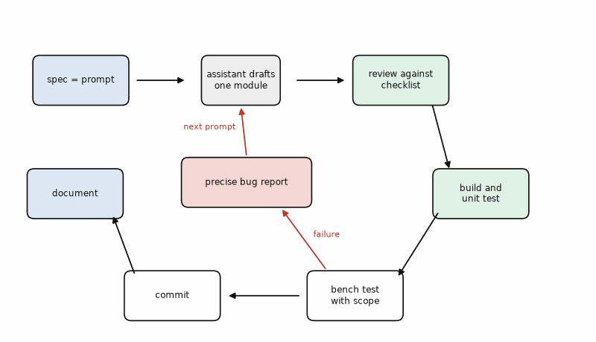
Figure 25.1 — The method with an assistant (Chapter 1's loop, specialized): the spec becomes the prompt, the assistant drafts one module, and the engineer reviews, builds, tests on the PC and the bench, and commits; a failure becomes a precise bug report that is the next prompt. The assistant's box is small on purpose.

Worked Example 25.1: From spec to prompt
Problem. Turn the reader lab's sensor-to-PC module into a prompt for the ESP32-S3 firmware, using the prompt skeleton.
Solution. Listing 25.1 is the result. Every item comes from the spec, not from memory: the board (ESP32-S3-DevKitC-1), the I2C pins 8 and 9 and the 4.7 kΩ pull-ups on the breakout, the address 0x76 because SDO is tied to ground, the line format with its decimals and the period as separator, the version command that the HIL test of Chapter 24 uses, the library by name, the forbidden delay() and Serial calls in ISRs, the error behavior when the sensor is missing, and a request to list unstated assumptions. Writing it took ten minutes; each line closes a door the assistant would otherwise have walked through with a guess. The last line is the cheapest review tool there is: the list of assumptions shows where the assistant filled gaps.
Listing 25.1 — The prompt for the ESP32-S3 module, built from the spec with the prompt skeleton (plain text).
Role: You are helping me write firmware for an ESP32-S3 with the Arduino core (esp32 3.x).
Goal: Read a BME280 once per second and send one line per reading over USB serial,
for a C# dashboard on the PC.
Hardware (from my spec):
- Board: ESP32-S3-DevKitC-1. BME280 breakout on I2C: SDA = GPIO 8, SCL = GPIO 9,
4.7 kOhm pull-ups on the breakout. I2C address 0x76 (SDO to GND). 3.3 V.
- Button on GPIO 0 (BOOT), active low, internal pull-up.
Interface:
- Serial at 115200 baud. Each reading as "t,h,p\r\n": temperature in degC with 2 decimals,
humidity in % with 1 decimal, pressure in hPa with 2 decimals, period as decimal separator.
- On receiving the line "version", reply "fw 1.0.0\r\n".
- Pressing the button prints "mark\r\n" once per press (debounced, 30 ms).
Constraints:
- Library: Adafruit BME280 (Adafruit_BME280.h), forced mode, oversampling x1, filter off.
- No delay() in loop(); use millis(). No Serial calls and no delay() inside any ISR.
- If the sensor is not found at startup, print "error,bme280\r\n" every 2 s and keep trying.
Deliver: one .ino file, then a list of every assumption you made that is not in this prompt.
Listing 25.2 — An assistant's first answer to a shorter prompt, without the hardware facts. It compiles; review it before reading Worked Example 25.2 (Arduino C++).
// The assistant's first answer, before review. It compiles. Find the problems before reading on.
#include <Wire.h>
#include <Adafruit_BME280.h>
Adafruit_BME280 bme;
volatile bool marked = false;
void IRAM_ATTR onButton() {
delay(30); // debounce
Serial.println("mark");
}
void setup() {
Serial.begin(9600);
Wire.begin(21, 22);
bme.begin();
pinMode(0, INPUT_PULLUP);
attachInterrupt(digitalPinToInterrupt(0), onButton, FALLING);
}
void loop() {
Serial.print(bme.readTemperature());
Serial.print(",");
Serial.print(bme.readHumidity());
Serial.print(",");
Serial.println(bme.readPressure());
delay(1000);
}

Worked Example 25.2: Reviewing the first draft
Problem. Review Listing 25.2 against the review checklist and the spec. List every finding and its consequence on the bench.
Solution. Eight findings. (1) Wire.begin(21, 22) uses the classic ESP32's pins; the ESP32-S3 has no GPIO 22, and the spec says 8 and 9: no sensor. (2) bme.begin() without an address uses the library's default 0x77; the module is at 0x76: no sensor, and (3) the return value is ignored, so the loop prints readings from an unconfigured device, typically NaN or nonsense, instead of an error. (4) Serial.begin(9600), while the dashboard expects 115 200: garbage on the PC. (5) delay(30) and Serial.println inside the ISR: on the ESP32-S3 this can trigger the interrupt watchdog or a crash, and it blocks everything else while it runs. (6) delay(1000) in loop() leaves no way to answer the version command, which is missing anyway. (7) readPressure() returns pascals, printed as 101325.00 instead of 1013.25 hPa, and Serial.print(float) gives two decimals for humidity, not one. (8) The sensor runs in the library's default normal mode instead of forced mode. None of these is a compiler error; each fails on the bench. Listing 25.3 is the reviewed version, produced by giving the full prompt of Listing 25.1 and correcting the remaining details by hand.
Listing 25.3 — The reviewed firmware: pins and address from the spec, a checked sensor start, forced mode, a millis() schedule, an ISR that only records the edge, a version command, and the error line when the sensor is missing (Arduino C++ on the ESP32-S3).
// Reviewed version: BME280 to USB serial as "t,h,p", a version command, and a debounced mark button.
#include <Wire.h>
#include <Adafruit_BME280.h>
const int PIN_SDA = 8, PIN_SCL = 9, PIN_BUTTON = 0;
const uint8_t BME_ADDR = 0x76;
const uint32_t PERIOD_MS = 1000, DEBOUNCE_MS = 30;
Adafruit_BME280 bme;
bool sensor_ok = false;
volatile uint32_t button_edge_ms = 0; // set by the ISR, handled in loop()
volatile bool button_edge = false;
String rx;
void IRAM_ATTR onButton() { // ISR: record and leave
button_edge_ms = millis();
button_edge = true;
}
bool startSensor() {
if (!bme.begin(BME_ADDR, &Wire)) return false;
bme.setSampling(Adafruit_BME280::MODE_FORCED,
Adafruit_BME280::SAMPLING_X1, Adafruit_BME280::SAMPLING_X1,
Adafruit_BME280::SAMPLING_X1, Adafruit_BME280::FILTER_OFF);
return true;
}
void setup() {
Serial.begin(115200);
Wire.begin(PIN_SDA, PIN_SCL, 400000);
pinMode(PIN_BUTTON, INPUT_PULLUP);
attachInterrupt(digitalPinToInterrupt(PIN_BUTTON), onButton, FALLING);
sensor_ok = startSensor();
}
void handleSerial() {
while (Serial.available()) {
char c = (char)Serial.read();
if (c == '\n') {
rx.trim();
if (rx == "version") Serial.print("fw 1.0.0\r\n");
rx = "";
} else if (rx.length() < 32) {
rx += c;
}
}
}
void handleButton() {
if (button_edge && millis() - button_edge_ms >= DEBOUNCE_MS) {
button_edge = false;
if (digitalRead(PIN_BUTTON) == LOW) Serial.print("mark\r\n"); // still pressed: real press
}
}
void loop() {
static uint32_t last = 0;
handleSerial();
handleButton();
if (millis() - last < (sensor_ok ? PERIOD_MS : 2000)) return;
last = millis();
if (!sensor_ok) {
Serial.print("error,bme280\r\n");
sensor_ok = startSensor();
return;
}
if (!bme.takeForcedMeasurement()) { sensor_ok = false; return; }
char line[48];
snprintf(line, sizeof line, "%.2f,%.1f,%.2f\r\n",
bme.readTemperature(), bme.readHumidity(), bme.readPressure() / 100.0f);
Serial.print(line);
}

25.3 The C# dashboard, by conversation
The PC side is where assistants are strongest, and where the developer's own PC hides the bugs best. The session follows the same steps: the spec (Chapter 22's line format and ranges) becomes the prompt; the first module requested is the parser with its unit tests, not the window; then the window; then the test bench.
Listing 25.4 — An assistant's first answer for the dashboard window from a one-sentence prompt. It compiles and runs on a PC with a decimal-point numeric locale (C#, WPF).
// The assistant's first C# answer for the dashboard, before review. It compiles and runs on the
// developer's PC, configured with a decimal-point numeric locale. Find the two bugs before reading on.
using System.IO.Ports;
using System.Windows;
using System.Windows.Controls;
namespace GardenBench;
public class FirstDraftWindow : Window
{
private readonly TextBlock _value = new() { FontSize = 28 };
private readonly SerialPort _port = new("COM5", 115200);
public FirstDraftWindow()
{
Content = _value;
_port.DataReceived += (s, e) =>
{
string[] f = _port.ReadLine().Split(',');
double t = double.Parse(f[0]);
_value.Text = $"{t:F2} °C";
};
_port.Open();
}
}

Worked Example 25.3: Two bugs and two bug reports
Problem. Listing 25.4 shows the temperature on the developer's PC. With Windows using the de-DE locale, it shows nothing, and the serial updates stop. Find both bugs and write the bug reports that make good follow-up prompts.
Solution. Bug 1: double.Parse(f[0]) uses the PC's culture; under de-DE "23.41" becomes 2341 (Chapter 5), so the display would show 2341.00 °C if it could update at all. Bug 2: the DataReceived handler runs on a thread-pool thread and sets _value.Text directly, which throws an InvalidOperationException; nothing catches it, so no value appears and the serial handling dies. Precise bug reports name the symptom, the condition, the cause, and the expected behavior: "With the de-DE locale active on Windows, '23.41' parses as 2341 because double.Parse uses the current culture. Parse with CultureInfo.InvariantCulture and NumberStyles.Float, and reject lines outside the BME280 ranges. Put the parsing in a separate class with xUnit tests, including one under de-DE." And: "DataReceived runs on a worker thread and sets TextBlock.Text directly, which throws. Marshal UI updates through Dispatcher.BeginInvoke and keep parsing on the worker thread." The answers to those two prompts, after review, are Listings 22.1 to 22.3, and all 13 xUnit tests pass. The vague report "it doesn't work on my PC" would have produced a guess.

25.4 When to trust and when to check
Not every line deserves the same scrutiny. Two questions decide it: how bad is the consequence if this line is wrong, and how readily will a wrong line show itself? A plotting script that draws a wrong axis label fails visibly and harmlessly: trust, glance, run. A parser is cheap to check with tests: check by testing. A pin assignment, an I2C address, or a register value fails silently or confusingly: check against the datasheet and the schematic every time. And anything touching safety, security, power electronics, or a battery charger is checked line by line by a person who understands it, then measured, whoever wrote it.
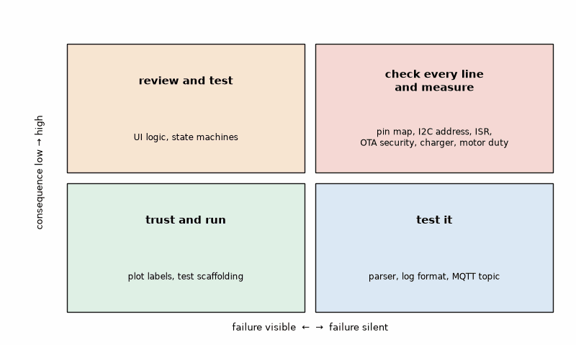
Figure 25.2 — Trust or check: the consequence of an error against how visibly it fails, with this chapter's examples placed. Low consequence and visible failure (plot labels, test scaffolding): trust and run. Low consequence, silent failure (log formats): test. High consequence, visible failure (UI logic): review and test. High consequence, silent failure (pins, addresses, ISRs, OTA security, charger and motor control): check line by line against the datasheet and measure.

Worked Example 25.4: Proving it on the hardware
Problem. The reviewed firmware and dashboard are ready. Which tests decide that the module is done, and what do they measure?
Solution. The acceptance tests come from the spec, not from the code. (1) The HIL tests of Listing 24.3 run against the board: plausible readings, an interval of 1.00 ± 0.05 s, and the version reply; against the simulated board in the box they passed 3 of 3 in 10.8 s, and on the bench they must pass on the real one. (2) A logic analyzer on SDA and SCL shows transactions to address 0x76 at 400 kHz and one forced measurement per second. (3) A scope on GPIO 0 while pressing the button 20 times, with the serial log beside it, shows exactly 20 "mark" lines, despite the bounce visible on the scope. (4) The dashboard runs for a night on a host using the de-DE locale, and the sensor is unplugged and replugged once: it reports "error,bme280" and recovers. Then commit, tag, and write in the README which parts were drafted with an assistant and how each was verified.
Key idea. An assistant drafts; the engineer specifies, reviews, tests, and owns the result. The spec is the prompt, one module at a time, the review checklist before every run, tests on the PC and the bench, a commit after every accepted step, and a precise bug report as the next prompt.
Common misconception. Accepting a large change because it compiles and the first run looks right. Compilers do not know your pins, your addresses, or your timing. Review the diff, run the tests, and measure; if a change is too large to review, ask for it in smaller pieces.
AI Pair-Programming Note
Keep a project notes file with the spec, the pin table, the decisions made, and the problems already solved, and paste the relevant part into every new session. Assistants have no memory of your project between sessions unless you give it to them, and the notes file is also step 9 of the method.
For a module revisited six months later, the minimum handoff is the source version, board and library versions, spec, assumptions, tests, known limits, and the last measured result. Without those, regeneration starts by rediscovering which guesses became design decisions; compare the new diff against the tests and recheck every version-sensitive API before accepting it.
On the Job
On the Job: Companies differ widely in what they allow: some forbid pasting source code into external services, some provide approved tools that keep code inside the company, some require AI-written code to be marked in reviews. Ask before you paste. Licensing matters too: an assistant can reproduce snippets of licensed code, so the usual rules for third-party code apply to its output. And in every company the person who commits the code is responsible for it, whoever drafted it.
From the Bench
Keep claimed numbers out of the design until measured under the intended load. If the loop is supposed to run at 1 kHz, toggle a pin while logging and Wi-Fi are active; if sleep current is supposed to be 10 µA, measure the complete board in its actual sleep state. A bench result without the load conditions is not a timing or current limit.

Practice
1. (Core) Name five items from the common AI mistakes box that a compiler cannot catch.
2. (Core) Why ask the assistant for a list of assumptions it made?
3. (Core) Rewrite the vague bug report "the button doesn't work" as a precise one, for a button that sometimes prints "mark" two or three times per press.
4. (Core) Place these in the trust-or-check grid: a Matplotlib axis label, a BLE characteristic's byte order, an MQTT topic string, the duty cycle limit of a motor driver.
5. (Extension) The assistant suggests Wire.begin() with no arguments on the ESP32-S3. Is that wrong? What do you check, and where?
6. (Extension) Write the prompt's "Constraints" section for a FreeRTOS task that reads the VL53L1X at 20 Hz on an ESP32-S3.
7. (Extension) An assistant answers with a call to bme.readAll(). How do you find out quickly whether it exists, and what do you do if it does not?
8. (Challenge) Plan an AI-assisted development of the OTA module of Chapter 19 with the nine-step method. Which steps get extra care, and which items are "check every line"?

What You’ll Actually Use
Everyday working tools
- The spec as the prompt; the prompt skeleton; one module at a time.
- The common AI mistakes box and the review checklist before every run.
- Precise bug reports: symptom, condition, measurement, cause, expected behavior.
- Tests on the PC and the bench decide, not the assistant's confidence.
- Commit before accepting large changes; git diff to see what changed.
- Trust or check by consequence and visibility of failure.
Mostly for exams and deeper study
- The internals of language models; useful background, not needed to use them well.

Chapter 26. HDL: Software That Becomes Hardware
Twenty lines of text describe a PWM generator. Run them through a C compiler and you get an error. Run them through a synthesis tool and you get flip-flops and gates, wired together on an FPGA board that typically costs about $20, producing a 105.5 kHz waveform with no CPU, no interrupts, and no jitter. Send a slightly larger text file to a shared shuttle, and some months later it comes back as silicon. A hardware description language looks like a programming language, but every line describes a circuit that exists all the time and does everything at once. Thinking of it as software that runs from top to bottom is the most common way to get it wrong.
Where you meet this: FPGA prototyping and products (camera interfaces, motor control, software-defined radio, test equipment), chip design at every scale, and the hobby route from an LED blinker to a self-designed chip.

26.1 Describing hardware
Verilog and its successor SystemVerilog are the HDLs most used for chip design; VHDL remains common in aerospace and in some European design flows. A module has ports, like a function's parameters, but its body describes circuits. An always block triggered by posedge clk describes flip-flops: every register in it takes its new value at the same clock edge, which is why such blocks use the nonblocking assignment <=. A continuous assign or an always @* block describes combinational logic, gates whose outputs follow their inputs. Everything in a module runs in parallel, all the time; the order of the blocks in the file means nothing to the hardware. Width is explicit: reg [7:0] is an 8-bit register, and arithmetic wraps at that width, which the PWM counter below uses on purpose. The logic gates and flip-flops themselves are Book 1's.
Listing 26.1 — An 8-bit PWM generator: a free-running counter, a compare, and a registered output (Verilog).
`timescale 1ns/1ps
// 8-bit PWM: the output is high while the free-running counter is below the duty value.
// At 27 MHz (Tang Nano 9K) the period is 256 clocks = 9.48 us, i.e. 105.5 kHz.
module pwm #(
parameter WIDTH = 8
) (
input wire clk,
input wire rst_n, // active-low reset
input wire [WIDTH-1:0] duty, // 0 = always off, 255 = on for 255 of 256 clocks
output reg out
);
reg [WIDTH-1:0] count;
always @(posedge clk or negedge rst_n) begin
if (!rst_n) begin
count <= {WIDTH{1'b0}};
out <= 1'b0;
end else begin
count <= count + 1'b1; // wraps from 255 to 0
out <= (count < duty); // registered output: no glitches
end
end
endmodule

26.2 Simulation and testbenches
Hardware is tested in simulation before it is built. A testbench is a Verilog module with no ports: it generates the clock, applies inputs, checks outputs, and reports. It may use constructs that cannot become hardware, such as delays (#18.518), loops over time, $display, and file output, because it only ever runs in the simulator. Icarus Verilog (iverilog) is a free event-driven simulator; Verilator compiles the design into fast C++ and is also an excellent linter; both write VCD waveform files that GTKWave or Surfer display. The testbench is step 5 of the method for hardware, and because a bug found after manufacturing cannot be patched, it is a much larger part of the work than in firmware.
Listing 26.2 — A self-checking testbench: it counts high clocks over whole periods for five duty values and reports failures (Verilog, Icarus).
// Testbench: measure the PWM duty cycle over whole periods and compare with the setting.
`timescale 1ns/1ps
module pwm_tb;
reg clk = 0, rst_n = 0;
reg [7:0] duty;
wire out;
integer high, i, errors = 0;
pwm #(.WIDTH(8)) dut (.clk(clk), .rst_n(rst_n), .duty(duty), .out(out));
always #18.518 clk = ~clk; // 27 MHz: period 37.037 ns
task check(input [7:0] d);
begin
duty = d;
repeat (256) @(posedge clk); // let the new value take effect
high = 0;
for (i = 0; i < 256; i = i + 1) begin
@(posedge clk);
high = high + out;
end
if (high !== d) begin
errors = errors + 1;
$display("FAIL duty %0d: %0d of 256 clocks high", d, high);
end else
$display("ok duty %3d: %3d of 256 clocks high (%.1f %%)", d, high, 100.0 * high / 256);
end
endtask
initial begin
$dumpfile("pwm.vcd");
$dumpvars(0, pwm_tb);
duty = 0;
#100 rst_n = 1;
check(0); check(1); check(64); check(128); check(255);
$display("%0d errors", errors);
$finish;
end
endmodule

Worked Example 26.1: The PWM on a Tang Nano 9K
Problem. The Tang Nano 9K has a 27 MHz oscillator. Find the PWM frequency of the 8-bit generator, the duty resolution, and the shortest pulse, and check them in simulation.
Solution. The counter wraps every 256 clocks: 27 MHz/256 = 105.47 kHz, a period of 9.48 µs. Duty steps are 1/256 = 0.39 %, and the shortest pulse is one clock, 37.0 ns. Duty 255 gives 255 of 256 clocks, 99.6 %; a full 100 % would need a ninth bit or a special case. The testbench of Listing 26.2 measured exactly 0, 1, 64, 128, and 255 high clocks per period for the five settings, 0 errors, in Icarus Verilog 12, and Verilator's lint with all warnings enabled reported nothing. Compare Chapter 7's ESP32-S3 LEDC: the same arithmetic with a hardware timer, but here the timer is something you wrote.
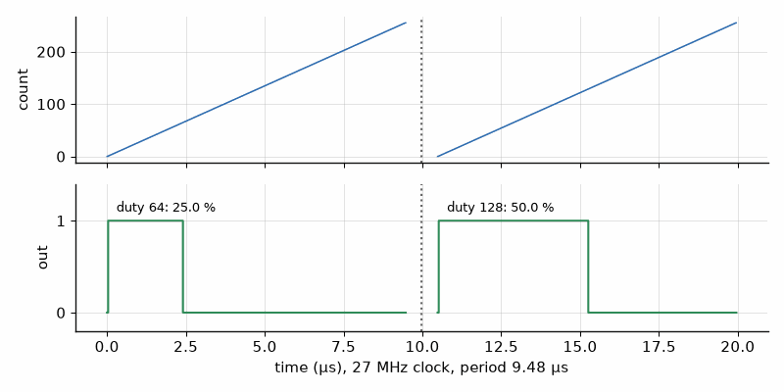
Figure 26.1 — Waveforms from the PWM simulation (Worked Example 26.1), as a waveform viewer shows them: the counter and the output for duty 64 (high for 64 of 256 clocks, 25 %) and duty 128 (50 %), one period of 9.48 µs each at 27 MHz.
Listing 26.3 — A UART transmitter for 8N1 with a clock divider parameter: start bit, eight data bits LSB first, stop bit (Verilog).
`timescale 1ns/1ps
// UART transmitter, 8N1. DIV = clock / baud, rounded: 27 MHz / 115200 = 234.375 -> 234.
module uart_tx #(
parameter DIV = 234
) (
input wire clk,
input wire rst_n,
input wire [7:0] data,
input wire start, // one-clock pulse; ignored while busy
output reg tx, // idles high
output wire busy
);
reg [15:0] tick; // clocks within the current bit
reg [3:0] bit_idx; // 0 = start bit, 1..8 = data, 9 = stop bit
reg [9:0] frame;
reg active;
assign busy = active;
always @(posedge clk or negedge rst_n) begin
if (!rst_n) begin
tx <= 1'b1; active <= 1'b0; tick <= 0; bit_idx <= 0; frame <= 10'h3FF;
end else if (!active) begin
tx <= 1'b1;
if (start) begin
frame <= {1'b1, data, 1'b0}; // stop, data (LSB first), start
active <= 1'b1;
tick <= 0;
bit_idx <= 0;
tx <= 1'b0; // start bit begins now
end
end else if (tick == DIV - 1) begin
tick <= 0;
if (bit_idx == 9) begin
active <= 1'b0; // stop bit done
tx <= 1'b1;
end else begin
bit_idx <= bit_idx + 1'b1;
tx <= frame[bit_idx + 1];
end
end else begin
tick <= tick + 1'b1;
end
end
endmodule
Listing 26.4 — A testbench with a behavioral receiver that samples each bit in its middle, checks four bytes, and measures the baud rate (Verilog, Icarus).
// Testbench: a behavioral receiver samples tx in the middle of each bit and checks the bytes.
`timescale 1ns/1ps
module uart_tb;
localparam DIV = 234;
reg clk = 0, rst_n = 0, start = 0;
reg [7:0] data;
wire tx, busy;
integer errors = 0, k;
reg [7:0] got;
reg [7:0] tests [0:3];
real t0, t1;
uart_tx #(.DIV(DIV)) dut (.clk(clk), .rst_n(rst_n), .data(data), .start(start), .tx(tx), .busy(busy));
always #18.518 clk = ~clk; // 27 MHz
task receive(output [7:0] b);
integer n;
begin
@(negedge tx); // start bit edge
t0 = $realtime;
repeat (DIV / 2) @(posedge clk); // middle of the start bit
if (tx !== 1'b0) $display("FAIL: start bit not low");
for (n = 0; n < 8; n = n + 1) begin
repeat (DIV) @(posedge clk);
b[n] = tx; // LSB first
end
repeat (DIV) @(posedge clk);
if (tx !== 1'b1) begin errors = errors + 1; $display("FAIL: stop bit not high"); end
t1 = $realtime;
end
endtask
initial begin
tests[0] = 8'h55; tests[1] = 8'hA3; tests[2] = 8'h00; tests[3] = 8'hFF;
$dumpfile("uart.vcd");
$dumpvars(0, uart_tb);
#100 rst_n = 1;
for (k = 0; k < 4; k = k + 1) begin
fork
receive(got); // listening before the start bit
begin
@(negedge clk) begin data = tests[k]; start = 1; end // away from the DUT's edge
@(negedge clk) start = 0;
end
join
if (got !== tests[k]) begin
errors = errors + 1;
$display("FAIL sent %h got %h", tests[k], got);
end else
$display("ok sent %h got %h", tests[k], got);
wait (!busy);
end
$display("bit time %.1f ns -> %.0f baud", (t1 - t0) / 9.5, 9.5e9 / (t1 - t0));
$display("%0d errors", errors);
$finish;
end
endmodule

Worked Example 26.2: The divider and an off-by-one
Problem. Find the divider for 115 200 baud from 27 MHz and the resulting error. Then suppose the comparison in the transmitter is written tick == DIV instead of tick == DIV - 1. What happens, and which test catches it?
Solution. 27 000 000/115 200 = 234.375, so DIV = 234, a bit time of 8.667 µs and 115 385 baud, +0.16 %, far inside the few percent a UART tolerates (Chapter 9). The testbench of Listing 26.4 received 55, A3, 00, and FF correctly and measured a bit time of 8666 ns, 115 388 baud, which agrees with 115 385 within its simulated clock period of 37.036 ns. With tick == DIV the counter runs 0 to 234, 235 clocks per bit, so 114 894 baud, −0.27 %. The bytes would still decode, because the error is small, so a test that checks only the bytes passes; the measured baud rate in the testbench shows the error. Off-by-one errors in counters are the most common HDL bug, and the reason the testbench measures time, not only data.
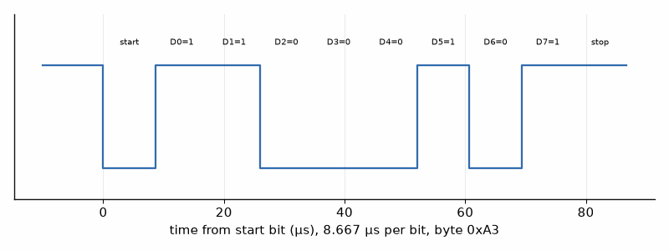
Figure 26.2 — The transmitter's output for the byte 0xA3 from the simulation VCD (Worked Example 26.2): idle high, start bit, data bits 1, 1, 0, 0, 0, 1, 0, 1 (LSB first), stop bit, each 8.667 µs long at DIV = 234.

26.3 From simulation to a board
An FPGA is a chip full of lookup tables, flip-flops, memory blocks, and programmable wiring; synthesis turns the HDL into those resources, place and route positions and connects them, and the result is a bitstream loaded at power-up. Inexpensive boards make this a hobby: the Tang Nano 9K (Gowin GW1NR-9, about 8640 lookup tables, 27 MHz oscillator) and the iCEBreaker (Lattice iCE40UP5K, 12 MHz) are typical, both usable with the open-source flow of Yosys for synthesis, nextpnr for place and route, and openFPGALoader or iceprog to load the board, or with the vendor's own tools. A constraints file ties each top-level port to a physical pin and its I/O standard.
Listing 26.5 — The Tang Nano 9K top level: a breathing LED from the PWM block and one UART byte per second from the transmitter (Verilog).
`timescale 1ns/1ps
// Tang Nano 9K top level: a "breathing" LED from the PWM block and one UART byte per second.
module top (
input wire sys_clk, // 27 MHz crystal oscillator
input wire btn_n, // user button (pin 4), active low: used as reset
output wire led_n, // LED, active low
output wire uart_tx // to the on-board USB-UART bridge
);
wire rst_n = btn_n;
// Slow ramp for the duty value: changes every 2^17 clocks (4.85 ms), 0..255..0 in 2.5 s.
reg [24:0] slow;
reg down;
reg [7:0] duty;
always @(posedge sys_clk or negedge rst_n) begin
if (!rst_n) begin
slow <= 0; duty <= 0; down <= 1'b0;
end else begin
slow <= slow + 1'b1;
if (slow[16:0] == 17'h1FFFF) begin
if (!down && duty == 8'hFF) down <= 1'b1;
else if (down && duty == 8'h00) down <= 1'b0;
else duty <= down ? duty - 1'b1 : duty + 1'b1;
end
end
end
wire pwm_out;
pwm #(.WIDTH(8)) u_pwm (.clk(sys_clk), .rst_n(rst_n), .duty(duty), .out(pwm_out));
assign led_n = ~pwm_out;
// One byte per second: 27 000 000 clocks.
reg [24:0] sec;
reg [7:0] counter;
reg start;
wire busy;
always @(posedge sys_clk or negedge rst_n) begin
if (!rst_n) begin
sec <= 0; counter <= 0; start <= 1'b0;
end else begin
start <= 1'b0;
if (sec == 25'd26_999_999) begin
sec <= 0;
if (!busy) begin start <= 1'b1; counter <= counter + 1'b1; end
end else
sec <= sec + 1'b1;
end
end
uart_tx #(.DIV(234)) u_tx (.clk(sys_clk), .rst_n(rst_n), .data(counter), .start(start),
.tx(uart_tx), .busy(busy));
endmodule
Listing 26.6 — Pin constraints for the Tang Nano 9K: clock, button, LED, and UART pins with their I/O standards (Gowin constraints).
// Pin constraints for the Tang Nano 9K (Gowin GW1NR-9). Check against your board's schematic.
IO_LOC "sys_clk" 52;
IO_PORT "sys_clk" IO_TYPE=LVCMOS33 PULL_MODE=UP;
IO_LOC "btn_n" 4;
IO_PORT "btn_n" IO_TYPE=LVCMOS18 PULL_MODE=UP; // user buttons are on pins 3 and 4
IO_LOC "led_n" 10;
IO_PORT "led_n" IO_TYPE=LVCMOS18 DRIVE=8;
IO_LOC "uart_tx" 17;
IO_PORT "uart_tx" IO_TYPE=LVCMOS33 PULL_MODE=UP;

Worked Example 26.3: Timing the breathing LED
Problem. In Listing 26.5 the duty value changes once every 2¹⁷ clocks and ramps from 0 to 255 and back. Find the step time and the breathing period, and check that the one-second counter is right.
Solution. 2¹⁷/27 MHz = 131 072/27 000 000 = 4.85 ms per step; 2 × 256 steps take 2.49 s for one breath, close to the 2.5 s in the comment. The one-second counter counts 0 to 26 999 999, 27 000 000 clocks, exactly 1.000 s; a 25-bit register holds up to 33 554 431, enough. The usual mistake is to compare with 27 000 000 and get one extra clock per second, harmless here and fatal in a frequency counter.

26.4 From FPGA to ASIC
Firmware and HDL follow different flows after the code is written. Firmware is compiled, flashed in seconds, and fixed by an update. An HDL design is simulated, prototyped on an FPGA, and then, if volume, power, or cost demand it, turned into an ASIC: synthesized to a library of standard cells, placed and routed, checked for timing and manufacturing rules, and sent to a foundry. After tapeout a fix means new masks and months. The open-source tools (Yosys, OpenROAD, OpenLane) and open process design kits such as SkyWater's 130 nm now let individuals do this. Tiny Tapeout pools many small designs on one shared chip: one tile is about 160 × 100 µm, room for roughly a thousand logic gates, with 8 inputs, 8 outputs, and 8 bidirectional pins plus clock and reset; designs are entered in Verilog or drawn in the Wokwi simulator, hardened automatically by a GitHub Actions flow, and manufactured in about six to nine months. In October 2026 its price calculator showed about €70 per tile, with a development board extra. The fab, the process, and the economics of chips are Book 3's.
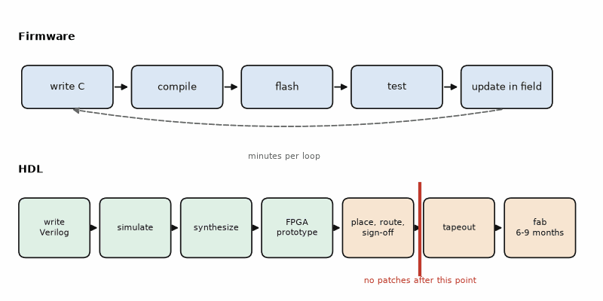
Figure 26.3 — Two flows from the same kind of text: firmware (write, compile, flash, test, update in the field in minutes) and HDL (write, simulate, synthesize, FPGA prototype, then optionally ASIC: standard cells, place and route, sign-off, tapeout, months of manufacturing). The red bar marks the point after which a bug can no longer be patched in an ASIC.

26.5 AI-assisted HDL
The method of Chapter 25 applies, with higher stakes and some HDL-specific traps. Assistants write Verilog that simulates but does not synthesize (delays and initial blocks in design code), blocking assignments in clocked blocks that change the behavior, incomplete if statements in combinational blocks that create latches, mismatched widths that silently truncate, and counters off by one. Ask for the testbench first, from the spec, with measured timing and not only data checks; then the design; then run both through Verilator's lint and the simulator before any synthesis. A design that has not passed a self-checking testbench is not reviewed yet, whoever wrote it.
Key idea. HDL describes circuits that run in parallel on every clock edge. Simulate with a self-checking testbench that measures timing, lint with Verilator, prototype on an inexpensive FPGA, and treat an ASIC tapeout as the point after which nothing can be patched.
Common misconception. Writing Verilog as if it were C: a sequence of blocking assignments in a clocked block, expecting each line to happen after the previous one. In hardware every register updates at the same edge; use <= in clocked blocks and = only in combinational ones.
AI Pair-Programming Note
Ask the assistant to explain, for every always block it writes, whether it describes flip-flops or combinational logic, and what each register holds after reset. An answer that cannot say is a design that is not understood, and the same question is a good review for code you wrote yourself.
On the Job
On the Job: In chip companies verification engineers often outnumber designers, and their tools (SystemVerilog with UVM, formal property checking, coverage metrics) are a career of their own. The habit that transfers to every level is the one in this chapter: a design is finished when an independent testbench says so, not when the designer believes it.
From the Bench
Before loading a new bitstream, route the signal you care about to a spare pin as well, and look at it with the logic analyzer from Chapter 23. The PWM frequency, the UART bit time, and the reset behavior are then measured on the real board in a minute, against the numbers the simulation predicted.

Practice
1. (Core) What is the PWM frequency of the 8-bit generator on the iCEBreaker's 12 MHz clock?
2. (Core) Find the divider and baud-rate error for 9600 baud from 27 MHz.
3. (Core) Why may a testbench use #delays and $display while the design may not?
4. (Core) What is the difference between = and <= in a clocked always block?
5. (Extension) Make the PWM reach 100 %: what is the smallest change to Listing 26.1?
6. (Extension) Find the divider for 115 200 baud on the iCEBreaker's 12 MHz clock and its error. Is it acceptable?
7. (Extension) An always @* block contains "if (sel) y = a;" with no else. What does synthesis build, and why is it a problem?
8. (Challenge) A Tiny Tapeout tile has 8 inputs and 8 outputs. Design the interface for the PWM generator with a programmable duty: how do 8 inputs set an 8-bit duty without losing other control?

What You’ll Actually Use
Everyday working tools
- Clocked always blocks with <=, combinational logic with = and full assignments.
- Self-checking testbenches that measure time; Icarus Verilog and Verilator lint; GTKWave.
- Divider arithmetic and the off-by-one check.
- An inexpensive FPGA board with Yosys, nextpnr, and openFPGALoader, and a constraints file.
- The flow from FPGA prototype to ASIC, and Tiny Tapeout as the hobby route.
Mostly for exams and deeper study
- SystemVerilog classes, UVM, and formal verification; a specialist path.

Appendix A. Quick Reference: Formulas, Spec Template, Review Checklist, and Prompt Skeleton

A.1 Formulas used in this book
Build sizes (Chapter 2): flash = text + data; static RAM = data + bss, plus stack and heap.
Bit operations (Chapter 3): set r |= m; clear r &= ~m; toggle r ^= m; read a field (r & mask) >> shift.
Timer and PWM (Chapter 7): f_PWM = f_clk/((PSC + 1)(ARR + 1)); duty = CCR/(ARR + 1). Servo pulses of 1.0 to 2.0 ms in a 20 ms frame.
Ultrasonic ranging (Chapter 7): d = c t/2, with c ≈ 331.3 + 0.606 T m/s for T in °C; 5.824 ms of echo is 1.000 m at 20 °C.
ADC (Chapter 8): code = V_in/V_ref × 2^N and V_in = code × V_ref/2^N; averaging n samples divides random noise by √n; a two-point calibration fits gain and offset.
UART (Chapter 9): one bit lasts 1/baud, 8.68 µs at 115 200 baud; an 8N1 frame is 10 bits, 86.8 µs.
Average current and battery life (Chapter 14): I_avg = (I_active t_active + I_sleep t_sleep)/T; life ≈ capacity/I_avg, reduced by self-discharge and the cell's usable fraction.
Fixed point (Chapter 15): a Qm.n value is the integer divided by 2^n; Q15 covers −1 to 1 − 2^−15 in steps of 1/32 768. A first-order IIR filter y ← y + (x − y)/2^k has a time constant of −1/ln(1 − 2^−k) samples, 15.5 samples for k = 4.
Complementary filter (Chapter 16): angle ← α(angle + ω Δt) + (1 − α) angle_acc, with time constant τ = α Δt/(1 − α). Kalman gain in one dimension K = P/(P + R).
LoRa duty cycle (Chapter 18): the shortest legal interval is airtime/duty cycle, 123.9 ms/0.01 = 12.4 s at SF9 for 8 bytes. The airtime formula is Book 5's.
Reconnect back-off (Chapter 17): wait = min(cap, base × 2^attempt), less up to 25 % random jitter.
Time of flight (Chapter 20): t = 2d/c; each centimeter of range adds 66.7 ps of round-trip time.
Int8 quantization (Chapter 20): q = round(x/s) + z, clipped to −128..127; x ≈ s(q − z). For the range −2 to 6, s = 8/255 = 0.03137 and z = −64.
RC low-pass corner (Chapter 21): f_c = 1/(2πRC), 1591.5 Hz for 10 kΩ and 10 nF.
Test limits with guard band (Chapter 22): accept only readings inside the specification limits shrunk by the measurement uncertainty on each side.
Ring buffer (Chapter 24): with free-running counters and a power-of-two size N, the index is count & (N − 1) and the fill level is head − tail, which stays correct across counter wrap-around.
HDL counters (Chapter 26): an N-bit PWM counter at f_clk gives f_clk/2^N, 105.5 kHz for 8 bits at 27 MHz; a UART divider of 27 000 000/115 200 rounds to 234, giving 115 385 baud, 0.16 % fast.

A.2 Spec template
- Purpose: one sentence. What the module does and for whom.
- Hardware: board, chip, sensor or actuator, supply voltage, logic level.
- Pins: every GPIO with its direction, pull-up or pull-down, and active level.
- Interfaces: bus and speed (I2C 400 kHz, UART 115200 8N1, SPI mode 0 at 8 MHz), addresses, data formats, units.
- Timing: how often it runs, deadlines, the longest it may block, and its startup time.
- Power: active and sleep current targets, and when it may sleep.
- Error handling: what happens on a timeout, a bad checksum, an out-of-range value, a lost connection.
- Acceptance tests: numbered, measurable checks that decide when the module is done.
- Out of scope: what this module deliberately does not do.

A.3 Review checklist
- Pins and addresses match the spec and the schematic, not a tutorial.
- Bus speed, baud rate, mode, and byte order match both ends.
- Every wait has a timeout; nothing blocks forever.
- Interrupt handlers are short, set a flag or send to a queue, and call no blocking or printing functions.
- Shared mutable data is accessed atomically or protected by an appropriate lock or critical section; volatile alone does not make shared access thread-safe. Use volatile for memory-mapped I/O or asynchronous observations only when the platform requires it.
- Every return code is checked, and every error path does something sensible.
- Units and scaling are written down and tested at both ends of the range.
- No secrets, passwords, or keys in the source code.
- Every library call exists in the version you build against; check the documentation for each one you have not used before.
- A watchdog or a recovery path exists for the case nobody thought of.

A.4 Common AI mistakes in firmware
- Pins from a different board: the classic ESP32's I2C pins 21 and 22 on an ESP32-S3, which has no GPIO 22 at all.
- Wrong or default addresses: a library's default I2C address instead of the one on your module.
- Blocking calls in interrupt handlers: delay(), Serial.print, printf, or a mutex inside an ISR.
- Missing pull-ups or wrong input modes: buttons and I2C lines assumed to have resistors that are not on the board.
- Wrong baud rate, data format, units, or byte order between the two ends.
- Invented or outdated library APIs: a function that sounds right but does not exist in the version you use.
- Wrong register names or bit positions copied from a related chip.
- Error handling left out: return codes ignored, no timeouts, no reconnect.
- Security shortcuts that make an example work: certificate checks off, passwords in the source.

A.5 Prompt skeleton
- Role and platform: chip, board, framework and version, language.
- Goal: one module, one sentence.
- Hardware facts from the spec: pins, addresses, voltages, pull-ups, clock and baud rates.
- Interface: exact formats, units, decimal separator, line endings, commands and replies.
- Constraints: libraries by name and version, no blocking in ISRs, timeouts, memory limits.
- Error behavior: what happens when the sensor, the link, or the input is missing or wrong.
- Deliverable: the file(s), plus a list of every assumption not stated in the prompt.

Appendix B. Worked Solutions to the Practice Problems
Each solution shows the working and, where one is common, the usual mistake. Problems are numbered as in their chapter.

Chapter 1
1. C (and C++) on the microcontroller, for small fast code with register access; Python on the board for quick experiments and on the PC for instruments, logging, and plots; C# on the PC for dashboards, test benches, and unit tests; Verilog for describing logic inside an FPGA. The usual mistake is to pick one language for everything: Python on a battery node, or C for a quick plot.
2. The record is 8 + 4 × 2 = 16 bytes. 1 048 576/16 = 65 536 records. The usual mistake is to forget the timestamp, or to count 1 MB as 1 000 000 bytes, which gives 62 500.
3. One record per 30 s gives 86 400/30 = 2880 records per day, so 65 536/2880 = 22.8 days. Check the units: records divided by records per day gives days. The usual mistake is to stop at 2185, dividing 65 536 by 30, which is a count of 30-second intervals, not days.
4. "Button: sampled every 5 ms, debounced over 20 ms, recognized within 50 ms of the press. OLED: redrawn every 500 ms; a redraw may block for at most 30 ms." The usual mistake is a timing line without numbers ("the button should feel responsive"), which cannot be tested.
5. (1) With the sensor disconnected, the module returns an error code within 100 ms and the display shows "SENSOR?" within one measurement period. (2) After the sensor is reconnected, valid readings resume within two periods without a reset. Each test names a measurable time. The usual mistake is "the module handles errors", which is a wish, not a test.
6. Only the thin hardware layers: the I2C read in bme280, the flash writes in logger, and the OLED driver in display. They depend on real peripherals and timing. The compensation math, the ring-buffer arithmetic, and the failure counting are pure functions and run on the PC. The usual mistake is to test everything on the board, which makes every test slow and every failure ambiguous.
7. "Firmware commit 3f2a1c, ESP32-S3 board B. After power-up the OLED shows the first reading, then stays blank from the second update on. Expected: a new reading every 10 s. The logic analyzer shows the I2C write to 0x3C is NACKed from the second update. Started after the change that raised I2C to 1 MHz." It says what was done, what was expected, what was measured, and when it started. The usual mistake is a report that names the symptom but not the firmware version, the board, what was expected, or what was measured.
8. 90 days need 90 × 8640 = 777 600 records of 16 bytes, which is 12 441 600 bytes, about 11.9 MB, three times the 4 MB available. Options: log every 30 s instead of 10 s (one third the data, 4 147 200 bytes, which fits with only 1 % to spare), store temperature, humidity, and pressure as scaled 16-bit integers instead of floats (4 + 3 × 2 = 10 bytes, 7.8 MB at 10 s, 2.6 MB at 30 s), or keep hourly averages after the first week. The usual mistake is to change the requirement silently instead of writing the trade-off into the spec.

Chapter 2
1. The linker. The function was declared (in a header, so the compiler was satisfied) but no object file or library defines it: usually the .c file is not in the build (missing from CMakeLists.txt or the src folder) or the library is not linked. The usual mistake is to keep editing the header, which the linker never reads.
2. Flash = 210 000 + 3 000 = 213 000 bytes. Static RAM = 3 000 + 41 000 = 44 000 bytes. The usual mistake is to count bss in flash; it costs only RAM, because the startup code zeroes it.
3. 460 800/10 = 46 080 bytes per second; 600 000/46 080 = 13.0 s. Half the image at half the baud rate takes the same time. The usual mistake is to use 8 bits per byte, which gives 10.4 s and forgets the start and stop bits.
4. A .uf2 file. Hold the BOOTSEL button while plugging the Pico into USB; it appears as a drive called RPI-RP2 (RP2350 on a Pico 2), and copying the file flashes it and reboots the chip. The usual mistake is to press BOOTSEL after plugging in; the button must be held while the board powers up.
5. A non-const initialized array is a variable: its 1024 bytes of starting values sit in flash (data) and are copied into 1024 bytes of RAM at startup, where the program may change them. A const array never changes, so the linker places it in flash (text or rodata) and the program reads it there; it costs 1024 bytes of flash and no RAM. The usual mistake is to forget const on large lookup tables and run out of RAM. (On the ESP32 the same is true; on AVR chips such as the classic Uno, const alone is not enough and PROGMEM is needed.)
6. A library or toolchain updated itself (an unpinned lib_deps entry or a framework update), or the build picked up a different board or configuration file. Prevent both by pinning library and platform versions in platformio.ini or the component manifest, and by committing the configuration (sdkconfig, platformio.ini) to version control. The usual mistake is to start editing the code before checking what changed in the toolchain and the libraries.
7. Only 264 − 252 = 12 KB remain for the stack, the heap, and anything the SDK allocates at run time. The program will probably crash or behave strangely when a deep call chain or an allocation overruns that space, and the linker cannot predict it. Reduce the large buffers or move constant tables to flash. The usual mistake is to take a successful link as proof that RAM is sufficient; the linker counts only static data, not the stack and the heap.
8. The image is 905 000 + 48 000 = 953 000 bytes. Adding 90 000 gives 1 043 000 bytes, which is below 1 048 576, so it fits, but with only 5 576 bytes to spare, too little for the next change. First check the map file for the largest symbols: debug logging strings, unused library features, and fonts or images are the usual suspects. The usual mistake is to compare against 1 000 000 instead of 1 048 576, or to forget that data also lives in flash.

Chapter 3
1. Set: r |= (uint8_t)(BIT(0) | BIT(4)), that is r |= 0x11. Clear bit 7: r &= (uint8_t)~0x80, which is r &= 0x7F. The cast avoids a conversion warning, because ~0x80 is an int with many high bits set. The usual mistake is to write r |= ~0x80 or r &= 0x80, which set or clear every other bit instead.
2. 0x5A is 0101 1010; XOR with 0000 1111 gives 0101 0101 = 0x55. XOR flips exactly the bits that are 1 in the mask. The usual mistake is to confuse XOR with OR, which would give 0x5F.
3. 0x1C is 0001 1100. Mask with 0x1C (bits 4..2), giving 0x1C, then shift right by 2: 0x07, so the field is 7. The usual mistake is to forget the shift and report 28.
4. 2^32 µs = 4 294.97 s = 71.6 minutes, so a microsecond counter wraps every 71.6 minutes, not days. A seconds counter wraps after 4 294 967 296 s = 136 years. The usual mistake is to assume a 32-bit counter "never" wraps; at microsecond resolution it wraps many times a day.
5. 180 + 90 = 270 is computed as an int and then truncated to 270 − 256 = 14 when stored. -Wconversion warns about the implicit narrowing; storing into uint16_t, or checking with an explicit test before the store, avoids it. The usual mistake is to think the addition itself overflows in 8 bits; it is computed as an int, and the value is lost at the store.
6. a at 0, padding at 1, b at 2 and 3, c at 4, padding at 5 to 7, d at 8 to 11: 12 bytes. Ordered d, b, a, c: 0 to 3, 4 and 5, 6, 7: 8 bytes, the sum of the field sizes, so no smaller layout exists without packing. The usual mistake is to add the field sizes, 8 bytes, and forget the padding that alignment inserts.
7. At -O2 the compiler sees that nothing in the loop changes data_ready, reads it once, and loops forever on the cached value. Declaring it volatile bool data_ready forces a fresh read each time. In an RTOS, a better fix is to block on a semaphore or queue that the interrupt gives (Chapter 13), which also lets the CPU sleep. The usual mistake is to blame the optimizer and ship at -O0, which hides the bug instead of fixing it.
8. int16_t spans −32 768 to 32 767, so −327.68 °C to +327.67 °C. A reading of 400.00 °C is 40 000 hundredths, which does not fit; converted to int16_t it wraps to 40 000 − 65 536 = −25 536, which reads as −255.36 °C. Validate the range before storing (Chapter 1's checklist: units and scaling tested at both ends) and store an explicit error code instead. The usual mistake is to assume the conversion stops at 327.67 °C; it wraps to a large negative value instead.

Chapter 4
1. 0x60, read from register 0xD0. 0x58 is the BMP280, a pressure and temperature sensor without humidity, often sold on look-alike modules. The usual mistake is to treat 0x58 as a faulty BME280 and keep debugging the humidity code; the chip is a different part.
2. 32 bytes × 10 bits = 320 bits; 320/115 200 = 2.78 ms. The usual mistake is 32 × 8 = 256 bits, which gives 2.22 ms and ignores the start and stop bits.
3. MicroPython runs main.py at boot (after boot.py). CircuitPython runs code.py and restarts it whenever the file is saved to the CIRCUITPY drive. The usual mistake is to save code.py to a MicroPython board, or main.py to a CircuitPython board, and wonder why nothing runs.
4. 8640 rows per day × 365 = 3 153 600 rows; × 60 bytes = 189 216 000 bytes, about 189 MB per year (180 MiB). The usual mistake is to count 6 rows per hour instead of 6 per minute, which is 60 times too small.
5. 1000/0.038 s = 26 300 samples per second, but with jitter from the interpreter. A 1 kHz tone needs more than 2 kS/s, so the rate is enough on paper, but irregular sample spacing smears the spectrum. For audio, use the ADC with DMA or a timer-triggered conversion (Chapter 8), or write that part in C. The usual mistake is to look only at the average rate and ignore the jitter, which matters more than the rate for a spectrum.
6. A range check against the sensor's physical limits, for example: if not (-40 <= t <= 85 and 0 <= h <= 100 and 300 <= p <= 1100): print("out of range:", line); continue. The BME280's specified operating ranges are −40 to +85 °C and 300 to 1100 hPa. The usual mistake is to check only the format, so a well-formed line with an impossible value, such as 150 °C after an I2C glitch, ends up in the log.
7. The file object buffers writes in memory. If the script is stopped with Ctrl-C or the PC loses power, the buffered rows are lost and the last row can be cut in half. Flushing after every row costs little at one row per second and keeps the file valid. The usual mistake is to rely on the file being written when the script ends; a crash or Ctrl-C does not guarantee it.
8. Printing to a console is slow, often slower than 576 lines per second on Windows, so the loop falls behind, the operating system's serial buffer fills, and bytes are dropped. Fixes: stop printing every line (print a summary every second), read in a separate thread into a queue and write in batches, or reduce the data rate at the board by averaging. The method step that catches this is the hardware test at the full data rate, not only at one line per second. The usual mistake is to raise the baud rate, which makes the PC side fall behind even faster.

Chapter 5
1. For C#: compile-time type checking and a strong debugger in Visual Studio; a single executable that runs on a test station without installing an interpreter; fast desktop UIs with WPF or WinForms. For Python: faster experimenting and a huge scientific library (numpy, pandas, matplotlib), and pyvisa for instruments. The usual mistake is to choose by habit rather than by who runs the program: an operator at a test station needs an executable, an engineer exploring data needs Python.
2. 921 600/10 = 92 160 bytes per second; 4096/92 160 = 44 ms. At high baud rates the buffer covers only a few tens of milliseconds, so a background reader is mandatory. The usual mistake is to use 8 bits per byte, which gives 36 ms; the start and stop bits make it 10.
3. It returns 2341. In the de-DE locale, the period is the thousands separator, and double.Parse's default number style accepts thousands separators, so the value is silently a hundred times too large, with no exception. Use double.Parse(s, CultureInfo.InvariantCulture) or TryParse with NumberStyles.Float and the invariant culture, as Listing 5.1 does. The usual mistake is to expect an exception; there is none, which is why a test suite run only with a decimal-point locale can miss the bug.
4. One per tick: 1/0.015625 = 64 per second, the same as for 10 ms. Any period shorter than the tick gives the tick rate. Measure with Listing 5.2. The usual mistake is to expect 200 callbacks per second from a 5 ms setting.
5. DataReceived runs on a thread-pool thread, and WPF and WinForms controls may only be touched from the UI thread that created them. Touching them from another thread throws an InvalidOperationException (WPF) or causes intermittent faults. Queue the data and update the UI through the Dispatcher or a UI timer. The usual mistake is to wrap the update in a try-catch, which hides the exception but keeps the threading bug.
6. foreach (string name in SerialPort.GetPortNames()) Console.WriteLine(name); The method returns names such as COM3 and COM5 on Windows and /dev/ttyACM0 on Linux. The usual mistake is to hard-code COM3, which works on one PC and fails on the next.
7. nanoFramework runs a subset of C# on many third-party boards, including the ESP32 family and some STM32 boards, and you flash its firmware onto your own board. Meadow runs full .NET, but only on Wilderness Labs' own Meadow boards. The usual mistake is to expect nanoFramework to run any .NET library; it runs its own, smaller set of packages.
8. The ESP32-S3 owns the timing: a hardware timer triggers the ADC every 10 ms (Chapter 8), the firmware stores 200 samples with their sample indices, and sends the block over USB when done. The C# program starts the test with a command, waits for the block, checks that 200 samples arrived with consecutive indices, and evaluates the limits. The PC is never asked to keep 10 ms timing, which Worked Example 5.1 shows it cannot promise. The usual mistake is to let the PC keep the 10 ms timing with a Windows timer, whose 15.6 ms tick makes the specification impossible.

Chapter 6
1. GPIO 0, 3, 45, and 46. They are read at reset to choose the boot mode and flash voltage settings; a button that holds GPIO 0 low at power-up puts the chip into download mode instead of running the firmware. The usual mistake is to pick pins from a tutorial for a different ESP32 variant.
2. Bounce ends after 4 ms; the next sample comes up to 10 ms later; two more samples take 20 ms. Worst case 4 + 10 + 20 = 34 ms. The usual mistake is to count only the three samples, 30 ms, and forget the bounce and the wait for the first sample.
3. Blocking (delays or waiting for a bus), printing or logging, allocating memory, and long computation. Also any API that is not marked ISR-safe, such as the non-FromISR FreeRTOS queue calls. The usual mistake is to print from the ISR while debugging it, which blocks, slows, or crashes the very thing being debugged.
4. The PIR module's output idles low and goes high on motion, and the interrupt is on the rising edge. A pull-down keeps the input low if the sensor is unplugged, so a missing sensor reads as "no motion" instead of floating and firing random interrupts. With a pull-up, an unplugged sensor would read as constant motion. The usual mistake is to enable the pull-up from habit, which makes an unplugged sensor look like permanent motion.
5. 96 × 10 = 960 interrupts per second; 960 × 4 µs = 3.84 ms per second, 0.38 % of the CPU. The usual mistake is to use the turns per second alone and forget the 96 edges per turn.
6. A 32-bit aligned read is a single instruction on a 32-bit core, so the main loop sees either the old or the new value, never a mix: safe, provided the variable is volatile. A 64-bit counter is read with two instructions; if the ISR increments it between them, for example from 0x00000000FFFFFFFF to 0x0000000100000000, the main loop can read 0x00000001FFFFFFFF. Disable interrupts around the read, or read the high word twice and retry if it changed. The usual mistake is to think volatile makes the 64-bit read safe; it forces two fresh reads but does not make them one.
7. Keep the debouncer unchanged and test the result: if (debounce_update(&d, raw) && d.stable == false) count++; The debouncer's job is to report clean level changes; deciding which ones are presses belongs to the caller. The usual mistake is to change the debouncer itself, which breaks its test.
8. Timing: a rising edge on the PIR line starts a capture within 300 ms; after a capture, further edges are ignored for 30 s; a retrigger during the lockout does not extend it. Error handling: if the camera does not answer within 2 s, log the error, skip the photo, and keep the lockout running; if the PIR line stays high for more than 60 s, report a stuck sensor. In the ISR: only timestamp the edge and send it to a queue. In the task: the lockout check, the capture, and the error handling. The usual mistake is to start the capture inside the ISR; the ISR should record the edge and its time, and nothing else.

Chapter 7
1. 72 MHz/1 MHz = 72, so PSC = 71. A 1 ms period is 1000 ticks, so ARR = 999. The usual mistake is PSC = 72 and ARR = 1000, forgetting that the timer divides by the register value plus one.
2. Duty = CCR/(ARR + 1), so CCR = 0.25 × 4000 = 1000. The usual mistake is 0.25 × 3999 = 999.75, which forgets that the counter has ARR + 1 states.
3. 20 ms/4096 = 4.88 µs per step. The usual mistake is to divide 20 ms by 12 instead of by 2¹² = 4096.
4. c = 331.3 + 0.606 × 25 = 346.5 m/s. t = 2 × 2.50/346.5 = 14.43 ms. The usual mistake is to forget the factor 2 for the round trip, which gives 7.22 ms.
5. 80 MHz/20 kHz = 4000 steps, log2(4000) = 11.97, so a little under 12 bits. The usual mistake is to call 4000 steps 12 bits; 12 bits would need 4096.
6. 45° is a quarter of the range: 500 + 2000/4 = 1000 µs. Duty = 1000/20 000 × 16 384 = 819.2, so 819. The usual mistake is to map 45° onto the nominal 1 to 2 ms range, which gives 1.25 ms and a different angle on this servo.
7. The echo width is 2 × 0.85/343 = 4.956 ms. At 35 °C, c = 331.3 + 21.2 = 352.5 m/s, so the true distance is 352.5 × 4.956 ms/2 = 0.874 m. The program reads 24 mm short. The usual mistake is to correct in the wrong direction; sound is faster when it is warm, so the true distance is longer than the reading.
8. One period of 1 kHz is 1000 ticks, so one tick is 0.1 % resolution. One period of 100 kHz is 10 ticks: 10 % resolution, useless. Measure many periods instead: capture the time of 1000 periods (10 ms, 10 000 ticks) for 0.01 %, or count edges in a fixed 100 ms gate with the signal clocking a counter, which gives 10 000 counts. Faster signals need gate counting; slow ones need period timing. The usual mistake is to raise the tick rate; measuring over many periods improves the resolution more cheaply.

Chapter 8
1. 3.3/1024 = 3.22 mV; 2.5/65 536 = 38.1 µV. The usual mistake is to mix the conventions V_ref/2^N and V_ref/(2^N − 1) within one program; pick the data sheet's and use it everywhere.
2. 3000 × 3.3/4096 = 2.417 V at the pin, × 2 = 4.834 V, which is above the 4.2 V maximum of a lithium-ion cell: check the wiring, the divider, or the reference before believing it. The usual mistake is to forget the divider and report 2.42 V, or to report 4.83 V without asking whether a lithium cell can show it.
3. √64 = 8, three bits' worth. The usual mistake is to expect a factor of 64; random noise falls with the square root of the number of samples.
4. On the ESP32 family ADC2 is shared with the Wi-Fi radio, and reads fail or are blocked while Wi-Fi is active. ADC1 is free for the application. The usual mistake is to choose the pin for layout convenience and discover the ADC2 conflict only when Wi-Fi is added.
5. Ratio: 3.0/4.2 = 0.714 maximum. Current: 3.7 V/2 µA = 1.85 MΩ minimum total. Try R_top = 820 kΩ and R_bottom = 1.8 MΩ: ratio 1.8/2.62 = 0.687, so 4.2 V gives 2.885 V (below 3.0 V), and 3.7 V/2.62 MΩ = 1.41 µA. Add 100 nF at the pin to supply the sampling charge from such a high impedance. The usual mistake is to leave out the capacitor: without it, a megohm divider reads low because the ADC's sampling capacitor cannot charge through it in time.
6. The single point makes 1.500 V read correctly, but the slope stays 2 % too steep: at 3.000 V the reading is 1.500 + 1.500 × 1.02 = 3.030 V, a 30 mV error. One point cannot fix the slope. The usual mistake is to trust a one-point calibration because it reads correctly at its calibration point.
7. Nothing: the average of sixteen 1823s is 1823. Without noise, averaging cannot resolve fractions of an LSB. Either the input is quieter than one LSB (add a little dither, or accept 12-bit resolution) or something is filtering the input heavily. The usual mistake is to keep increasing the number of samples; with no noise, more averaging changes nothing.
8. Acceptance tests: (1) with a reference source at 3.000, 3.600, and 4.200 V on the battery terminal, each averaged reading is within ±20 mV; (2) with 50 mV of ripple at 1 kHz added, the readings stay within ±20 mV; (3) after a power cycle, the stored calibration constants are used (readings unchanged within ±5 mV). Bench: a programmable supply in place of the cell, checked with a 5½-digit multimeter at the battery connector, and a script (Chapter 21) that steps the supply, waits 1 s, and logs the firmware's reading against the meter. The usual mistake is to test at one voltage only, which cannot reveal a gain error.

Chapter 9
1. 10 bits/9600 = 1.04 ms per byte; 960 bytes per second. The usual mistake is 9600/8 = 1200 bytes per second, which forgets the start and stop bits.
2. 0xEE >> 1 = 0x77. The usual mistake is to use 0xEE in software, which addresses a non-existent device.
3. G (0x47) ^ P (0x50) = 0x17; ^ T (0x54) = 0x43; ^ X (0x58) = 0x1B; ^ T (0x54) = 0x4F; ^ ',' (0x2C) = 0x63; ^ '0' (0x30) = 0x53; ^ '1' (0x31) = 0x62. The checksum is 62, sent as *62. The usual mistake is to include the $ or the * in the XOR.
4. 33° + 29.6720'/60 = 33° + 0.49453° = 33.4945° N. The usual mistake is to read 3329.6720 as 33.296720°, which mixes minutes with decimal degrees and puts you 22 km off.
5. 48 MHz/(16 × 230 400) = 13.02, rounded to 13: 48 MHz/(16 × 13) = 230 769 baud, +0.16 %. Fine. The usual mistake is to leave out the factor 16 of the oversampling, which gives a divider of 208 and a link that does not work.
6. Two burst reads. The first: about 2 × 9 + 9 + 26 × 9 = 261 clocks plus start and stop, about 265 clocks. The second: 2 × 9 + 9 + 7 × 9 = 90, about 94 clocks. Total about 360 clocks, 0.9 ms at 400 kHz. It is done once at startup. The usual mistake is to count 8 clocks per byte and forget the acknowledge bit that makes every byte 9.
7. 10 Hz is 4500 characters per second, 45 000 bit/s. At 60 % load the link must carry 75 000 bit/s, so 115 200 baud is the lowest standard rate (57 600 would be 78 % loaded). Alternatively, disable GSV and VTG sentences to cut the load. The usual mistake is to stop at 57 600 baud because it exceeds 45 000 bit/s; the 60 % load limit rules it out.
8. (1) Supply and ground at the BME280 pins with a multimeter: the LED shows only that the board has power, not that the sensor pins do. (2) The address pin (SDO): tied high gives 0x77; scan for 0x77. (3) SDA and SCL on the logic analyzer during a scan: if the sensor's lines are swapped, the analyzer shows the controller's address bytes but no ACK from 0x76 at all. (4) The chip itself: read register 0xD0 at whatever address answers; 0x58 means a BMP280, and a module with no answer anywhere may be a different sensor in a look-alike package. The checks go from cheapest and most likely to least likely. The usual mistake is to take the lit LED as proof that the sensor is powered and start with the software.

Chapter 10
1. SCK (clock), MOSI or COPI (controller out), MISO or CIPO (controller in), CS (chip select, active low). CPOL = 1, CPHA = 1 (mode 3): the clock idles high, and data is sampled on the second edge, which is the rising edge. The usual mistake is to think CPHA = 1 always means the rising edge; the sampling edge depends on CPOL as well.
2. 512 × 8 = 4096 bits; 4096/20 MHz = 205 µs. The usual mistake is to divide the byte count by the clock rate without multiplying by 8 bits.
3. 1/250 000 = 4 µs; 135 × 4 µs = 540 µs. The usual mistake is to take the 111-bit frame without stuffing as the worst case.
4. 2150 = 0x0866, so the bytes are 0x66, 0x08. The usual mistake is to send 0x08 first, big-endian, while the receiver expects little-endian.
5. 240 × 240 × 16 = 921 600 bits per frame; × 30 = 27.6 Mbit/s, so at least 27.6 MHz; a 40 MHz clock leaves room for commands and gaps. The usual mistake is to forget the 16 bits per pixel and take pixels per second as bits per second.
6. 0x0F0 is lower, so it wins: at the first bit where they differ, its dominant 0 overwrites the other node's recessive 1. The node sending 0x120 sees the difference, stops transmitting, receives the winning frame, and retries automatically afterward. No frame is destroyed. The usual mistake is to think a collision destroys both frames, as on early Ethernet; CAN arbitration is non-destructive.
7. On a native USB CDC device the data is carried in USB packets at 12 Mbit/s; the baud rate is only a setting the PC passes to the device, which a USB-native port ignores. Only a USB-to-UART bridge chip uses it to set its UART speed. The usual mistake is to raise the setting on the PC and expect more speed, or to slow the firmware down to match a baud rate that is not used.
8. Motor frames: 6 × 200 = 1200 per second; IMU: 1000 per second; total 2200 frames of up to 135 bits = 297 000 bit/s, 59 % load in the worst case (49 % without stuffing). That is above the comfortable 50 %, so latency for low-priority frames grows. Options: raise the bit rate to 1 Mbit/s (30 % load), move to CAN FD with a faster data phase, or pack two IMU samples per frame at 500 Hz. Give the IMU the lower identifiers if its latency matters most. The usual mistake is to count only the 64 data bits per frame, which ignores the frame overhead and the stuffing and gives a load less than half the real one.

Chapter 11
1. Reset PA0: bit 16; reset PA1: bit 17; set PA15: bit 15. 0x0003 0000 + 0x0000 8000 = 0x0003 8000. The usual mistake is to put the reset bits in the low half; in BSRR the low 16 bits set pins and the high 16 bits reset them.
2. The SIO GPIO_OUT_XOR register, sio_hw->gpio_togl in the SDK, at 0xd0000000 + 0x01c = 0xd000001c, written with (1 << 2) | (1 << 3) = 0x0C. The usual mistake is a read-modify-write of GPIO_OUT, which takes several instructions and can lose a change made by an interrupt or the other core.
3. GPIOA->MODER &= ~(3u << 14); GPIOA->MODER |= 1u << 14; (pin 7 uses bits 15 and 14). Writing a combined expression in one assignment, as in Listing 11.1, avoids a brief intermediate state. The usual mistake is to shift by 7 instead of 14, forgetting that each pin has two mode bits.
4. 80 MHz/8 = 10 million toggles per second; 5 MHz square wave. The usual mistake is to report 10 MHz; two toggles make one period.
5. (1) The main code reads ODR = 0x0000 into a CPU register. (2) An interrupt sets PA3: ODR = 0x0008. (3) The main code writes its modified copy, 0x0020 (PA5 set), and PA3 is cleared again without anyone asking. BSRR avoids step 1. The usual mistake is to think the read-modify-write is atomic because it is one line of C.
6. A byte arrives every 10/921 600 = 10.85 µs; 1.5 µs per interrupt is 13.8 % of the CPU during a burst. With DMA the 64 bytes are written to memory by hardware and one interrupt fires at the end (or on line idle): about 1.5 µs per burst instead of 96 µs. The usual mistake is to use 8 bits per byte, which gives a byte every 8.7 µs and overstates the load.
7. HAL_Delay waits for the HAL tick counter to advance, and the counter is advanced by the SysTick interrupt. Inside a handler with a higher priority than SysTick, SysTick cannot run, the counter never changes, and the loop never ends. Never wait inside an interrupt handler. The usual mistake is to raise SysTick's priority above every other interrupt, which hides the design error instead of removing it.
8. A timer generates a 48 kHz trigger (Chapter 7); the ADC converts on each trigger; DMA in circular mode writes the results into a 1024-sample buffer and raises a half-transfer interrupt after 512 samples and a transfer-complete interrupt after 1024. On half-transfer the CPU processes samples 0 to 511 while DMA fills 512 to 1023; on complete it processes 512 to 1023. The CPU has 512/48 000 = 10.7 ms per half; if processing takes longer, data is overwritten, so measure it. The usual mistake is to process the whole buffer after the transfer-complete interrupt, while DMA is already overwriting its first half.

Chapter 12
1. One full loop, 1 + 3 + 8 = 12 ms, if the press arrives right after the sample. The usual mistake is to take the longest job, 8 ms, as the worst case; the input waits for the whole loop.
2. static uint32_t last = 0; if (millis() - last >= 250) { last += 250; digitalWrite(LED, !digitalRead(LED)); } Using last += 250 instead of last = millis() keeps the average period exact even if a call is late. The usual mistake is last = millis(), which lets late calls accumulate so that the period drifts.
3. NOT_CONNECTED → CHARGING on plug-in; CHARGING → FULL when the current falls below the end-of-charge threshold; CHARGING → FAULT on over-temperature or timeout; FULL → CHARGING when the voltage drops (top-up); any state → NOT_CONNECTED on unplug; FAULT → NOT_CONNECTED on unplug only, so a fault needs a deliberate reset. The charge algorithm itself is Book 6's. The usual mistake is to let FAULT clear itself when the condition goes away, which can restart charging into the same fault.
4. It is ignored: the SAVE case only reacts to EV_SAVED. That is deliberate; a second photo while saving is the deer bug. The usual mistake is to queue the event for later, which takes the second photo the state machine exists to prevent.
5. The 8 ms job becomes 2 ms per loop, so the loop takes 1 + 3 + 2 = 6 ms. Worst case: up to one loop to the first sample plus 4 samples, 5 × 6 = 30 ms. The usual mistake is to count only the 4 samples and forget the wait for the first one.
6. (SLEEP, long press) → SETUP, action: show the menu. (SETUP, long press) → SLEEP, action: save the settings. Also decide what SETUP does with motion (ignore) and with low battery (go to LOWBATT, as from every state). The usual mistake is to add the two rows and forget the events every state must handle, such as low battery.
7. With events as parameters, the test can feed any sequence instantly on the PC, including rare ones, without hardware or timing. A machine that reads pins inside the switch needs the pins, so its tests need either the hardware or a fake GPIO layer, and they are slower and harder to make repeatable. Keep inputs at the edges and logic in the middle. The usual mistake is to test the state machine only on the hardware, where rare sequences almost never happen.
8. CLOSED + button → OPENING; OPENING + top limit → OPEN; OPENING + button → STOPPED; OPEN + button → CLOSING; CLOSING + bottom limit → CLOSED; CLOSING + button → STOPPED; STOPPED + button → OPENING (a common, safe choice); CLOSING + obstacle → OPENING. The obstacle transition while closing is the safety-critical one: it must reverse the door immediately, it must be tested on every build, and real products also have a hardware safety path and standards to meet that do not rely on firmware alone. The usual mistake is to make the obstacle stop the door; a closing door must reverse, not merely stop.

Chapter 13
1. One tick is 1 ms, so delays resolve to 1 ms (with up to 1 ms of uncertainty at the start). pdMS_TO_TICKS(5) = 5000/1000 = 5 ticks. The usual mistake is to pass milliseconds to vTaskDelay; it takes ticks, which equal milliseconds only at a 1000 Hz tick.
2. xQueueSendFromISR. An ISR must never block, so the ISR version never waits, and it reports through a flag whether a higher-priority task was woken so the ISR can request a context switch on exit (portYIELD_FROM_ISR). The usual mistake is to call xQueueSend from the ISR, which may try to block and corrupt the scheduler's state.
3. 1/5 + 3/20 + 10/100 = 0.20 + 0.15 + 0.10 = 45 %. The usual mistake is to add the execution times, 14 ms, without dividing each by its own period.
4. 2(2^(1/2) − 1) = 0.828, 82.8 %. The usual mistake is to assume 100 %; with fixed priorities, schedulability is guaranteed only up to the bound.
5. vTaskDelay waits a fixed time after the work is done, so the period becomes 100 ms plus the work time plus any preemption, and the error accumulates. vTaskDelayUntil wakes at fixed multiples of the period measured from a reference time, so late cycles do not shift later ones. The usual mistake is to subtract the work time from the delay by hand, which breaks as soon as the work time varies.
6. Deadlock: A holds 1 and waits for 2 while B holds 2 and waits for 1, and neither can proceed. Prevent it with a fixed global order: every task takes mutex 1 before mutex 2. Timeouts on mutex takes turn a silent deadlock into a reported error. The usual mistake is to add delays or retries; only a fixed lock order removes the cycle.
7. Readings arrive at 500 per second and leave at 333 per second, so the backlog grows by 167 per second without limit; any queue fills and readings are dropped. A deeper queue only delays the overflow. The consumer must get faster, the producer slower, or readings must be combined (averaged) before queuing. The usual mistake is to enlarge the queue; a queue absorbs bursts, not a lasting mismatch of rates.
8. Sensor: 10 ms, highest priority, 3 KB, 0.4 ms (4 %). Display: 100 ms, 8 ms (8 %). Logger: 10 s, 40 ms (0.4 %). LoRa: 60 s, 60 ms (0.1 %). Total 12.5 %. By rate the order is sensor, display, logger, LoRa, so LoRa gets the lowest priority. That is acceptable because its deadline is long; if the radio driver had strict timing of its own, its time-critical part would live in an ISR or a high-priority helper task, and the rest would stay low. The usual mistake is to give the most important task the highest priority; rate-monotonic priority follows the period, not the importance.

Chapter 14
1. Active: 50 × 2/300 = 0.333 mA. Sleep: 0.010 × 298/300 = 0.010 mA. Average 0.343 mA. The usual mistake is to add the active and sleep currents without weighting each by its share of the time.
2. 2500/0.343 = 7290 h = 304 days, before Book 6's derating. The usual mistake is to stop at the paper figure; self-discharge, temperature, and the cutoff voltage shorten it (Book 6).
3. RTC memory (RTC_DATA_ATTR variables, and the RTC memory MicroPython exposes), the RTC timer, and, if configured, RTC GPIO states. Normal globals are re-initialized at the wake-up reset, because the chip boots again. The usual mistake is to expect deep sleep to resume where the code stopped; the program restarts from the beginning.
4. The RTC timer, an external level on an RTC-capable GPIO (ext0 or ext1), touch pads, and the ULP coprocessor. The usual mistake is to choose a pin that is not RTC-capable for an ext0 wake-up; on the S3 only GPIO 0 to 21 can wake the chip.
5. Two years is 730 days, so I_avg ≤ 3000/(730 × 24) = 0.171 mA. Sleep contributes about 0.020 mA, so the active part may be 0.151 mA: 80 × 3/T = 0.151 gives T = 1590 s, about 26.5 minutes. The usual mistake is to forget the sleep floor and get 23.4 minutes from 80 × 3/T = 0.171.
6. 0.7 mA × 0.010 s/600 s = 0.0117 µA from the measurements, plus 0.1 µA in sleep: about 0.11 µA, negligible against 20 µA. Forced mode is the right choice; normal mode with continuous measurement would add far more. The usual mistake is to use normal mode out of habit, which measures continuously and wastes current between readings.
7. The resistor conducts 3.3 V/10 kΩ = 330 µA for as long as the pin is held low, more than 40 times the chip's deep-sleep current. Release the pin (high impedance) during sleep, or drive it high, or use a larger pull-up. The usual mistake is to measure sleep current on a bare board and miss the pull-up current that the product's wiring adds.
8. Per day: events 40 × 1.5 s × 180 mA = 10 800 mA·s; reports 24 × 2 s × 80 mA = 3840 mA·s; sleep 0.025 mA × (86 400 − 60 − 48) s = 2157 mA·s. Total 16 797 mA·s per day, an average of 16 797/86 400 = 0.194 mA. Two cells give 6000 mAh: 6000/0.194 = 30 900 h, about 3.5 years on paper. Events dominate (64 %), so a stricter cool-down (Chapter 12) is the lever; Book 6 will shorten the paper figure considerably. The usual mistake is to leave out the sleep charge; even at 25 µA it is 13 % of the total.

Chapter 15
1. 0.75 = 24576 and −0.5 = −16384. Product: 24576 × (−16384) = −402 653 184; shifted right by 15 gives −12288 = −0.375. The usual mistake is to forget the shift and overflow the 16-bit result.
2. ESP32-S3 (single precision), Teensy 4.1 (Cortex-M7, double precision), nRF52840 (Cortex-M4F, single precision). The RP2040 has none. The usual mistake is to assume every Cortex-M has an FPU; the RP2040's Cortex-M0+ cores have none.
3. 8000/512 = 15.6 Hz per bin; 512/8000 = 64 ms per frame. The usual mistake is to divide by 256, the number of useful bins, instead of by the FFT length.
4. −1/ln(7/8) = 7.49 samples, so 7.49/50 = 0.150 s. The common shortcut τ ≈ 1/α = 8 samples is close but slightly high. The usual mistake is to quote 7.49 as seconds; it is a count of samples until it is divided by the sample rate.
5. (x − y) >> 3 is zero while x − y is below 8, so the output can stop 7 counts short of a rising step. The usual mistake is to expect the output to settle eventually; the truncated step is zero, so it never moves.
6. 0.1 is a double constant, so x is promoted to double and the multiplication runs in software double-precision routines; the FPU handles only single precision. 0.1f keeps everything in float. The usual mistake is to expect the compiler to make the constant single precision; without the f suffix, C makes it a double.
7. With k fractional bits the dead band is 15/2^k counts, so 2^k > 150 needs k = 8 (15/256 = 0.06 count). Listing 15.1 uses 8. The usual mistake is to solve 2^k > 15 and choose k = 4, which leaves a dead band of almost one count.
8. The tones are 10 Hz apart, so the bin width must be well below 10 Hz: N = 1024 gives 1.95 Hz and a frame of 0.512 s; N = 512 gives 3.9 Hz, marginal. The Hann window reduces leakage, which helps when one tone is much weaker, but it widens each peak to about 4 bins, so it needs the finer resolution of N = 1024 to separate them. The usual mistake is to choose N = 256 (7.8 Hz bins) and see a single broad peak.

Chapter 16
1. Tilt 0° (gravity entirely on z); gx = 262/131 = 2.0 °/s. The usual mistake is to divide the gyro reading by 16 384, the accelerometer's scale, instead of 131.
2. 0.2 × 60 = 12°, all of it drift. The usual mistake is to expect the error to average out; a bias integrates into an ever-growing angle.
3. τ = 0.99 × 0.005/0.01 = 0.495 s. The usual mistake is to use Δt = 200 instead of 1/200 s.
4. K = 2.0/4.0 = 0.5; estimate 5.0 + 0.5 × 1.0 = 5.5; P = 0.5 × 2.0 = 1.0. Equal confidence gives the midpoint. The usual mistake is to set the new P to R or leave it unchanged, instead of (1 − K)P.
5. b τ = 0.2 × 0.495 = 0.099°, about 0.1°. The usual mistake is to think the filter removes the bias completely; it only limits the error to b τ.
6. p > 0.99 needs log-odds above ln(99) = 4.60; 4.60/0.847 = 5.4, so 6 readings. The usual mistake is to round 5.4 down to 5 readings.
7. The accelerometer measures the vector sum of gravity (1 g down) and the reaction to the car's acceleration (0.3 g horizontal), and atan2 reads that sum as a tilt of atan(0.3) = 16.7°. The fusion filter must trust the gyro more while |a| differs from 1 g, or the speed signal must be used to remove the acceleration. The usual mistake is to trust the accelerometer whenever the board is not rotating; linear acceleration fools it without any rotation.
8. The accelerometer path is a first-order low-pass with corner 1/(2πτ); at 20 Hz its attenuation is about 2π × 20 × τ, so a factor of 50 needs τ ≥ 50/(2π × 20) = 0.40 s. The bias condition b τ < 0.1° with b = 0.05 °/s allows τ < 2 s. Choose τ = 1 s: α/(1 − α) = τ/Δt = 100, α = 100/101 = 0.990. Check: attenuation 2π × 20 × 1 = 126 > 50, bias error 0.05 × 1 = 0.05° < 0.1°. The usual mistake is to pick α = 0.9 (τ = 0.09 s), which passes most of the vibration.

Chapter 17
1. lab/# (all levels below lab), lab/garden/+ (one level), and # (everything). lab/+/status does not match, because the last level is bme280, not status. The usual mistake is to think + matches several levels; it matches exactly one.
2. Remaining length 2 + 6 + 4 = 12; packet 1 + 1 + 12 = 14 bytes. The usual mistake is to forget the 2-byte topic length field, which gives 12 bytes.
3. A retained message gives a new subscriber the last value at once instead of waiting for the next publish. The last will tells the others that a client disappeared without disconnecting cleanly, so a dashboard shows "offline" instead of a stale value. The usual mistake is to confuse the two: a retained message does not tell anyone that the node has gone.
4. Source code is copied, shared, and committed; the password then lives forever in the git history and in every copy. Keep it in configuration (menuconfig, NVS, a secrets file listed in .gitignore) or provision it per device. The usual mistake is to delete the line in a later commit; the password stays in the history.
5. The broker disconnects a client after 1.5 times the keepalive without traffic, so within 180 s. The usual mistake is to answer 120 s; the broker waits one and a half keepalive periods.
6. The retries spread over 15 s, so 200/15 = 13 per second on average. The usual mistake is to divide by 60 s, forgetting that every wait is at least 45 s.
7. QoS 1 guarantees at least once: two messages were resent after a lost PUBACK and delivered twice. Include a sequence number or timestamp in the payload and let the subscriber drop duplicates. The usual mistake is to suspect the node's clock; duplicates are the normal price of QoS 1.
8. Version 1 byte, sequence 1, temperature as int16 in 0.01 °C (2), humidity as uint16 in 0.01 % (2), pressure as uint32 in Pa (4): 10 bytes. Remaining length 2 + 17 + 10 = 29; packet 31 bytes against 53 for JSON, about 42 % less. JSON costs bytes but can be read in mosquitto_sub and parsed by any tool; on Wi-Fi the readability usually wins, on LoRa the bytes do.

Chapter 18
1. −5.20/0.01 = −520 = 0xFDF8 as a 16-bit two's complement value, sent little-endian as F8 FD. The usual mistake is to send the bytes in reading order, FD F8, which a phone decodes as −17.95 °C.
2. Version 1, sequence 7, temperature 0xFF06 = −250 → −2.50 °C, humidity 0x64 = 100 → 50.0 %, pressure 0x279F = 10143 → 1014.3 hPa, battery 0x32 = 50 → 2.5 + 1.00 = 3.50 V. The usual mistake is to read 0xFF06 as unsigned 65286 and report 652.86 °C.
3. 0.2468 s/0.01 = 24.7 s between packets, at most. The usual mistake is to read the 1 % as a fixed number of packets per hour; the allowed rate scales with the airtime.
4. The NMEA sentence arrives over a UART some unspecified time after the second it describes (tens to hundreds of milliseconds, varying), while the PPS edge marks the start of the second within well under a microsecond. Use the sentence to label the second and the edge to time it. The usual mistake is to timestamp the sentence on arrival and treat that as the time of the fix.
5. 30/0.056576 = 530 messages per day in the ideal calculation; a three-minute interval gives 480 messages and about 27.2 s of airtime per day, leaving limited room for retries or extra MAC commands. The usual mistake is to calculate from the 8-byte application payload alone and omit LoRaWAN’s 13 bytes of on-air overhead.
6. Cold: 25 mA × 30 s = 750 mA·s = 0.21 mAh. Hot: 25 mA × 2 s = 50 mA·s = 0.014 mAh, fifteen times less. The backup supply (a small cell or supercapacitor on the module's V_BACKUP pin) keeps the time and orbit data so that most fixes are hot. The usual mistake is to leave V_BACKUP unconnected on a module that has the pin, so that every fix is a cold start.
7. The receiving device may have no floating-point unit, the byte order and rounding of integers are unambiguous, and a fixed resolution (0.01 °C) is all the measurement deserves. It is the same reasoning as Chapter 15's. The usual mistake is to send a float in the device's native layout and assume the phone uses the same byte order and format.
8. 1 m is about 0.000009° of latitude, so use degrees × 10^5 (1.11 m) as int32: latitude 4 bytes (±9 000 000 fits), longitude 4 bytes (±18 000 000 fits); battery 1 byte; sequence 1 byte: 10 bytes. Packing the coordinates into 24 bits each is possible (±90° × 10^5 needs 25 bits, so use a coarser 2.2 m scale or a regional offset), saving 2 bytes. The usual mistake is to send the NMEA text, 40 bytes or more.

Chapter 19
1. The new image is written while the old one runs, and the old one stays intact until the new one has proven itself; with one slot, a failed download or a bad image leaves the device with no working firmware. The usual mistake is to think a checksum on the download makes one slot safe; power can fail during the flash write itself.
2. 1.6 × 10⁶ × 8/10⁶ = 12.8 s, plus connection setup. The usual mistake is to forget the factor 8 between megabytes and megabits, which gives 1.6 s.
3. A hash shows that the file is unchanged since the hash was computed; anyone can compute one. A signature shows that the holder of the private key approved this exact file, and only that holder can produce it. The usual mistake is to rely on a hash published next to the file; whoever can replace the file can replace the hash too.
4. Unique per-device passwords, no secrets in git (a .gitignore entry and a secrets file), length and range checks on network input, and turning on certificate verification in TLS. Signed boot costs more setup. The usual mistake is to postpone all security to the end of the project and then ship without even these.
5. The image no longer fits a 3 MB slot (3 145 728 bytes), so OTA fails or the build reports it. Options: shrink the storage partition and enlarge both slots (two 3.5 MB slots plus 0.875 MB of storage fit 8 MB with the first 128 kB), move to a 16 MB module, or reduce the image (logging levels, unused components). The usual mistake is to enlarge only ota_0, which breaks the A/B symmetry.
6. A crash or hang before confirmation triggers the automatic rollback, but a firmware that runs and cannot reach the network would confirm itself and be stuck, possibly beyond any further update. The self-test should check that the BME280 answers, that Wi-Fi connects and MQTT reaches the broker within a timeout, and that the update server is reachable, so the next fix can arrive. The usual mistake is to confirm the image as soon as it boots, which reduces rollback to a safety net for crashes only.
7. Anyone who knows one unit's password knows them all, and default passwords are among the first things automated attacks try; several regulations now forbid them. Fix: a unique password per unit, printed on its label or set during provisioning, or a pairing procedure with no static password. The usual mistake is to ask users to change the password; most never do, so the default stays.
8. Each packet carries 48 bytes of data, so 4096/48 = 85.3, 86 packets; airtime 86 × 0.33 = 28.4 s; at 1 % duty cycle the minimum time is 2840 s, about 47 minutes, before acknowledgments and retries. Feasible for configuration, impractical for a 1.2 MB image (Worked Example 19.1). The usual mistake is to divide 4096 by 50 instead of 48, forgetting the sequence-number bytes.

Chapter 20
1. 96 × 96 = 9216 bytes; 640 × 480 × 2 = 614 400 bytes. The usual mistake is to use 3 bytes per pixel for RGB565, which has 2.
2. Δt = 2 × 0.005/(3 × 10⁸) = 33.3 ps. The usual mistake is to forget the factor 2 for the round trip, which gives 16.7 ps.
3. 1/0.100 = 10 readings per second. The usual mistake is to set a measurement period shorter than the timing budget and expect more readings; the budget sets the floor.
4. 2.5/0.03137 = 79.7, rounded 80; q = 80 − 64 = 16; back 0.03137 × 80 = 2.5098. The usual mistake is to forget the zero point and store 80, which dequantizes to 0.03137 × (80 + 64) = 4.52.
5. 64 × 15 = 960 points per second; 1920 bytes per second, trivial for I2C at 1 MHz or SPI. The usual mistake is to count 8 zones per frame instead of 8 × 8.
6. Horizontal 19.69°, vertical 2.81°: 1/(cos 19.69° × cos 2.81°) = 1/(0.9415 × 0.9988) = 1.0634 m, so about 1063 mm. The usual mistake is to use only the horizontal angle, which gives 1062 mm and drops the small vertical term.
7. 720 pixels per column × 5000 columns per second = 3.6 million events per second, 28.8 MB/s at 8 bytes per event. Event formats packed to 2 or 4 bytes per event exist because of exactly this; at this speed the stream is larger than 1280 × 720 frames at 30 fps (27.6 MB/s for 8-bit gray). The usual mistake is to multiply by all 1280 columns; only the columns the edge crosses produce events, 5000 per second with 720 pixels each.
8. Capture QVGA grayscale (or JPEG and decode, which costs time), crop or downscale to 96 × 96 (a few milliseconds), normalize and quantize to int8 with the model's input scale and zero point, run the model (200 ms), and threshold the person score, ideally over two or three consecutive frames to suppress false alarms. About 1/0.21 = 4.8 decisions per second, with inference taking more than 90 % of the time; the camera runs ahead with CAMERA_GRAB_LATEST so the model always gets the newest frame. The usual mistake is to speed up the capture while the model's 200 ms dominates the frame time.

Chapter 21
1. A line with the manufacturer, model, serial number, and firmware version. It confirms that the script talks to the right instrument at the expected address, and the answer belongs in the log file header for traceability. The usual mistake is to skip it and find out hours later that the script was talking to the wrong instrument.
2. Five decades × 10 + 1 = 51 points. The usual mistake is to forget the endpoint and answer 50.
3. fc = 1/(2π × 4700 × 22 × 10⁻⁹) = 1539 Hz. The usual mistake is to forget the 2π and quote 9671, which is the corner in radians per second.
4. 1.00871 × 30.00 − 0.6443 = 29.62 °C. The usual mistake is to add the offset instead of subtracting it, which gives 30.91 °C.
5. Each point makes two queries, and each query waits for the scope to measure and answer, often 100 to 300 ms over USB or LAN, plus the generator's own settling. Reduce it by querying both channels in one command if the scope allows, reducing the averaging, or using the scope's single-acquisition mode with *OPC?. The usual mistake is to shorten the settling time, which risks wrong data, before measuring where the time actually goes.
6. Local time jumps by an hour twice a year, which creates a duplicate or missing hour in the data and breaks every rate calculation across the change. UTC is continuous; convert to local time only for display. The usual mistake is to log local time and repair the duplicate and missing hours by hand later.
7. The sensor's response is not linear over this range, so a straight line leaves a systematic error. Fit a second-order polynomial (and check that its residuals are random), or calibrate a narrower range. The usual mistake is to accept the line because the rms residual looks small.
8. Calibrate many sensors in the chamber at once: a fixture with, for example, 50 sensors on a bus (each with its own address or a multiplexer) and one reference. Two temperature points of 10 minutes each per batch of 50 gives 20 minutes per 50 sensors, 24 s of chamber time per sensor; ten batches cover the day's 500. The script reads all sensors and the reference at each point, computes each sensor's gain and offset, and writes them into the sensor's board, with its serial number, into the log. The usual mistake is to calibrate one sensor at a time: 20 minutes each is 167 chamber hours a day for 500 sensors.

Chapter 22
1. The node always sends a period as the decimal separator; parsing with the PC's current culture would misread "23.41" as 2341 in de-DE, fr-FR, and other decimal-comma locales. InvariantCulture makes the parse independent of the PC. The usual mistake is to switch the whole application to an English culture instead, which also changes the dates and numbers shown to the user.
2. A thread-pool thread. The handler must hand the update to the UI thread with Dispatcher.BeginInvoke (or Invoke); touching the control directly throws an InvalidOperationException. The usual mistake is to use Invoke, which makes the serial thread wait whenever the UI is busy; BeginInvoke does not wait.
3. 4.75 V to 5.25 V. The usual mistake is to take 5 % of 5.0 V as 0.5 V.
4. [InlineData("23.41,101,1013.25", "humidity 101 out of range")] The usual mistake is to test only values far out of range, such as 150 %, and miss the boundary at 101 %.
5. 4.77 V to 5.23 V. A board must read inside these to pass. The usual mistake is to widen the limits by the uncertainty instead of narrowing them, which passes bad boards.
6. Updating the UI 200 times per second wastes the UI thread; collect the readings in a thread-safe queue in the handler and refresh the display from a DispatcherTimer at about 20 Hz, drawing at most as many points as the plot has pixels. The parser stays the same, which is the payoff of keeping it separate. The usual mistake is to redraw on every line, which freezes the window although the parser keeps up.
7. So the bench logic can be tested with fakes (Listing 22.5) without hardware, and so a different DMM model needs only a new class implementing IDmm, not changes to the test logic. The usual mistake is to test the bench only on the real station, where a failing limit check cannot be told apart from a faulty instrument.
8. Each board needs 32 s of station time; one station handles 7.5 × 3600/32 = 843 boards per shift, so one station suffices with margin. If the test took 60 s plus 20 s handling, one station would give 337, and two would be needed. The largest reductions come from a fixture that cuts handling time (pogo pins, a lever instead of connectors) and from running independent test steps in parallel; the usual mistake is to shorten the measurement's settling time and buy speed with false failures.

Chapter 23
1. 25 × 10/115 200 = 2.17 ms. The usual mistake is to use 8 bits per character, which gives 1.74 ms.
2. It stops the CPU when a chosen memory location is written (or read). It finds memory corruption, a variable overwritten by a wrong pointer or a buffer overrun, in one run instead of days of guessing.
3. The scope. A logic analyzer reduces every signal to 0 or 1 at a threshold and hides the analog shape. The usual mistake is to take a clean logic-analyzer trace as proof of a clean signal.
4. log₂ 1000 = 9.97, so 10 steps. The usual mistake is to answer 500, as if bisect removed one commit at a time; each step halves the range.
5. 6.4 µs × 2000/s = 12.8 ms per second, 1.28 % of the CPU. The usual mistake is to drop the conversion from microseconds and report 12.8 %.
6. trace_head++ is a read, an add, and a write. If an interrupt arrives between the read and the write and records its own event, both get the same slot index; one event is overwritten and the counter loses a step. An atomic fetch-and-add (or briefly disabling interrupts) makes the claim indivisible. The usual mistake is to declare trace_head volatile and believe that makes the increment atomic.
7. An 8 MHz SPI bit lasts 125 ns; four samples per bit needs 32 MS/s and ten needs 80 MS/s, so a 24 MS/s analyzer (3 samples per bit) is not enough. Slow the SPI clock for debugging (the bus works at any lower clock), or use a faster analyzer. The usual mistake is to trust a decode at 24 MS/s because it looks plausible most of the time.
8. Log the reset reason and an uptime counter in RTC memory at every boot, plus the task watchdog's report, which names the task that failed to feed it; keep a trace buffer in RTC memory or noinit RAM and dump it after the reset. Reproduce faster by stressing the suspect: shorten the reporting interval tenfold, cut the Wi-Fi link repeatedly, unplug the sensor. First hypotheses: a blocking call without a timeout (an I2C read or a network wait), a priority problem that starves a task (Chapter 13), and a deadlock between two mutexes. Test each with an observation, not a change. The usual mistake is to change several things at once to make the resets stop, which destroys the evidence of which change mattered.

Chapter 24
1. Host unit tests, integration tests on the chip, hardware-in-the-loop tests, system tests. The usual mistake is to rely on the slow upper layers for everything, which makes each test cycle take hours.
2. 92 160 bytes per second; 4 294 967 296/92 160 = 46 603 s, about 12.9 hours. A faster link makes the rare case a daily one. The usual mistake is to assume a 32-bit counter never wraps in practice.
3. (499 + 1) × 64/32 000 = 1.0 s. The usual mistake is to use 499 instead of 499 + 1, or the 40 kHz LSI value of other STM32 families.
4. "Fix ring buffer count across 32-bit counter wrap. rb_count compared head and tail directly and failed after 2^32 bytes (4.3 days at 115200 baud). Use unsigned head - tail; add test_index_wraparound." The usual mistake is "fix bug", which says nothing to the next reader.
5. Unsigned overflow is defined in C to wrap modulo 2^N, so the difference is always correct modulo 2^32. Signed overflow is undefined behavior: the compiler may assume it never happens and optimize the comparison in ways that break at the wrap. The usual mistake is to cast the counters to int for the subtraction, which brings the undefined behavior back.
6. A task blocked forever on a mutex or an I2C read without a timeout. SysTick keeps interrupting and feeding the watchdog, so the board never resets and the product is silently dead. The usual mistake is to think any feeding is good; the feed must depend on every task having made progress.
7. The exact toolchain version (a later rebuild gives a different binary or fails), the partition table and configuration files such as sdkconfig (the build differs from the shipped one), and the tests themselves (the next developer cannot check a change). Secrets committed by mistake are the opposite error and must be rotated, not only deleted, because the history keeps them.
8. The test switches the broker's power (or network port) off with a relay, waits 5 minutes, switches it on, and subscribes to the node's topic. It measures the time from broker availability to the node's first message and checks that no reset occurred (the boot counter or uptime in the message). Pass: first message within 75 s (Chapter 17's spec), uptime continuous, and the broker log shows one connection, not a storm. Repeat ten times, because a reconnect bug may show only sometimes. The usual mistake is to check only that messages resume, not how long it took or whether the node reset itself to get there.

Chapter 25
1. Pins from a different board, wrong I2C addresses, blocking calls in ISRs, missing pull-ups, wrong baud rates or units or byte order, missing error handling, security shortcuts. Invented APIs and wrong register names are caught by the compiler only if the real library or header is used.
2. It turns hidden guesses into a visible list. Every assumption is either confirmed against the spec or corrected, and gaps in the spec show up for the next prompt. The usual mistake is to accept the code because it compiles, leaving the guesses inside it unexamined.
3. "Pressing the BOOT button (GPIO 0) once prints 'mark' two or three times in about one press in five. The scope shows about 2 ms of bounce on the falling edge. The ISR prints directly on every falling edge. Expected: one 'mark' per press. Record the edge time in the ISR and print from loop() only after 30 ms without a new edge, if the pin is still low." The usual mistake is to omit the measurement, which leaves the cause to be guessed.
4. Axis label: low consequence, visible: trust and run. BLE byte order: silent until a phone shows 94.77 °C, medium consequence: test with nRF Connect. MQTT topic string: silent (messages go nowhere), low to medium consequence: test with mosquitto_sub. Motor driver duty limit: high consequence, possibly silent until something burns: check every line against the datasheet and measure. The usual mistake is to judge by how hard the code looks rather than by how costly and how hidden a failure would be.
5. Not necessarily: on the Arduino ESP32 core, Wire.begin() without arguments uses the board variant's default SDA and SCL, which for the ESP32-S3 DevKitC-1 are GPIO 8 and 9 in current core versions. Check the variant's pins_arduino.h for your core version and board; better, pass the pins from the spec explicitly so the code does not depend on a default. The usual mistake is to copy the classic ESP32's pins 21 and 22 into the call; the S3 has no GPIO 22.
6. Idea: put the hardware facts and failure behavior in the prompt so they are reviewable. Example constraints: ESP-IDF 5.x, stack size in bytes, task priority below Wi-Fi, I2C on port 0 with SDA 1 and SCL 2 at 400 kHz, sensor address 0x29 with 16-bit registers, a 20 ms transfer timeout, three-failure recovery, 50 ms period, and a four-item queue that never blocks when full. Check: verify the pins and register format against the board and sensor documentation, then measure timing and stack use under Wi-Fi load. Usual mistake: leave timeout and recovery behavior to the assistant, whose first draft may wait indefinitely.
7. Idea: establish whether the function belongs to the library version in the build. Check: search Adafruit_BME280.h or its versioned documentation, or compile against the installed library; then ask the assistant to use only declared functions and provide the relevant declarations. Usual mistake: implement the invented function from the assistant's description, hiding the library's actual interface.
8. Idea: specify the partition layout, image limit, server trust, signature verification, rollback conditions, and self-test before asking for the OTA module. Check: review certificate and signature settings, rollback behavior, and any eFuse operation line by line; then run Chapter 19’s interrupted-download, altered-image, and failed-self-test cases. Tag each OTA-capable release so the last known-good image and its verification evidence remain identifiable. Usual mistake: review only application logic and let the assistant supply security settings.

Chapter 26
1. 12 MHz/256 = 46.9 kHz. The usual mistake is to divide by 255 instead of 256; an 8-bit counter has 256 states.
2. 27 000 000/9600 = 2812.5, so 2812 or 2813; 2812 gives 9601.7 baud (+0.018 %), 2813 gives 9598.3 baud (−0.018 %). Either is fine, and tick needs 12 bits. The usual mistake is to divide by 16 as well, as for a microcontroller UART with oversampling; this transmitter counts one bit per divider period.
3. The testbench only ever runs in the simulator, which can wait for time and print; synthesis turns the design into gates, which have no notion of "wait 18 ns" or of printing, so it ignores or rejects those constructs. The usual mistake is to add a #delay to the design to fix a timing problem; it works in simulation and disappears in hardware.
4. With <= every right-hand side is evaluated with the values from before the clock edge, and all registers update together, which matches flip-flops. With = each line sees the result of the previous one, so the meaning depends on the order of the lines and often differs from the intended hardware; synthesis and simulation can even disagree. The usual mistake is to use = in a clocked block for a shift register, which gives every stage the same value in one clock.
5. Compare with a 9-bit duty, or add a special case: out <= (duty == 8'hFF) ? 1'b1 : (count < duty). The second keeps the 8-bit port but makes 255 mean 100 %, losing the 255/256 step. The usual mistake is to change the comparison to <=, which makes duty 0 produce a one-clock pulse.
6. 12 000 000/115 200 = 104.17, so DIV = 104: 115 385 baud, +0.16 %, acceptable. The same error as on the Tang Nano 9K, by coincidence of the ratios. The usual mistake is to round 104.17 up to 105, which gives 114 286 baud, −0.79 %, still usable but needlessly worse.
7. Idea: when sel is 0, y must retain its old value, so synthesis builds a latch: a level-sensitive storage element, timing-sensitive and usually unintended. Check: exercise sel transitions in the testbench and inspect the synthesized design for unintended storage. If y controls a PWM or power-stage output, the latch can hold an old level and shift a switching interval. Usual mistake: test only steady inputs, which may never expose the latch.
8. Use the 8 inputs as a data bus and the bidirectional pins (configured as inputs) for control: one pin as a write strobe that loads the 8 inputs into the duty register on its rising edge, one as an enable. Alternatively load the duty serially over a 2-wire interface (clock and data) on two inputs and keep six for other functions. The outputs carry the PWM signal and status. The usual mistake is to wire the 8 inputs straight to the comparator, which makes the duty change in the middle of a period whenever the inputs change.

Appendix C. Sources
The facts, register values, and limits quoted in this book were checked against the documentation below, current in October 2026; the books listed go deeper. Data sheets and framework documentation are revised often, so check the version you build against.
Espressif Systems, ESP-IDF Programming Guide for the ESP32-S3, and the ESP32-S3 product page with its datasheet and Technical Reference Manual, for the toolchain, GPIO, LEDC, ADC, I2C, FreeRTOS, sleep modes, Wi-Fi, OTA, and security features (most chapters from 2 to 25).
For the ESP32-S3 ADC limits in Chapter 8, see the ESP32-S3 Series Datasheet v2.2, section 5, Electrical Characteristics: https://documentation.espressif.com/esp32_s3_datasheet_en.pdf. Its ADC figures state their capacitor, input, temperature, and Wi-Fi conditions.
For Chapter 13 task stack sizing and runtime high-water measurements, see Espressif, ESP-IDF Programming Guide, ‘Minimizing RAM Usage’: https://docs.espressif.com/projects/esp-idf/en/v5.5/esp32/api-guides/performance/ram-usage.html. Stack margins are workload measurements, not portable constants.
For Chapter 19 OTA rollback state and recovery behavior, see Espressif, ESP-IDF Programming Guide, ‘Over The Air Updates’: https://docs.espressif.com/projects/esp-idf/en/v5.3/esp32s3/api-reference/system/ota.html.
For Chapter 19 OTA and image authenticity, consult the ESP-IDF 5.3 ESP HTTPS OTA and Secure Boot V2 guides: https://docs.espressif.com/projects/esp-idf/en/v5.3/esp32s3/api-reference/system/esp_https_ota.html and https://docs.espressif.com/projects/esp-idf/en/v5.3/esp32s3/security/secure-boot-v2.html.
For Chapter 9 I2C timing and clock stretching, see NXP, UM10204 I2C-bus specification and user manual, and Espressif, ESP-IDF v5.3 I2C driver guide for ESP32-S3: https://cache.nxp.com/docs/en/user-guide/UM10204.pdf and https://docs.espressif.com/projects/esp-idf/en/v5.3/esp32s3/api-reference/peripherals/i2c.html.
For Chapter 23 logic-analyzer sample-rate guidance, see Saleae, “What Sampling Rate Should I Use?”: https://www.saleae.com/support/logic-software/capturing-data/what-sample-rate-is-required.
Espressif Systems, Arduino core for ESP32 documentation, and the PlatformIO documentation, for the Arduino framework and project builds (Chapters 2, 12, 18, 20, 24, and 25).
Raspberry Pi Ltd, Pico SDK and RP2040 documentation, the Raspberry Pi 5 documentation, the AI HAT+ documentation, and the Picamera2 manual (Chapters 2, 4, 10, 11, 16, 17, and 20).
STMicroelectronics, STM32F411 product page and reference manual RM0383, for register-level GPIO, the HAL, and the independent watchdog (Chapters 11 and 24).
Bosch Sensortec, BME280 datasheet, for the register map, compensation formulas, and measurement ranges (used throughout, in detail in Chapters 9, 22, and 25).
TDK InvenSense, ICM-42688-P and MPU-6050 product pages and register maps, for the IMU registers and scale factors (Chapter 16).
STMicroelectronics, VL53L1X product page and datasheet, with the Pololu VL53L1X Arduino library (Chapters 9 and 20).
Semtech, SX1276 product page and datasheet, with the RadioLib library; The Things Network’s fair-use policy and LoRaWAN airtime calculator (Chapter 18): https://www.thethingsnetwork.org/airtime-calculator.
OASIS, MQTT Version 5.0 specification, for topics, quality of service, retained messages, and the last will (Chapter 17).
Bluetooth SIG specifications, including the Environmental Sensing Service, for the BLE example (Chapter 18). NMEA 0183 from the National Marine Electronics Association, for GPS sentences (Chapters 9 and 18).
Regulation (EU) 2024/2847, the Cyber Resilience Act; Commission Delegated Regulation (EU) 2022/30, as amended by (EU) 2023/2444 and repealed from 11 December 2027 by (EU) 2026/339; EUR-Lex (Chapter 19): https://eur-lex.europa.eu/eli/reg/2024/2847/oj/eng; https://eur-lex.europa.eu/eli/reg_del/2022/30/oj/eng; https://eur-lex.europa.eu/eli/reg_del/2023/2444/oj/eng; https://eur-lex.europa.eu/eli/reg_del/2026/339/oj/eng.
Espressif esp32-camera and ESP-DL repositories, and LiteRT for Microcontrollers, for camera capture and on-device inference (Chapter 20). Guillermo Gallego and coauthors, Event-based Vision: A Survey, IEEE Transactions on Pattern Analysis and Machine Intelligence, 2022, for event cameras (Chapter 20).
MicroPython and CircuitPython documentation, PyVISA, pySerial, and pytest documentation (Chapters 4, 6 to 11, 14, 16 to 18, 21, and 24).
Microsoft .NET documentation for System.IO.Ports, the .NET nanoFramework documentation, the Wilderness Labs Meadow documentation, and xUnit.net (Chapters 5, 22, 24, and 25).
FreeRTOS documentation and Richard Barry, Mastering the FreeRTOS Real Time Kernel, for tasks, queues, and priorities (Chapters 6, 13, and 20).
Elecia White, Making Embedded Systems, 2nd edition, and Jack Ganssle, The Art of Designing Embedded Systems, as further reading on firmware structure, debugging, and design habits (Parts I, III, and V).
James W. Grenning, Test-Driven Development for Embedded C, for host unit tests of firmware (Chapter 24). Scott Chacon and Ben Straub, Pro Git, 2nd edition, and the GitHub Actions documentation, for version control and continuous integration (Chapter 24).
MISRA C:2023 from the MISRA consortium, and Michael Barr, Embedded C Coding Standard, for coding rules in safety-related firmware (Chapters 3 and 24).
Richard G. Lyons, Understanding Digital Signal Processing, 3rd edition, for fixed-point filters and the FFT (Chapter 15). Sebastian Thrun, Wolfram Burgard, and Dieter Fox, Probabilistic Robotics, for the Kalman filter and occupancy grids (Chapters 16 and 20).
Pete Warden and Daniel Situnayake, TinyML, for machine learning on microcontrollers (Chapter 20).
Icarus Verilog and Verilator documentation, the Sipeed Tang Nano 9K documentation, and Tiny Tapeout, for simulation, linting, a hobby FPGA, and shared-shuttle chips (Chapter 26). Sarah L. Harris and David Harris, Digital Design and Computer Architecture, and Pong P. Chu, FPGA Prototyping by Verilog Examples, for HDL design (Chapter 26).
WG14, ISO/IEC 9899:201x Committee Draft N1570 (C11), clauses 5.1.2.4, 6.7.3, and 7.17, for data races, volatile access, and atomic synchronization: https://www.open-std.org/jtc1/sc22/wg14/www/docs/n1570.pdf (Chapter 24).
If this book gave you something, a laugh, an idea, or a better question, I'd love to hear about it. A short review on Amazon, even a sentence or two, helps other curious readers find it, and I read every one.

About the Author
Lothar J. Musiol is a graduate of Munich University of Applied Sciences who spent more than forty years in the semiconductor industry, first at Germany's largest company in the field, then at a string of American start-ups. He studied physics alongside all of it, seriously enough to know exactly how much he is simplifying. Dual citizenship, put to its most sensible use, lets him split his time between San Clemente, California, and Passau, Bavaria, where Austria begins at the garden fence. The household includes one married daughter, one grumpy Teacup Pomeranian named Gucci, and eleven chickens, listed in order of seniority rather than volume.
He writes to make complex ideas clearer and more engaging than most treatments manage, without ever pretending they are simpler than they actually are.

Also by Lothar J. Musiol
Physics, Actually
Physics, Actually, Volume 1: Motion, Forces, Time, and Relativity
Physics, Actually, Volume 2: Gravity, Cosmology, and the Limits of Spacetime
Physics, Actually, Volume 3: The Standard Model, Chaos, and the Edge of Knowledge
Life, Actually: From the First Cell to the Edited Genome and the Search for Life Elsewhere
More Actually Books
Gravity, Actually: Einstein’s Relativity in Plain Words: Falling, Time, Black Holes, and the Waves We Finally Heard
The Universe, Actually: What Humanity Currently Understands About Reality
Math, Actually
Math, Actually, Volume 1: From Arithmetic to Calculus
Math, Actually, Volume 2: From Multivariable Calculus to Set Theory & Logic
Math, Actually, Volume 3: From Differential Equations to Abstract Algebra
Math, Actually, Volume 4: From Category Theory to the Frontier
Quantum, Actually
Quantum, Actually, Volume 1: Questions and Answers from the Double Slit to the Superconducting Wire
Quantum, Actually, Volume 2: A QED Course
Science Sparks
Science Sparks: Physics, Life, and Mathematics — The Same Few Rules, Told in Highlights
Look First
Look First, Volume 1: The Universe Has No Now
Look First, Volume 2: A Trip Is Not a New Life
Electrical Engineering Series
Foundations of Electronics (Book 1)
Circuits, Components, and Control (Book 2)
Semiconductor Physics and Devices (Book 3)
RF, Microwave, and Transceivers (Book 4)
Communications, Wireless, and SDR (Book 5)
Power and Energy (Book 6)
Packaging, Layout, EMC, and Test (Book 7)
Test and Measurement Instruments (Book 9)
History
The Dolphins’ View of History
Fiction
The Murder That Hadn’t Happened Yet (The Relativistic Investigation Bureau, Book 1), Lothar J. Musiol writing as Spezala Genara Relavi (S.G.R.)
The Warning That Was Sent Too Late (The Relativistic Investigation Bureau, Book 2), Lothar J. Musiol writing as Spezala Genara Relavi (S.G.R.)
Schrödinger’s Paperwork (Lolly Wren’s Curious Science Adventures, Book 1), Lothar J. Musiol writing as Quentin Edmund Darling (Q.E.D.)
The Permitted Options (Lolly Wren’s Curious Science Adventures, Book 2), Lothar J. Musiol writing as Quentin Edmund Darling (Q.E.D.)
Protocol Flamingo (The Invasion Storybooks, Book 1), Lothar J. Musiol writing as George Herbert Fontaine
In Love with Murder, Actually: A Derailed Mystery in Provence, Lothar J. Musiol writing as Romuald Livingston
In German
Auswandern – Ab in die USA, Kanada, Australien oder Neuseeland?

